Please change the dataset description section as below:
F. Maxwell Harper and Joseph A. Konstan. 2015. The MovieLens Datasets: History
and Context. ACM Transactions on Interactive Intelligent Systems (TiiS) 5, 4,
Article 19 (December 2015), 19 pages. DOI=http://dx.doi.org/10.1145/2827872
The Movielens 1M data set has 71567 users ratings to 10681 movies. The users in this data set has performed rating s for minimum 20 movies. There are 10000054 ratings available in this data set. The Movielens data set is explicit feedback data set where users give ratings for items.

The authors emphasize the high speed of Apache spark. The reviewer thinks the authors should compare their speed with the different standard systems
Clarify why Apache Spark has been chosen in this study ?
To be added in System Architecture Section:

The recommendation system is designed for interactive e-commerce sites. In this case, real time recommendation and retraining the recommendation system are two most important requirements. Therefore, dealing with increasing volume of data and change of data are major challenges. The number of transactions on e-commerce sites varies with time as new users arrive frequently. Predicting the new users recommendations is important to keep users attracted and for good feedback.

The system stores and manages master dataset in a distributed file system Hadoop distributed file system (HDFS) so that data can be accessed faster. The recommendations are pre-computed by processing master dataset in batch using Apache Spark and are stored in HBase. Real time views are computed on user data streaming by using Apache Spark streaming and are also stored in HBase. The real time recommendations are calculated by merging the batch view and real time view. Therefore, following the lambda architecture is a sustainable option to develop the system.

The project undergoes a task of experimenting the difference of total execution time required for calculating recommendations using Singular Value Decomposition training algorithm in non-distributed system and spark system. The experiment is conducted on a desktop with AMD Sempron(tm) processor (2.8 GHz) and 4GB RAM. The experiment shows that the total execution time is reduced in spark system significantly shown in the following table.

 | Dataset | Total execution time
Non-distributed | Movielens 1M | 6 minutes 13 Seconds
Apache spark | Movielens 1M | 4 minutes 43 Seconds

4) Performance evaluation is not satisfactory(SG,AW)
5)Not enough discussion made on analyzing the obtained results.(SG,AW)
How did the authors determine the Lamda and Iteration parameters?(SG)
The experimental results are limited. Table II only shows a particular result. The authors should show the total performance of the proposed system.(SG)

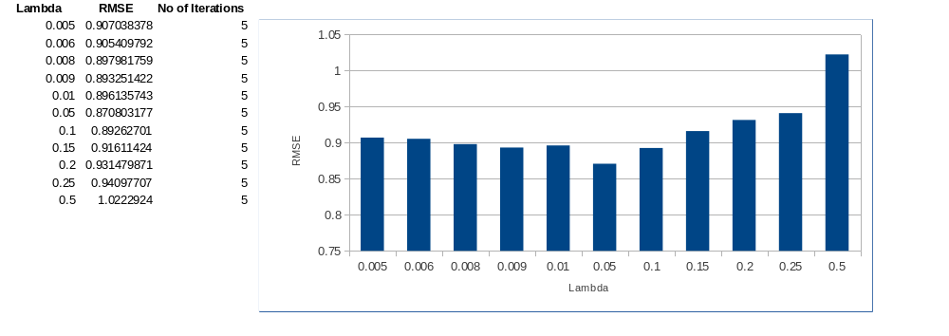
As shown in (flowchart figure number) the training process includes a RMSE threshold check step where the lambda value can be changed to optimize the recommendation model. In the figure (above figure number) keeping the number of iteration fixed at 5 and changing the lambda value in the range 0.005 to 1 the minimum RMSE value of 0.870803177 is found when lambda value is 0.05.

6) No comparison is made between the proposed method's results and the existing state-of-the-art methods' results(SG,AW)

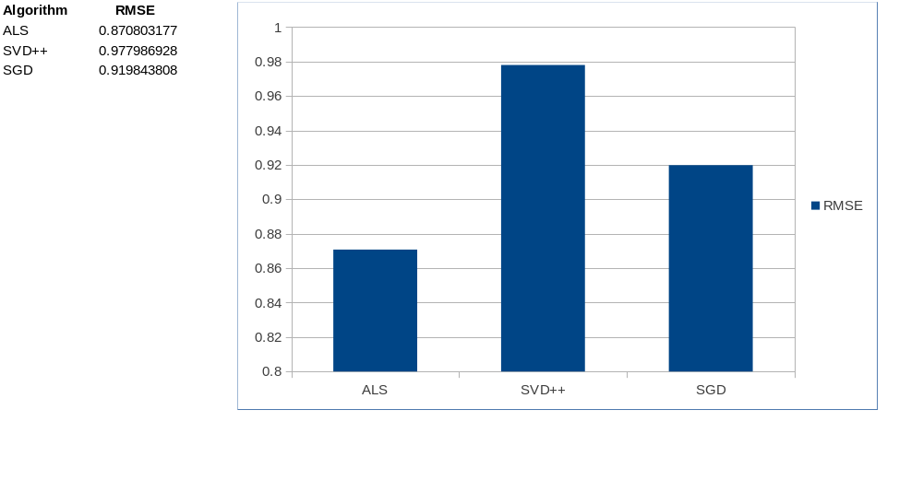
In this research, a comparative analysis is performed to evaluate the performance of proposed recommendation system training algorithm Alternating Least Square (ALS). Therefore, a comparison is made among ALS, SVD++ and Parallelized SGD matrix factorization methods. The result shows that the RMSE value is significantly reduced using ALS matrix factorization method and the RMSE is 0.870803177. Consequently, the experiment shows that the ALS algorithm is suitable for training explicit feedback data set where users provide ratings for items.

Add result / finding in Abstract section. This section also should be more concrete and specific instead of popular article.(SG)
The research shows that the RMSE value is significantly reduced using ALS matrix factorization method and the RMSE is 0.870803177. Consequently, it is shown that the ALS algorithm is suitable for training explicit feedback data set where users provide ratings for items. The proposed recommendation system architecture is designed following lambda architecture so that the users can see the recommendations real time.

Note: Please add the above paragraph in the conclusion also.

