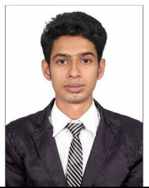

**PRANAB BARAI CAREER OBJECTIVE**

[pranabarai@gmail.com](mailto:pranabarai@gmail.com) with my amiable, caring and friendly nature

89611411995 dedicated attitudes, I would like to pursue my career

**TIME-OFF** in the service sector.

* Internet surfing **ACADEMIC QUALIFICATION**

|  |  |  |
| --- | --- | --- |
| **COURSE / EXAMINATION** | **BOARD / UNIVERSITY** | **YEAR OF PASSING** |
| HIGHER SECONDARY EXAMINATION | WBCHSE | 2008 |
| SECONDARY EXAMINATION | WEST BENGAL BORD OF SECONDARY EDUCATION | 2006 |

* Interaction with People

**PERSONALITY TRAITS**

* Openness to experience
* Highly Motivated
* Attention to detail

**PERSONAL DETAILS**

Father’s Name: Prabir Barai

Date of birth: 15th January 1990

Religion: Hindu

Nationality: Indian

**EXPERIENCE:**

SHREE GURU SALE AGENCY 2016-17 AT CHANDPARA, MA KALI ENTERPRISE 2017 -2018 AT BHEBIA, UNDER DISTRIBUTOR, DHONOLAXMI SOHAYOK KENDRA 2018-2019 FINANCE COLLECTOR, ECO HOSPITAL AND DIGNOSTIC BARASAT 2022 ( JAMUARY-OCTOBER)

**ADDRESS:**

VILL: ChandPara

P.O – ChandPara Bazar

P.S –GAIGHATA

DIST – NORTH 24 PARGANAS

PIN –743245

STATE- West Bengal

Place:

Date:

(pranab barai)