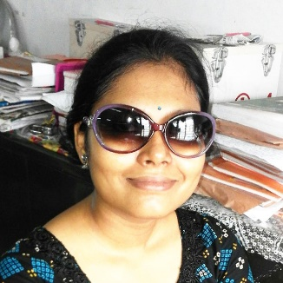

Life Science teacher

**SAYANI ADAK NATH**

**Phone:** +91 98305 74406   
**Email:** sayaniadaksa@gmail.com  
**LinkedIN:** https://www.linkedin.com/in/sayani-adak-b71a811a5/

**PROFILE**

I was born and brought up in a family of teachers. As I was growing up, being a teacher was always a preferred career choice. up to this day, being teacher is my only career goal as I’m working for this.

**EDUCATION**

**B.Ed specialization in Life Science** Currently EnrolledWBUTTEPA Marks 81%

**Bachelor in Science** Graduated, July 2017University of Calcutta Marks 54%

**10+2** Graduated, July 2012Bishnupur Siksha Sangha Marks 56%  
WBCHSE Board Division 2nd

**CAREER GOAL**

I’m looking to build a career in teaching and be the best teacher I can be.

**SOFT SKILLS**

Leadership Communication

Teamwork Problem Solving

Cultural Competence

**WORK EXPERIENCE**

Even though I’ve taught students at home for last 5 years, I’m currently looking for my first professional experience.

**COMPUTER PROFICIENCY**

* Word 2010
* Excel 2010
* Power Point 2010
* HTML

**LANGUAGES**

* Hindi
* English
* Bengali

**INTERESTS**

|  |  |
| --- | --- |
| * Poetry |  |
| * Dancing |  |
| * Swimming |  |

**PERSONAL DETAILS**

Father’s Name: Mr. Sukanta Adak Marital Status: Married  
Birthday: November 2, 1993 Nationality: Indian  
Gender: Female

**Address:** Village – South Kajir Hat, P.O+P.S – Bishnupur, District – South 24 pgs, PIN - 743503

**Declaration**

I, Sayani Adak Nath, hereby declare that the information contained herein is true and correct to the best of my knowledge and belief.

____________________________  
Sayani Adak Nath Place: Kolkata 700104