# Silicon Institute of Technology

## | An Autonomous Institute |

TRAINING DIARY



Name SIC No:

Regd. No: Branch Year

# Silicon Institute of Technology

## Silicon Hills, Patia, Bhubaneswar – 751024

**MEMORANDA**

Name SIC No:

Paste your Passport Size Photograph

Regd. No: Branch:

Name & Address of Organization:

Details of Reporting Officer / Training In-Charge:

Name:

Designation: Phone:

Email Address:

Period of Traning: From To

Total No. of Days No. of Days Absent

Date:

Seal Signature of Training-In-Charge

# INSTRUCTIONS & GUIDELINES

The student is required to adhere to the following instructions during the entire duration of the summer internship / training:

1. S/he must carry this Training Diary with details duly filled up, photograph attested by FIC – II Cell.
2. S/he must carry the Evaluation Form issued by II Cell.
3. S/he must report for the internship / training in time on the day/date specified by the organization.
4. S/he must carry the Institute Identity Card at all times along with any other ID Card/Pass issued by the organization.
5. S/he must get the Training Diary signed by the Training In- Charge on the first day of internship / training.
6. S/he must write the training diary every day and get it countersigned by the Training In-charge.
7. At the end of the internship / training, s/he must get the “Training Completion Certificate” filled in and signed by the Training In-Charge with his/her official seal.
8. The Evaluation Form must be filled in properly by the Training In-Charge on the last day of internship / training and handed over to the student in a sealed envelope.
9. S/he must submit the Training Diary and sealed Evaluation Form to the FIC – II Cell within 7 days of start of the next semester.
10. S/he must submit a Training Report (maximum 5 pages) to the evaluation committee at the time of presentation & viva.

Date Time from to

Details of Training / Observations:

Countersigned By Signature of Trainee

# COMPLETION CERTIFICATE

Certified that Mr/Ms

SIC No: Regd. No:

has successfully completed the Summer Internship / Training program at

from Date to .

The student has invested a total of Hours on the Summer Internship / Training Program. The performance of the student was found to be Satisfactory / Unsatisfactory during the training.

**Signature of Training In-Charge** Seal Name:

Designation:

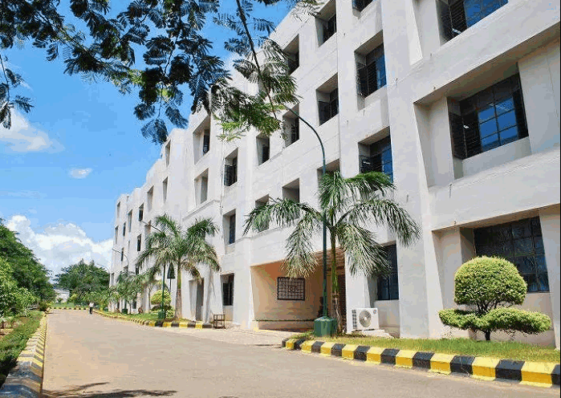

# Silicon Institute of Technology

Silicon Hills, Patia, Bhubaneswar – 751024 Website: [www.silicon.ac.in,](http://www.silicon.ac.in/) Email: [pcell@silicon.ac.in](mailto:pcell@silicon.ac.in)

Phone: +91-8260333609