
DIGITAL LITERACY PROJECT REPORT
CSE0001-Digital Literacy

STUDENT NAME- SUBHASREE DALAI
STUDENT REGN NO. 25BEC10091
FALL SEMESTER- 2025-26
FACULTY NAME- DR. KANNAN
SLOT-E21

INTRODUCTION
Digital literacy is an essential skill in today’s technology-driven world. It refers to the ability to effectively use digital tools, access and evaluate information, and communicate responsibly in online environments. For students, digital literacy plays a crucial role in academic success as well as in building a strong professional identity.
This project aims to explore key aspects of digital literacy, including the use of digital tools, safe internet practices, professional online presence, email etiquette, and awareness of cybercrime. Through practical activities such as creating an infographic, developing a digital portfolio, using online platforms, and conducting a survey using Google Forms, this project provides hands-on experience with digital technologies.
The objective of this project is to enhance awareness about responsible and effective use of digital tools among students. It also highlights the importance of maintaining online safety and developing essential skills required for future academic and career growth.

Task 1: Infographic

I created an infographic on Digital Literacy using Canva. The infographic covers three important aspects: online safety, digital communication, and data privacy. Online safety includes strong password usage and avoiding suspicious links. Digital communication focuses on proper email etiquette and responsible social media behavior. Data privacy highlights the importance of protecting personal information online.

The tool Canva was chosen because it provides easy templates, icons, and design features that help in creating visually appealing content. The infographic is designed to be simple, informative, and engaging for students.

One challenge I faced was selecting the most relevant information and presenting it in a limited space without making it overcrowded. However, this helped me understand how to prioritize important points and improve visual communication skills.

Overall, this task helped me learn how to present digital awareness topics in a creative and understandable way.

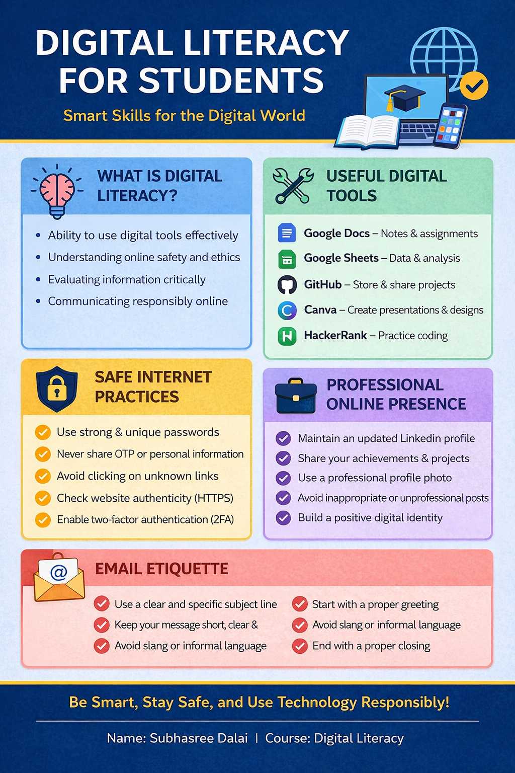

Infographic

Task 2: Digital Portfolio

For my digital portfolio, I selected GitHub, LinkedIn, and HackerRank. GitHub is used to showcase coding projects and maintain repositories, which is useful for version control and collaboration. LinkedIn helps in building a professional network and sharing achievements, internships, and skills. HackerRank is a coding platform that helps in improving problem-solving abilities.

I updated my GitHub profile by adding my projects, including this Digital Literacy project. On LinkedIn, I completed my profile with education, skills, and a professional summary. On HackerRank, I solved beginner-level coding problems to improve my logical thinking.

These platforms are important for academic and career growth. They help in building a strong online presence and can be useful during placements and internships. In the future, I plan to regularly update these platforms with new projects and achievements.

This task helped me understand the importance of maintaining a digital identity and using online platforms effectively.

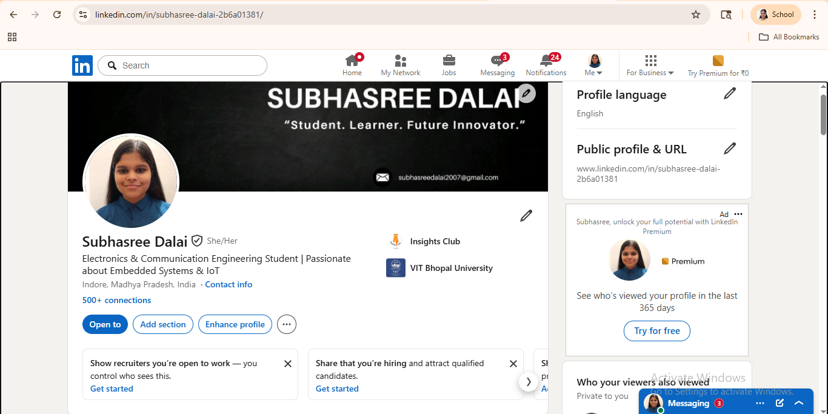

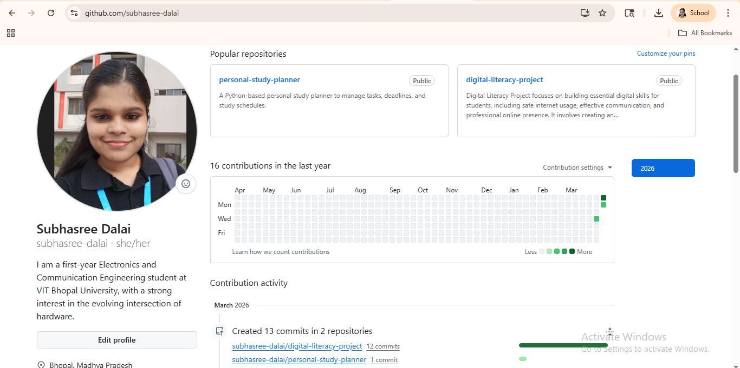

Task 3: Platforms Write-up

For this task, I used HackerRank as the coding platform and solved a beginner-level problem on basic programming concepts. This helped me improve my coding logic and understand problem-solving approaches.

I also created a Google Form consisting of 5 questions related to digital literacy awareness. The questions focused on topics like password safety, phishing awareness, and responsible internet usage. I shared the form and collected responses, which were automatically stored in Google Sheets.

Using these platforms helped me understand how digital tools can be used for both learning and data collection. HackerRank helps students practice coding and prepare for technical interviews, while Google Forms and Sheets are useful for surveys, research, and academic projects.

This task enhanced my technical and analytical skills and showed how different platforms can be integrated for educational purposes.

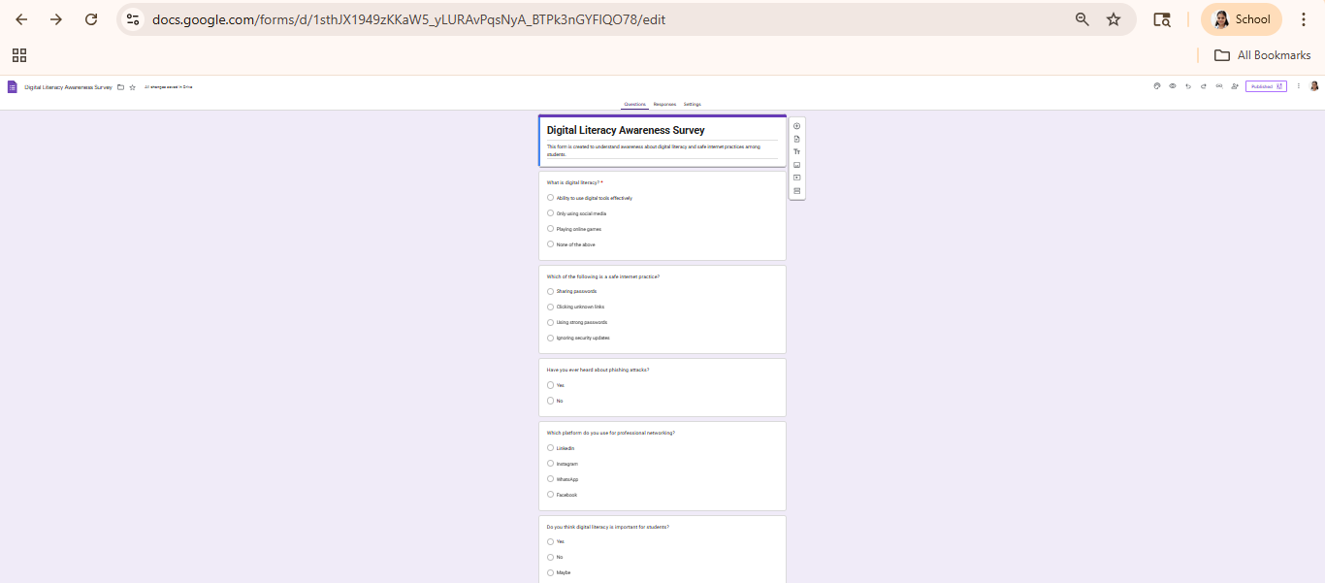

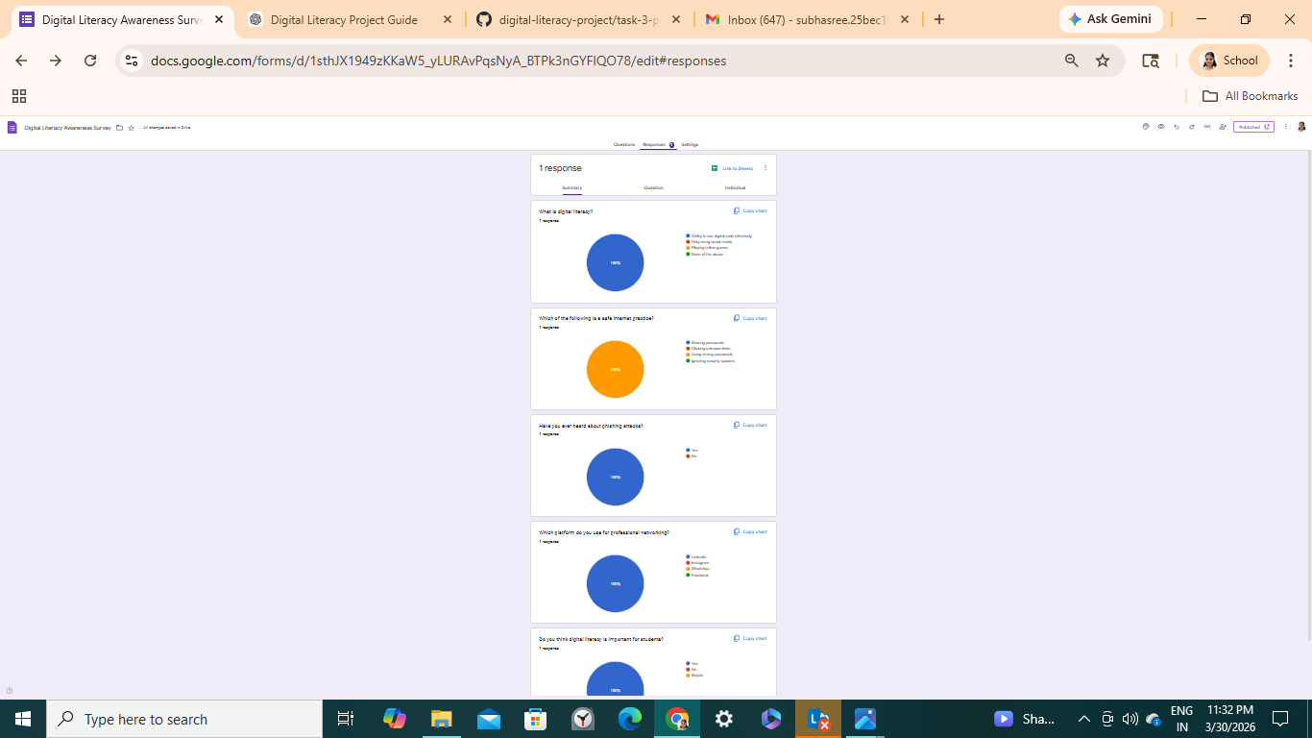

Task 4: Email Etiquette + Social Media

📧 Email 1 (Assignment Extension)

Subject: Request for Assignment Extension

Dear Sir/Ma’am,

I hope you are doing well. I am writing to request a short extension for submitting my assignment due to unforeseen circumstances.

I assure you that I am working on the assignment and will submit it as soon as possible. I kindly request you to grant me some additional time.

Thank you for your understanding.

Yours sincerely,

Subhasree Dalai

📧 Email 2 (Internship Interest)

Subject: Inquiry Regarding Internship Opportunity

Dear Sir/Ma’am,

I hope this message finds you well. I am writing to express my interest in internship opportunities available in your organization.

I am currently pursuing my undergraduate degree in Electronics and Communication Engineering and am eager to gain practical experience. I am particularly interested in enhancing my technical and problem-solving skills.

I would be grateful if you could consider my application.

Thank you for your time and consideration.

Yours sincerely,

Subhasree Dalai

📱 Social Media Do’s & Don’ts
Do’s:
1. Use strong and unique passwords
2. Verify information before sharing
3. Maintain respectful communication
4. Protect personal information
5. Use privacy settings wisely
Poor Communication Reflection

Don’ts:
1. Do not share sensitive personal data
2. Avoid posting inappropriate content
3. Do not click on unknown links
4. Avoid spreading misinformation
5. Do not engage in online harassment

Poor Communication Reflection
A common example of poor digital communication is sending informal or unclear emails to professors or professionals. Sometimes students send messages without proper subject lines, greetings, or structure, which can appear unprofessional.

Such communication can lead to misunderstandings and may create a negative impression. To improve this, emails should be clear, concise, and respectful. Proper formatting, including subject lines, greetings, and closing statements, should always be used.

This task helped me understand the importance of professional communication in digital platforms and how it can impact academic and career opportunities.

Task 5: Cybercrime Case Study
Phishing is one of the most common types of cybercrime where attackers trick users into revealing sensitive information such as passwords, OTPs, or bank details. A common example is receiving fake emails or messages that appear to be from banks or trusted organizations.

In one such case, a user received a message claiming that their bank account would be blocked unless they verified their details immediately. The message included a link to a fake website that looked identical to the official bank website. The user entered their login credentials and OTP, after which money was withdrawn from their account.

This incident highlights the importance of being cautious while dealing with online messages and links. Cybercriminals often create urgency to make users act without thinking.

To prevent such incidents, users should always verify the authenticity of messages and avoid clicking on suspicious links. Awareness and careful behavior are key to avoiding cyber threats.

Prevention Checklist (8 points)
1. Do not click on suspicious links or emails
2. Always verify website URLs before entering details
3. Never share OTP or banking credentials
4. Use strong passwords and enable two-factor authentication
5. Regularly monitor bank transactions
6. Use official apps for UPI transactions
7. Report fraud on National Cyber Crime Portal (https://cybercrime.gov.in)
8. Call helpline number 1930 immediately in case of fraud

Reflection
While researching cybercrime, I was surprised to learn how easily people can fall victim to phishing attacks. The use of fake websites and urgent messages makes it difficult for users to identify fraud.

This task made me more aware of online threats and the importance of verifying information before taking action. One habit I will change is being more cautious while clicking on links and sharing personal information online.

Overall, this activity improved my understanding of cybersecurity and the steps needed to stay safe in the digital world.

CONCLUSION
This project provided valuable insights into the importance of digital literacy in modern education and professional life. Through various tasks, I gained practical experience in using digital tools, creating visual content, building a digital portfolio, and understanding online safety practices.
I learned how to communicate professionally through emails, maintain a strong online presence, and use platforms like GitHub, LinkedIn, HackerRank, and Google Forms effectively. The study of cybercrime, especially phishing, helped me understand the risks associated with digital platforms and the importance of precautionary measures.
Overall, this project enhanced my technical, analytical, and communication skills. It encouraged me to use digital technologies responsibly and continue improving my digital competence. These skills will be highly beneficial for my academic journey and future career.

REFERENCES
- https://www.canva.com
- https://www.github.com
- https://www.linkedin.com
- https://www.hackerrank.com
- https://forms.google.com
- https://cybercrime.gov.in
- https://www.google.com

