FitHub CRM – Fitness Center Management

Project Title: FitHub CRM – Fitness Center Management
Project Type: Team Project
Developed By:
• Team lead : Subhasree S
• Member 1 : Sanjana K
• Member 2 : Roshini M
• Member 3 : Ranjani V
• Member 4 : Sharmila P
Course: Naan Mudhalvan - Salesforce
Institution: Tagore Engineering College
Guide: Asst. Professor Suganthi J
Date: 05-04-2026

Abstract

Fitness centers require efficient systems to manage members, trainers, and workout plans. This project presents a CRM-based application called Fithub CRM, designed to simplify and automate fitness center management.
The system allows administrators to manage member details, assign trainers, and track workout plans effectively. It also helps in monitoring membership status, including active and expired memberships. Based on the data, the system provides useful insights through reports and dashboards.
Automation features such as trainer assignment and membership expiry notifications improve efficiency and reduce manual effort. Overall, the application enhances management processes, ensures better organization, and improves the overall user experience.

Introduction

Managing fitness centers manually can be difficult due to the need to track member records, trainer assignments, and workout plans. This project introduces a CRM-based solution that digitizes and simplifies fitness center operations.
The system provides an easy-to-use interface for managing members, trainers, and workout plans. Administrators can efficiently handle data, while automation features reduce repetitive tasks. By using CRM functionalities, the system improves data management, reduces errors, and enhances overall efficiency in fitness center operations.

Industry: Fitness & Health
Project Type: B2C Salesforce CRM Implementation
Target Users: Gym Admin, Trainers, Members , Reception Staffs

Project Overview

Fithub CRM is a Salesforce-based application designed to manage fitness center operations efficiently. It helps in maintaining member records, assigning trainers, managing workout plans, and generating reports. The system replaces manual methods such as spreadsheets and paper-based tracking with a centralized digital solution. Key features include membership tracking, trainer allocation, and dashboard-based reporting for better decision-making.

Objectives

The main objective of this project is to develop a CRM system using Salesforce to simplify gym management processes. The system focuses on organizing member and trainer data, automating basic workflows, and generating reports. This improves efficiency, reduces manual errors, and enhances overall management.

Phase 1: Requirement Analysis & Planning

Understanding Business Requirements

- Manual data handling leads to errors and inefficiency
- Difficulty in tracking active and expired memberships
- No proper system for assigning trainers
- Lack of centralized reporting system

Defining Project Scope and Objectives

- Develop a CRM system for fitness center management
- Manage members, trainers, and workout plans
- Automate basic processes like notifications
- Generate reports and dashboards
- Ensure secure data access

Data Model and Security Model

- Custom Objects:

Member
Trainer
Workout Plan

- Relationships:

Member → Trainer (Lookup Relationship)
Member → Workout Plan (Master-Detail Relationship)

- Security:

Organization-Wide Defaults set to Private
Role hierarchy implemented
Sharing rules used for controlled access

Stakeholders Mapping

Admin: Full control over system
Trainer: Manage assigned members and workout plans
Receptionist: Add and manage member details

Execution Roadmap

- Requirement analysis
- Object creation
- Relationship setup
- Automation implementation
- Reports and dashboards creation
- Testing and validation

Phase 2: Salesforce Development – Backend & Configuration

Setup Environment & Configuration

- Salesforce Developer Edition used
- Users, roles, and profiles created
- Business settings configured

Customization

- Created custom objects: Member, Trainer, Workout Plan
- Added required fields for each object
- Applied validation rule

Automation

- Implemented automation using Flow Builder
- Membership expiry notification configured
- Basic trainer assignment logic applied

Apex Development

- Apex is used to implement custom business logic that cannot be fully handled using declarative tools. In this project, both Apex Triggers and Apex Classes are developed to automate specific operations and improve system functionality.
- Apex Trigger
An Apex Trigger is created on the Member object to automate processes during record creation and updates. The trigger ensures that necessary actions, such as trainer assignment or data validation, are performed automatically without manual intervention.
- Apex Class
An Apex Class is developed to handle reusable business logic such as calculating membership status (Active or Expired) based on membership dates. This improves code reusability and maintains better structure in the applications

Triggers run before insert/update for automation
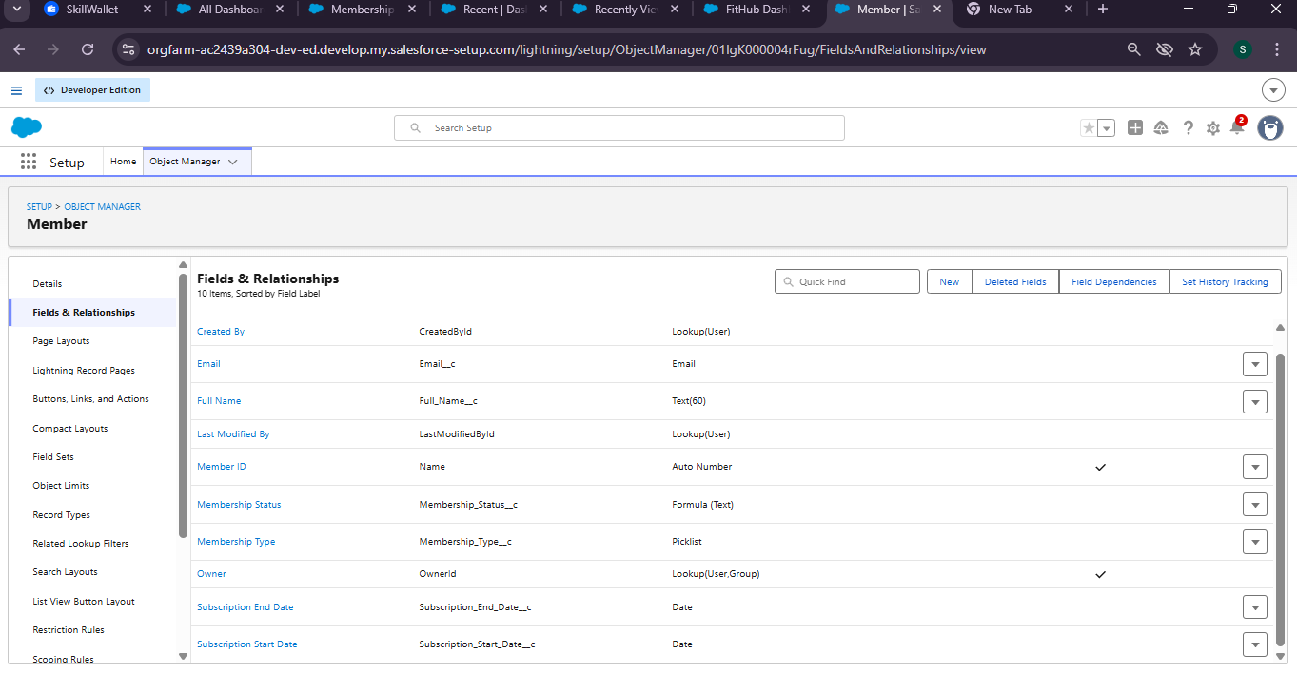

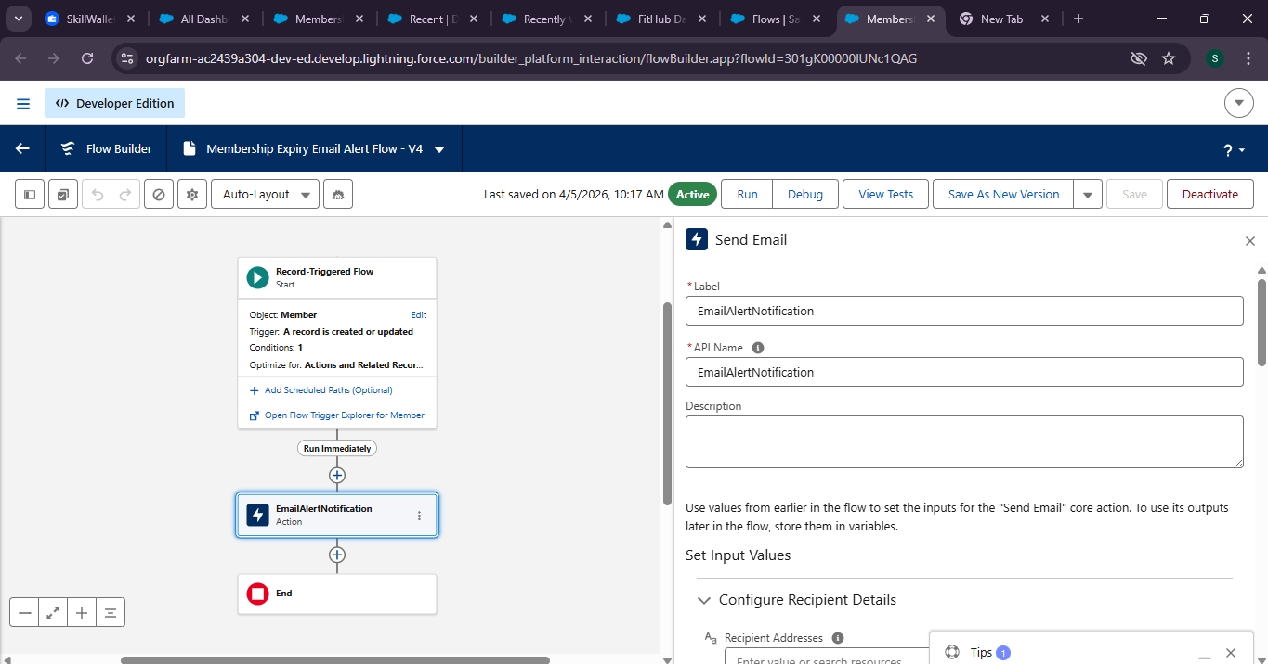

Phase 3: UI/UX Development & Customization

Lightning App Setup

- Created application using App Manager

Page Layouts & Lightning Pages

- Customized layouts for Member and Workout Plan
- Important fields added for better visibility

User Management

- Profiles created: Admin, Trainer, Receptionist
- Role hierarchy defined

Reports and Dashboards

- Reports created:
- Active vs Expired Members
- Trainer workload
- Dashboard created with charts for visualization

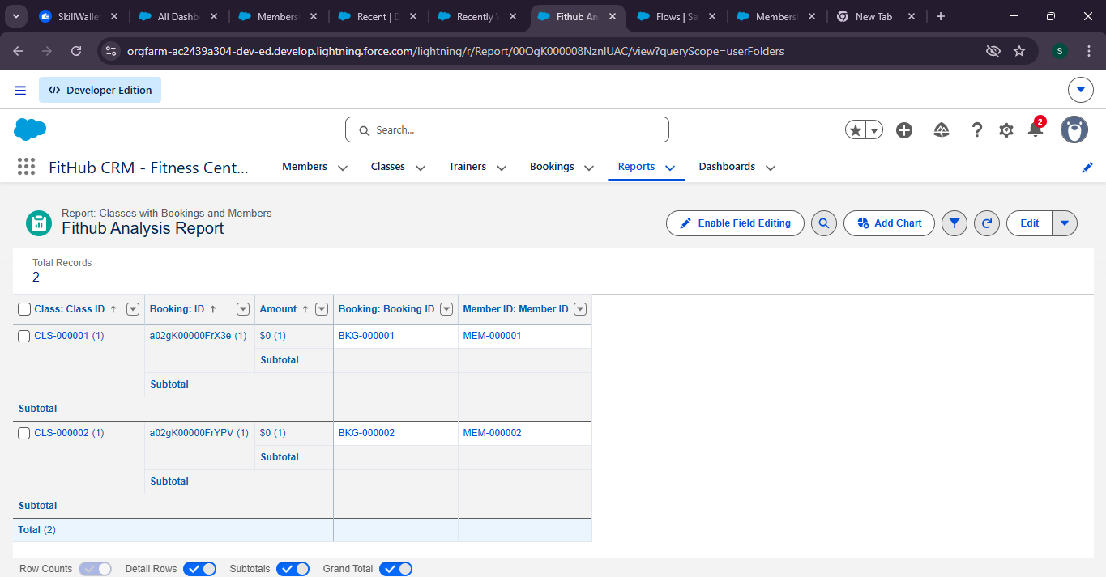

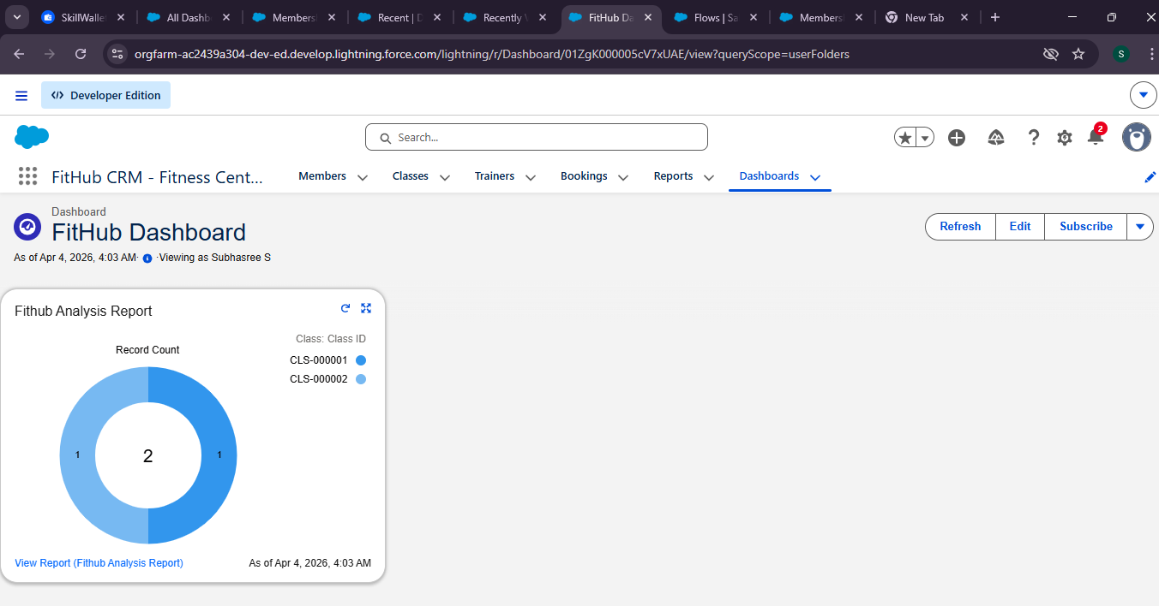

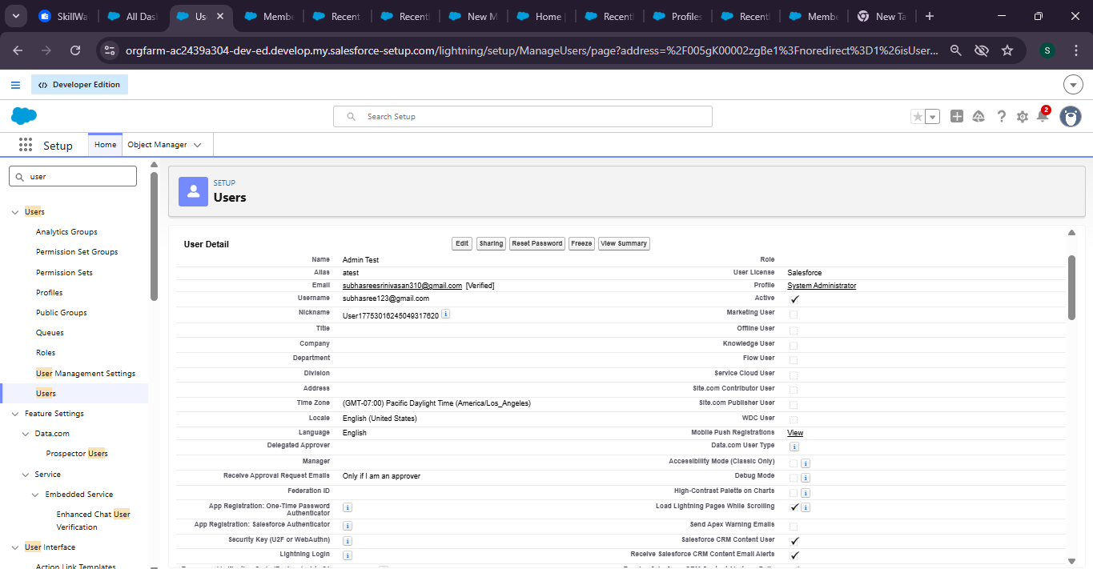

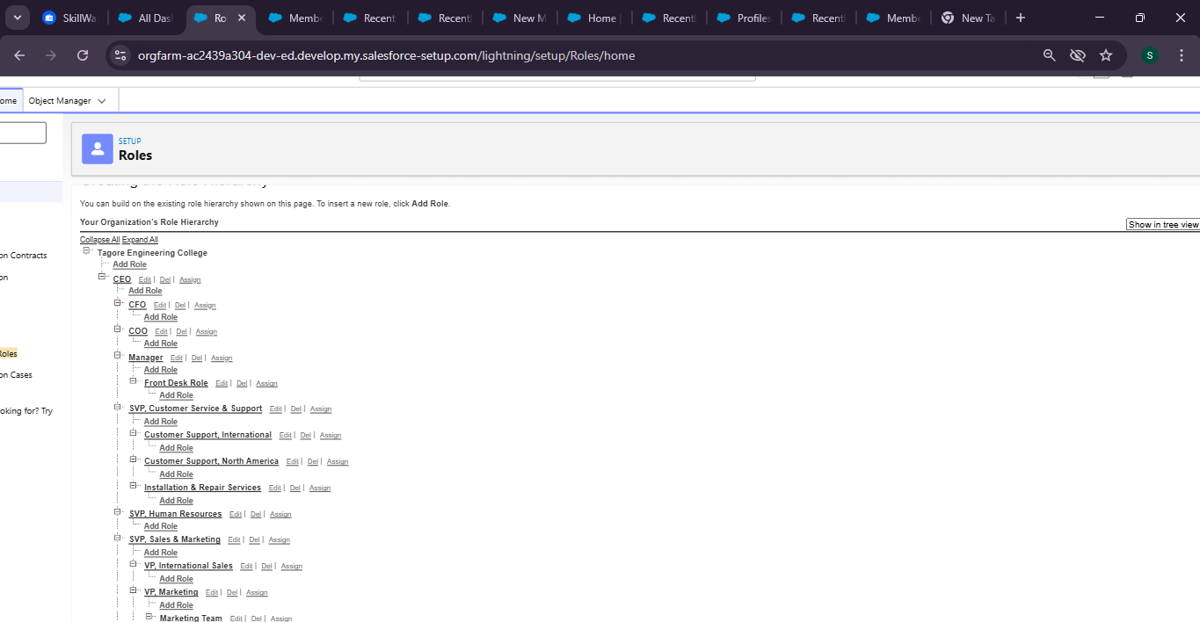

Phase 4: Data Migration, Testing & Security

Data Migration

- Data imported using Data Import Wizard
- CSV files used for uploading sample records

Security Implementation

- Profiles and roles configured
- Permission sets assigned
- Duplicate rules implemented to avoid repeated entries

Testing Approach

- Tested member creation and updates
- Verified trainer assignment
- Checked automation processes
- Validated reports and dashboards
- Testing was performed using sample data, and outputs were verified through system-generated results.

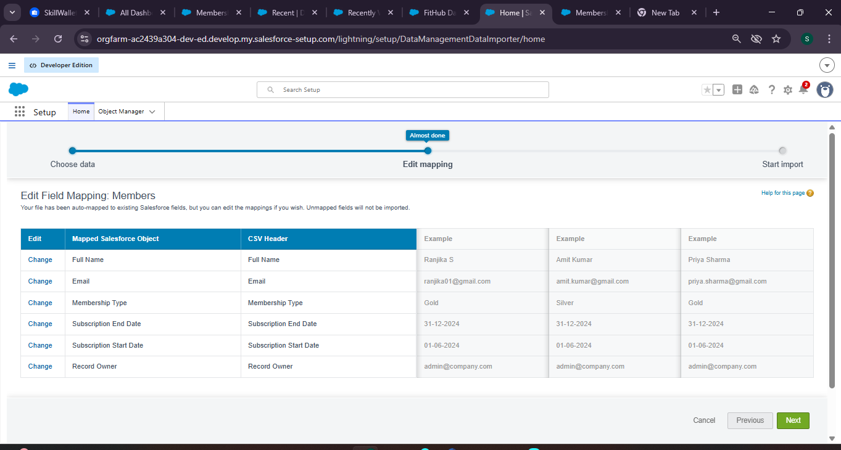

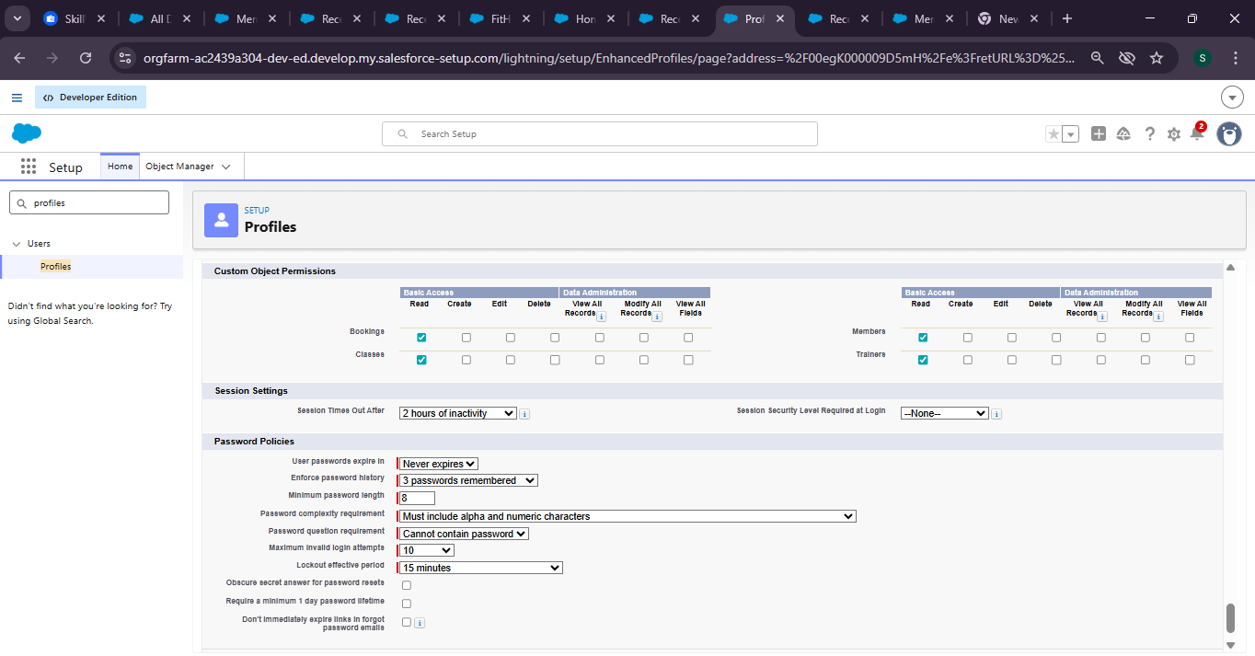

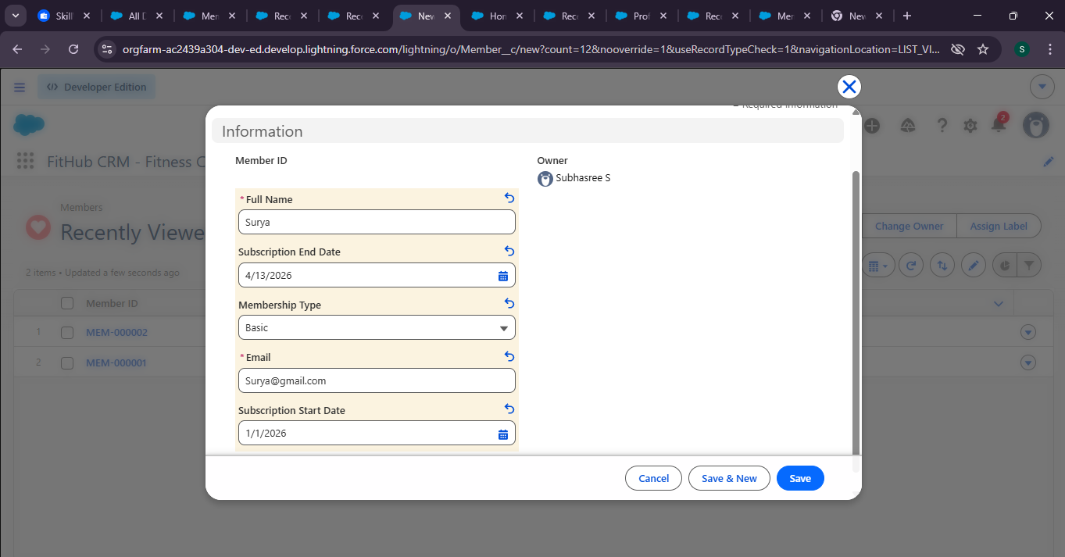

- The system was tested by creating a new member record in Salesforce.
- Verified that the trainer was automatically assigned during member creation.
- Checked that membership expiry notifications were triggered correctly.
- Confirmed that the data was accuirately reflected in reports and dashboards.

The record was successfully saved, confirming proper data handling and system functionality.

Phase 5: Deployment, Documentation & Maintenance

Deployment Strategy

- Change Sets can be used to deploy components between environments

Maintenance

- Regular data monitoring
- Periodic updates to workflows
- Data backup using export tools

Troubleshooting

- Checked validation rule errors
- Verified flow execution
- Reviewed data consistency

Advantages

- Automation reduces manual work in managing members and trainers
- Easy tracking of active and expired memberships
- Improved trainer assignment and workload management
- Better data accuracy and centralized record management
- Real-time reporting through dashboards

What we Learned

- Understanding of CRM concepts and real-time implementation
- Hands-on experience with Salesforce
- Working with Apex, Triggers, and Flows for automation
- Designing objects, relationships, and security models
- Practical knowledge of reports and dashboards

Future Enhancements

- Mobile application integration for members
- Integration with fitness tracking devices
- Advanced automation using Apex
- AI-based fitness recommendations
- Member self-service portal

Conclusion

Fithub CRM successfully automates fitness center operations using Salesforce. It reduces manual work, improves efficiency, and provides better insights through reports and dashboards.

Reference

- Salesforce Documentation
- CRM Concept Books
- Online Tutorials

Demo Video Link:

https://drive.google.com/drive/folders/1ujE_6rtdqaaGjPg9LeDfzQTcI5n2O1MW

GitHub Link:

https://github.com/subhasree-vasan/Fithub_CRM

