ASG Airlines: Project Documentation

Technologies Used: Azure Data Factory | Azure Data Lake Storage Gen2 | Azure Databricks | PySpark | Power BI
Project Components : Data Ingestion • Data Cleaning • Data Transformation • Data Validation • KPI Analysis • Power BI Reporting
Prepared By : Subhasree Sahu

Code Implementation
1.1 Pipeline Overview
- Source: UseCase - Airlines.xlsx
- Azure Data Factory used for ingestion.
- Azure Data Lake Storage Gen2 used for storage.
- Raw data stored in raw container.
- ADF Copy Activity transfers the Excel data into the processed container as CSV.
- Databricks used for data validation, cleaning and transformation.
- PySpark used for transformations.
- Final cleaned dataset generated as final_flights.csv.
- Power BI used for analytics and visualization.
1.2 Data Ingestion
- Source Excel file contains flight operational data.
- ADF linked service created for Azure Storage.
- Excel dataset configured with the flights worksheet.
- ADF Copy Activity used to move data from raw storage to processed storage.
- Pipeline validation and execution completed successfully.
1.3 Data Validation
- Row count
- Column count
- Null/missing-value check
- Duplicate-record check
- Flight identifier validation
- Airline-value validation
- Duration validation
Actual results:
- Initial rows: 1,020
- Columns: 7
- Missing airline values: 41
- Exact duplicate rows: 15
1.4 Data Cleaning
Includes:
- Removed exact duplicate records.
- Trimmed whitespace from string columns.
- Standardized airline values.
- Replaced missing/blank airline values with Unknown.
- Standardized Unknown/UNKNOWN into Unknown.
- Validated flight identifiers using the defined pattern.
- Created invalid_flight_id flag.
1.5 Data Transformation
Includes the creation of:
- duration_minutes
- route
- is_anomaly
- invalid_flight_id
1.6 Data Loading
- Cleaned dataset written to the processed ADLS Gen2 location.
- Final dataset consolidated into a single CSV.
- Final file: final_flights.csv
- Dataset used by Power BI for reporting.
1.7 Tools Used
- Azure Data Factory
- Azure Data Lake Storage Gen2
- Azure Databricks
- PySpark
- Power BI

Dataset Documentation
2.1 Dataset Structure
Includes table with:
Column | Description
flight_id | Flight identifier
airline | Airline name
source | Departure city/airport
destination | Arrival city/airport
departure_time | Flight departure time
arrival_time | Flight arrival time
duration_minutes | Calculated flight duration in minutes
route | Combined source and destination
is_anomaly | Flag identifying duration anomalies
invalid_flight_id | Flag identifying invalid flight identifiers
Conclusion :
Original dataset: 1,020 records
Original dataset: 7 columns
Final cleaned dataset: 1,005 records
15 duplicate records removed
41 missing airline values initially identified.
The original case-study fields are flight_id, airline, source, destination, departure_time, and arrival_time.
2.2 Architecture Diagram
UseCase - Airlines.xlsx
↓
ADLS Gen2 – Raw Container
↓
Azure Data Factory – Copy Activity
↓
ADLS Gen2 – Processed Container
↓
Azure Databricks / PySpark
↓
Cleaned & Transformed Dataset
↓
final_flights.csv
↓
Power BI
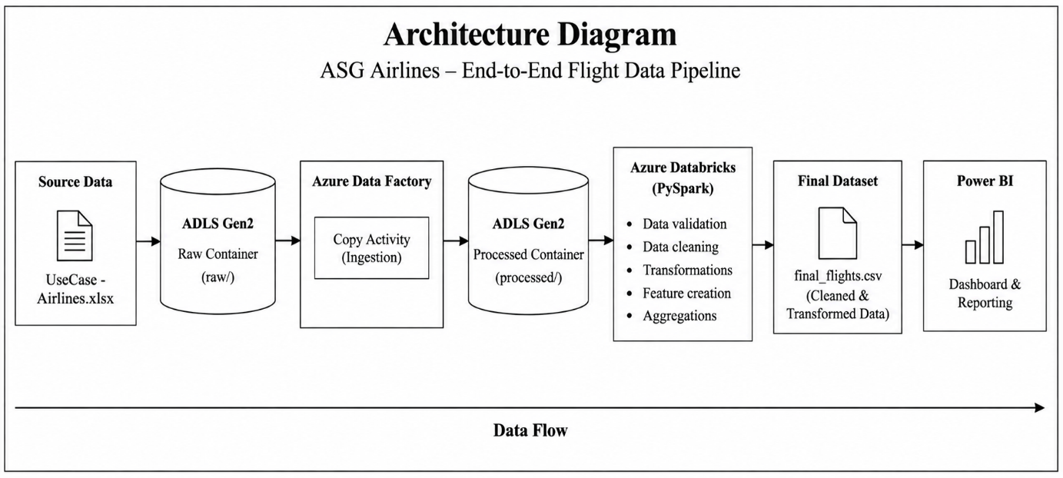
2.3 Data Flow Diagram
Source Data
→ Ingestion
→ Raw Storage
→ ADF Processing
→ Processed Storage
→ Databricks Validation & Cleaning
→ Transformation
→ Final Dataset
→ Power BI Reporting
Main operations:
- Ingestion
- Validation
- Cleaning
- Transformation
- Storage
- Reporting

2.4 Data Model
final_flights
Columns:
- flight_id
- airline
- source
- destination
- departure_time
- arrival_time
- duration_minutes
- route
- is_anomaly
- invalid_flight_id

The final dataset is represented as a single flat analytical table, with each row representing one flight record and calculated fields added for analysis and data-quality monitoring.
2.5 Assumptions Made
- Arrival time earlier than departure time is treated as an overnight/cross-day flight.
- For overnight flights, 24 hours is added to the arrival time before calculating duration.
- Exact duplicate records are removed.
- Missing or blank airline values are represented as Unknown.
- UNKNOWN and Unknown airline values are standardized to Unknown.
- Flight identifiers are validated using a defined alphanumeric pattern.
- is_anomaly is used to identify zero-duration records.
- The supplied dataset does not contain passenger personal information, so PII masking is not applicable.
- Delay cannot be calculated as a separate KPI because the dataset does not contain scheduled and actual departure/arrival timestamps.

2.6 Data Cleaning Logic and Strategy
Includes:
Duplicate Handling
- Checked for exact duplicate records.
- Identified 15 duplicates.
- Removed duplicates using dropDuplicates().
Missing Values
- Checked missing values for all columns.
- airline contained 41 missing values.
- Missing/blank airline values were standardized to Unknown.
Standardization
- Trimmed whitespace from string columns.
- Standardized airline values.
- Converted UNKNOWN and Unknown into the single value Unknown.
Flight ID Validation
- Flight IDs were checked against the defined format.
- invalid_flight_id flag was created.
Anomaly Detection
- is_anomaly flag was created.
- Zero-duration flights were treated as anomalies.
- Final anomaly count: 0.
2.7 Transformation Steps and Logic
Duration Calculation
Duration = Arrival Time − Departure Time
When:
Arrival Time < Departure Time
the flight is considered an overnight flight, so 1,440 minutes (24 hours) is added to the arrival time before calculating duration.
Example:
Departure = 23:00
Arrival = 01:30
Without overnight handling → negative duration.
With overnight handling:
01:30 + 24 hours = 25:30
Duration:
25:30 − 23:00 = 150 minutes
Route Creation
Document:
route = source + " - " + destination
Example:
DEL + CCU → DEL - CCU
Anomaly Flag
- Duration of 0 minutes → is_anomaly = True
- Otherwise → is_anomaly = False
- Final anomaly count: 0
Invalid Flight ID Flag
- Flight IDs are checked against the required pattern.
- Valid IDs → False
- Invalid IDs → True
- Final invalid-flight-ID count: 0
Final Dataset
- Duplicate removal reduced the dataset from 1,020 to 1,005 records.
- Final dataset was saved as final_flights.csv.
- The final dataset was used as the source for Power BI.
Dashboard and Reporting
3.1 Power BI Report
Includes:
- The final cleaned dataset final_flights.csv was imported into Power BI.
- The report was designed to provide an overview of flight operations and support analysis of duration, routes, airlines, and anomalies.
- KPI cards, charts and slicers were used to make the report interactive.
- The report contains five analytical pages:
  - Executive Overview
  - Duration Analysis
  - Route Performance
  - Airline Trends
  - Delay & Anomaly Insights
3.2 Key KPIs
Include the actual final values:
KPI | Result
Total Flights | 1,005
Average Flight Duration | 164.62 minutes
Total Routes | 30
Airlines | 5
Total Anomalies | 0
Invalid Flight IDs | 0
3.3 Dashboard Visualizations
Executive Overview
- Total Flights
- Average Flight Duration
- Total Routes
- Airlines
- Anomalies
- Distribution of Flights by Airline
- Route-wise Traffic
- Airline, Source and Destination slicers
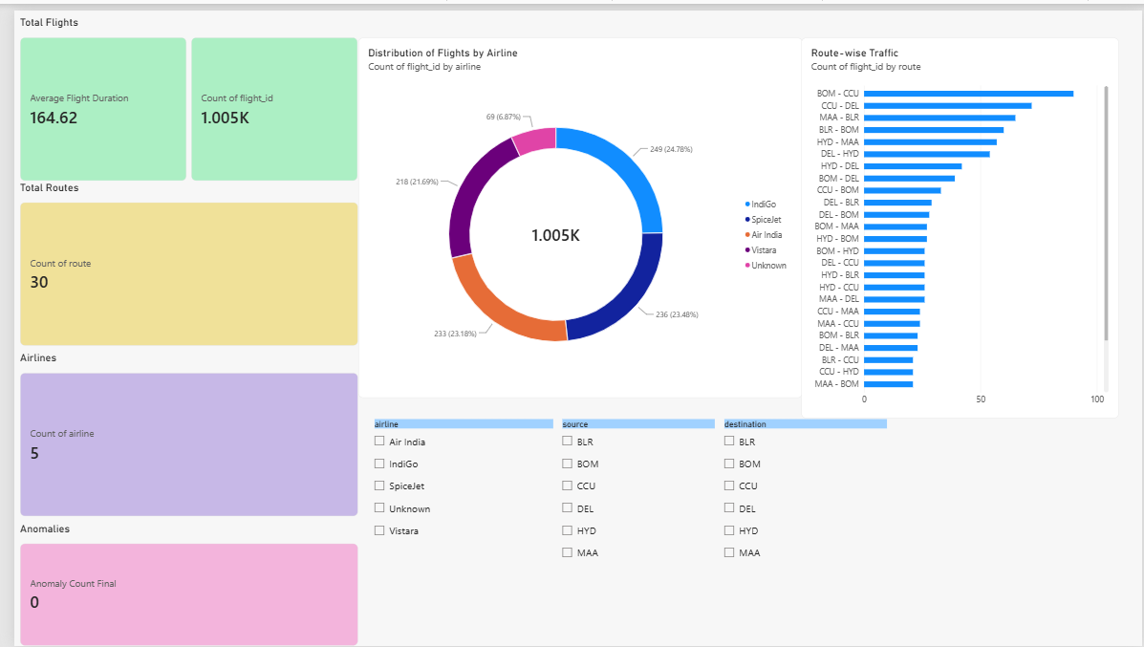

Duration Analysis
- Average Flight Duration
- Flight Duration Distribution
- Average Flight Duration by Airline
- Average Flight Duration by Route
- Overnight Flight Handling explanation
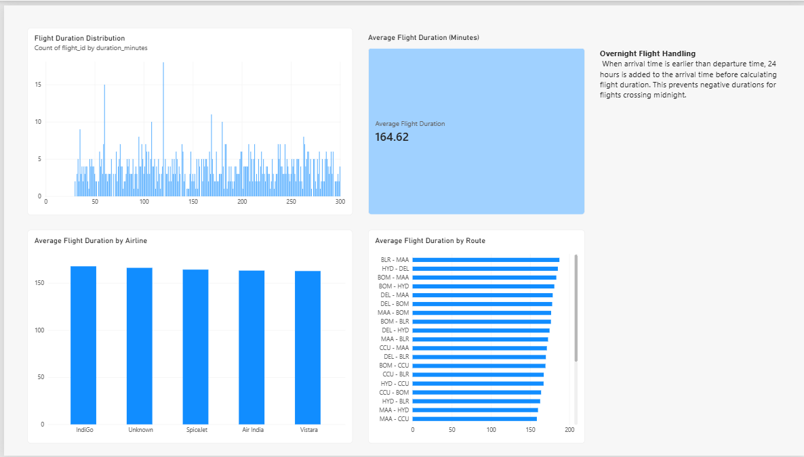
Route Performance
- Total Routes
- Route-wise Traffic
- Average Flight Duration by Route
- Route filter
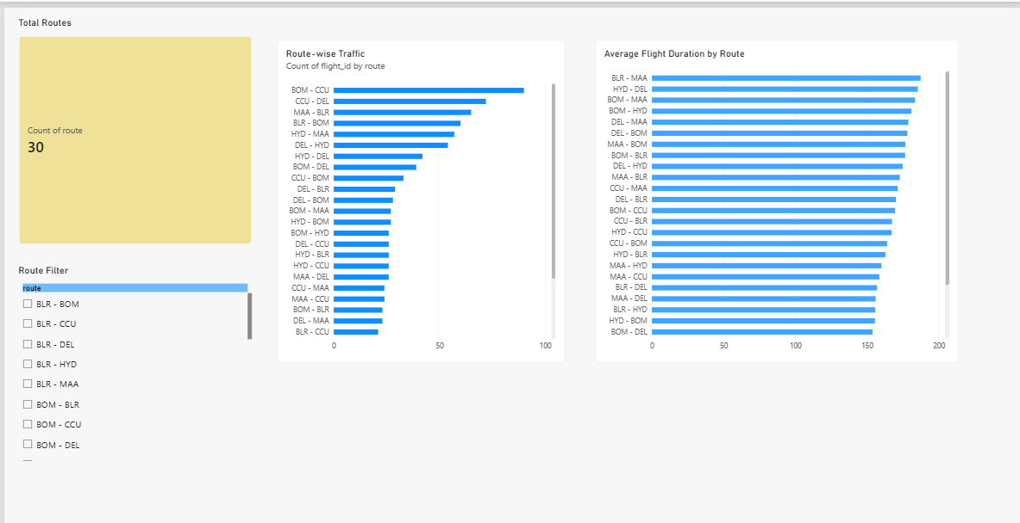
Airline Trends
- Total Flights
- Distribution of Flights by Airline
- Average Flight Duration by Airline
- Airline filte
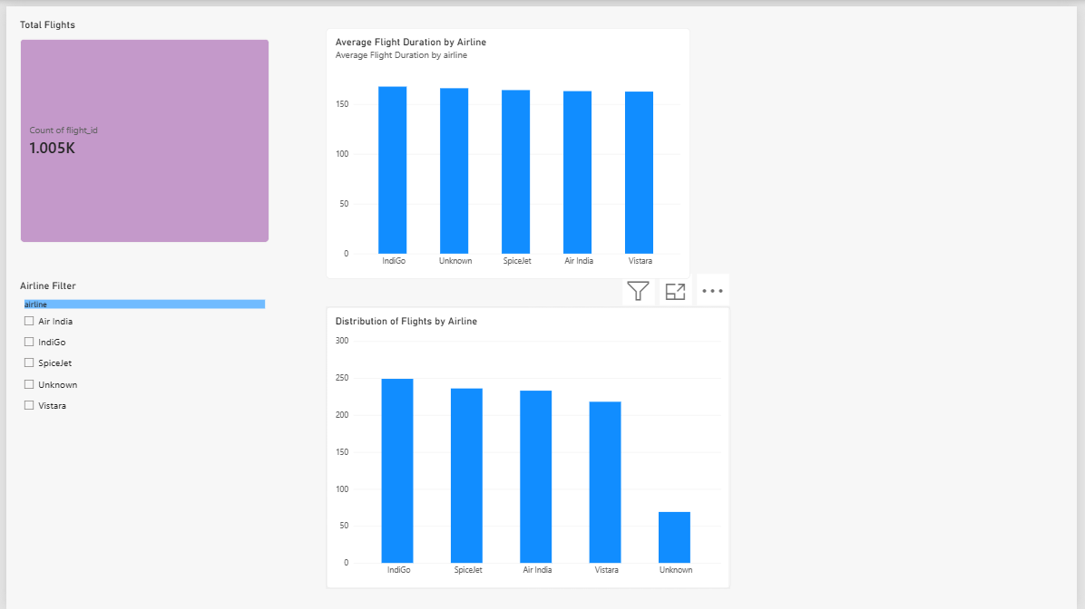

Delay & Anomaly Insights
- Total Anomalies
- Invalid Flight IDs
- Flights by Anomaly Status
- Anomaly and Data Quality Insights
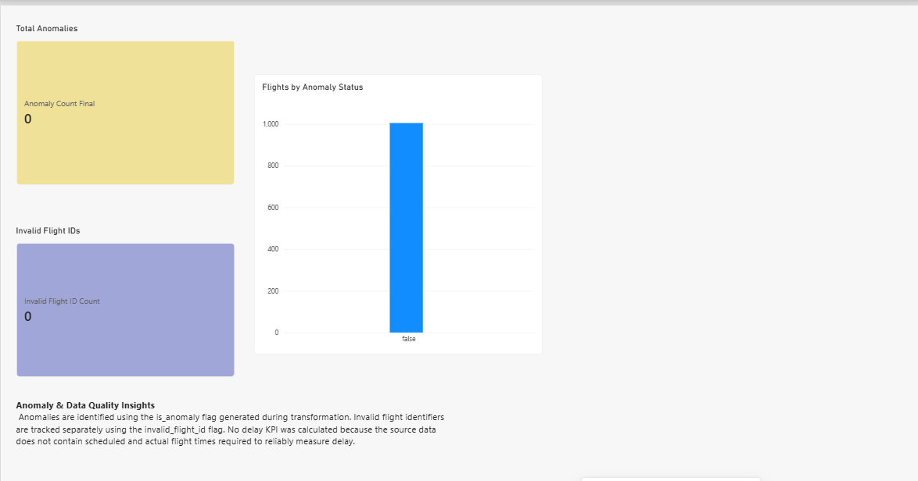
3.4 Interactivity
- Airline slicers/filters
- Source filters
- Destination filters
- Route filter
- Airline filter
- Interactive charts and KPI cards
- Cross-filtering between report visuals
3.5 Dashboard Screenshot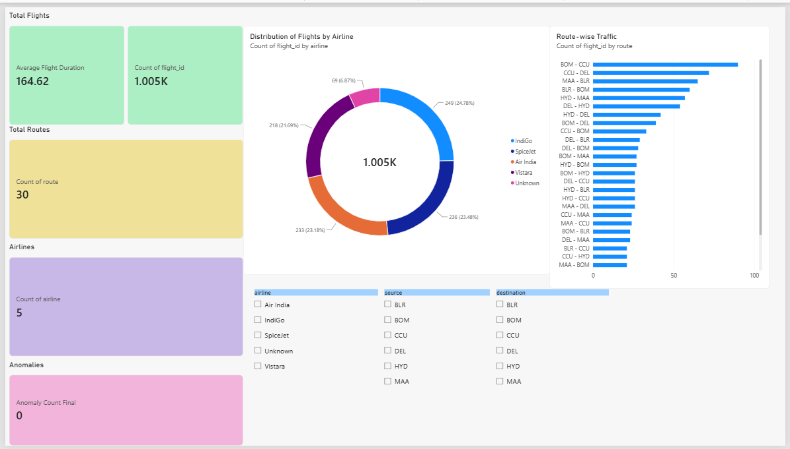
Screenshot Explanation
- The Executive Overview provides a consolidated view of the airline's operational data.
- The KPI cards show the total number of flights, average flight duration, total routes, number of airlines, and detected anomalies.
- The Distribution of Flights by Airline visual compares the number of flights handled by each airline.
- The Route-wise Traffic visual highlights the routes with higher and lower flight volumes.
- The Airline, Source, and Destination slicers allow users to filter the report interactively.
- The dashboard provides a quick way to identify flight-volume patterns, route activity, and data-quality issues.

