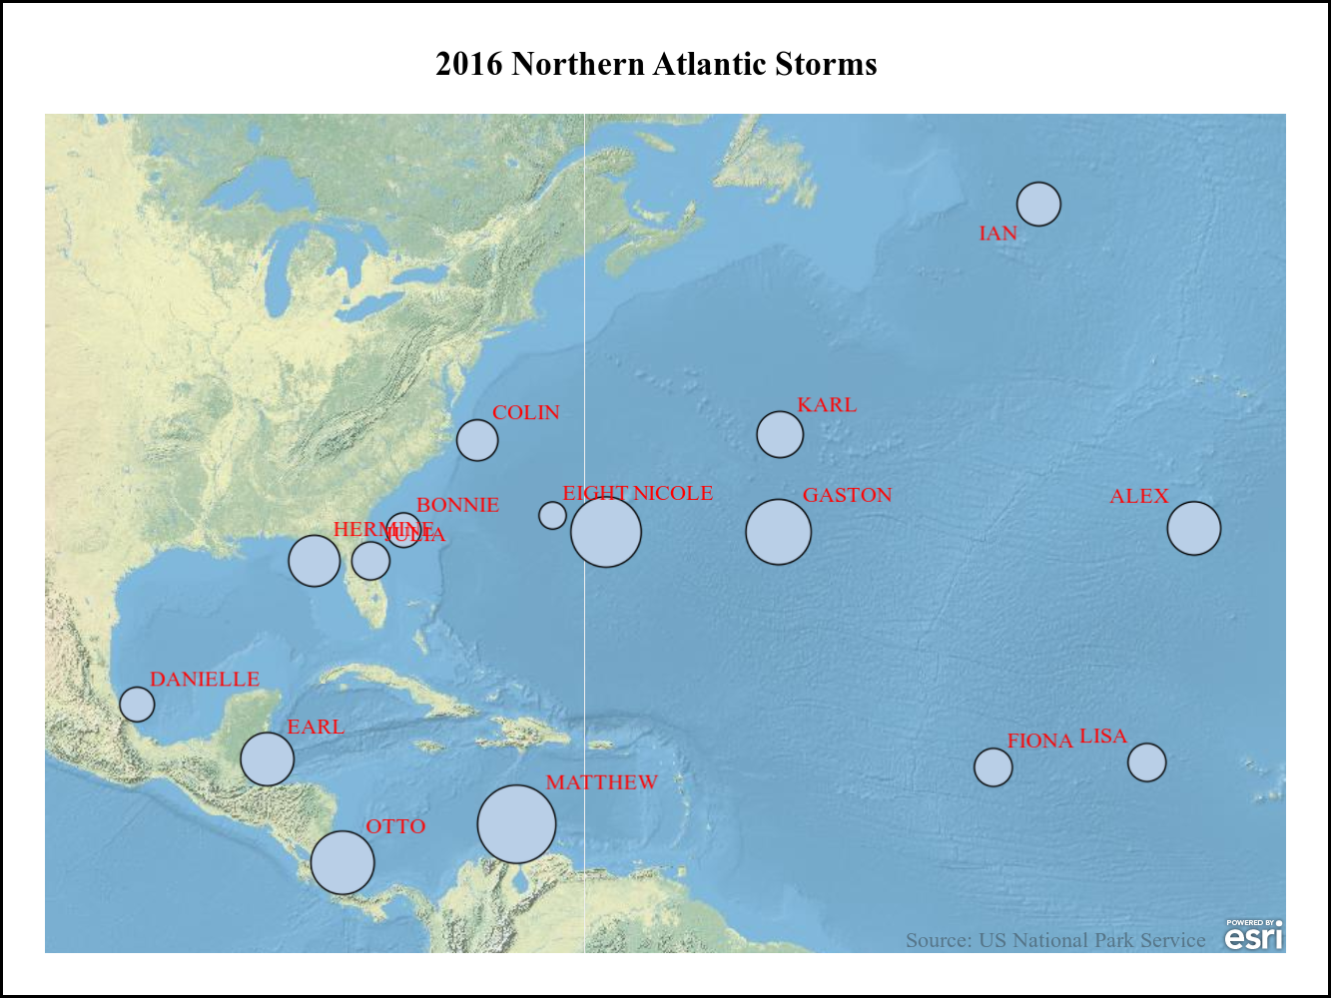
Name | StartDate | MaxWindMPH | StormLength
ALEX | JAN2016 | 86 | 10
BONNIE | MAY2016 | 46 | 13
COLIN | JUN2016 | 58 | 3
DANIELLE | JUN2016 | 46 | 3
EARL | AUG2016 | 86 | 4
FIONA | AUG2016 | 52 | 8
GASTON | AUG2016 | 121 | 13
EIGHT | AUG2016 | 35 | 5
HERMINE | AUG2016 | 81 | 11
IAN | SEP2016 | 63 | 5
KARL | SEP2016 | 69 | 14
JULIA | SEP2016 | 52 | 8
LISA | SEP2016 | 52 | 7
MATTHEW | SEP2016 | 167 | 12
NICOLE | OCT2016 | 138 | 15
OTTO | NOV2016 | 115 | 8

