

**SKILL ASSESSMENT**

|  |  |
| --- | --- |
| NAME OF THE FACULTY | Dr. S. IMRAN HUSSIAN |
| NAME OF THE STUDENT | TARANE.G, SUBASRI.R, AISHWARYA.C |
| REG.NO | 212222060271,212222060258,212222060007 |
| DEPARTMENT | ELECTRONICS AND  COMMUNICATION ENGINEERING |
| SLOT NAME | 5S1-1 |
| SUBMITTED DATE |  |
| MARKS OBTAINED |  |

**AIM:**

To determine the working principal of filer alaram circuit using 555 timer IC.

**INTRODUCTION:**

An automatic fire alarm system is designed to detect the unwanted presence of fire by monitoring environmental changes associated with combustion. In general, afire alarm system is either classified as automatic, manually activated, or both.Automatic fire alarm systems can be used to notify people to evacuate in theevent of a fire or other emergency, to summon emergency services, and to preparethe structure and associated systems to control the spread of fire and smoke. Firealarm systems have become increasingly sophisticated and functionally morecapable and reliable in recent years. They are designed to fulfill two generalrequirements: protection of property and assets and protection of life. As a result ofstate and local codes, the life-safety aspect of fire protection has become a majorfactor in the last two decades. There are a number of reasons for the substantialincreases in the life-safety form of fire protection during recent years, foremost ofwhich are

1. The proliferation of high-rise construction and the concern for life safety withinthese buildings.
2. A growing awareness of the life-safety hazard in residential, institutional, andeducational occupancies.
3. Increased hazards caused by new building materials and furnishings that createlarge amounts of toxic combustion products (i.e.,plastics, synthetic fabrics, etc.).
4. Vast improvements in smoke detection and related technology made possiblethrough quantum advances in electronic technology.

**APPARATUS REQUIRED:**

* 1. bread board
  2. 555 timer ic
  3. buzzer

4.variable resister-1M

5.transistor BC547npn

6.thermistor 10k

7.electrolytic capacitor 10uf

8.resistor 1k

9.resister 4.7k

10.resister 100k

**CRCUIT DIAGRAM** **AND EXPLANATION:**

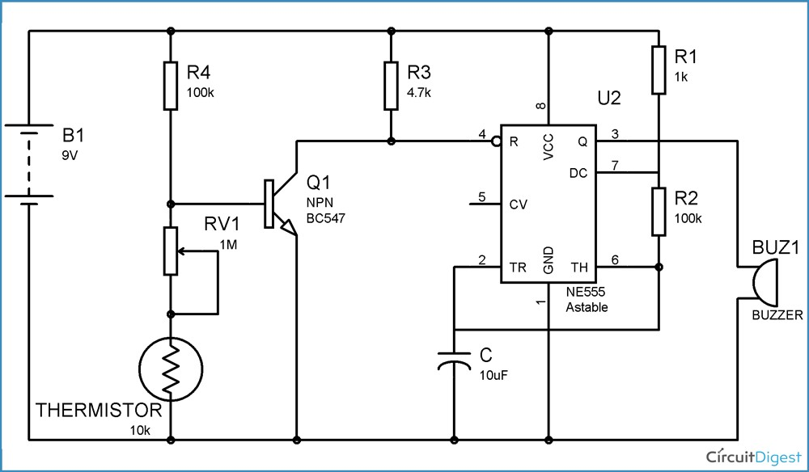

You can see the **circuit diagram of fire alarm** in above figure. When there is no FIRE, thermistor remains at 10k ohm. And transistor remains at ON state because there is sufficient voltage across the base-emitter of transistor, which makes it ON. When the Transistor is ON, Pin 4 (RESET) is connected to the Ground, and when Reset pin is Grounded, 555 IC doesn't operate.

Now when we start heating the Thermistor through Fire, its resistance starts to decrease, and when its resistance decreases, the voltage at the base of Transistor starts to decrease and when the voltage becomes less than the operating voltage (base-emitter voltage VBE) of transistor, then transistor becomes OFF. And when transistor becomes OFF, Reset pin of 555 timer IC, gets positive voltage through R3, and 555 IC starts to work and buzzer beeps.

In transistor, usually 0.7v voltage is required across the Base and Emitter, to turn it ON. So we have to carefully adjust the value of Variable resistance RV1 and Thermistor, to make the circuit work properly. To do this remove the thermistor and let RV1 be the grounded, now adjust the value of RV1 to that point, where even slight turning of the RV1 starts the Buzzer. Means from this point, if we decrease the resistance, even very little, Buzzer starts to beep. Now at this point, connect the thermistor again.

We should also note that we can also build a **Fire alarm circuit**, **using DR25 germanium diode**, as it works as heat sensor. When DR25 germanium diode is connected in reverse bias, it has a very high reverse resistance and it only conducts at more than 70 degree of room temperature.

**WORKING :**

Here the [**555 timer IC**](https://circuitdigest.com/article/555-timer-ic) has been configured in [**Astable mode**](https://circuitdigest.com/electronic-circuits/555-timer-astable-multivibrator-circuit-diagram) so that Alarm (Buzzer) can produce an oscillating sound. In Astable mode, capacitor C charges though resistance R1 and R2, till 2/3 Vcc and discharges through R2 till it reaches to 1/3Vcc. During the charging time OUT PIN 3 of 555 IC remains HIGH and during discharging it remains LOW, thats how it oscillate. We have connected a Buzzer to OUT pin, so that it produce beep sound, when 555 is high. We can control the oscillation frequency of the alarm by adjusting the value of R2 and/or capacitor C.

**APPLICATION:**

* Fire Alarm System You Can Trust. Cease Fire & Electrical Services LLP is one of the India’s Leading Fire Fighting Companies for the Design, Installation, and Maintenance of Fire Alarm System.
* Today, fire alarm systems are not an optional extra but are an essential for protecting life and property. Appropriate fire safety measures remain one of the most important health and safety requirements for all of us. Whether it is a multi-storey residential building or any other commercial place, people, employees, and visitors all need to be protected from the risk of fire with appropriately designed fire alarm systems.
* Cease Fire & Electrical Services LLP is one of the leading names in fire alarm system installations. At Cease Fire & Electrical Services LLP, we design, supply, install, commission & maintain a comprehensive range of fire alarm systems in Mumbai, India. Having more than 30 years of experience, we are one of the most trusted in the Fire Safety Industry.
* Whatever fire alarm system you need, we will design, install and maintain the system. We also provide a free site survey so that we can provide a custom-made quote, and also offer a fire risk assessment service to help make sure you are fulfilling all safety requirements for a commercial building. Contact us for specializedfire alarm system installations, customized to your offices, buildings, and properties needs according to Indian Fire Industry standards

**OUTPUT:**

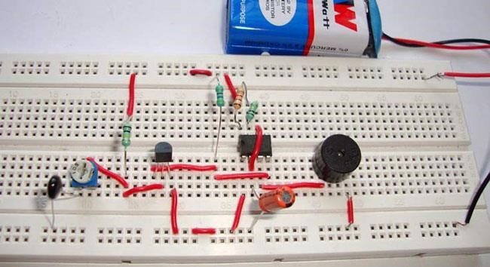

**RESULT:**

The working of fire alarm circuit using 555 timer IC was determined practically.