Things to care in Firebase.

When you add/configure one feature in firebase(either cloud messaging or firestore or db or any other feature) make sure google-services.json is present in the project once you link your app to firebase

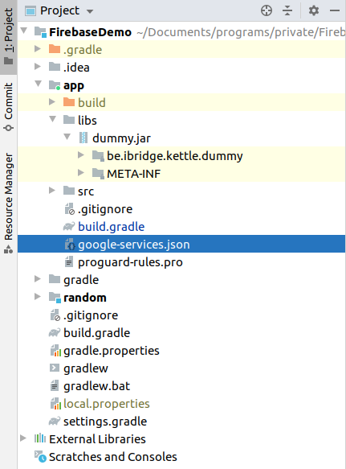

To add it manually, go to firebase project.

Click on setting(gear) icon next to Project Overview on top left side.

Select project settings

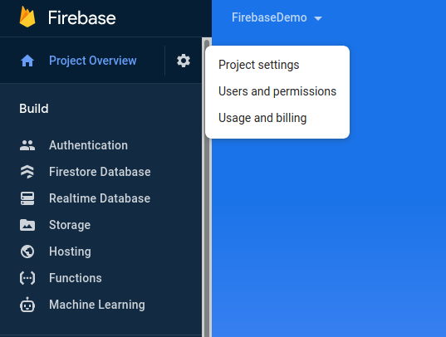

Download google-services.json from your apps section.

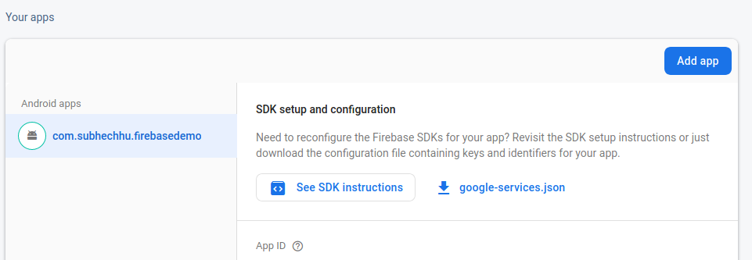

Add the json file on the same location inside app folder parallel to src directory like shown in next image.

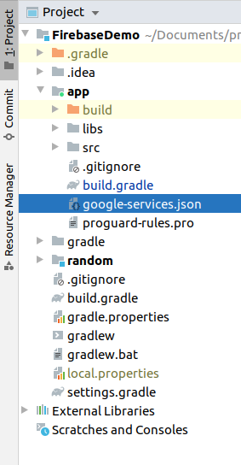

make sure you are in Project view not in Android on top