Sentiment Analysis on Movie Reviews

Amit Mahapatra
1601209050
7th Sem, CSE-A

Saurav Panda
1601209099
7th Sem, CSE-A

Subhendu S.Sahoo
1601209109
7th Sem, CSE-A

Karunesh Kumar
1601209371
7th Sem, CSE-B,

Supervised by: Pradipta Kumar Pattanayak.

Abstract— In this project, we introduce a method to tackle the problem of sentiment classification of large movie reviews, each consisting of multiple sentences. Sentiment analysis has become important tool that can analyse review on any product or service that can be reviewed. Same goes to movie, all the audient are freely to make their own reviews on the movie that they watch and the reviews can be positive or negative based on audient satisfactions. Automated sentiment analysis is very important to make sure the analysis produce an accurate result and in faster time. By using this machine learning model, Upgrading the sentiment analysis using Neural Networks and addition of Long Short-term Memory and also some modification on the number of layer with the mathematical calculation can improve the analysis accuracy. The dataset of the movie reviews will be collected on IMDB movie reviews database.
Sentiment analysis, also refers as opinion mining, is a sub machine learning task where we want to determine which is the general sentiment of a given document. Using machine learning techniques and natural language processing we can extract the subjective information of a document and try to classify it according to its polarity such as positive, neutral or negative. It is a really useful analysis since we could possibly determine the overall opinion about a selling objects, or predict stock markets for a given company like, if most people think positive about it, possibly its stock markets will increase, and so on. Sentiment analysis is actually far from to be solved since the language is very complex (objectivity/subjectivity, negation, vocabulary, grammar but it is also why it is very interesting to working on.

- INTRODUCTION
Sentiment Analysis is process of collecting and analyzing data based upon the person feelings, reviews and thoughts. Sentimental analysis often called as opinion mining as it mines the important feature from people opinions. Sentimental Analysis is done by using various machine learning techniques, statistical models and Natural Language Processing (NLP) for the extraction of feature from a large data[6]. Sentiment Analysis can be done at document, phrase and sentence level. In document level, summary of the entire document is taken first and then it analyzes whether the sentiment is positive, negative or neutral. In phrase level, analysis of phrases in a sentence is taken in account to check the polarity. In Sentence level, each sentence is classified in a particular class to provide the sentiment[1].
  - NEED OF SENTIMENT ANALYSIS:
Decision Making: Every person who stores information on the blogs, various web applications and the web social media, social websites for getting the relevant information you need a particular method that can be used to analyze data and consequently return some of the useful results. It is going to be very difficult for company to conduct the survey that will be on the regular basis so that there comes the need to analyze the data and locate the best of the products that will be based on user’s opinions, reviews and advices. The reviews and the opinions also help the people to take important decisions helping them in research and business areas[1].
Internet Marketing: Another important reason behind the increase in the demand of sentimental analysis is the marketing done via internet by the business and companies organization. Now they regularly monitor the opinion of the user about their brand, product, or event on blog or the social post. Thus, we see that the sentimental Analysis could also work as a tool for marketing too[1].
  - APPLICATION OF SENTIMENT ANALYSIS:
Sentimental Analysis has various applications. It is used to generate opinions for people of social media by analyzing their feelings or thoughts which they provide in form of text. Sentiment Analysis is domain centered, i.e. results of one domain cannot be applied to other domain. Sentimental Analysis is used in many real life scenarios, to get reviews about any product or movies, to get the financial report of any company, for predictions or marketing.
- PROBLEM STATEMENT:
Sentiment Analysis is a process of extracting feature from user’s thoughts, views, feelings and opinions which they post on any social network websites. The result of sentiment analysis is classification of natural language text into classes such as positive, negative and neutral. The amount of data generated from social network sites is huge; this data is unstructured and cannot give any meaningful information until it is analyzed. Thus, to make this huge amount of data useful we perform sentiment analysis, i.e. extracting feature from this data and classify them. Sentiment analysis is very necessary in today’s world, as people always get affected by the thinking and opinions other people. Today, if any one wants to purchase a product or to give vote or to watch a movie, etc. then that person will first want to know what are other people reviews, reactions and opinions about that product or candidate or movie on social media websites like Twitter, Facebook, Tumbler, etc. So there is a need of system that can automatically generate sentiment analysis from this huge amount of data[5].
- PROPOSED APPROACH
Our approach towards solving the problem is divided into a number of steps. As we mentioned earlier this problem is divided into two task, data extraction, data pre-processing and data training. Data training is basically done by using a classical model, which is created by using a machine learning approach.

- DATABASE USED
IMDB (Internet Movie Database): It is an online database of information related to films, television programs, home videos, video games, and streaming content online including cast, production crew and personal biographies, plot summaries, trivia, fan and critical reviews, and ratings. An additional fan feature, message boards, was abandoned in February 2017. Originally a fan-operated website, the database is owned and operated by IMDb.com[4].
The dataset used for this task was collected from Large Movie Review Dataset which was used by the AI department of Stanford University for the associated publication. The dataset contains 50,000 training examples collected from IMDb[4] where each review is labelled with the rating of the movie on scale of 1-10. As sentiments are usually bipolar like good/bad or happy/sad or like/dislike, we categorized these ratings as either 1 (like) or 0 (dislike) based on the ratings. Initially the dataset was containing 50,000 reviews out of those first 25000 reviews of training , we have kept first 10000 for validation and rest 15000 for training. After the training and validation is carried out we perform the testing on next 25000 reviews and get the testing accuracy. Then we pick a single review or at times multiple reviews from test data and compare the predicted and actual value of either positive(1) or negative(0).

- DATA EXTRACTION AND DATA PRE-PROCESSING:
To gather the data many options are possible. In some previous paper researches, they built a program to collect automatically a corpus of reviews based on two classes, “positive” and “negative”, by querying Social sites with two type of emoticons:
- Happy emoticons, such as “:)”, “:P”, “:)” etc.
- Sad emoticons, such as “:(“, “:’(”, “=(“.

Others make their own dataset of reviews my collecting and annotating them manually which very long and fastidious[5]. Additionally, to find a way of getting a corpus of reviews, we need to take of having a balanced data set, meaning we should have an equal number of positive and negative texts, but it needs also to be large enough. Indeed, more the data we have, more we can train our classifier and more the accuracy will be. After many researches, we found a dataset of 1578612 reviews in english coming from two sources: Kaggle and Sentiment140. It is composed of four columns that are ItemID, Sentiment, Sentiment Source and Sentiment Text.. We are only interested by the Sentiment column corresponding to our label class taking a binary value, 0 if the review is negative, 1 if the review is positive and the Sentiment Text columns containing the tweets in a raw format[2].

Data Pre-processing:
Machine learning algorithms take numbers as inputs. This means that we will need to convert the texts into numerical vectors. There are two steps to this process[8]:
- Tokenization: Divide the texts into words or smaller sub-texts, which will enable good generalization of relationship between the texts and the labels. This determines the “vocabulary” of the dataset (set of unique tokens present in the data).
- Vectorization: Define a good numerical measure to characterize these texts.

The Above 2 Steps are Exemplified Below :
Texts: 'The mouse ran up the clock' and 'The mouse ran down'
Index assigned for every token:
{'clock': 5, 'ran': 3, 'up': 4, 'down': 6, 'the': 1, 'mouse': 2}.
NOTE: 'the' occurs most frequently, so the index value of 1 is assigned to it.
Some libraries reserve index 0 for unknown tokens, as is the case here.
Sequence of token indexes: 'The mouse ran up the clock' = [1, 2, 3, 4, 1, 5]

There are two options available to vectorize the token sequences:
One-hot encoding: Sequences are represented using word vectors in n- dimensional space where n = size of vocabulary. This representation works great when we are tokenizing as characters, and the vocabulary is therefore small. When we are tokenizing as words, the vocabulary will usually have tens of thousands of tokens, making the one-hot vectors very sparse and inefficient.
Example:
'The mouse ran up the clock' =
[
[0, 1, 0, 0, 0, 0, 0],
[0, 0, 1, 0, 0, 0, 0],
[0, 0, 0, 1, 0, 0, 0],
[0, 0, 0, 0, 1, 0, 0],
[0, 1, 0, 0, 0, 0, 0],
[0, 0, 0, 0, 0, 1, 0]
]
Word embeddings: Words have meaning(s) associated with them. As a result, we can represent word tokens in a dense vector space (~few hundred real numbers), where the location and distance between words indicates how similar they are semantically. This representation is called Word Embedding.
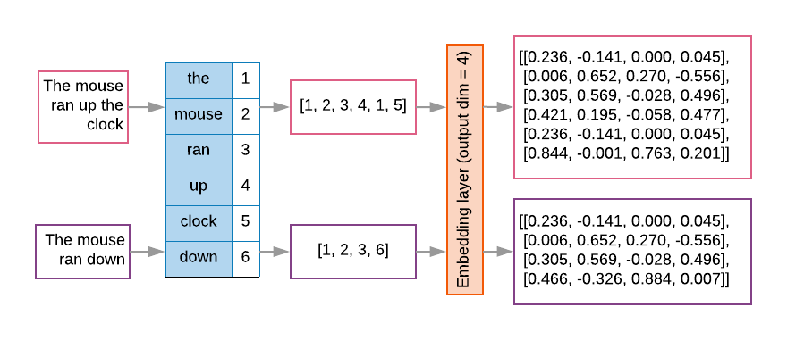

Feature selection : Not all words in the data contribute to label predictions. We can optimize the learning process by discarding rare or irrelevant words from the vocabulary. In fact, it is observed that using the most frequent 20,000 features is generally sufficient.

VI. BUILD, TRAIN, AND EVALUATE THE MODEL:
Building machine learning models with Keras(in Python ) is all about assembling together layers, data-processing building blocks, much like we would assemble Lego bricks. These layers allow to specify the sequence of transformations to perform on the input. As the learning algorithm takes in a single text input and outputs a single classification, we can create a linear stack of layers using the Sequential Model API exist in Python.
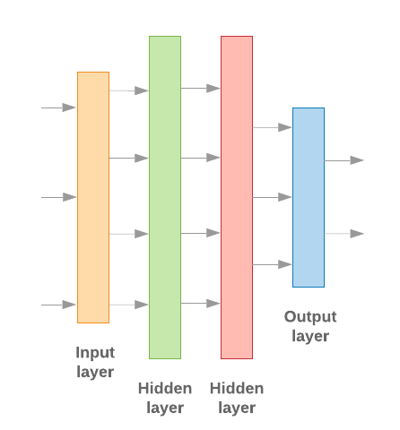

Fig 1: Ann Model

Train The Model : Now that the model architecture is prepared, the model need to be trained. Training involves making a prediction based on the current state of the model, calculating how incorrect the prediction is, and updating the weights or parameters of the network to minimize this error and make the model predict better. We repeat this process until our model has converged and can no longer learn. There are three key parameters to be chosen for this process[8].
- Metric: How to measure the performance of our model using a metric.
- Loss function: A function that is used to calculate a loss value that the training process then attempts to minimize by tuning the network weights. For classification problems, cross-entropy loss works well.
- Optimizer: A function that decides how the network weights will be updated based on the output of the loss function.

- CONCLUSION:
Sentiment analysis is used to identifying people’s opinion, attitude and emotional states. The views of the people can be positive or negative. Commonly, parts of speech are used as feature to extract the sentiment of the text. An adjective plays a crucial role in identifying sentiment from parts of speech. Sometimes words having adjective and adverb are used together then it is difficult to identify sentiment and opinion.
To do the sentiment analysis of movie reviews, the proposed system first extracts the reviews from IMDB datasets by user. The system can also computes the frequency of each term in the data. Using neural network predicted class labels we obtain the results.
Internet is a large source of data, which makes it more attractive for sentiment analysis. We saw how training more and more data increased the accuracy of the predictor and how it can predict simple sentences accurately. We also saw that the increase in the length and complexity of a sentence tests the validity of the predictor and may not always give correct results. Neural network uses multiple layer for reviews classification (1- positive, 0- negative) each label falls into different categories. We used Artificial neural network which gave correct results on the testing datasets with an accuracy of 86%.

Scope of future work:

Some of future scopes that can be included in our research work are:
- Use of parser can be embedded into system to improve results.

- We can also increase the classification categories(like good, very good, bad, excellent, poor, very bad) by inserting more output layer, so that we can get better results.

- A web-based application can be made for our work in future.

- We can improve our system that can deal with sentences of multiple meanings.

- We can start work on multi languages like Hindi, Spanish, and Arabic to provide sentiment analysis to more local.

REFERENCES:

[1] P. Pang, L. Lee and S. Vaithyanathan, “Thumbs up? sentiment classification using machine learning techniques”, Proc. ACL-02 conference on Empirical methods in natural language processing, vol.10, pp. 79-86, 2002

[2] P. Pang and L. Lee, “Opinion Mining and Sentiment Analysis. Foundationand Trends in Information Retrieval”, vol. 2(1-2), pp.1-135, 2008

[3] E. Loper and S. Bird, “NLTK: the Natural Language Toolkit”, Proc. ACL-02 Workshop on Effective tools and methodologies for teaching natural language processing and computational linguistics ,vol. 1,pp. 63-70, 2002

[4] H. Wang, D. Can, F. Bar and S. Narayana, “A system for realtime Twitter sentiment analysis of 2012 U.S.presidential election cycle”, Proc. ACL 2012 System Demostration, pp. 115-120, 2012

[5] Niek Sanders. Twitter sentiment corpus. http://www.sananalytics.com/lab/twitter-sentiment/. Sanders Analytics.

[6] Y. Bengio, R. Ducharme, P. Vincent. A neural probabilistic language model. Journal of Machine Learning Research, 3:1137-1155, 2003.

[7] https://en.wikkipedia.org/wiki/Artificialneuralnetwork

We suggest that you use a text box to insert a graphic (which is ideally a 300 dpi TIFF or EPS file, with all fonts embedded) because, in an MSW document, this method is somewhat more stable than directly inserting a picture.
To have non-visible rules on your frame, use the MSWord “Format” pull-down menu, select Text Box > Colors and Lines to choose No Fill and No Line.

