**Programming Paradigms Laboratory**

**B.Tech.**



**Name : Subhendu Maji**

**Roll Number : 18ETCS002121**

**Department : Computer Science and Engineering**

**Faculty of Engineering & Technology**

**Ramaiah University of Applied Sciences**

|  |  |
| --- | --- |
| Faculty | Engineering & Technology |
| Programme | B. Tech. in Computer Science and Engineering |
| Year/Semester | 2nd Year / 4th Semester |
| Name of the Laboratory | Programming Paradigms Laboratory |
| Laboratory Code | 19CSL217A |

**Laboratory 5**

Title of the Laboratory Exercise: Strings

* Questions
* Develop an application that inputs a line of text and a search character and uses String method indexOf to determine the number of occurrences of the character in the text.
* Develop a Java program to reads a five-letter word from the user and produces every possible three-letter string that can be derived from the letters of that word.

For example, the three-letter words produced from the word “bathe” include “ate,” “bat,” “bet,” “tab,” “hat,” “the” and “tea.”

* Calculations/Computations/Algorithms

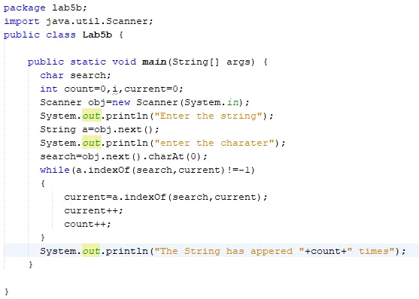

Fig1.1 Represents the java program String method indexOf to determine the number of occurrences of the character in the text

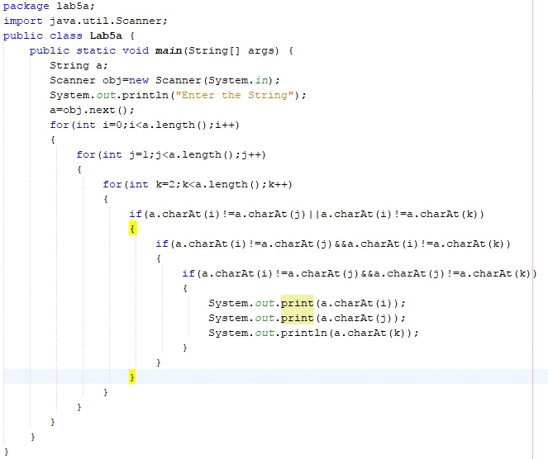

Fig2.1 Represents the java program to reads a five-letter word from the user and produces every possible three-letter string that can be derived from the letters of that word.

* Presentation of Results

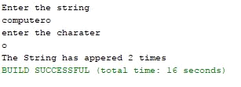

Fig1.2 Represents the output of the java program String method indexOf to determine the number of occurrences of the character in the text

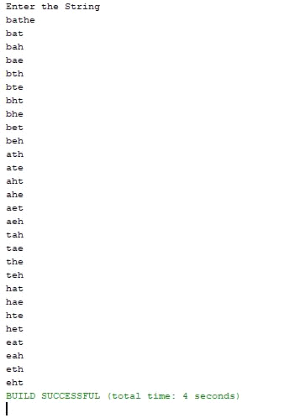

Fig2.2 Represents the output of java program to reads a five-letter word from the user and produces every possible three-letter string that can be derived from the letters of that word.

* Conclusions

We have learned how to do some operations on the strings that is String method indexOf to determine the number of occurrences of the character in the text and also reads a five-letter word from the user and produces every possible three-letter string.

* Limitations of Experiments and Results

To do the String operations the java packages should be imported for the Strings to do some tasks.