# Laboratory 4

Title of the Laboratory Exercise: Data flow modelling with CASE tools – Low Level Design

1. Introduction and Purpose of Experiment

Students will apply data flow modelling to develop the low level design for given scenario

1. Aim and Objectives

Aim

* To develop low level software design for a given requirements specification using Structured analysis and Design Technique

Objectives

At the end of this lab, the student will be able to

* + Identify functions in modules
  + Identify Inputs, Outputs and Data dependencies for functions
  + Create low level design document for a given SRS

1. Experimental Procedure

* Work in teams of 7 students
* Each team should read the problem statement and identify requirements as a group
* Each team will then confirm the requirements and document the requirements in an low level design document
* Each individual will then write their lab manual, documenting their observations

1. Calculations/Computations/Algorithms

Sequence diagrams is a behavioural diagram shows interaction between objects.It shows the involved objects and classes and the messages exchanged between two object to carry out some functionality of the particular given scenario. The components are Objects,lifeline,activation box,messages,response

1. Presentation of Results

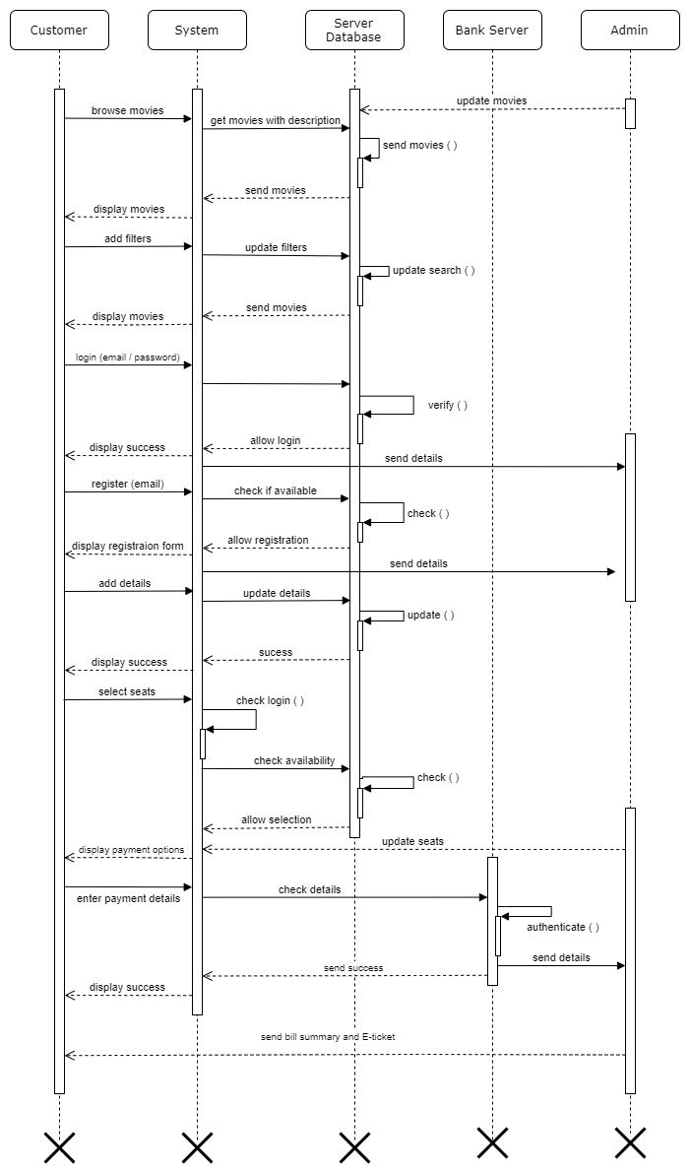

1. Analysis and Discussions

We have discussed about the sequence diagram and its components. We have analysed how the messages are passed between two objects in a sequential order and have used the sequence diagram to represent them. We have discussed about the messages(call and recursion) and responses by the objects in the given scenario of online booking application.

1. Conclusions

We were able to draw sequence diagram for the functional requirements (of the online booking application) discussed in previous lab sessions

1. Comments

1. Limitations of Experiments

2. Limitations of Results

3. Learning happened

4. Recommendations

|  |  |  |
| --- | --- | --- |
| **Component** | **Max Marks** | **Marks Obtained** |
| **Viva** | **6** |  |
| **Results** | **7** |  |
| **Documentation** | **7** |  |
| **Total** | **20** |  |