# Laboratory 5

Title of the Laboratory Exercise Class Diagrams

1. Introduction and Purpose of Experiment

Students will apply object-oriented analysis and design for the given scenario for analysis of requirements and possible interactions

1. Aim and Objectives

Aim

* To construct a UML class diagram for a given system and identify the class members and determine their relationships

Objectives

At the end of this lab, the student will be able to

* + Explain the purpose of the sequence diagram
  + Identify the logical sequence of activities undergoing in a system, and represent them pictorially
  + Design and model a given use case using UML-sequence diagrams

1. Experimental Procedure

* Work in teams of 7 students
* Each team should read the problem statement and discuss the requirements as a group
* Each team will then create and confirm the design and document the design in an software architecture specifications document
* Each individual will then write their lab manual, documenting their observations

1. Calculations/Computations/Algorithms
2. Presentation of Results

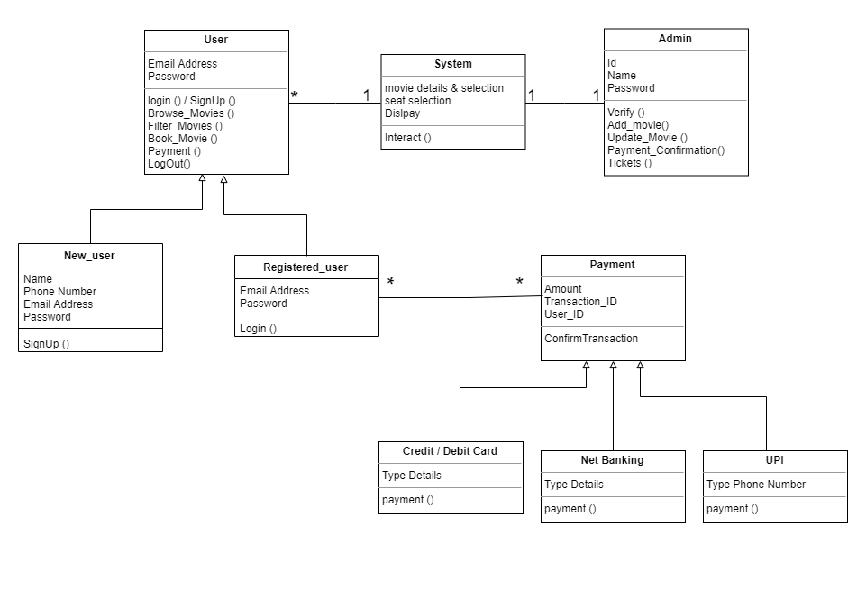

Figure 1 class diagram

1. Analysis and Discussions

Class diagrams are structural models which are most widely used as it helps understand the requirements of the problem domain and to identify its components.

In this lab we developed a class diagram containing various class members which has attributes and functions. We used class members like user, existing user, new user, payment, Paytm, credit, debit, and logout

1. Conclusions

* We constructed a class diagram for a online movie ticket booking application and identified the class members and determined their relationships.

1. Comments

1. Limitations of Experiments

* In class diagram, as only class members are the elements, we cannot include all the functional requirements. We can include only limited functional requirements which are function of only particular class members.

|  |  |  |
| --- | --- | --- |
| **Component** | **Max Marks** | **Marks Obtained** |
| **Viva** | **6** |  |
| **Results** | **7** |  |
| **Documentation** | **7** |  |
| **Total** | ****20**** |  |