# Laboratory 6

Title of the Laboratory Exercise: State Chart & Activity Diagrams

1. Introduction and Purpose of Experiment

Students will apply object oriented analysis and design for the given scenario for object decomposition

1. Aim and Objectives

Aim

* To construct a UML class diagram for a given system and identify the class members and determine their relationships

Objectives

At the end of this lab, the student will be able to

* + Identify the main members of the family
  + Identify how they are related to each other
  + Find the characteristics of each family member
  + Determine relations among family members
  + Decide the inheritance of personal traits and characters

1. Experimental Procedure

* Work in teams of 7 students
* Each team should read the problem statement and discuss the requirements as a group
* Each team will then create and confirm the design and document the design in an software design specifications document
* Each individual will then write their lab manual, documenting their observations

1. Calculations/Computations/Algorithms
2. Presentation of Results

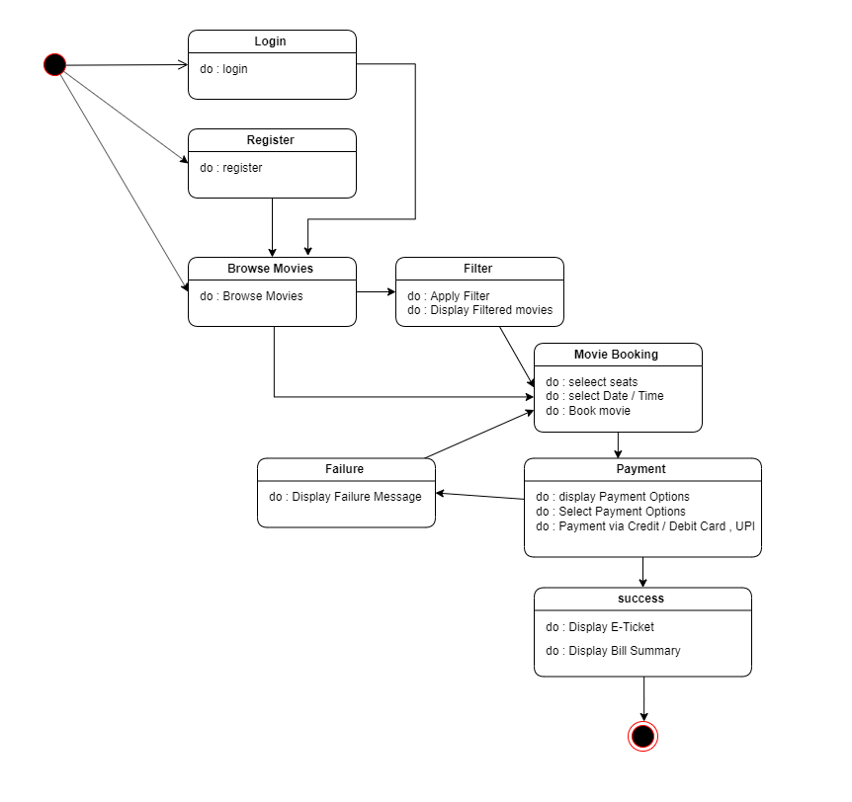

Figure state chart diagram

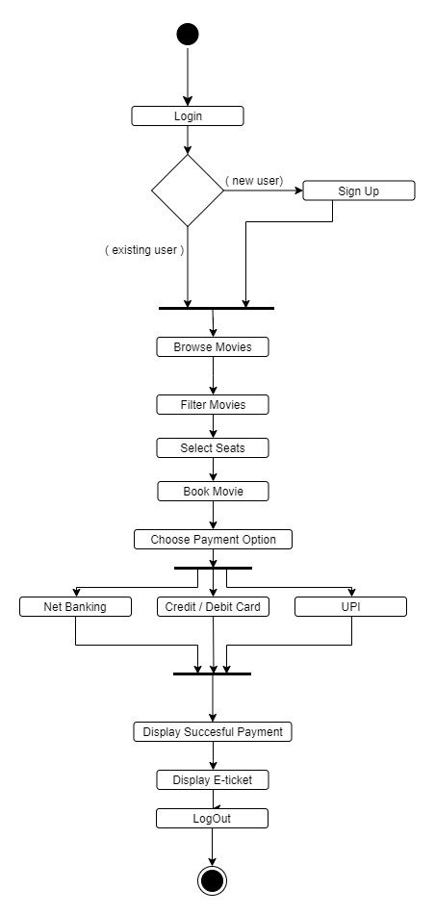

Figure activity diagram

1. Analysis and Discussions

In this lab we worked on the activity diagram and the state chart diagram, which are behavioural models, for an online movie booking website. The activity diagram lays emphasis on the flow of the activity, we specified the activities like login, filter movies, select seats, book tickets and logout, we also determined the flow of the activities. The state chart diagram is a model which is used to describe the various states of the different objects in its life cycle. Here, the emphasis is laid on the state changes upon some internal and external events. In this lab we created the various states for the online movie booking website, like login, register, browse movies, filter, movie booking, payment and success and identified the triggers for the same which leads to the next state.

1. Conclusions

In this lab we created the state chart diagram and activity diagram using the dia software for a movie booking system.

|  |  |  |
| --- | --- | --- |
| **Component** | **Max Marks** | **Marks Obtained** |
| **Viva** | **6** |  |
| **Results** | **7** |  |
| **Documentation** | **7** |  |
| **Total** | ****20**** |  |