# Experiment 3: Neighbor Table Determination

**Aim:** To create neighbor table for a given network topology

**Objective:** After carrying out this experiment, students will be able to:

* Generate neighbor table for all the nodes in a given topology.
* Analyze how this is useful in the process of routing data

**Problem statement:** You are required to write a program that calculates neighbor table for all the nodes in a given network. Consider a network with 10 nodes that is deployed in an area of 500 m2. Your program should initially determine the distance between each node and all other nodes. Then the range of the nodes is given as input to the user. Using this range information, determine the neighbors of all the nodes.

**Analysis:** While analyzing your program, you are required to address the following points:

* How this is useful in the process of routing data?
* For a 3D topology, how would your program need to be changed?

**MARKS DISTRIBUTION**

|  |  |  |
| --- | --- | --- |
| **Component** | **Maximum Marks** | **Marks Obtained** |
| Preparation of Document | 7 |  |
| Results | 7 |  |
| Viva | 6 |  |
| **Total** | **20** |  |

Submitted by: Subhendu Maji

Register No: 18ETCS002121

1. Algorithm/Flowchart

The algorithm for the neighbour table determination program is as follows:

STEP 1: Start

STEP 2: x, y, distance $←$ [], count $←$ 0, inRange $←$“”

STEP 3: nodes, gridSizes, commRange $←$ from user

STEP 4: for i from 0 to nodes, do

4.1: x[i] $←$ random number % (gridSize + 1)

4.2: y[i] $←$ random number % (gridSize + 1)

STEP 5: for i from 0 to nodes, do

5.1: for j from 0 to nodes, do

5.1.1: distance[count] $←$ $\sqrt{{\left(x\left[i\right]-x\left[j\right]\right)}^{2}+{\left(y\left[i\right]-y\left[j\right]\right)}^{2}}$

5.1.2: if distance[count] <= commRange, inRange = “Yes”, else inRange = “No”

5.1.3: print result

5.1.4: count++

STEP 6: Stop

1. Program

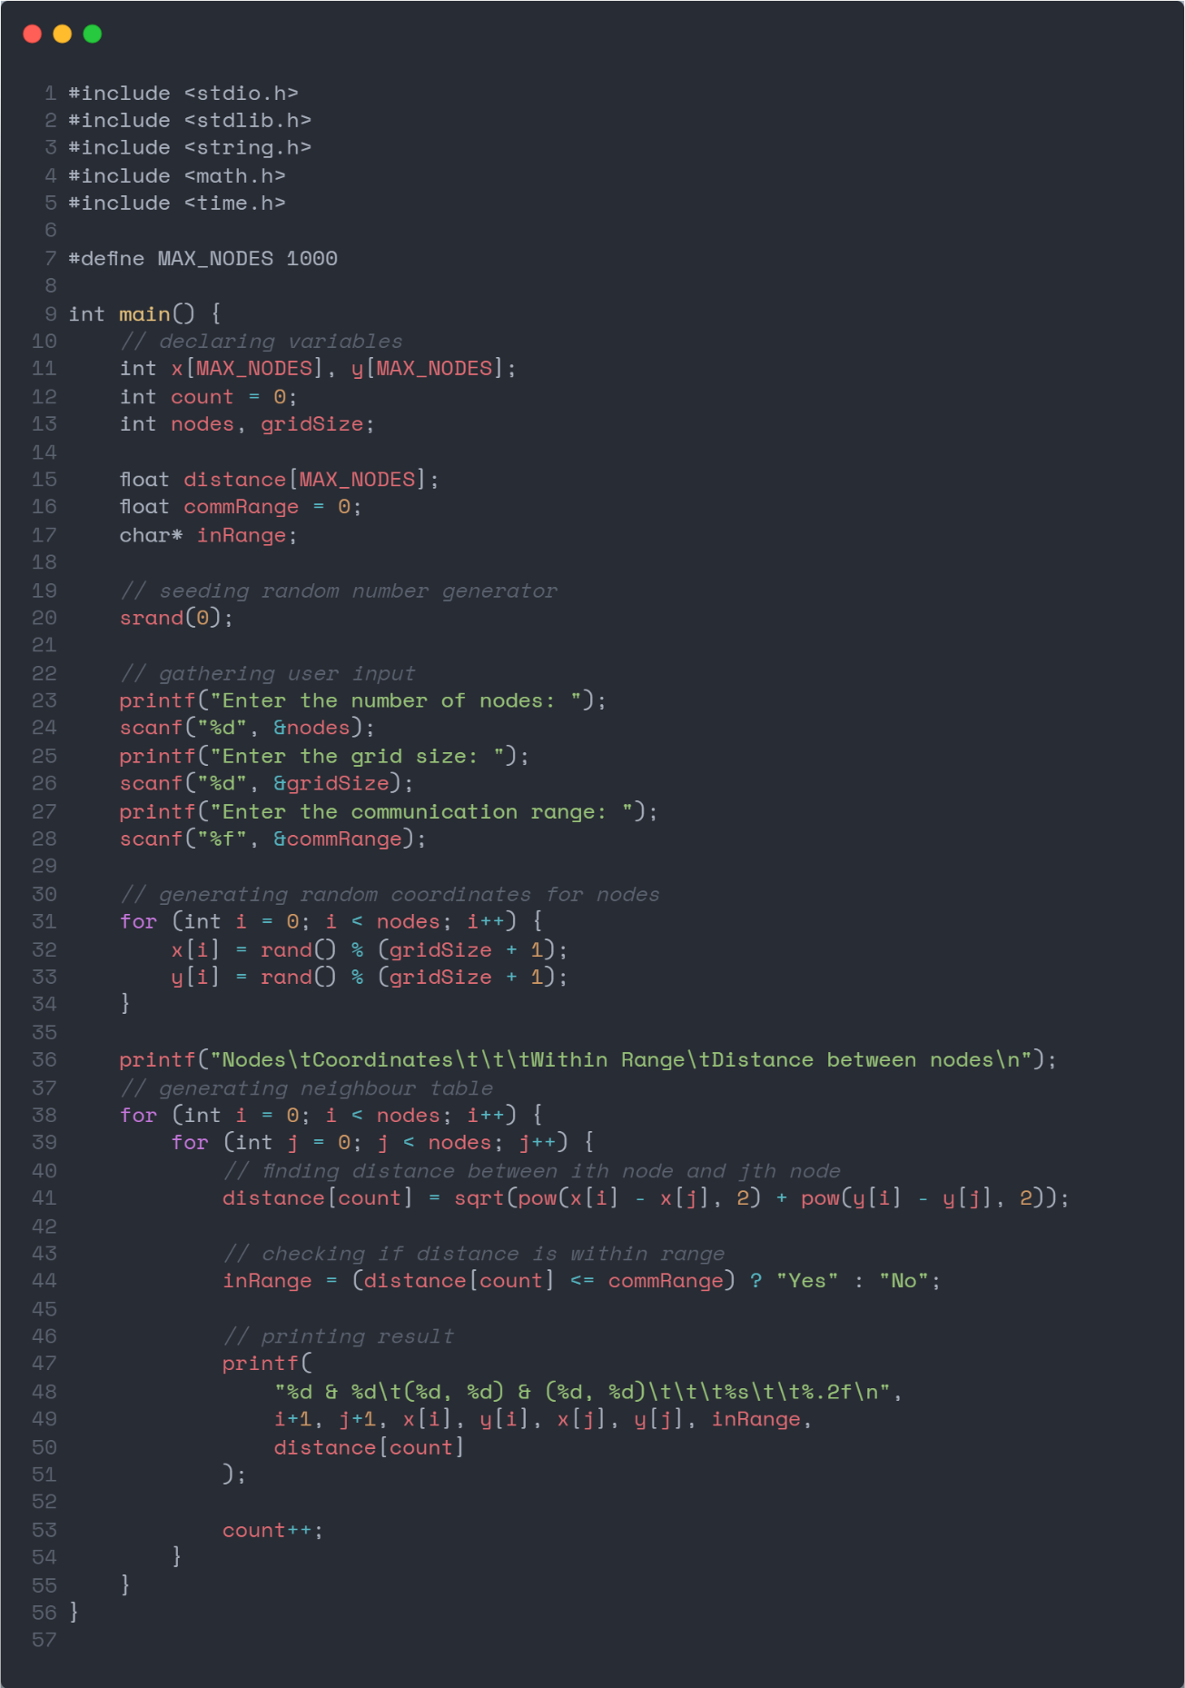

Figure 1 source code

1. Results

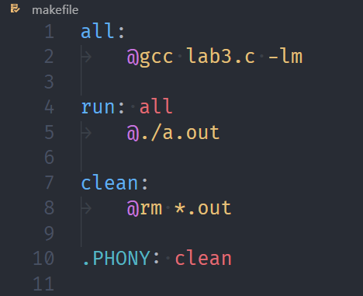

Figure 2 makefile

**Note:** No. of nodes = 10 prints a big output (difficult to paste screenshot). Hence running the program with no. of nodes = 5 for simplicity.

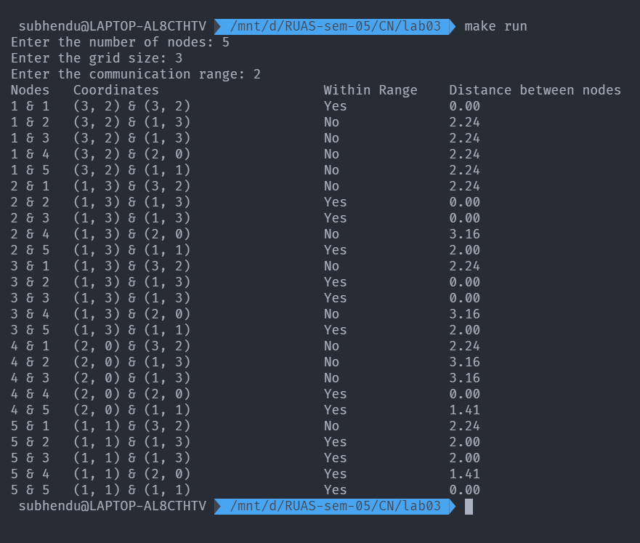

Figure 3 Execution of program with no. of nodes = 5

1. Analysis and Discussions

This experiment involves creating a routing table for nodes in a network using a naïve approach. This table is used by other nodes to determine whether they can communicate with each other, their position and the distances between different nodes.

The nodes calculate the distance between each other using the distance formula:

$$distance=\sqrt{{\left(x_{1}-x_{2}\right)}^{2}+{\left(y_{1}-y_{2}\right)}^{2}}$$

If the nodes are within range of each other, they can communicate. The grid size is taken from the user and x and y coordinates are randomly chosen according to the data given. The distances between the nodes are calculated using the distance formula. Using this data, the neighbour table from the calculations.

For a 3D topology, another dimension must me taken into account. The distance formula becomes:

$$distance=\sqrt{{\left(x_{1}-x_{2}\right)}^{2}+{\left(y_{1}-y_{2}\right)}^{2}+{\left(z_{1}-z_{2}\right)}^{2}}$$

1. Conclusions

The neighbour table for nodes in a network was successfully created and the program to do so was implemented.

1. Comments
   1. Limitations of Experiment

The program does not take into account the multitude of other factors that determine whether nodes can communicate with each other.

* 1. Limitations of Results

The table generation is based on static data.

* 1. Learning Happened

The method to construct the neighbour table using distance formula was learned.