**MSRUAS**

Assignment-1

|  |  |  |  |
| --- | --- | --- | --- |
| Registration No.: | **18ETCS002121** | Faculty: | FET |
| Student Name: | **Subhendu Maji** | Department: | CSE |
| Programme: | B.Tech | Semester | 5 |
| Course Code: | 19CSC301A | Submission Date | 10 Nov’ 2020 |
| Course Title: | Probability and Statistics |  |  |
| Total number of pages enclosed: | 6 |  |  |

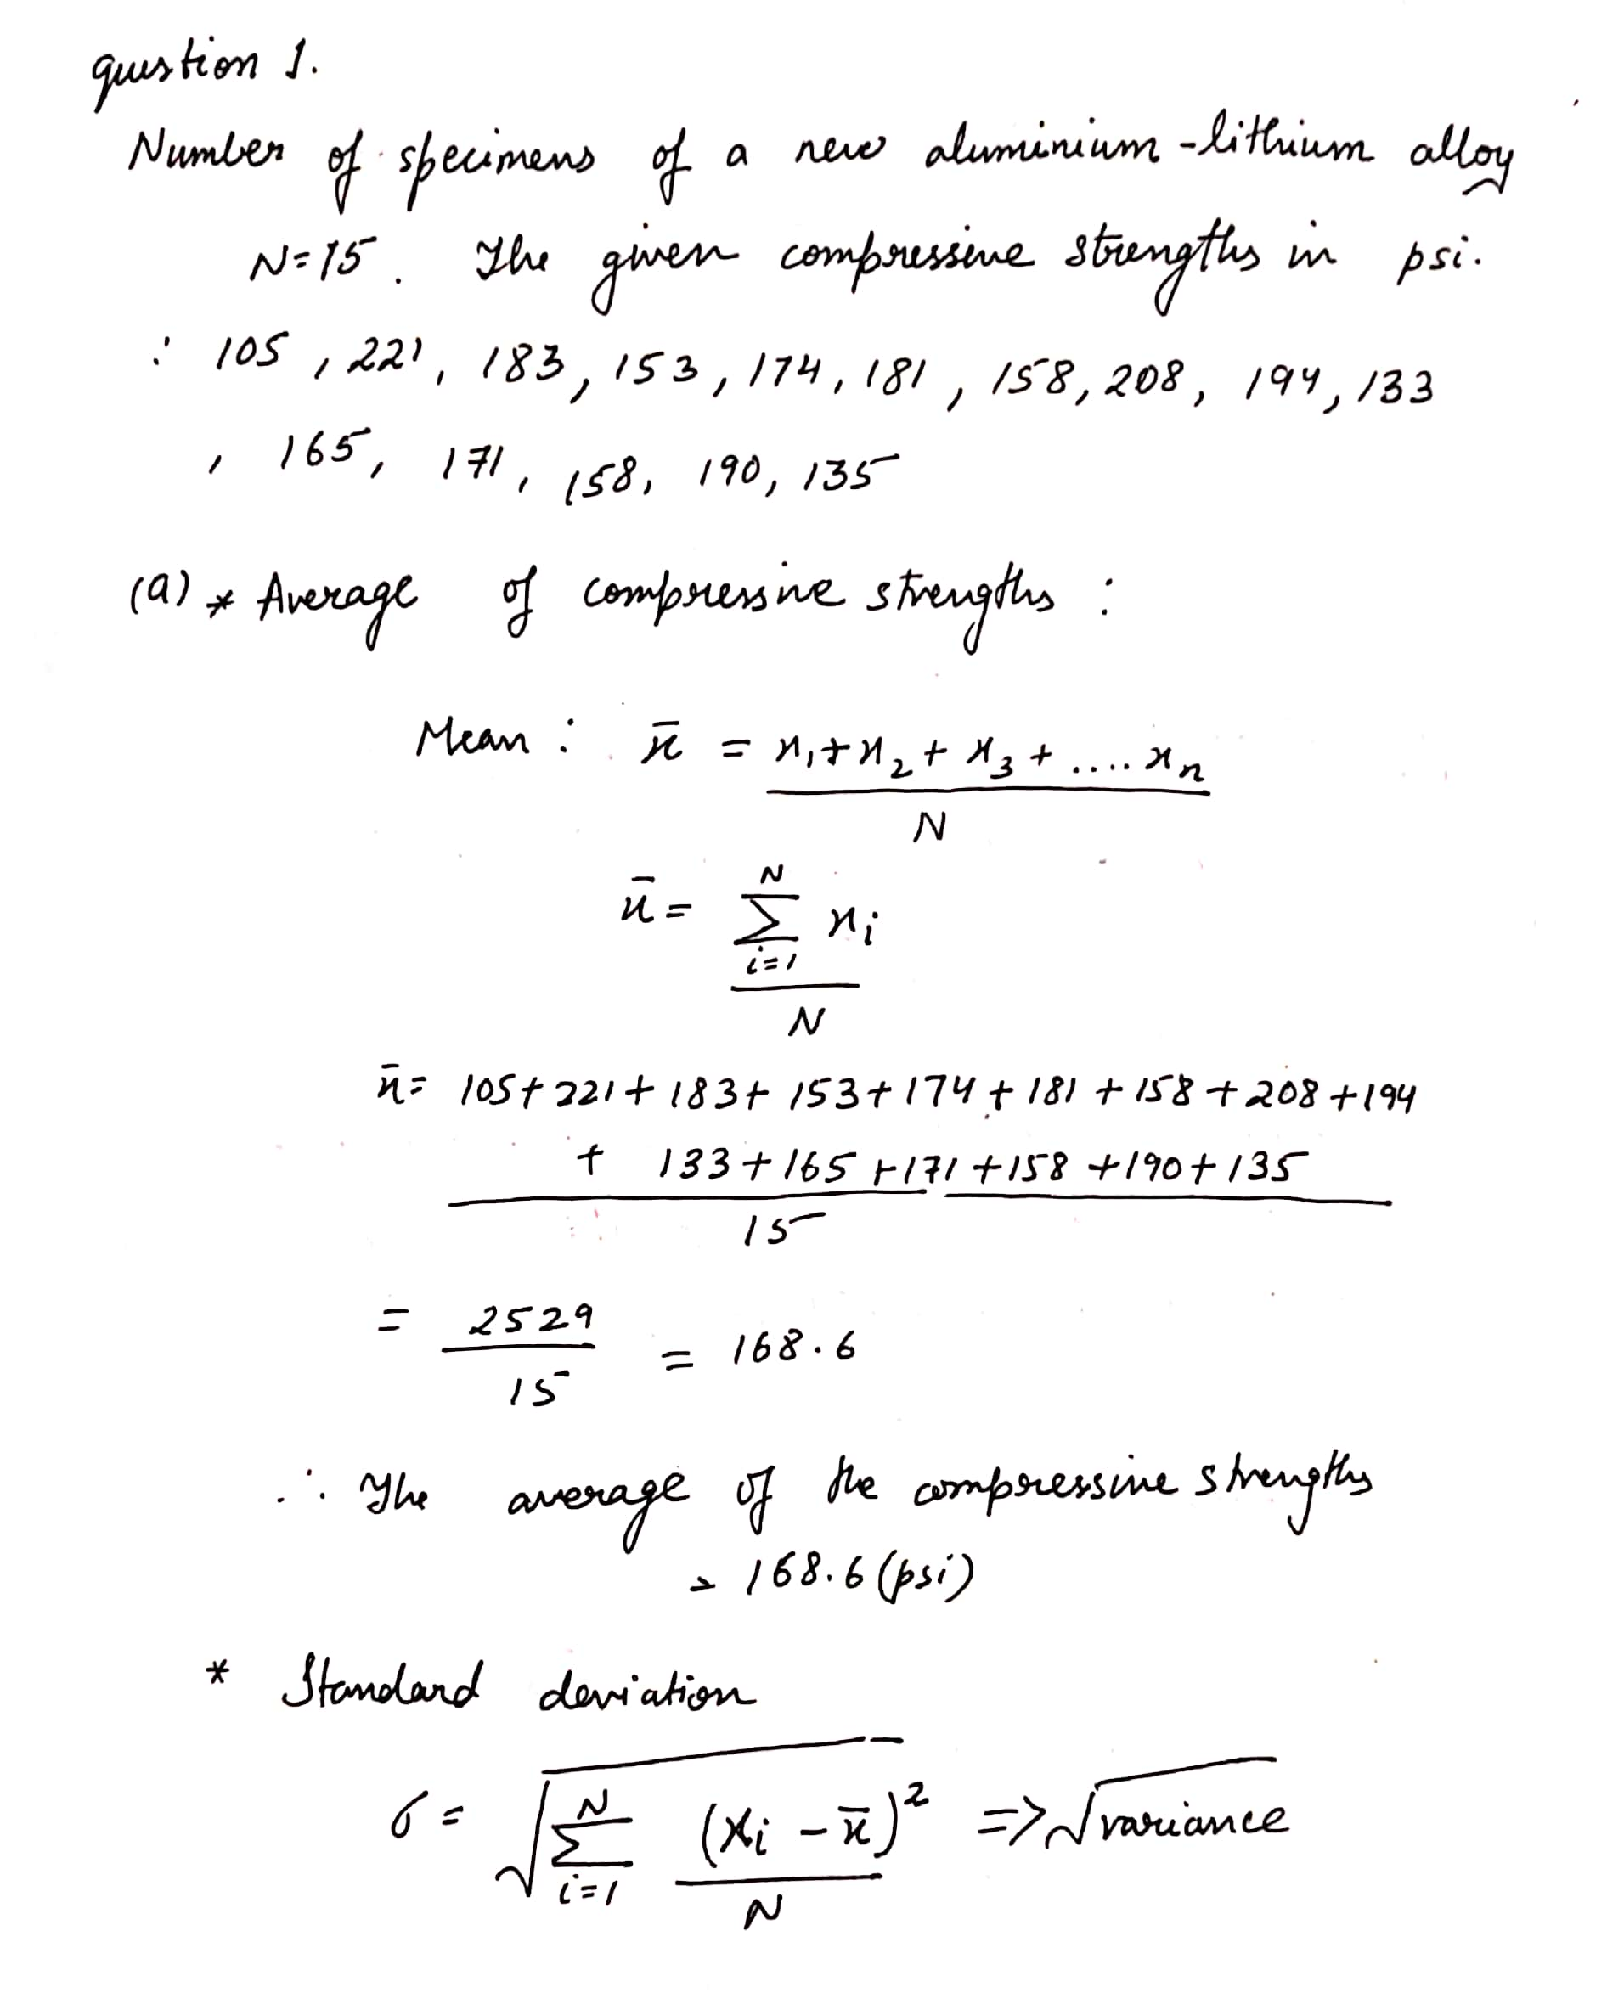

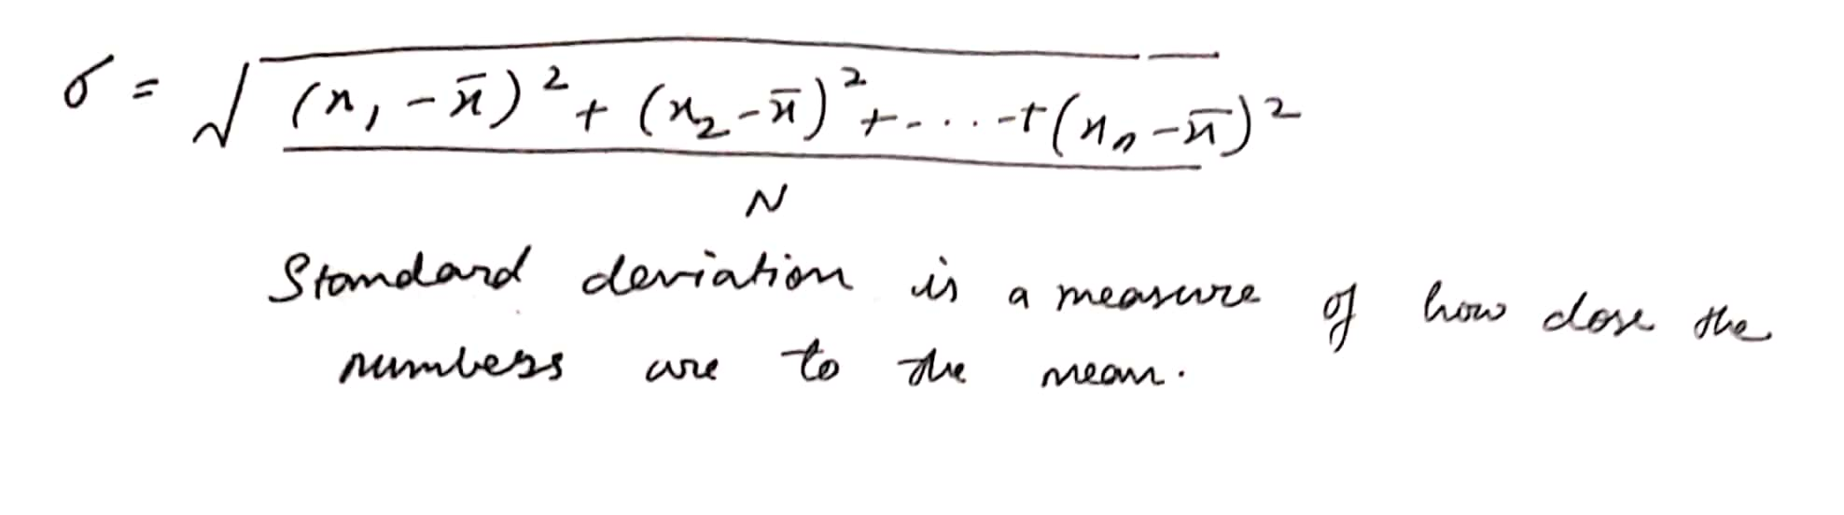

|  |  |  |  |
| --- | --- | --- | --- |
|  | *xi* | *xi-x̅* | *(xi-x̅)2* |
| 1 | 105 | -63.6 | 4044.96 |
| 2 | 221 | 52.4 | 2745.76 |
| 3 | 183 | 14.4 | 207.36 |
| 4 | 153 | -15.6 | 243.36 |
| 5 | 174 | 5.4 | 29.16 |
| 6 | 181 | 12.4 | 153.76 |
| 7 | 158 | -10.6 | 112.36 |
| 8 | 208 | 39.4 | 1552.36 |
| 9 | 194 | 25.4 | 645.16 |
| 10 | 133 | -35.6 | 1267.36 |
| 11 | 165 | -3.6 | 12.96 |
| 12 | 171 | 2.4 | 5.76 |
| 13 | 158 | -10.6 | 112.36 |
| 14 | 190 | 21.4 | 457.96 |
| 15 | 135 | -33.6 | 1128.96 |
| Total | **2529** | **0** | **12719.6** |

