

|  |  |
| --- | --- |
| **ASSIGNMENT** | |
| **Course Code** | 19CSE422A |
| **Course Name** | Computational Intelligence |
| **Programme** | B. Tech. |
| **Department** | Computer Science & Engineering |
| **Faculty** | Faculty of Engineering & Technology |

|  |  |
| --- | --- |
| **Name of the Student** | Tanishq Porwar |
| **Reg. No** | 18ETCS002131 |
| **Semester/Year** | 7th semester / 2018 batch |
| **Course Leader/s** |  |

|  |  |  |  |  |  |  |  |  |
| --- | --- | --- | --- | --- | --- | --- | --- | --- |
| Declaration Sheet | | | | | | | | |
| Student Name | Tanishq Porwar | | | | | | | |
| Reg. No | 18ETCS002131 | | | | | | | |
| Programme | B. Tech. | | | | | Semester/Year | 7th sem /2018 batch | |
| Course Code | 19CSE422A | | | | | | | |
| Course Title | Computational Intelligence | | | | | | | |
| Course Date |  | | to | |  | | | |
| Course Leader |  | | | | | | | |
| **Declaration**  The assignment submitted herewith is a result of my own investigations and that I have conformed to the guidelines against plagiarism as laid out in the Student Handbook. All sections of the text and results, which have been obtained from other sources, are fully referenced. I understand that cheating and plagiarism constitute a breach of university regulations and will be dealt with accordingly. | | | | | | | | |
| Signature of the Student | |  | | | | | Date |  |
| Submission date stamp  (by Examination & Assessment Section) | |  | | | | | | |
| Signature of the Course Leader and date | | | | Signature of the Reviewer and date | | | | |
|  | | | |  | | | | |

# Contents

____________________________________________________________________________

Declaration Sheet ii

Contents iii

Marking Scheme 4

Question No. 1 5

1.1 Design solution candidates and fitness to meet the requirements of the problem 5

1.2 Design solution candidates and fitness to meet the requirements of the problem 5

1.3 Conclusion 5

Question No. 2 6

2.1 Design solution candidates and fitness to meet the requirements of the problem 6

2.2 Design solution candidates and fitness to meet the requirements of the problem 6

2.3 Design solution candidates and fitness to meet the requirements of the problem 6

|  |  |  |  |
| --- | --- | --- | --- |
|  | **Faculty of Engineering and Technology** | | |
|  | **Ramaiah University of Applied Sciences** | | |
| Department | Computer Science and Engineering | Programme | B. Tech. in CSE- Summer |
| Semester/Batch | 7/2018 | | |
| Course Code | 19CSE422A | Course Title | Computational Intelligence |
| Course Leader | Dr. Vaishali R. Kulkarni and Dr. Monika Ravishankar | | |

|  |  |  |  |  |  |  |  |  |  |
| --- | --- | --- | --- | --- | --- | --- | --- | --- | --- |
|  | | | **Assignment-2** | | | | | | |
| **Reg. No.** | | | **18ETCS002131** | | **Name of Student** | **Tanishq Porwar** | | | |
|  |  | |  | | |  |  |  | |
| **Sections** |  | | Marking Scheme | | |  | **Marks** |  | |
| **Max**  **Marks** | **First**  **Examiner Marks** | **Moderator** | |
| **Part A** | **Part A** | |  | | |  |  |  | |
| **A1** | | **Review of deterministic and metaheuristic algorithms** | | | **05** |  |  | |
| **A2** | | **Case studies** | | | **03** |  |  | |
| **A3** | | **Conclusion** | | | **02** |  |  | |
|  | | **Part-A Max Marks** | | | **10** |  |  | |
| **Part B** |  | |  | | |  |  |  | |
| **B.1** | | **Design candidate solutions and fitness and algorithm** | | | **07** |  |  | |
| **B.2** | | **Discuss the graph model** | | | **03** |  |  | |
| **B.3** | | **Software Simulation with sample input and output** | | | **05** |  |  | |
|  | | **B.1 Max Marks** | | | **15** |  |  | |
|  |  | | **Total Assignment Marks** | | | **25** |  |  | |

|  |  |  |  |  |
| --- | --- | --- | --- | --- |
|  |  | **Course Marks Tabulation** | |  |
| **Component-1 (B) Assignment** | **First**  **Examiner** | **Remarks** | **Moderator** | **Remarks** |
| **A** |  |  |  |  |
| **B** |  |  |  |  |
| **Marks (out of 25)** |  |  |  |  |

# Question No. 1

**Solution to Question No. 1:**

## Review of deterministic and metaheuristic algorithms

Mathematical optimization (alternatively spelled optimisation) or mathematical programming is the selection of a best element, with regard to some criterion, from some set of available alternatives. Optimization problems of sorts arise in all quantitative disciplines from computer science and engineering to operations research and economics, and the development of solution methods has been of interest in mathematics for centuries.

In the simplest case, an optimization problem consists of maximizing or minimizing a real function by systematically choosing input values from within an allowed set and computing the value of the function.

Deterministic Optimization techniques

**Dynamic programming** is both a mathematical optimization method and a computer programming method. The method was developed by Richard Bellman in the 1950s and has found applications in numerous fields, from aerospace engineering to economics.In both contexts it refers to simplifying a complicated problem by breaking it down into simpler sub-problems in a recursive manner. While some decision problems cannot be taken apart this way, decisions that span several points in time do often break apart recursively. Likewise, in computer science, if a problem can be solved optimally by breaking it into sub-problems and then recursively finding the optimal solutions to the sub-problems, then it is said to have optimal substructure. dynamic programs can be solved to optimality by using backward recursion or forward recursion algorithms. Memoization is typically employed to enhance performance.

However, like deterministic dynamic programming also its stochastic variant suffers from the curse of dimensionality. For this reason approximate solution methods are typically employed in practical applications.

**Branch and bound** is an algorithm design paradigm for discrete and combinatorial optimization problems, as well as mathematical optimization. A branch-and-bound algorithm consists of a systematic enumeration of candidate solutions by means of state space search: the set of candidate solutions is thought of as forming a rooted tree with the full set at the root. The algorithm explores branches of this tree, which represent subsets of the solution set. Before enumerating the candidate solutions of a branch, the branch is checked against upper and lower estimated bounds on the optimal solution, and is discarded if it cannot produce a better solution than the best one found so far by the algorithm.

The algorithm depends on efficient estimation of the lower and upper bounds of regions/branches of the search space. If no bounds are available, the algorithm degenerates to an exhaustive search. The name "branch and bound" first occurred in the work of Little et al. on the traveling salesman problem. In the travelling salesman problem, the search-space of candidate solutions grows faster than exponentially as the size of the problem increases, which makes an exhaustive search for the optimal solution infeasible.

**linear programming** is a technique for the optimization of a linear objective function, subject to linear equality and linear inequality constraints. Its feasible region is a convex polytope, which is a set defined as the intersection of finitely many half spaces, each of which is defined by a linear inequality. The simplex algorithm, developed by George Dantzig in 1947, solves LP problems by constructing a feasible solution at a vertex of the polytope and then walking along a path on the edges of the polytope to vertices with non-decreasing values of the objective function until an optimum is reached for sure. In many practical problems, "stalling" occurs: many pivots are made with no increase in the objective function.[9][10] In rare practical problems, the usual versions of the simplex algorithm may actually "cycle".[10] To avoid cycles, researchers developed new pivoting rules.

In practice, the simplex algorithm is quite efficient and can be guaranteed to find the global optimum if certain precautions against cycling are taken. However, the simplex algorithm has poor worst-case behavior: Klee and Minty constructed a family of linear programming problems for which the simplex method takes a number of steps exponential in the problem size.

An **integer programming** problem is a mathematical optimization or feasibility program in which some or all of the variables are restricted to be integers. In many settings the term refers to integer linear programming (ILP), in which the objective function and the constraints (other than the integer constraints) are linear. Since integer linear programming is NP-hard, many problem instances are intractable and so heuristic methods must be used instead.

Meta-Heuristic

In computer science and mathematical optimization, a metaheuristic is a higher-level procedure or heuristic designed to find, generate, or select a heuristic (partial search algorithm) that may provide a sufficiently good solution to an optimization problem, especially with incomplete or imperfect information or limited computation capacity. Metaheuristics sample a subset of solutions which is otherwise too large to be completely enumerated or otherwise explored. Metaheuristics may make relatively few assumptions about the optimization problem being solved and so may be usable for a variety of problems.

Compared to optimization algorithms and iterative methods, metaheuristics do not guarantee that a globally optimal solution can be found on some class of problems. Many metaheuristics implement some form of stochastic optimization, so that the solution found is dependent on the set of random variables generated. In combinatorial optimization, by searching over a large set of feasible solutions, metaheuristics can often find good solutions with less computational effort than optimization algorithms, iterative methods, or simple heuristics. As such, they are useful approaches for optimization problems.

Metaheuristics are used for combinatorial optimization in which an optimal solution is sought over a discrete search-space. An example problem is the travelling salesman problem where the search-space of candidate solutions grows faster than exponentially as the size of the problem increases, which makes an exhaustive search for the optimal solution infeasible. Additionally, multidimensional combinatorial problems, including most design problems in engineering such as form-finding and behavior-finding, suffer from the curse of dimensionality, which also makes them infeasible for exhaustive search or analytical methods. Metaheuristics are also widely used for jobshop scheduling and job selection problems. Popular metaheuristics for combinatorial problems include simulated annealing, genetic algorithms, scatter search, tabu search and Swarm Intelligence .

Swarm intelligence (SI) is the collective behavior of decentralized, self-organized systems, natural or artificial.[1] The concept is employed in work on artificial intelligence. The expression was introduced by Gerardo Beni and Jing Wang in 1989, in the context of cellular robotic systems.[2]

SI systems consist typically of a population of simple agents or boids interacting locally with one another and with their environment.[3] The inspiration often comes from nature, especially biological systems. The agents follow very simple rules, and although there is no centralized control structure dictating how individual agents should behave, local, and to a certain degree random, interactions between such agents lead to the emergence of "intelligent" global behavior, unknown to the individual agents. Evolutionary algorithms (EA), particle swarm optimization (PSO), differential evolution (DE), ant colony optimization (ACO) and their variants dominate the field of nature-inspired metaheuristics. When appropriate parameters are determined, and when sufficient convergence stage is achieved, they often find a solution that is optimal, or near close to optimum – nevertheless, if one does not know optimal solution in advance, a quality of a solution is not known.[15] In spite of this obvious drawback it has been shown that these types of algorithms work well in practice, and have been extensively researched, and developed

Ant colony optimization (ACO), introduced by Dorigo in his doctoral dissertation, is a class of optimization algorithms modeled on the actions of an ant colony. ACO is a probabilistic technique useful in problems that deal with finding better paths through graphs. Artificial 'ants'—simulation agents—locate optimal solutions by moving through a parameter space representing all possible solutions. Natural ants lay down pheromones directing each other to resources while exploring their environment. The simulated 'ants' similarly record their positions and the quality of their solutions, so that in later simulation iterations more ants locate for better solutions

Particle swarm optimization (PSO) is a global optimization algorithm for dealing with problems in which a best solution can be represented as a point or surface in an n-dimensional space. Hypotheses are plotted in this space and seeded with an initial velocity, as well as a communication channel between the particles.[31][32] Particles then move through the solution space, and are evaluated according to some fitness criterion after each timestep. Over time, particles are accelerated towards those particles within their communication grouping which have better fitness values. The main advantage of such an approach over other global minimization strategies such as simulated annealing is that the large number of members that make up the particle swarm make the technique impressively resilient to the problem of local minima

ABC

Artificial bee colony (ABC) algorithm is an optimization technique that simulates the foraging behavior of honey bees, and has been successfully applied to various practical problems [citation needed]. ABC belongs to the group of swarm intelligence algorithms and was proposed by Karaboga in 2005.

A set of honey bees, called swarm, can successfully accomplish tasks through social cooperation. In the ABC algorithm, there are three types of bees: employed bees, onlooker bees, and scout bees. The employed bees search food around the food source in their memory; meanwhile they share the information of these food sources to the onlooker bees. The onlooker bees tend to select good food sources from those found by the employed bees. The food source that has higher quality (fitness) will have a large chance to be selected by the onlooker bees than the one of lower quality. The scout bees are translated from a few employed bees, which abandon their food sources and search new ones.

In the ABC algorithm, the first half of the swarm consists of employed bees, and the second half constitutes the onlooker bees.

The number of employed bees or the onlooker bees is equal to the number of solutions in the swarm. The ABC generates a randomly distributed initial population of SN solutions (food sources), where SN denotes the swarm size.

Genetic algo

a genetic algorithm (GA) is a metaheuristic inspired by the process of natural selection that belongs to the larger class of evolutionary algorithms (EA). Genetic algorithms are commonly used to generate high-quality solutions to optimization and search problems by relying on biologically inspired operators such as mutation, crossover and selection.[1] Some examples of GA applications include optimizing decision trees for better performance, automatically solve sudoku puzzles,[2] hyperparameter optimization, etc.

In a genetic algorithm, a population of candidate solutions (called individuals, creatures, or phenotypes) to an optimization problem is evolved toward better solutions. Each candidate solution has a set of properties (its chromosomes or genotype) which can be mutated and altered; traditionally, solutions are represented in binary as strings of 0s and 1s, but other encodings are also possible.[3]

The evolution usually starts from a population of randomly generated individuals, and is an iterative process, with the population in each iteration called a generation. In each generation, the fitness of every individual in the population is evaluated; the fitness is usually the value of the objective function in the optimization problem being solved. The more fit individuals are stochastically selected from the current population, and each individual's genome is modified (recombined and possibly randomly mutated) to form a new generation. The new generation of candidate solutions is then used in the next iteration of the algorithm. Commonly, the algorithm terminates when either a maximum number of generations has been produced, or a satisfactory fitness level has been reached for the population.

## Case studies

Case Study 1:

**Operational zones for comparing metaheuristic and deterministic one-dimensional global optimization algorithms**

Univariate continuous global optimization problems are considered in this case study. Several widely used multidimensional metaheuristic global optimization methods—genetic algorithm, differential evolution, particle swarm optimization, artificial bee colony algorithm, and firefly algorithm—are adapted to the univariate case and compared with three Lipschitz global optimization algorithms. For this purpose, it has been introduced a methodology allowing one to compare stochastic methods with deterministic ones by using operational characteristics originally proposed for working with deterministic algorithms only. As a result, a visual comparison of methods having different nature on classes of randomly generated test functions becomes possible. A detailed description of the new methodology for comparing, called “operational zones”, is given and results of wide numerical experiments with five metaheuristics and three Lipschitz algorithms are reported.

Let us consider the following univariate continuous global optimization problem

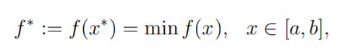

where the function f(x) satisfies the Lipschitz condition over the search interval [a, b]:

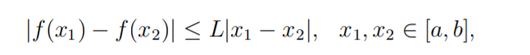

where L is the Lipschitz constant, 0 < L < ∞.

The traditional way to do this is to use a number of test functions and to show that a new method is better in some sense than its competitors. Then, a trade-off between the number of test functions, reliability of the comparison, and visibility of results arises. Clearly, a small number of test functions does not lead to a reliable comparison and a huge number of functions produces huge tables with a lot of data that sometimes are difficult for a fast visualization and an immediate comprehension

Let us consider among these methods the following two classes:

* Metaheuristic methods;
  + Genetic algorithm (GA),
  + Differential Evolution algorithm (DE),
  + Particle Swarm Optimization (PSO),
  + Artificial Bee Colony algorithm (ABC)
  + Firefly algorithm (FA)
* Lipschitz methods.
  + Geom-AL: Geometric method with an A priori given overestimate of the Lipschitz constant
  + Geom-GL: Geometric method with a Global estimate of the Lipschitz constant. It is the same method as Geom-AL but the Lipschitz constants are estimated adaptively during the search.
  + Geom-LTI: Geometric method with a maximum-additive Local Tuning and a pessimistic local Improvement

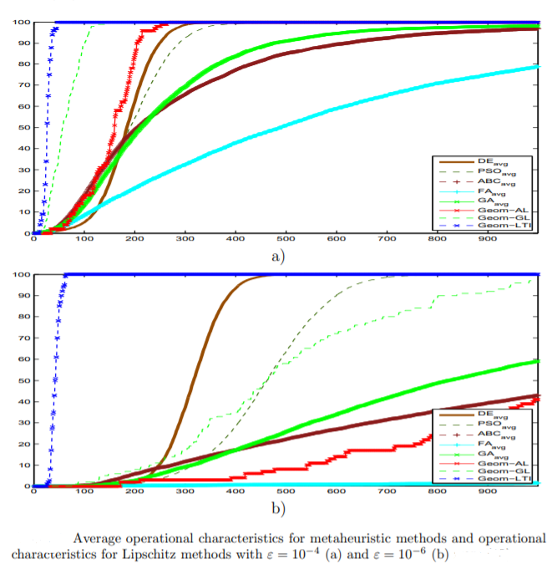

Case Study 2:

**Deterministic vs Heuristic Algorithms for Eco-Driving Application in Metro Network**

This case study investigates the performances of two different algorithms for calculating the metro vehicles speed profiles minimizing the energy consumption of a given path. The optimization problem, formulated as a Mixed-Integer Nonlinear Programming (MINLP) problem, take into account constraints related to the trip (time-table, distances, acceleration limits, etc.) and constraints related to the electric feeding system (line voltage, substations supplied power, etc.). We implement a deterministic algorithm based on Dynamic Programming Optimization (DPO) method, and a heuristic one based on Particle Swarm Optimization (PSO) method, and we evaluate the performances in terms of the time spent on search of a feasible solution and the goodness of the obtained solution. The resulting speed profiles are tested in a metro network simulation tool, based on the ‘quasi static’ backwards looking method, and taking into account the track topology, the characteristics of the metro system.

The problem we aim to solve now consists in finding the optimal/suboptimal speed profile obtained as sequence of basic control regimes that leads to the minimization of energy consumed for a given trip; the traction or braking force u is the control variable, and the state variables are the train position x and its speed v. We consider as objective function, the energy absorbed for a fixed amount of time T, thus the optimization problem can be written as:

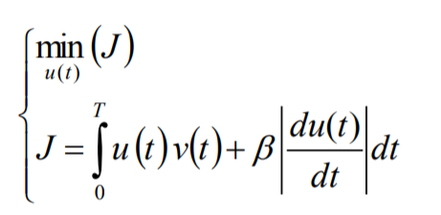

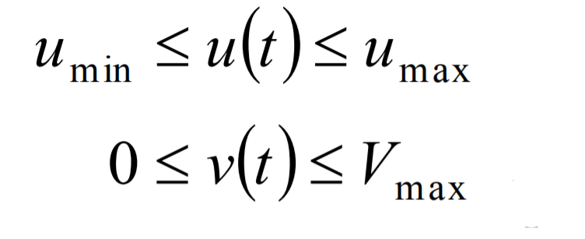

and the boundary conditions:

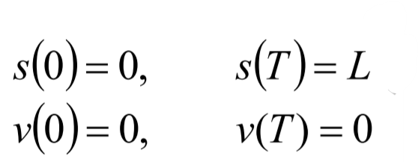

The research of the eco-drive speed profiles can be formulated as a Mixed-Integer Nonlinear Programming problem (MINLP).

The high computational demand of deterministic algorithms in solving these problems, has suggested to find heuristic algorithms to explore more quickly the solution space, even finding a suboptimal solution.

In order to compare the performances of deterministic and heuristic algorithm, the optimization problem is addressed using both,

* DPO (Dynamic Programming Optimization Method)
* PSO (Particle Swarm Optimization Method)

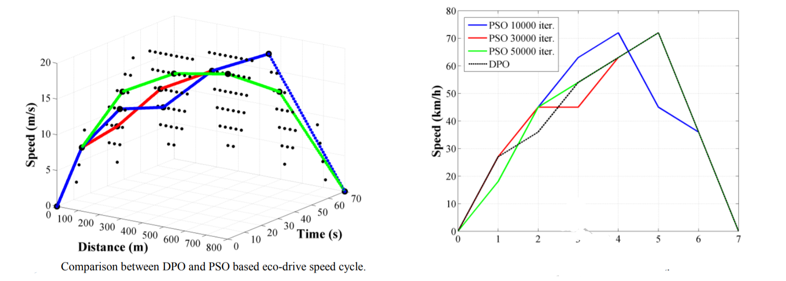

Figure (a) Comparison between DPO and PSO based eco-drive speed cycle

(b )Interactions effect on PSO eco-drive algorithm.

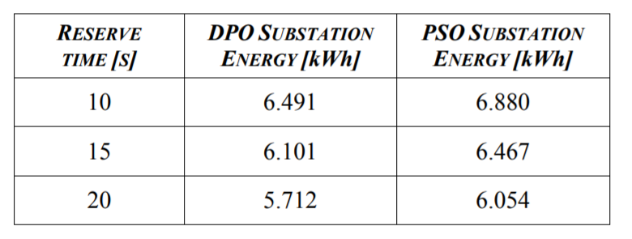

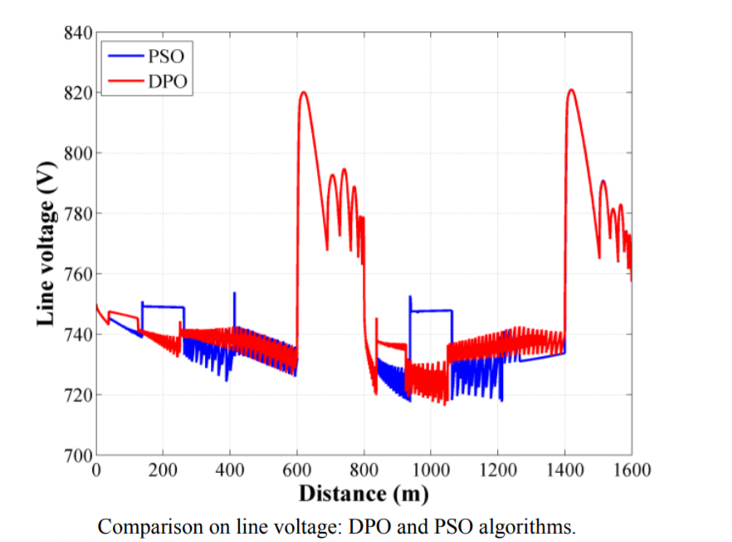

## Conclusion

The success of metaheuristic algorithms comes from the fact that they have seen to be applicable to almost all types of optimization problems, with continuous and/or discrete variables, with no requirements about differentiability of the functions considered, with all types of constraints, for linear or non-linear formulations. This is not the case for conventional deterministic methods, which are generally designed for some well-defined problems with strict limits and become of no use for other problems. To give an example, linear programming, for instance, is applicable only to linear problems with continuous variables with linear constraints and it cannot be applied to other problems is there is any non-linearity somewhere in the formulation. When the function to be optimized becomes quadratic, then one can apply the technique named quadratic programming which is designed only for those problems. If the variables are integers, then one has to apply a specially prepared algorithm. Thus, one can say that the biggest advantage of metaheuristic algorithms is their versatility, i.e. their applicability to almost all type of problems. As far as the speed of computations, one has to state that, in general, if a problem can be solved both by a conventional method and by a metaheuristic algorithm, the central processor time for the former will be much shorter. But this does not form an important disadvantage for metaheuristic algorithms considering that they are especially successful in cases where classical methods are inapplicable or insufficient.

Although deterministic approaches take advantage of analytical properties of the problem to generate a sequence of points that converge to a global solution, metaheuristic approaches have been found to be more flexible and efficient than deterministic approaches. For solving nonconvex or large-scale optimization problems, deterministic methods may not be easy to derive a globally optimal solution within reasonable time due to the high complexity of the problem. Metaheuristic approaches therefore are presented to reduce the computational time of solving an optimization problem, but the obtained solution is not guaranteed to be a feasible or globally optimal solution. These two types of optimization methods have different pros and cons. Therefore, integrating deterministic and metaheuristic approaches may be a good way of solving large-scale optimization problems for finding a global optimum.

Thus, to conclude, if highly precise answers are necessary, it is better to make use of deterministic algorithms, whereas, if imprecise answers are allowed to a certain extent, it may be beneficial to implement a metaheuristic algorithm. Moreover, depending on the problem and computation and space limitations, either a deterministic or metaheuristic algorithm might be more apt for the application

# Question No. 2

**Solution to Question No. 2:**

## 2.1 Design solution candidates and fitness to meet the requirements of the problem

The traveling salesman problem (TSP) is a deceptively simple combinatorial problem. It can be stated very simply: a salesman spends his time visiting n cities (or nodes) cyclically. In one tour he visits each city just once, and finishes up where he started. The question is: in what order should he visit the cities to minimize the distance traveled? TSP became a benchmark for many new approaches in combinatorial optimization (CO)

Due to the practical importance of CO problems, many algorithms to tackle them have been developed. These algorithms can be classified as either complete or approximate algorithms. Complete algorithms are guaranteed to find for every finite size instance of a CO problem an optimal solution in bounded time. Yet, for CO problems that are N P-hard, no polynomial time algorithm exists, assuming that. Therefore, complete methods might need exponential computation time in the worst-case. This often leads to computation times too high for practical purposes. Thus, the development of approximate methods—in which we sacrifice the guarantee of finding optimal solutions for the sake of getting good solutions in a significantly reduced amount of time—has received more and more attention

Ant colony optimization (ACO) is one of the most recent techniques for approximate optimization. The inspiring source of ACO algorithms are real ant colonies. More specifically, ACO is inspired by the ants’ foraging behavior. At the core of this behavior is the indirect communication between the ants by means of chemical pheromone trails, which enables them to find short paths between their nest and food sources. This characteristic of real ant colonies is exploited in ACO algorithms in order to solve, for example, discrete optimization problems.

Marco Dorigo and colleagues introduced the first ACO algorithms in the early 1990’s. The development of these algorithms was inspired by the observation of ant colonies. Ants are social insects. They live in colonies and their behavior is governed by the goal of colony survival rather than being focused on the survival of individuals. The behavior that provided the inspiration for ACO is the ants’ foraging behavior, and in particular, how ants can find shortest paths between food sources and their nest.

The functioning of an ant colony provides indirect communication with the help pheromones, which ants excrete. Pheromones are chemical substances which attract other ants searching for food. The attractiveness of a given path depends on the quantity of pheromones that the ant feels. Pheromone excretion is governed by some rules and has not always the same intensity. The quantity of pheromones depends on the attractiveness of the route. The use of more attractive route ensures that the ant exudes more pheromones on its way back and so that path is more also attractive for other ants. The important characteristic of pheromones is evaporation. This process depends on the time. When the way is no longer used, pheromones are more evaporated and the ants begin to use other paths. What is important for ACO algorithm the moving of ants. This motion is not deterministic, but it has stochastic character, so the ants can find the path, which is firstly unfavorable, but which is ultimately preferable for food search. The important characteristic is that a few individuals continuously use non-preferred path and look for another best way.

Design

Moving of virtual ant depends on the amount of pheromone on the graph edges. The probability pi k of transition of a virtual ant from the node i to the node k is given by formula below. We assume the existence of internal ant’s memory.

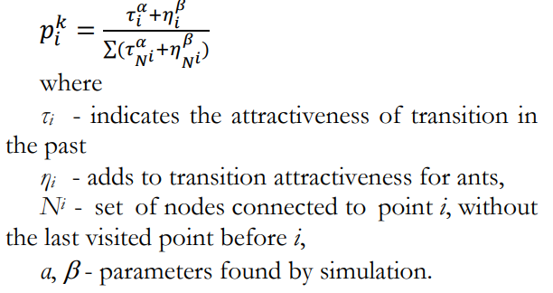

Virtual ant is using the same reverse path as the path to the food resource based on his internal memory, but in opposite order and without cycles, which are eliminated. After elimination of the cycles, the ant puts the pheromone on the edges of reverse path according to formula:

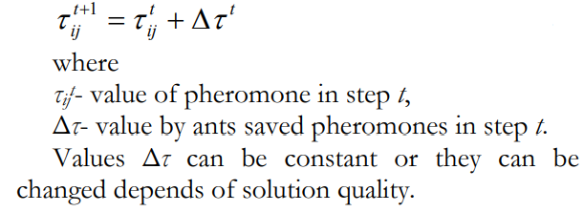

At last, the pheromones on the edges are evaporated. The evaporation helps to find the shortest path and provide that no other path will be assessed as the shortest. This evaporation of pheromones has an intensity ρ

This formula is applied on all graph edges with intensity ρ (interval (0, 1)). On this knowledge we can compose an algorithm of ACO, which can be used for solving the travelling salesman problem.

1. Ants scan graph . The aim of this scan is to find an optimal solution

2. Every ant has its own memory, which is used for saving information about travelled path (for example about travelled nodes). This memory can also serve to ensure constraints or to evaluate of the solution.

3. The process begins in state and has one or more ending constraints . Let the actual state

of an ant be the state and no ending constraint is complied, so the ant moves to node j in neighborhood of the state and the ant moves to the new state . In case that some ending constraint is complied with, the ant ends with process of scan. The transition to a state that represents unacceptable solution is usually banned by appropriate implementation of internal ant memory.

4. The next ant motion depends on the probability, which is calculated on the base of pheromone quantity on edges of graph, and it also takes into consideration its local memory and the acceptance of this step.

5. If the ant can to add new component of graph , it can update the value of corresponding pheromone information (information is bound with corresponding edge, or aim node).

6. The ant can update pheromone values after reverse path construction by editing associate pheromone values.

## 2.2 Use any graph model to illustrate the results

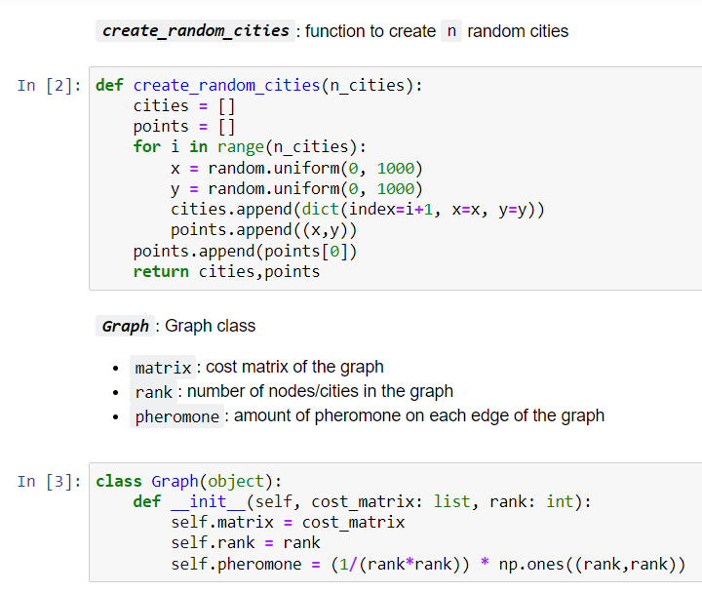

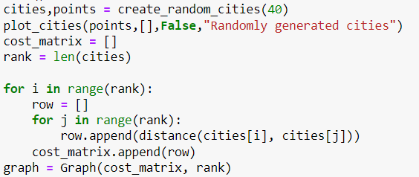

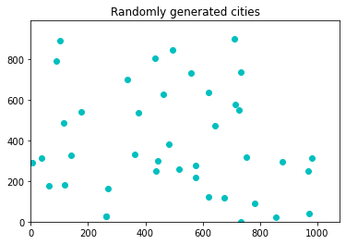

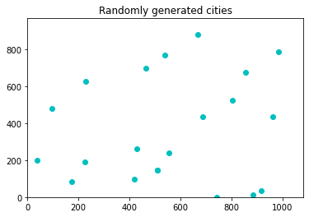

## 2.3 Design solution candidates and fitness to meet the requirements of the problem

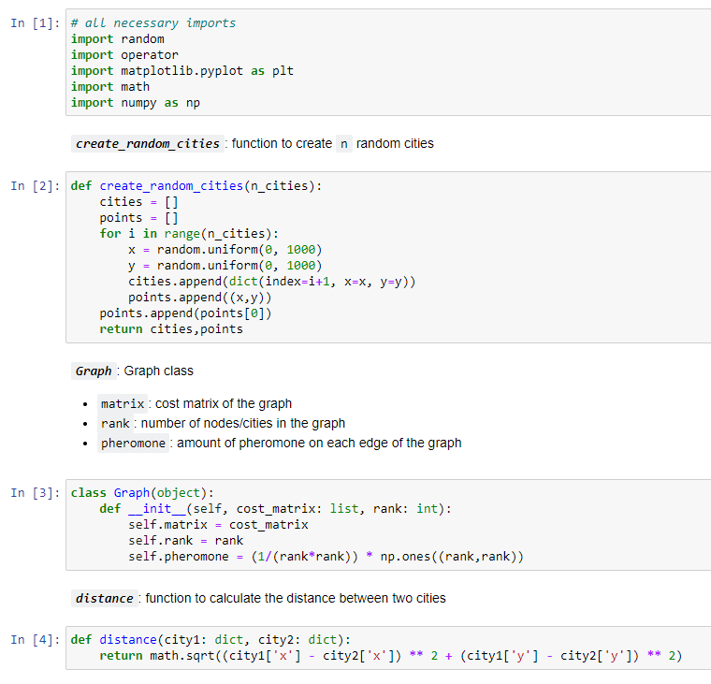

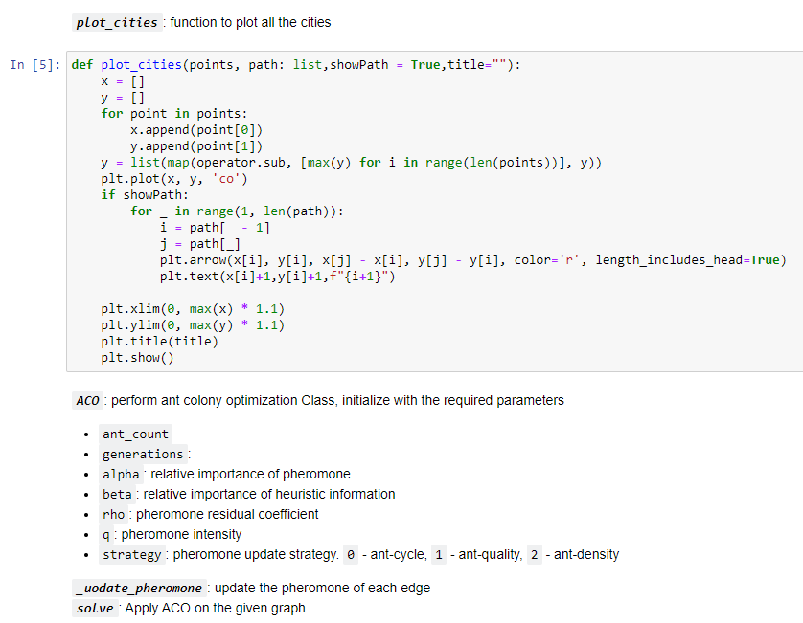

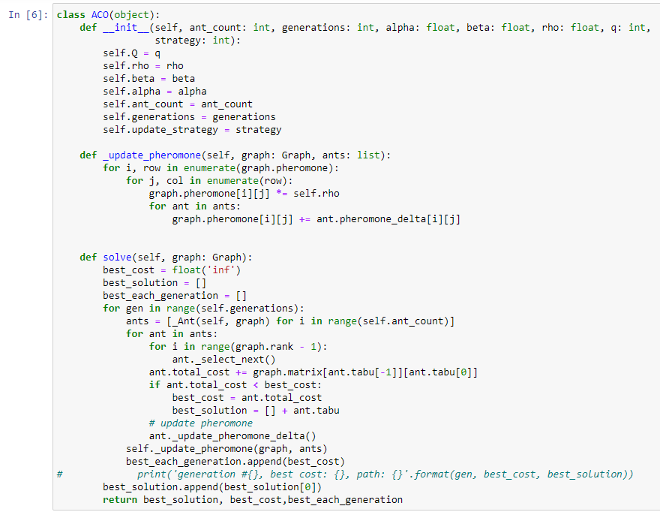

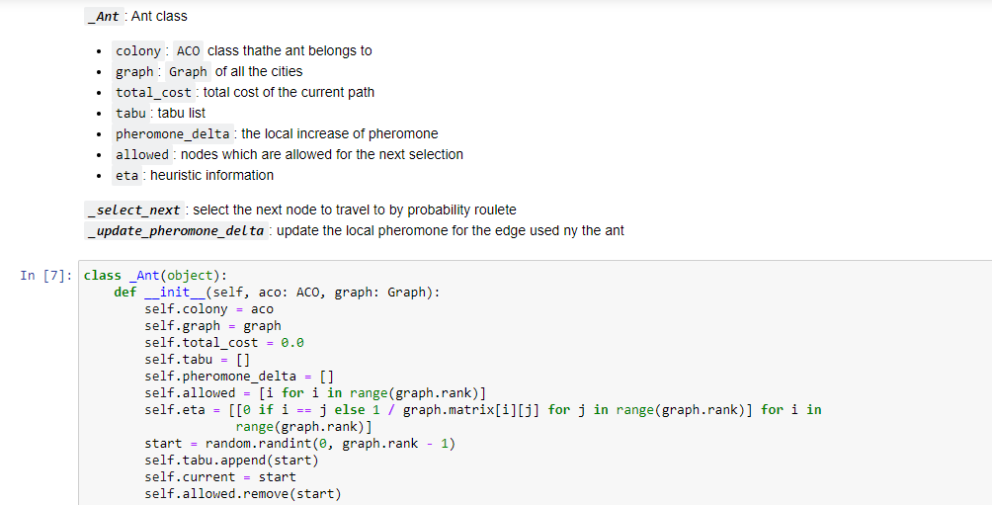

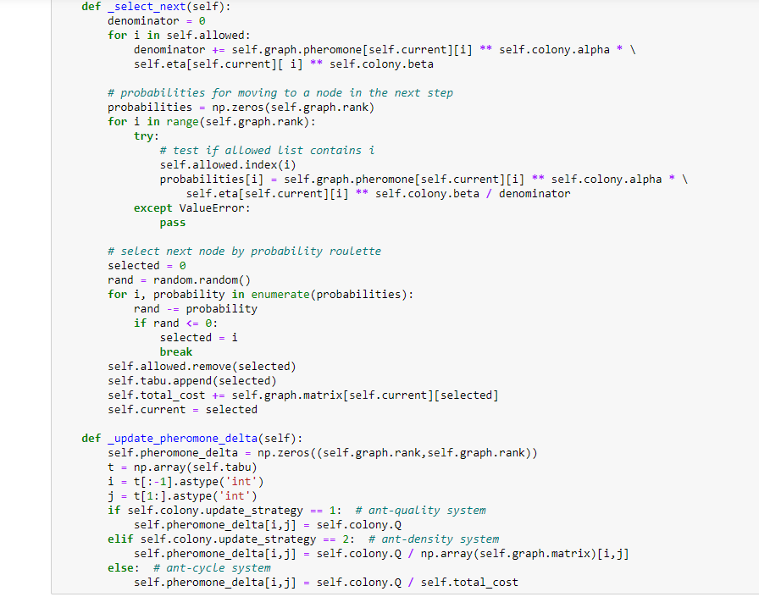

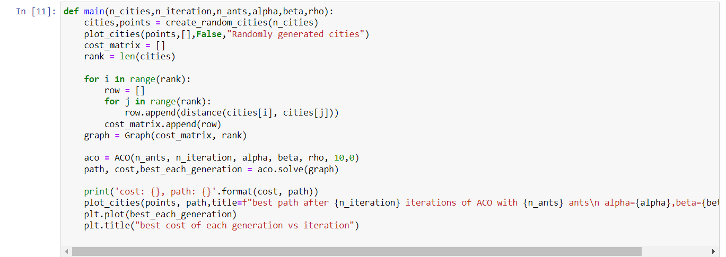



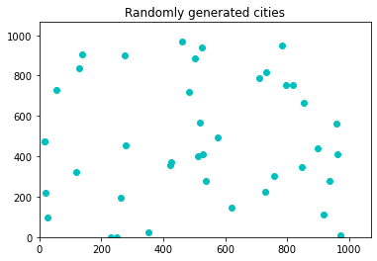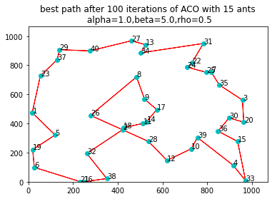

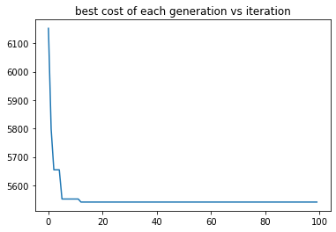

cost: 5541.029862013705, path: [3, 32, 14, 35, 29, 19, 2, 34, 6, 24, 23, 21, 30, 33, 12, 26, 39, 28, 36, 22, 0, 4, 18, 5, 20, 15, 37, 31, 1, 17, 10, 13, 16, 8, 7, 25, 27, 11, 9, 38, 3]

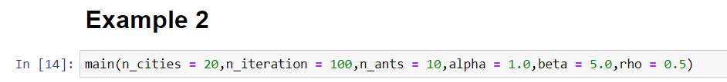

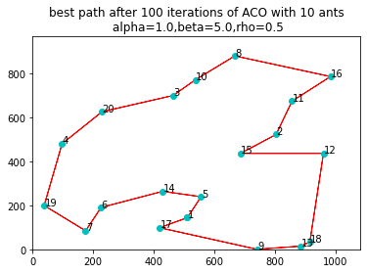

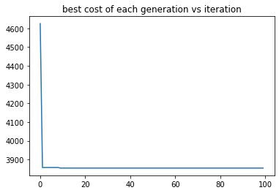

cost: 3854.763108188222, path: [1, 10, 15, 7, 9, 2, 19, 3, 18, 6, 5, 13, 4, 0, 16, 8, 12, 17, 11, 14, 1]

# Bibliography

________________________________________________________________________________