

|  |  |
| --- | --- |
| **ASSIGNMENT** | |
| **Course Code** | 20CSE421A |
| **Course Name** | Data Science Foundation |
| **Programme** | B. Tech. |
| **Department** | Computer Science & Engineering |
| **Faculty** | Faculty of Engineering & Technology |

#### 

|  |  |
| --- | --- |
| **Name of the Student** | Subhendu Maji |
| **Reg. No** | 18ETCS002121 |
| **Semester/Year** | 7th semester / 2018 batch |
| **Course Leader/s** |  |

|  |  |  |  |  |  |  |  |  |
| --- | --- | --- | --- | --- | --- | --- | --- | --- |
| **Declaration Sheet** | | | | | | | | |
| Student Name | Subhendu Maji | | | | | | | |
| Reg. No | 18ETCS002121 | | | | | | | |
| Programme | B. Tech. | | | | | Semester/Year | 7th sem /2018 batch | |
| Course Code | 20CSE421A | | | | | | | |
| Course Title | Data Science Foundation | | | | | | | |
| Course Date |  | | to | |  | | | |
| Course Leader |  | | | | | | | |
| **Declaration**  The assignment submitted herewith is a result of my own investigations and that I have conformed to the guidelines against plagiarism as laid out in the Student Handbook. All sections of the text and results, which have been obtained from other sources, are fully referenced. I understand that cheating and plagiarism constitute a breach of university regulations and will be dealt with accordingly. | | | | | | | | |
| Signature of the Student | |  | | | | | Date |  |
| Submission date stamp  (by Examination & Assessment Section) | |  | | | | | | |
| Signature of the Course Leader and date | | | | Signature of the Reviewer and date | | | | |
|  | | | |  | | | | |

# **Contents**

____________________________________________________________________________

**Declaration Sheet** ii

**Contents** iii

Marking Scheme 4

**Question No. 1** 6

A1.1 Python language and its usage in data science 6

A2 Python syntax and core constructs 7

A1.3 Functions: Namespaces and scopes 8

A4.1 Exception handling 9

A1.5 Libraries for Data Science Applications 13

A6 Data modelling, processing 15

**Question No. 2** 16

B1.1 Design a system for reading data in text format using pandas library 16

B1.2 Design a system for storing data in text format using pandas library 19

B1.3 Design about the task in a parallel system using Celery to obtain square root of a value 21

B1.4 Design about the client and server role in a parallel system using Celery to obtain square root of a value 22

**Question No. 3** 25

B2.1 Implement Python code for reading data in text format using pandas library 25

B2.2 Implement Python code for storing data in text format using pandas library 27

B2.3 Implement Python code for the task in a parallel system using Celery to obtain square root of a value 28

B2.4 Implement Python code for the client and server role in a parallel system using Celery to obtain square root of a value 30

|  |  |  |  |  |  |  |  |  |  |
| --- | --- | --- | --- | --- | --- | --- | --- | --- | --- |
| **Assignment - 01** | | | | |  | |  | |  |
| Register No | | | **18ETCS002121** | Name of Student |  | **Subhendu Maji** | | |  |
| Sections |  | Marking Scheme | | |  | | **Marks** | |  |
| Max  Marks | |  | First  Examiner  Marks | Moderat or Marks |
| **Part**  **-**  **A** |  | | | |  | |  | |  |
| A 1.1 | Python language and its usage in data science | | | 04 | |  |  |  |
| A 1.2 | Python syntax and core constructs | | | 06 | |  |  |  |
| A 1.3 | Functions: Namespaces and scopes | | | 05 | |  |  |  |
| A 1.4 | Exception handling | | | 04 | |  |  |  |
| A1.5 | Libraries for Data Science Applications | | | 05 | |  |  |  |
| A1.6 | Data modelling, processing | | | 06 | |  |  |  |
|  | **Part-A Max Marks** | | | **30** | |  |  |  |
| **Part B 1** |  | | | |  | |  | |  |
| B 1.1 | Design a system for reading data in text format using pandas library | | | 7 | |  |  |  |
| B 1.2 | Design a system for storing data in text format using pandas library | | | 8 | |  |  |  |
| B 1.3 | Design about the task in a parallel system using Celery to obtain square root of a value | | | 5 | |  |  |  |
| B 1.4 | Design about the client and server role in a parallel system using Celery to obtain square root of a value | | | 10 | |  |  |  |
|  | **Part-B1 Max Marks** | | | **30** | |  |  |  |
| **Part B 2** |  | | | |  | |  | |  |
| B2.1 | Implement Python code for reading data in text format using pandas library | | | 10 | |  |  |  |
| B2.2 | Implement Python code for storing data in text format using pandas library | | | 10 | |  |  |  |
|  | B2.3 | Implement Python code for the task in a parallel system using Celery to obtain square root of a value | | | 5 | | |  |  |
| B2.4 | Implement Python code for the client and server role in a parallel system using Celery to obtain square root of a value | | | 15 | | |  |  |
|  | **Part-B2 Max Marks** | | | **40** | | |  |  |
|  |  | **Total Assignment Marks** | | | **100** | | |  |  |

|  |  |  |  |  |
| --- | --- | --- | --- | --- |
| **Course Marks Tabulation** | | | | |
| **Component- CET B Assignment** | **First**  **Examiner** | **Remarks** | **Second Examiner** | **Remarks** |
| A |  |  |  |  |
| B.1 |  |  |  |  |
| B.2 |  |  |  |  |
| **Marks (Max 50)** |  |  |  |  |
| **Marks (out of 25)** |  |  |  |  |
| Signature of First Examiner Signature of Second Examiner | | | | |

# **Question No. 1**

**Solution to Question No. 1:**

## A1.1 Python language and its usage in data science

**Python Programming Language**

Python is an interpreted, object-oriented, high-level programming language with dynamic semantics. Its high-level built-in data structures, combined with dynamic typing and dynamic binding, make it very attractive for Rapid Application Development, as well as for use as a scripting or glue language to connect existing components together. Python's simple, easy to learn syntax emphasizes readability and therefore reduces the cost of program maintenance.

Python supports modules and packages, which encourages program modularity and code reuse. The Python interpreter and the extensive standard library are available in source or binary form without charge for all major platforms, and can be freely distributed.

Applications of python:

* Developing web sites and apps
* Data Analysis
* AI and Machine learning.
* Image processing
* Game development

In many scenarios, Python is the programming language of choice for the daily tasks that data scientists tackle, and is one of the top data science tools used across industries. For data scientists who need to incorporate statistical code into production databases or integrate data with web-based applications, Python is often the ideal choice. It is also ideal for implementing algorithms, which is something that data scientists need to do often.

There are also Python packages that are specifically tailored for certain functions, including pandas, NumPy, and SciPy. Data scientists working on various machine learning tasks find that Python’s scikit-learn is a useful and valuable tool. Matplotlib, another one of Python’s packages, is also a perfect solution for data science projects that require graphics and other visuals.

Reasons to use python in data science:

* The main reason of using python in data science is that python provides a lot of libraries which can be used for data science applications.
* Python is an open source and it is easy to implement because of its simple syntax.
* Python is used for data science because python contains some libraries like pandas, NumPy which can be used for analyzing the data or modification of data.
* Another important reason for using python in data science is that its syntax is simple so that it can be understood by all classes of people.

## A2 Python syntax and core constructs

**A2.1**

Python is completely object oriented, and not "statically typed". We do not need to declare variables before using them, or declare their type. Every variable in Python is an object.

Python variables do not need explicit declaration to reserve memory space. The declaration happens automatically when you assign a value to a variable. The equal sign (=) is used to assign values to variables.

The operand to the left of the = operator is the name of the variable and the operand to the right of the = operator is the value stored in the variable.

Example:

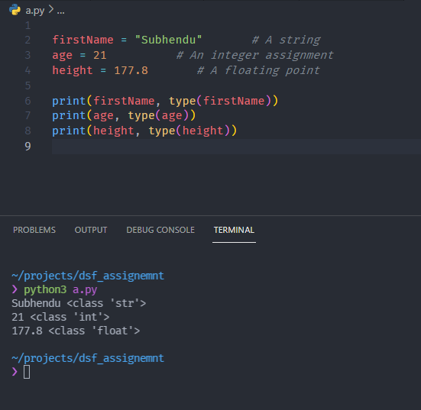

Figure 1 python is a dynamically typed language

We do not need to declare variables before using them or declare their type. A variable is created the moment we first assign a value to it. A variable is a name given to a memory location. It is the basic unit of storage in a program.

* The value stored in a variable can be changed during program execution.
* A variable is only a name given to a memory location; all the operations done on the variable effects that memory location.

**A2.2**

As we discussed python is a dynamically typed programming language. So, if we declare the variable without assigning it to value the interpreter will get confused and it will show error.

**A2.3**

* If we start the name of variable with an underscore, the interpreter will treat it as an inbuilt function.
* In python inbuilt functions start with underscore.
* If the variable name starts with underscore, the interpreter will think that the variable is an inbuilt function.

Rules for creating variables in Python:

* A variable name must start with a letter or the underscore character.
* A variable name cannot start with a number.
* A variable name can only contain alpha-numeric characters and underscores

(A-z, 0-9, and _).

* Variable names are case-sensitive (name, Name and NAME are three different variables).
* The reserved words(keywords) cannot be used naming the variable.

## A1.3 Functions: Namespaces and scopes

**Namespaces**

A namespace is a system that has a unique name for each and every object in Python. An object might be a variable or a method. Python itself maintains a namespace in the form of a Python dictionary. the Python interpreter understands what exact method or variable one is trying to point to in the code, depending upon the namespace.

* A namespace in python is a collection of underlying key words and objects that python has within the memory.
* It’s a very common concept in object-oriented programming.
* Name space is a key value pair implemented as a dictionary.
* Types of name spaces:
* Built-in
* Global
* Local

Example:

var1 = 5

def some_func():

# var2 is in the local namespace

var2 = 6

def some_inner_func():

# var3 is in the nested local

# namespace

var3 = 7

**Variable Scope**

Scope refers to the coding region from which a particular Python object is accessible. Hence one cannot access any particular object from anywhere from the code, the accessing has to be allowed by the scope of the object.

e.g.

def some_func():

print("Inside some_func")

def some_inner_func():

var = 10

print("Inside inner function, value of var:",var)

some_inner_func()

print("Try printing var from outer function: ",var)

some_func()

**output:**

Inside some_func

Inside inner function, value of var: 10

Traceback (most recent call last):

File "/home/1eb47bb3eac2fa36d6bfe5d349dfcb84.py", line 8, in

some_func()

File "/home/1eb47bb3eac2fa36d6bfe5d349dfcb84.py", line 7, in some_func

print("Try printing var from outer function: ",var)

NameError: name 'var' is not defined

## A4.1 Exception handling

To raise an exception, you use the raise statement:

Syntax:

*raise* ExceptionType()

The ExceptionType() must be subclass of the BaseException class. Typically, it is a subclass of the Exception class. Note that the ExceptionType doesn’t need to be directly inherited from the Exception class. It can indirectly inherit from a class that is a subclass of the Exception class.

The BaseException class has the __init__ method that accepts an *args argument. It means that you can pass any number of arguments to the exception object when raising an exception.

The following example uses the raise statement to raise a ValueError exception. It passes three arguments to the ValueError __init__ method:

*try*:

*raise* ValueError('The value error exception', 'x', 'y')

*except* ValueError *as* ex:

    print(ex.args)

**Reraise the current exception**

Sometimes, we want to log an exception and raise the same exception again. In this case, we can use the raise statement without specifying the exception object.

For example, the following defines a division() function that returns the division of two numbers:

def division(*a*, *b*):

*try*:

*return* *a* / *b*

*except* ZeroDivisionError *as* ex:

        print('Logging exception:', str(ex))

*raise*

If we pass zero to the second argument of the division() function, the ZeroDivisionError exception will occur. However, instead of handling the exception, we can log the exception and raise it again.

Note that we don’t need to specify the exception object in the raise statement. In this case, Python knows that the raise statement will raise the current exception that has been caught by the except clause.

The following code causes a ZeroDivisionError exception:

division(1, 0)

**Raise another exception during handling an exception**

When handling an exception, we may want to raise another exception. In the division() function, we raise a ValueErrorexception if the ZeroDivisionError occurs.

If we run the following code, we’ll get the detail of the stack trace:

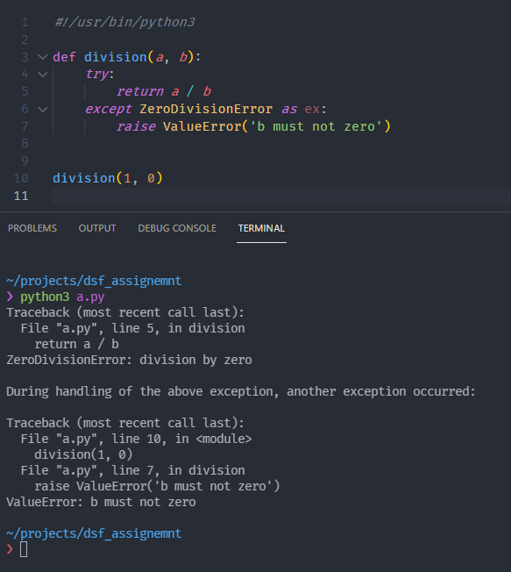

* **Try**
  + This block contains one or more statements which are likely to encounter an exception.
  + If the try block gets executed with out any exceptions the except block will be skipped.
* **Except**
  + Except block contains the statements which needs to be executed when we get an exception in the try block.
  + After the execution of except block, the error message will be displayed.
  + We can specify the type of exception in the except block. The except block contains multiple exception blocks. Depending on the type of exception occurred in the try block, the exception block of except will be executed.
* **Finally**
  + First the try block will be executed. If there is any exception occurred in try block then the occurred exception will be checked in the except block. Even if the type of exception is present or absent in the except block, finally will be executed.

**A4.2**

* Try- Except:
  + At first, try block will be executed. If there is no exception occurred in the try block, the statements in the try block will be execute and the output will be displayed.
  + If some exception occurs in the try block, the respective exception will be executed from the except block.
* Try- Finally:
  + At first, try block will be executed. Even if an exception occurred or there is no exception, finally block will execute for sure.

So, the main difference between try- except and try- finally is that in try except only if there is an exception in try block then except block will be executed. In the case of try- finally, even if there is no exception occurred in the try block, finally block will be executed for sure.

## A1.5 Libraries for Data Science Applications

Some essential libraries in Python for data analysis are:

1. NumPy
2. Pandas
3. Tensor flow
4. SciPy

**NumPy**

* It is a Python library for numerical computing on data that can be in the form of large arrays and multi-dimensional matrices.
* These multidimensional matrices are the main objects in NumPy where their dimensions are called axes and the number of axes is called a rank.
* NumPy also provides various tools to work with these arrays and high-level mathematical functions to manipulate this data with linear algebra, Fourier transforms etc.
* Some of the basic array operations that can be performed using NumPy include adding, slicing, multiplying, flattening, reshaping, and indexing the arrays.

**Pandas**

* Pandas is a Python library for data analysis and data handling.
* Pandas provides various high-performance and easy-to-use data structures and operations for manipulating data in the form of numerical tables.
* Pandas also has multiple tools for reading and writing data between in-memory data structures and different file formats.
* Pandas is perfect for quick and easy data manipulation, data aggregation, reading, and writing the data as well as data visualization. Pandas can also take in data from different types of files such as CSV, excel etc. and create a python object known as data frame.
* A data frame contains rows and columns and it can be used for data manipulation with operations such as join, merge, groupby etc.

**Tensor flow**

* TensorFlow is an end-to-end open-source platform that has a wide variety of tools, libraries, and resources for Artificial Intelligence.
* You can easily build and train Machine Learning models with high-level API’s such as Keras using TensorFlow.
* TensorFlow also allows you to deploy Machine Learning models anywhere such as the cloud, browser, or your own device.

**SciPy**

* SciPy is a python library for scientific computing and technical computing on the data.
* SciPy library is built on the NumPy array object and it is part of the NumPy stack which also includes other scientific computing libraries and tools such as Matplotlib, pandas etc.
* SciPy allows for various scientific computing tasks that handle data optimization, data integration, data interpolation, and data modification using linear algebra, Fourier transforms, random number generation, special functions, etc.
* Just like NumPy, the multidimensional matrices are the main objects in SciPy, which are provided by the NumPy module itself.

## A6 Data modelling, processing

**A6.1**

* NumPy is extremely fast for binary data loading and storage including support for memory mapped array.
* NumPy is a low-level library but it is extremely fast for data loading and storage.
* Reading text files and other more efficient on disk formats, loading data from databases, and interacting with network sources like web API’s.

**A6.2**

* Mat plot lib and D3 both the libraries are together combined to provide interactive features like zooming and panning.
* You can make a plot in matplotlib, add interactive functionality with plugins that utilize both Python and JavaScript, and then render it with D3.
* mpld3 includes built-in plugins for zooming, panning, and adding tooltips.

**A6.3**

* Pandas is used for flexible and high-performance group by facility enabling slice and dice and summarize data sets in a natural way.
* Python has some methods which are used to do aggregation on data.

# **Question No. 2**

**Solution to Question No. 2:**

## B1.1 Design a system for reading data in text format using pandas library

Pandas is one of those packages and makes importing and analyzing data much easier.

1. pandas.read_csv

Read a comma-separated values (csv) file into DataFrame. Also supports optionally iterating or breaking of the file into chunks. Additional help can be found in the online docs for IO Tools.

|  |  |
| --- | --- |
| **Parameter** | **use** |
| sep | Delimiter to use. If sep is None, the C engine cannot automatically detect the separator, but the Python parsing engine can, meaning the latter will be used and automatically detect the separator |
| **delimiter** | Alias for sep. |
| header | Row number(s) to use as the column names, and the start of the data. Default behavior is to infer the column names: if no names are passed the behavior is identical to header=0 and column names are inferred from the first line of the file, if column names are passed explicitly then the behavior is identical to header=None. |
| names | List of column names to use. If the file contains a header row, then you should explicitly pass header=0 to override the column names. |
| index_col | Column(s) to use as the row labels of the DataFrame, either given as string name or column index. If a sequence of int / str is given, a MultiIndex is used. |
| usecols | Return a subset of the columns. If list-like, all elements must either be positional (i.e. integer indices into the document columns) or strings that correspond to column names provided either by the user in names or inferred from the document header row(s). |

e.g.

import pandas as pd

pd.read_csv("pokemon.csv", header =[1, 2])

1. pandas.read_table

Read general delimited file into DataFrame. Also supports optionally iterating or breaking of the file into chunks.

|  |  |
| --- | --- |
| **Parameter** | **use** |
| **sep** | Delimiter to use. If sep is None, the C engine cannot automatically detect the separator, |
| header | Row number(s) to use as the column names, and the start of the data. Default behavior is to infer the column names: if no names are passed the behavior is identical to header=0 and column names are inferred from the first line of the file, if column names are passed explicitly then the behavior is identical to header=None. Explicitly pass header=0 to be able to replace existing names. The header can be a list of integers that specify row locations for a multi-index on the columns e.g. [0,1,3]. |
| names | List of column names to use. If the file contains a header row, then you should explicitly pass header=0 to override the column names. Duplicates in this list are not allowed. |
| index_col | Column(s) to use as the row labels of the DataFrame, either given as string name or column index. If a sequence of int / str is given, a MultiIndex is used. |
| usecols | Return a subset of the columns. If list-like, all elements must either be positional (i.e. integer indices into the document columns) or strings that correspond to column names provided either by the user in names or inferred from the document header row(s). |

e.g.

import pandas as pd

pd.read_table('nba.csv',delimiter=',')

1. pandas.read_fwf

Read a table of fixed-width formatted lines into DataFrame. Also supports optionally iterating or breaking of the file into chunks. Additional help can be found in the online docs for IO Tools.

|  |  |
| --- | --- |
| **Parameter** | **use** |
| **colspecs** | A list of tuples giving the extents of the fixed-width fields of each line as half-open intervals (i.e., [from, to[ ). |
| **widths** | A list of field widths which can be used instead of ‘colspecs’ if the intervals are contiguous. |
| **infer_nrows** | The number of rows to consider when letting the parser determine the colspecs. |

1. pandas.read_clipboard

Read text from clipboard and pass to read_csv.

|  |  |
| --- | --- |
| **Parameter** | **use** |
| **sep** | A string or regex delimiter. The default of ‘s+’ denotes one or more whitespace characters. |

1. pandas.DataFrame.to_csv

Write object to a comma-separated values (csv) file.

|  |  |
| --- | --- |
| **Parameter** | **use** |
| **sep** | String of length 1. Field delimiter for the output file. |
| **na_rep** | Missing data representation. |
| **columns** | Columns to write. |
| **header** | Write out the column names. If a list of strings is given it is assumed to be aliases for the column names. |
| **index** | Write row names (index). |
| **encoding** | A string representing the encoding to use in the output file, defaults to ‘utf-8’. |
| **compression** | If str, represents compression mode. If dict, value at ‘method’ is the compression mode. Compression mode may be any of the following possible values: {‘infer’, ‘gzip’, ‘bz2’, ‘zip’, ‘xz’, None}. |

## B1.2 Design a system for storing data in text format using pandas library

1. sqlite3.connect(database [,timeout ,other optional arguments])

This API opens a connection to the SQLite database file. We can use ":memory:" to open a database connection to a database that resides in RAM instead of on disk. If database is opened successfully, it returns a connection object.

When a database is accessed by multiple connections, and one of the processes modifies the database, the SQLite database is locked until that transaction is committed. The timeout parameter specifies how long the connection should wait for the lock to go away until raising an exception. The default for the timeout parameter is 5.0 (five seconds).

If the given database name does not exist then this call will create the database. You can specify filename with the required path as well if you want to create a database anywhere else except in the current directory.

1. cursor.execute(sql [, optional parameters])

This routine executes an SQL statement. The SQL statement may be parameterized (i. e. placeholders instead of SQL literals). The sqlite3 module supports two kinds of placeholders: question marks and named placeholders (named style).

For example − cursor.execute("insert into people values (?, ?)", (who, age))

1. connection.execute(sql [, optional parameters])

This routine is a shortcut of the above execute method provided by the cursor object and it creates an intermediate cursor object by calling the cursor method, then calls the cursor's execute method with the parameters given.

1. cursor.executemany(sql, seq_of_parameters)

This routine executes an SQL command against all parameter sequences or mappings found in the sequence sql.

1. cursor.executescript(sql_script)

This routine executes multiple SQL statements at once provided in the form of script. It issues a COMMIT statement first, then executes the SQL script it gets as a parameter. All the SQL statements should be separated by a semi colon (;).

1. connection.commit()

This method commits the current transaction. If you don't call this method, anything you did since the last call to commit() is not visible from other database connections.

1. cursor.fetchall()

This routine fetch all (remaining) rows of a query result, returning a list. An empty list is returned when no rows are available.

**To Check Entries in the Database**

In sqlite3 we do :

cursor = con.execute('select * from student222’)

rows = cursor.fetchall()

in pandas the same operation can be done :

import pandas as pd

pd.DataFrame(rows, columns=[x[0] for x in cursor.description])

This is quite a bit of munging that we woould rather not repeat each time you query the database.

import pandas.io.sql as sql

sql.read_sql('select * from student222', con)

pandas also has a read_sql function in its pandas.io.sql module that simplifies the process.

## B1.3 Design about the task in a parallel system using Celery to obtain square root of a value

**Parallel programming**: defined as an approach in which program data creates workers to run specific tasks simultaneously in a multicore environment without the need for concurrency amongst them to access a CPU. the workers that are sent to perform a task often need to establish communication so that there can be cooperation in tackling a problem. In most cases, this communication is established in such a way that data can be exchanged amongst workers. There are two forms of communication that are more widely known when it comes to parallel programming: shared state and message passing.

Celery is a framework that offers mechanisms to lessen difficulties while creating distributed systems. The Celery framework works with the concept of distribution of work units (tasks) by exchanging messages among the machines that are interconnected as a network, or local workers.

A task is the key concept in Celery; any sort of job we must distribute has to be encapsulated in a task beforehand.

It distributes tasks in a transparent way among workers that are spread over the Internet, or local workers. It supports synchronous, asynchronous, periodic, and scheduled tasks.

The first thing we need is a Celery instance. We call this the Celery application or just app for short. As this instance is used as the entry-point for everything you want to do in Celery, like creating tasks and managing workers, it must be possible for other modules to import it.

*from* celery *import* Celery

app = Celery('tasks', *broker*='redis://localhost:6379/0')

@app.task

def square_root(*x*):

*return* *x* ** 0.5

The first argument to Celery is the name of the current module. This is only needed so that names can be automatically generated when the tasks are defined in the __main__ module.

Celery requires a solution to send and receive messages; usually this comes in the form of a separate service called a *message* broker.

The second argument is the broker keyword argument, specifying the URL of the message broker you want to use. Here we are using Redis.

There are several choices available, including: RabbitMQ, Redis and Amazon SQS.

Then, we defined a single task, called square_root, which returning the square root of a number.

## B1.4 Design about the client and server role in a parallel system using Celery to obtain square root of a value

* The client program, as presented in the above section, have the function of creating and dispatching tasks to the brokers.
* It demonstrates the definition of a task by using the **@app.task** decorator, which is accessible through an instance of Celery application that, for now, will be called app.
* There are several types of tasks: synchronous, asynchronous, periodic, and scheduled. When we perform a task call, it returns an instance of type **AsyncResult**.
* The AsyncResult object is an object that allows the task status to be checked, its ending, and obviously, its return when it exists. However, to make use of this mechanism, another component, the result backend, has to be active.
* The **Message transport (broker)** is definitely a key component in Celery. Through it, we get to send and receive messages and communicate with workers
* The most complete in terms of functionality are **RabbitMQ** and **Redis**. We will use Redis as a broker as well asresult backend.
* A **broker** has the function of providing a means of communication between client applications that send tasks and workers that will execute them. This is done by using task queues. We can have several network machines with brokers waiting to receive messages to be consumed by workers.
* **Workers** are responsible for executing the tasks they have received. Celery displays a series of mechanisms so that we can find the best way to control how workers will behave. We can define the mechanisms as follows: Concurrency mode, Remote control, Revoking tasks
* The result backend component has the role of storing the status and result of the task to return to the client application. From the result backend supported by Celery, we can highlight RabbitMQ, Redis, MongoDB, Memcached, among others.

**Setting up the environment**

we will set up two virtual environments in Linux. The first one, hostname client, will perform the client role, where app Celery will dispatch the tasks to be executed. The other machine, hostname server, will perform the role of a broker, result backend, and the queues consumed by workers.

**Setting up the Client Machine**

We will set up a virtual environment with Python 3.8, using the tool pyvenv. The goal of pyvenv is to not pollute Python present in the operating system with additional modules, but to separate the developing environments necessary for each project.

Now, we have a virtual environment and starting off from the point from where you already installed pip, we will install the necessary packages for our client for e.g., celery.

**Setting up the Server Machine**

To set up the server machine, we will need redis. We can start a redis-server quickly in a docker container. We will start the redis-server which will listen on port 6379.

**Dispatching a simple task**

Now we have a ready environment. We can test it by sending a task that will calculate the square root of a value and return a result. First, we must define our task module tasks.py inside the server. we need to import necessary library for our function that will calculate the square root:

e.g.

from math import sqrt

from celery import Celery

Now, we can create the following instance of Celery, which will represent our client application:

app = Celery('tasks', broker='redis://lcoalhost:6379/0')

**Dispatching a task**

Next, we have to set up our result backend, which will also be in Redis, as follows:

app.config.CELERY_RESULT_BACKEND = 'redis://localhost:6379/0’

then, define our task with the @app.task decorator:

@app.task

def square_root(value):

return sqrt(value)

At this point, since we have our tasks.py module defined, we need to initiate our workers inside the server, where Redis and Celery (with support to Redis) are installed.

$ celery -A tasks worker --loglevel=INFO

**Publish a task**

we have a Celery server waiting to receive tasks and send them to workers. The next step is to create an application on the client side to call tasks.

1. We import the Celery class inside the celery module, as follows:

from celery import Celery

1. The next step is to create an instance of the Celery class informing the module containing the tasks and then the broker, as done in the server side. This is done with the following code:

app = Celery('tasks’, broker='redis://192.168.25.21:6379/0')

app.conf.CELERY_RESULT_BACKEND = 'redis://192.168.25.21:6397/0'

1. we can create a function to encapsulate the sending of the **sqrt_task(value)** task. We will create the manage_sqrt_task(value) function as follows:

def manage_sqrt_task(value):

result = app.send_task('tasks.sqrt_task', args=(value,))

print(result.get())

1. In the __main__ block, we executed the call to the manage_sqrt_task(value) function by passing the input value as 4:

if __name__ == '__main__’:

manage_sqrt_task(4)

# **Question No. 3**

**Solution to Question No. 3:**

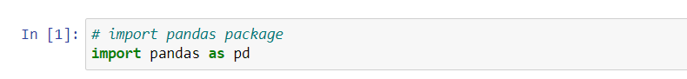

## B2.1 Implement Python code for reading data in text format using pandas library

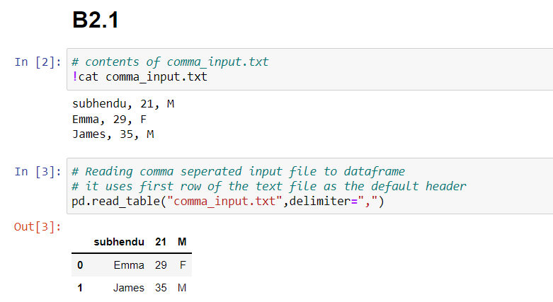

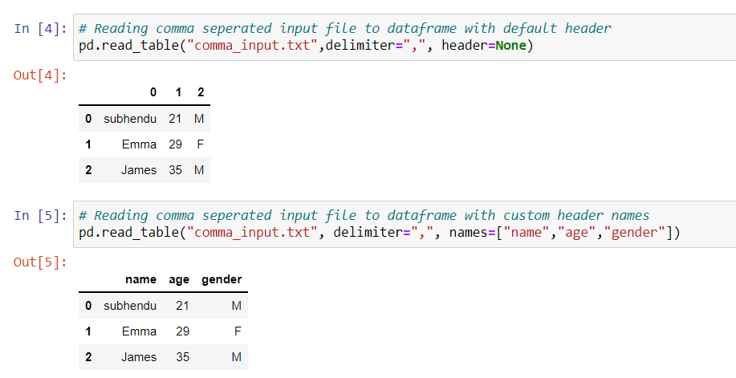

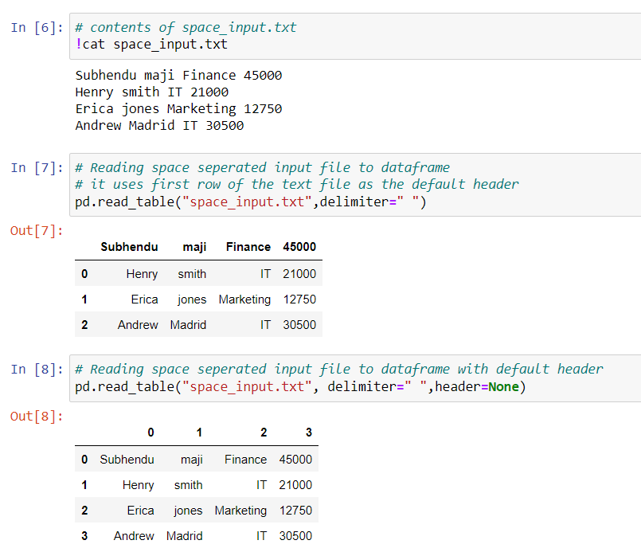

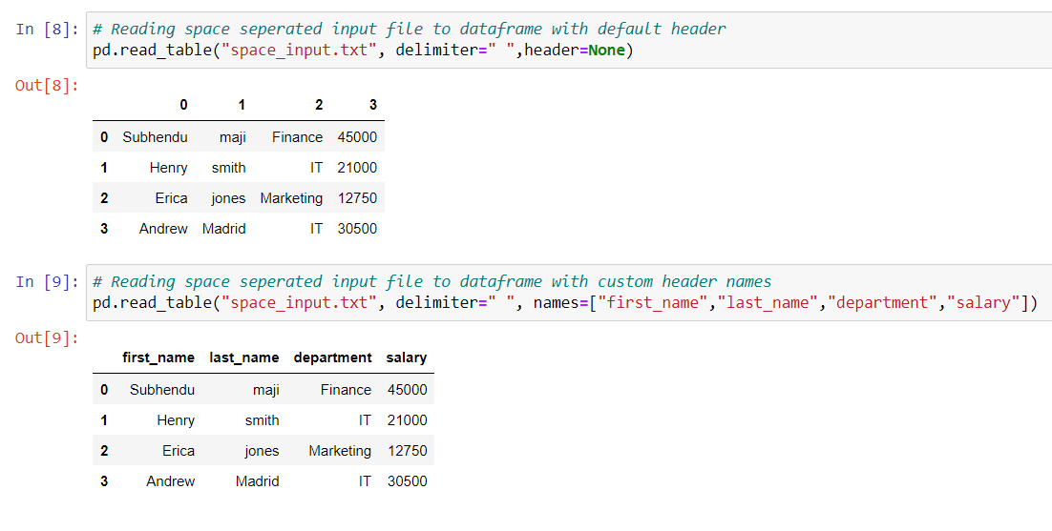

## B2.2 Implement Python code for storing data in text format using pandas library

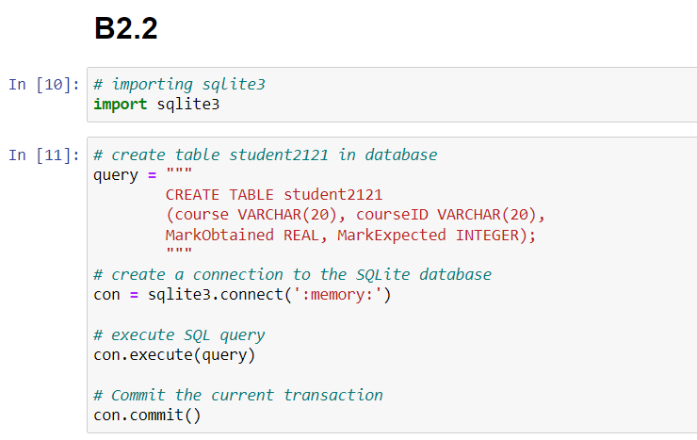

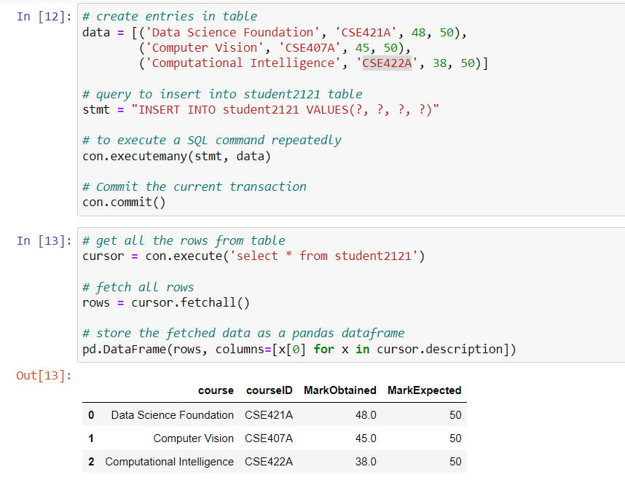

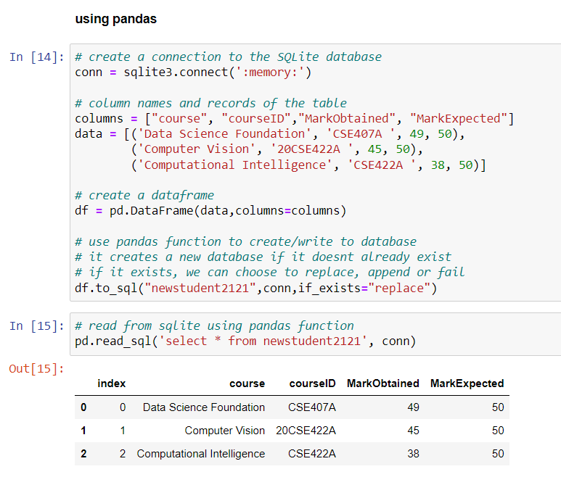

## B2.3 Implement Python code for the task in a parallel system using Celery to obtain square root of a value

Source code:

*# tasks.py*

*from* celery *import* Celery

*import* math

*from* time *import* sleep

app = Celery('tasks', *broker*='redis://localhost:6379/0',

*backend*='redis://localhost:6379/0')

@app.task

def square_root(*value*):

    sleep(5)

*return* f"square root of {*value*} is {math.sqrt(*value*)}"

To run the application

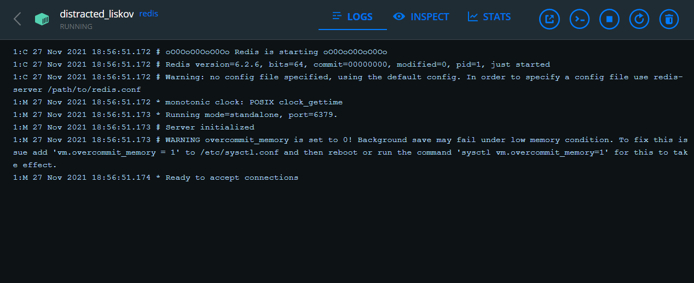

Figure 2 starting redis-server in a docker container

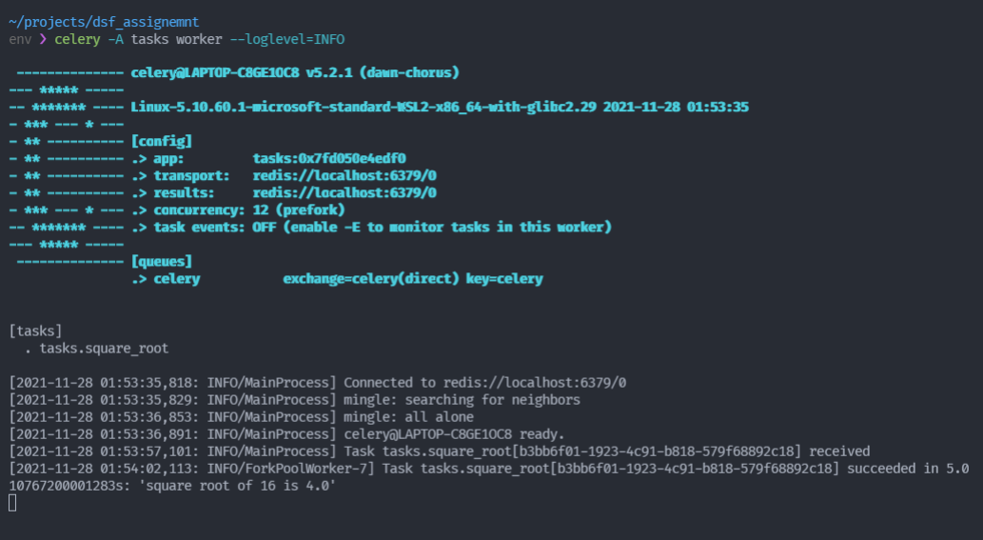

Figure 3 celery worker running and connected to redis-server

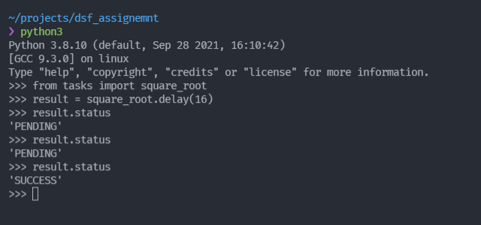

Figure 4 output of tasks.py

## B2.4 Implement Python code for the client and server role in a parallel system using Celery to obtain square root of a value

Source code of server:

*# tasks.py*

*from* celery *import* Celery

*import* math

app = Celery('tasks', *broker*='redis://localhost:6379/0',

*backend*='redis://localhost:6379/0')

@app.task

def square_root(*value*):

*return* f"square root of {*value*} is {math.sqrt(*value*)}"

Source code of client (publisher.py):

*# publisher.py*

*import* sys

*from* celery *import* Celery

app = Celery('tasks', *broker*='redis://localhost:6379/0',

*backend*='redis://localhost:6379/0')

promise = app.send_task('tasks.square_root', *args*=[int(sys.argv[1])])

print(promise.get())

To run the application

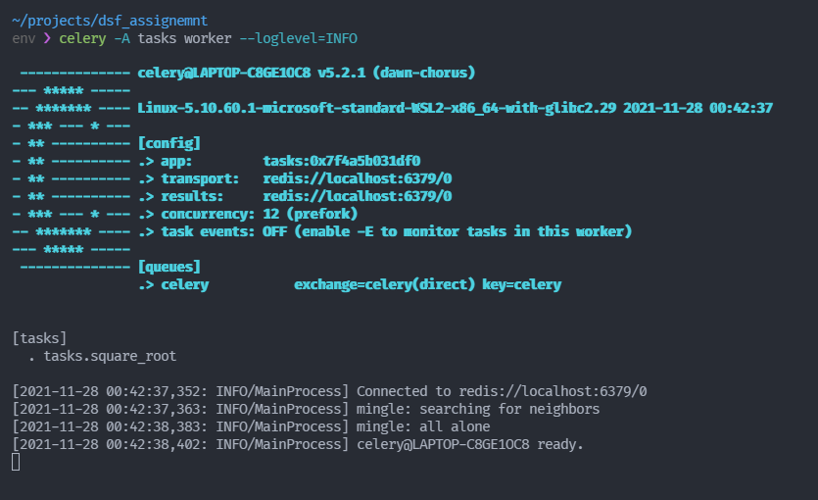

Figure 5 celery worker is running and connected to redis at localhost:6379 which is running in a docker container

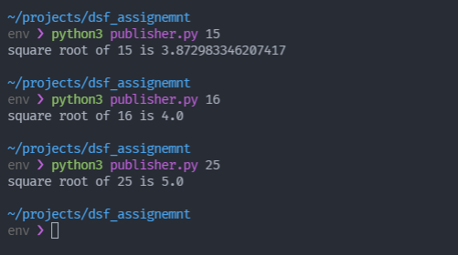

Figure 6 trigger from publisher.py

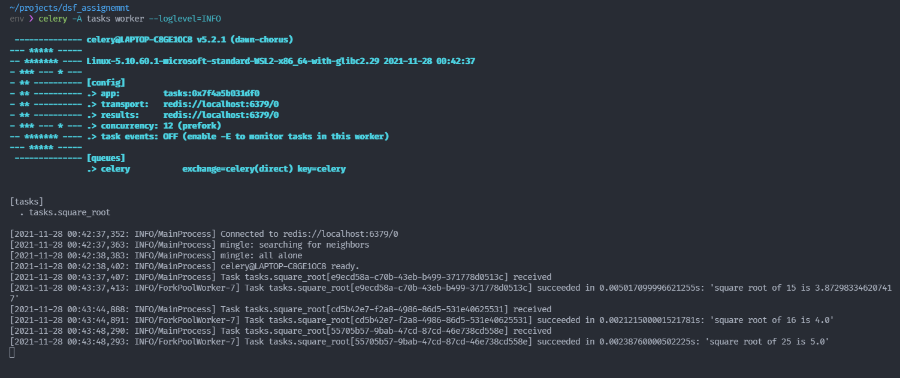

Figure 7 we can see the tasks captured in celery worker

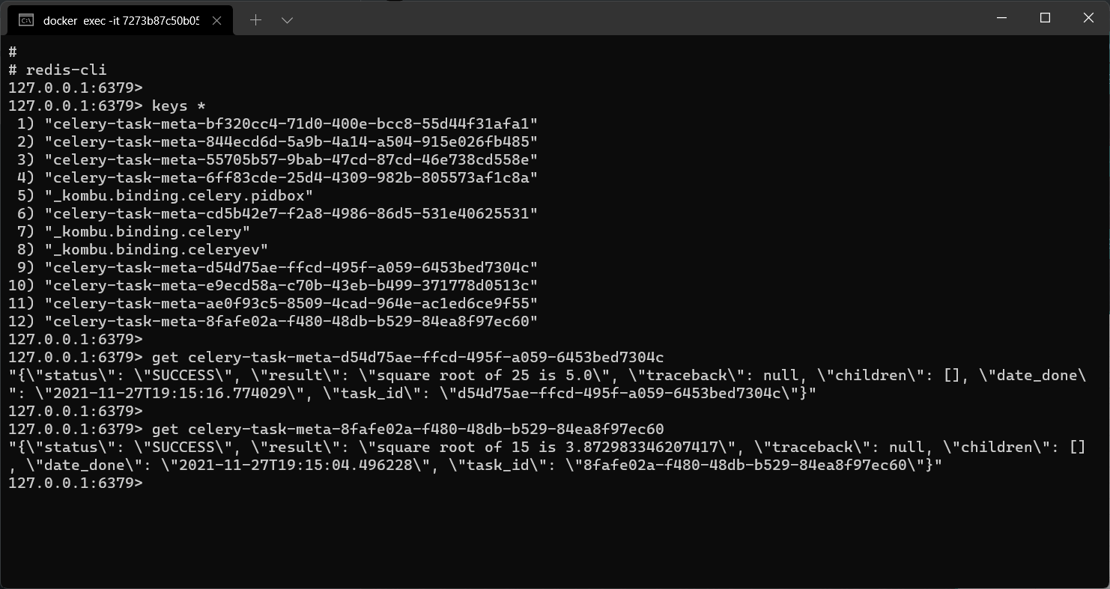

Figure 8 we can check the celery meta data stored in redis database

**Bibliography**

________________________________________________________________________________

1. <https://docs.celeryproject.org/en/stable/getting-started/introduction.html>
2. <https://docs.python.org/3/library/venv.html>
3. <https://pandas.pydata.org/docs/reference/io.html>
4. <https://pandas.pydata.org/docs/reference/api/pandas.read_csv.html>