**<Title Font: Calibri, 20>**

**<Design and Development of Electric Power Assisted Steering for a Sedan>**



**Seminar Member (s)**

**<The following text should have - Font: Calibri, 14>**

|  |  |  |
| --- | --- | --- |
| **Sl. No.** | **Reg. No.** | **Student Name** |
|  |  |  |
|  |  |  |
|  |  |  |
|  |  |  |

**Supervisors:**1. Prof. XXXXXXXXX

2. Mr. XXXXXXXXXX

**Jan/Feb – 2021**

**B. Tech. in Computer Science and Engineering**

**Faculty of ENGINEERING AND TECHNOLOGY**

## M. S. Ramaiah University of applied sciences

### Bengaluru -560 054

## Faculty of engineering and technology



**Certificate**

**<One per student>**

*This is to certify that the Seminar titled “Design and Development of Electric Power Assisted Steering for a Sedan” is a bonafide work carried out in the Department of Computer Science and Engineering by Mr./Ms.____________________bearing Reg. No. __________________ in partial fulfilment of requirements of the Course curriculum of 7th Sem Computer Science and Engineering of Ramaiah University of Applied Sciences.*

**Jan/Feb – 2021**

**(Name of Mentor)**

**Designation**

**Place:**

**Date:**

**Dr. Raghavendra V. Kulkarni Dr. M. Arulanantham**

**Professor and Head – Dept. of CSE Professor and Dean-FET**

# <Heading-1: Calibri, 16>Acknowledgements

1. Acknowledge your academic supervisor
2. Acknowledge all those who have helped you directly or indirectly for the successful completion of your seminar work
3. Acknowledge to HoD and Faculty Dean
4. Remember it is an opportunity to express your gratitude to whomever deemed fit

**<Font: Calibri, 12>**

### Length: Not to exceed one page

# <Heading-1: Calibri, 16>Summary

Complete the Summary in 3 paragraphs each paragraph not exceeding 80 words (1 page)

Paragraph-1:

You need to bring in

* The work you have chosen to do
* Motivation for selecting the Seminar Topic

**Paragraph-2:**

* Scope of the chosen Topic
* Methods and Methodology

Paragraph-3:

* Highlights of the seminar based on analysis and conclusions drawn

<Font: Calibri, 12>

### Length: Not to exceed one page

# <Heading-1: Calibri, 16>Table of Contents

Certificate ……………………………………………………………………………………………………………….…(ii)

Acknowledgements……………………………………………………………..…………………………………….(iv)

Summary …………………………………………………..……………………………………………………………..…(v)

Table of Contents………………………………………….……………………………………………………..…. (vi)

List of Tables……………………………………………….………………………………………………………..…..(x)

List of Figures……………………………………………………………………………………..………………….…(xi)

Nomenclature………………………………………………………………………………………………………….(xii)

Abbreviations and Acronyms……………………………………………………………………………..……(xiii)

Chapter-1: Introduction………………………………………………………..…………..………………………01 (1 Page)

Preamble to the Chapter

* 1. Heading 2………………………………………………………………………………………..……...02
  2. Heading 2…………………………………………………………………………………..…………...03

Chapter-2: Background Theory (1 Page)

Preamble to the Chapter

2.1 Background Theory to be Written in Various Sub-Sections

(Read books and survey papers on your domain and summarize with citations)

Chapter-3:Aim and Objectives (1 Page)

Preamble to the Chapter

3.1 Title of the Seminar

3.2 Aim of the Seminar

3.3 Objectives of the Seminar

Chapter-4: Discussion and Results (Not more than 10 Pages)

Preamble to the Chapter

* 1. Introduction to Topic
  2. Material Segment 1
  3. Material Segment 2
  4. Material Segment 3
  5. Material Segment 4
  6. Material Segment 5
  7. ……

Chapter-5: Conclusions and Suggestions for Future Work

Preamble to the Chapter

5.1 Conclusion

5.2 Suggestion

References

Appendices**<Font: Calibri, 12>**

# <Heading-1: Calibri, 16>List of Tables

A typical List of Tables content page looks like this

<Font: Calibri, 12>

Table 1.1 Title of the table……………………………………………………10

Table 2.1 Title of the table……………………………………………………14

…

…

Table 5.1 …………………………………

How to represent a table:

Table number, Table title, Units of the parameters are important

**Table 2.1 Enthalpy of formation of some common elements and compounds**

|  |  |  |  |
| --- | --- | --- | --- |
| **Sl. No.** | **Species** | **Reaction** | **State** |
|  |  |  |  |
|  |  |  |  |
|  |  |  |  |
|  |  |  |  |
|  |  |  |  |

**<Heading-1: Calibri, 16>**List of Figures

**________________________________________________________________________**

Figure 1.1 Title of the figure……………………………………………………..11

Figure 1.2 Title of the figure………………………………..

Figure 1.* …………………………………………………………..

Figure 2.1 ………………………………………………………….

Figure 3.1 …………………………………………………………

Figure 4.1 ……………………………………….

**How to represent a figure**

# <Heading-1: Calibri, 16>Nomenclature

**Figure 2.7 Levels of functionality required for control systems**

**<Font: Calibri, 12>**

*A* Acceleration (m/s2)

*F* Force (N)

*T* Temperature (K)

*t* Temperature (oC)

N Speed (RPM)

DOF Degrees of Freedom

*W* Track Width (m)

**<Font: Calibri, 12>**

**<Heading-1: Calibri, 16>Abbreviation and Acronyms**

**________________________________________________________________________**

DEA Data Envelopment Analysis

DMU Decision Making Unit

(To be filled in alphabetical order)

**<Font: Calibri, 12>**

# <Heading-1: Calibri, 16>1. Introduction

Preamble to the Chapter

**1.1 Introduction should address the following:<Heading-2: Calibri, 12>**

* Interesting research issues that the proposed project plans to explore with citations if applicable
* Brief preview to facilitate recognition and appreciation of core theme or the central focus of the project. Explain the scope of your effort here.
* Succinct and yet informative explanation for quick establishment of the significance of the proposed project
  + 1. **Sub Heading <Heading-3: Calibri, 12>**

* Heading and sub-heading can be highlighted in bold
  + 1. **Organization of the report <Heading-3: Calibri, 12>**
* Summarize each of the following chapters of the report, each in a single para of 4-8 lines

**<Font: Calibri, 12>**

# <Heading-1: Calibri, 16>2.Background Theory

Preamble to the Chapter

**2.1 Background Theory (or Theoretical basis) on ‘Project Topic’ should comprise of:**

* Need to discuss related work at start to set scene
* Principles and Assumptions
* Understanding of key definitions and its implications
* Standard Formulae, units and relation between important parameters
* Merits, Demerits and Applicability
* Relative comparison with peripheral topics
* Need to discuss related work at end to demonstrate your originality

**<Font: Calibri, 12>**

# <Heading-1: Calibri, 16>3. Aim and Objectives

**This chapter should contain the following:**

Preamble to the Chapter

* **Title**
* Title of the Seminar
* **Aim**
* Defined aim
* **Objectives**
* Defined objectives
* **Methods and Methodology/Approach to attain each objective**

|  |  |  |  |
| --- | --- | --- | --- |
| **Objective No.** | **Statement of the Objective** | **Method/ Methodology** | **Resources Utilised** |
| 1 |  |  |  |
| 2 |  |  |  |
| 3 |  |  |  |
| 4 |  |  |  |
| 5 |  |  |  |

**<Font: Calibri, 12>**

# heading-1: Calibri, 16> 4 Discussion and Results

Preamble to the Chapter

**Discussion:**

**<The actual right up of Seminar will come here.>**

**Presentation of results can be through:**

* Tables
* Graphs and Contours
* Photographs
* Can be any of the three or all
* Justification of Realisation of Objectives
* Relevant Discussions
* Propose Recommendations with substantiation

Results be interpreted and trends be explained based on stated principles

**<Font: Calibri, 12>**

# Heading-1: Calibri, 16>

# 5. Conclusions and Suggestions for Future Work

Preamble to the Chapter

**References**

**For the Project work, Harvard referencing style must be followed:**

* List of references be arranged in an alphabetical order

**Format of Referencing**

**[Referring a Journal Paper]**

1. Nakayama, W. and Nakajima, T. (1982) Effects of Pore Diameters and System Pressure on Saturated Pool Nucleate Boiling Heat Transfer from Porous Surfaces, *J. Enhanced Heat Trans.*, 104(2), pp. 286-291.

**[Referring a Book]**

1. Nield, D.A. and Bejan, A. (2005) *Convection in Porous Media*, New York: Springer-Verlag.

**[Referring a Edited Book]**

1. Yang, W. and Kim, J.H. (1992) *Rotating Machinery*, New York: Begell House.

**[Referring a Chapters of Edited Book]**

1. Nishikawa, K., Ito, T. and Eds (1982) Augmentation of Nucleate Boiling Heat Transfer by Prepared Surfaces, In Mizushima T. and Yang W.J., Eds., *Heat Transfer in Energy Problems*, Washington, D.C.: Hemisphere Publishing, pp. 1111-1182.

**[Referring a E-Book]**

1. Buyevich Yu, A. and Alexandrov, D.V. (2005) *Heat Transfer in Dispersons*, Connecticut: Begell House, Available at http://www.edata-center.com/ebooks/b7f98f1e271b3e77a.html/ E-Books [accessed 5 May 2005].

**[Referring a Conference Proceedings]**

1. Ma, T.M. (1987) Effects of Geometrical Shapes of Reentrant Grooves on Boiling Heat Transfer from Porous Surfaces, Heat Transfer 1986, *Proc. of 8th Intl. Heat Trans. Conf.*, Vol. 4, pp. 2013-2018.

**[Referring a Dissertation]**

1. Richmond, J. (2004) *Steady State Thermal Conductivity*, PhD Thesis, University of Connecticut.

**[Referring a White Paper]**

1. Bettencourt, S. and Anderson, J.L. (1990) Pen-Reared Salmonid Aquaculture in the Northeastern United States, U.S. Department of Agriculture, Northeast Regional Aquaculture Center Report 100. Kingston, RI.

**[Referring Standards]**

1. ASME, (1996) Scheme for the Identification of Piping Systems, ASME Standard A13.1.

**[Referring a Manual]**

1. Ricardo Software Company, (2005) VECTIS Help Manual, VECTIS Help Centre v3.9.2.

**[Referring Webpages]**

1. Nonperiodical Web Document - Author A.A., Author B.B., (Year of publication) *Title of document*. Retrieved month day, year, from http://Web address.
2. Chapter or Section of a Web document - Author A.A., Author B.B., (Year of publication) *Title of article, In Title of book or larger document* (chapter or section number), Retrieved month day, year, from <http://www.someaddress.com/full/url/>
3. Online Scholarly Journal Article - Author A.A., Author B.B., (Year of publication) Title of Article, *Title of Journal*, volume number, Retrieved month day, year, from <http://www.someaddress.com/full/url/>

**[Referring a Patent]**

1. Vladimir, E. S. (1996) Light Duty Box Wing Aeroplane, US Patent No. 5503352, available at www.freepatentsonline.com/5503352.pdf, April 2, 1996.

**Appendix**

**Appendix-A**

Any material, which is important but affects the flow of your writing can be brought under Appendix.

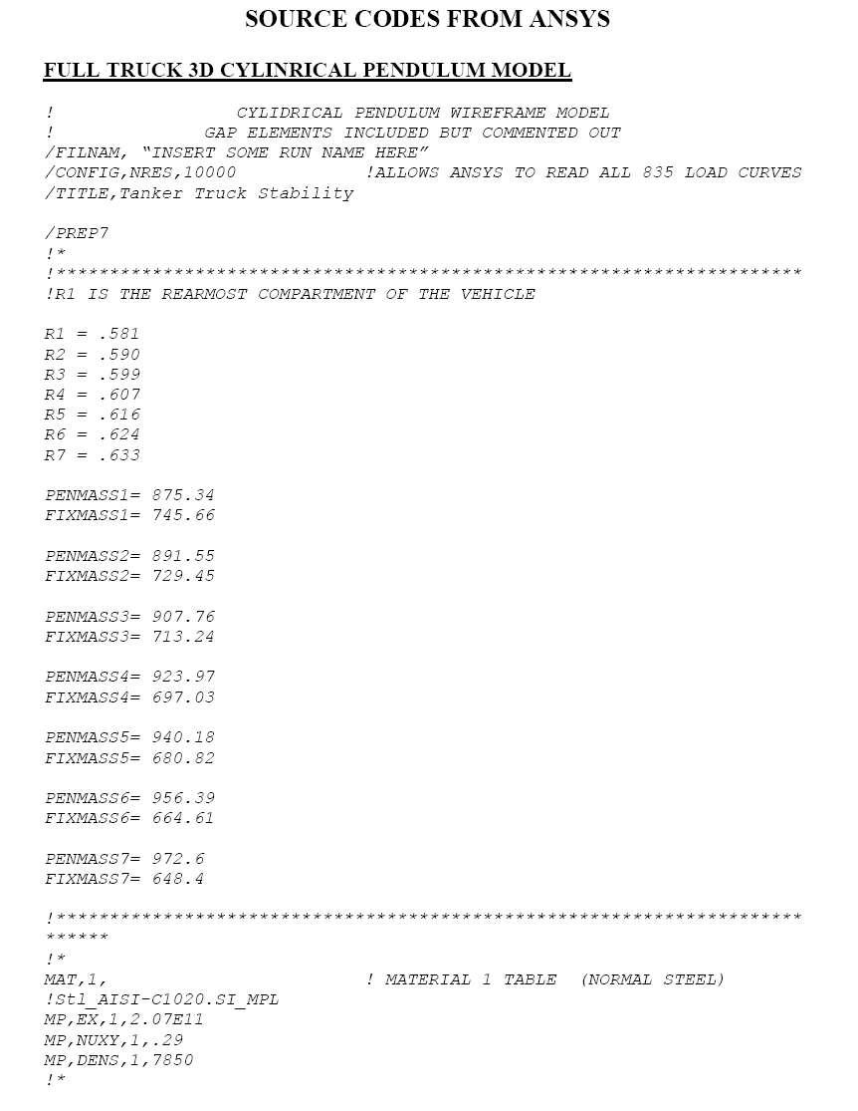

General Guidelines

1. A good project report can be written only if you have good piece of work
2. A good piece of work will be ignored if not presented properly
3. Remember –you are writing it because you want others to read
4. If you do not use sufficient care in writing, one will doubt whether you have taken good care in your work either
5. Use clear and short sentences and write in third person. Avoid using bombastic words or jargons
6. All the assumptions and input data should be documented
7. It should be possible to reproduce your computations/experiments by others using your dissertation.
8. Use British English-spelling
9. Units and consistency in the use of units is important. Use only SI Units
10. Use A4 white sheet (bond paper) for printing your seminar report. Use font size of 12, Calibri, sub-headings can be of same font size but bold
11. Margins should be as shown in the figure

