**Development of Login and Registration Feature using Auth0 and Microsoft Identity.  
  
Introduction:**

**Auth0:** It is a popular identity and access management (IAM) platform that provides solutions for authentication, authorization, and user management in web and mobile applications. It aims to simplify the process of adding secure user authentication and authorization to your applications, saving developers time and effort in implementing these critical functionalities.

**Key features and components of Auth0 include:**

1. **User Authentication:** Auth0 supports various authentication methods, including social logins (like Google, Facebook, and Twitter), username/password authentication, and multi-factor authentication. Developers can integrate Auth0 to enable users to sign up, log in, and manage their accounts securely.
2. **Authorization:** Auth0 helps manage user permissions and access control in applications. It supports role-based access control (RBAC) and fine-grained authorization policies, allowing developers to control what users can and cannot access within their applications.
3. **Identity Providers:** Auth0 integrates with numerous identity providers, allowing users to authenticate using their existing credentials from platforms such as Google, Microsoft, and others. This reduces the need for users to create new accounts for each application.
4. **Security Features:** Auth0 is designed with security in mind, providing features such as secure password storage, encryption, and protection against common security threats like cross-site scripting (XSS) and cross-site request forgery (CSRF).
5. **Single Sign-On (SSO**): Auth0 supports Single Sign-On, allowing users to log in once and access multiple applications without having to re-enter their credentials. This enhances the userexperience and simplifies authentication across different services.
6. **Customization and Branding:** Developers can customize the appearance and branding of the authentication pages to maintain a consistent user experience that aligns with their application's design.
7. **Analytics and Reporting:** Auth0 provides analytics and reporting tools to monitor user activity, track login attempts, and gain insights into the application's security and usage.
8. **Developer-Friendly APIs and SDKs:** Auth0 offers APIs and Software Development Kits (SDKs) for various programming languages, making it easy for developers to integrate and use Auth0 in their applications.
9. **Extensibility:** Auth0 allows developers to extend its functionality through custom scripts, hooks, and rules, providing flexibility in meeting specific business requirements.

**Microsoft Identity**: It refers to the set of services and technologies provided by Microsoft to manage and secure digital identities in applications and services. Microsoft's identity platform encompasses a range of tools, services, and standards designed to help developers integrate authentication, authorization, and user management into their applications.

**Key components of Microsoft Identity include:**

**Azure Active Directory (Azure AD):** Azure AD is Microsoft's cloud-based identity and access management service. It serves as the backbone for authenticating and authorizing users in applications and services. Azure AD supports various authentication methods, including username/password, multi-factor authentication, and integration with external identity providers.

**Microsoft Authentication Library (MSAL):**MSAL is a set of libraries and APIs that developers can use to integrate Microsoft Identity into their applications. MSAL supports multiple platforms and programming languages, including .NET, JavaScript, Python, and more.

**Azure AD B2C (Business to Consumer):** Azure AD B2C is a specialized service within Azure AD that focuses on providing identity and access management solutions for consumer-facing applications. It allows developers to build applications that can handle user authentication and authorization for a large number of external users.

**Azure AD B2B (Business to Business):** Azure AD B2B enables organizations to securely share their applications and services with external partners. It allows guest users to access resources within an organization's Azure AD, extending collaboration while maintaining security.

**Microsoft Graph API:** Microsoft Graph API provides a unified programmability model to access a wide range of Microsoft 365 services, including user and group management, calendar, emails, and more. It allows developers to leverage identity information and other Microsoft services in their applications.

**Identity Providers:** Microsoft Identity supports integration with various identity providers, including social identity providers (Microsoft Account, Google, Facebook) and other enterprise identity providers. This enables users to sign in using their existing credentials.

**Identity Security and Compliance:** Microsoft Identity includes features and tools for enhancing the security of identities, such as conditional access policies, Identity Protection, and reporting tools. These help organizations monitor and respond to potential security threats.

**Active Directory (On-Premises):** While Azure AD is cloud-based, Microsoft Identity also includes the traditional on-premises Active Directory. Organizations can use a combination of Azure AD and on-premises AD to manage identities across both cloud and on-premises environments.

**Objective*:* This report outlines the comprehensive setup process of Auth0 and Microsoft Identity for integrating authentication into a web application, including key configurations and steps required to achieve seamless integration.**

**1. Auth0 Setup Process:**

**Step 1: Create an Auth0 Account**

1. Visit the Auth0 website (<https://auth0.com/>) and sign up for an account.

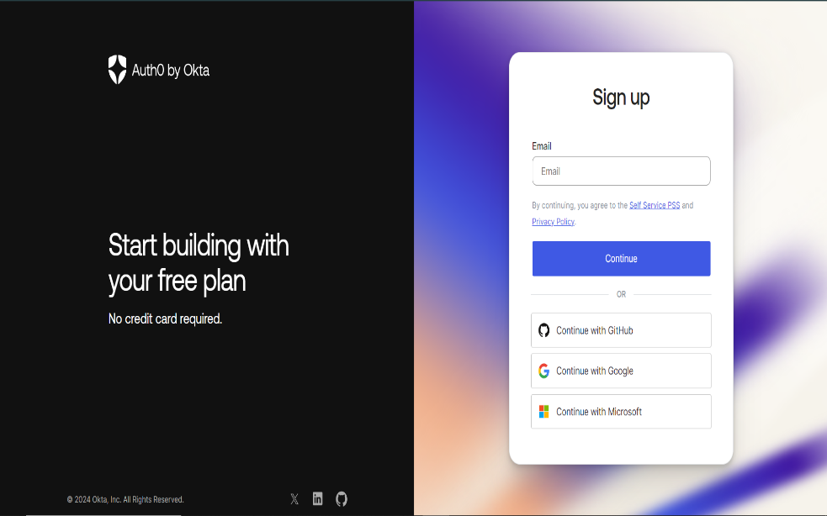

1. Upon successful registration, log in to the Auth0 Dashboard.

**Step 2: Create a New Application in Auth0**

1. In the Auth0 Dashboard, navigate to the "Applications" tab.
2. Click on "Create Application" and choose the type of application (e.g., Single Page App, Regular Web App) 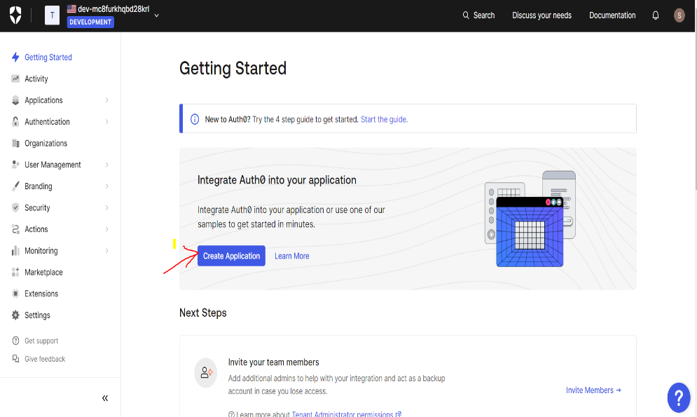.

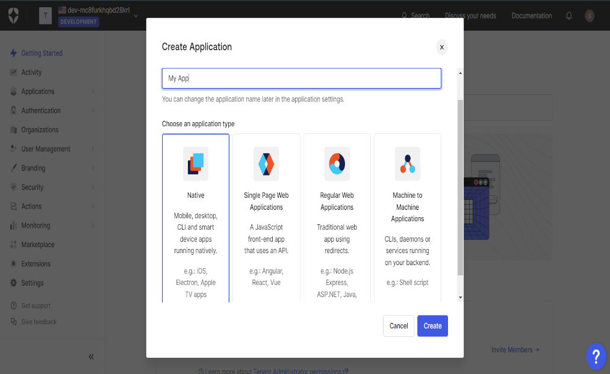

1. Configure application settings, such as name and allowed callback URLs.

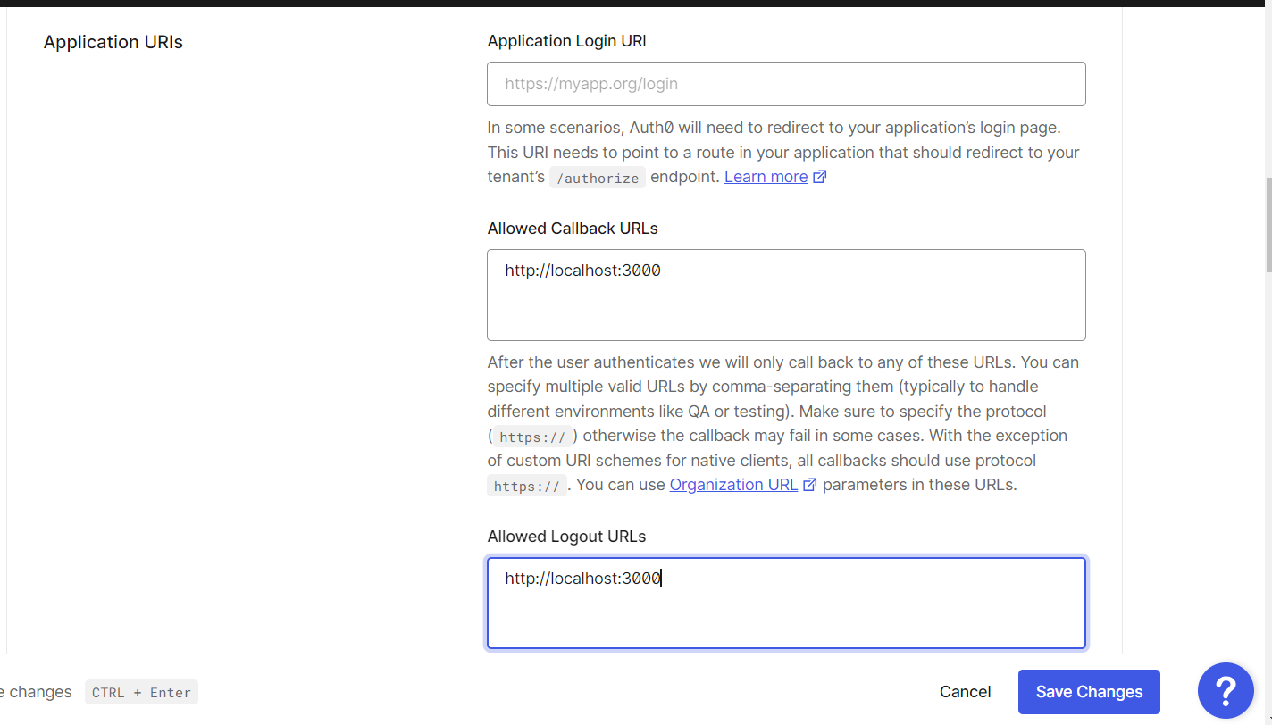

**Step 3: Obtain Auth0 Credentials**

1. After creating the application, go to the "Settings" tab.
2. Note down the "Client ID" and "Client Secret" – these credentials are crucial for the web application configuration.

**2. Microsoft Identity Setup Process:**

**Step 1: Access the Azure Portal**

1. Log in to the Azure portal (<https://portal.azure.com/>).

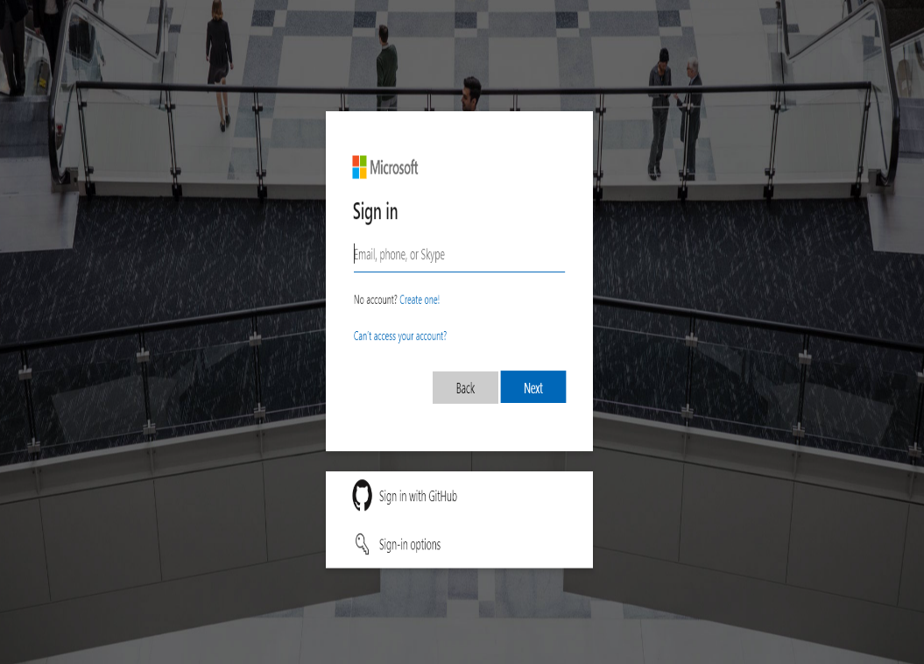

**Step 2: Create a New App Registration in Azure AD**

1. Navigate to "Azure Active Directory" > "App registrations."

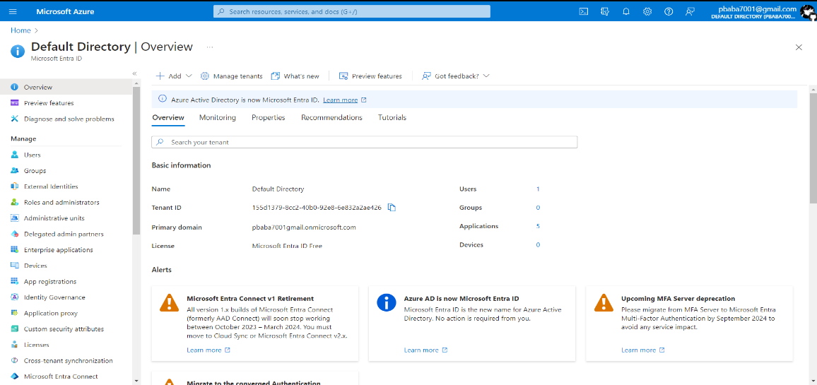

1. Click on "New registration" and fill in required details (e.g., Name, Supported account types).  
   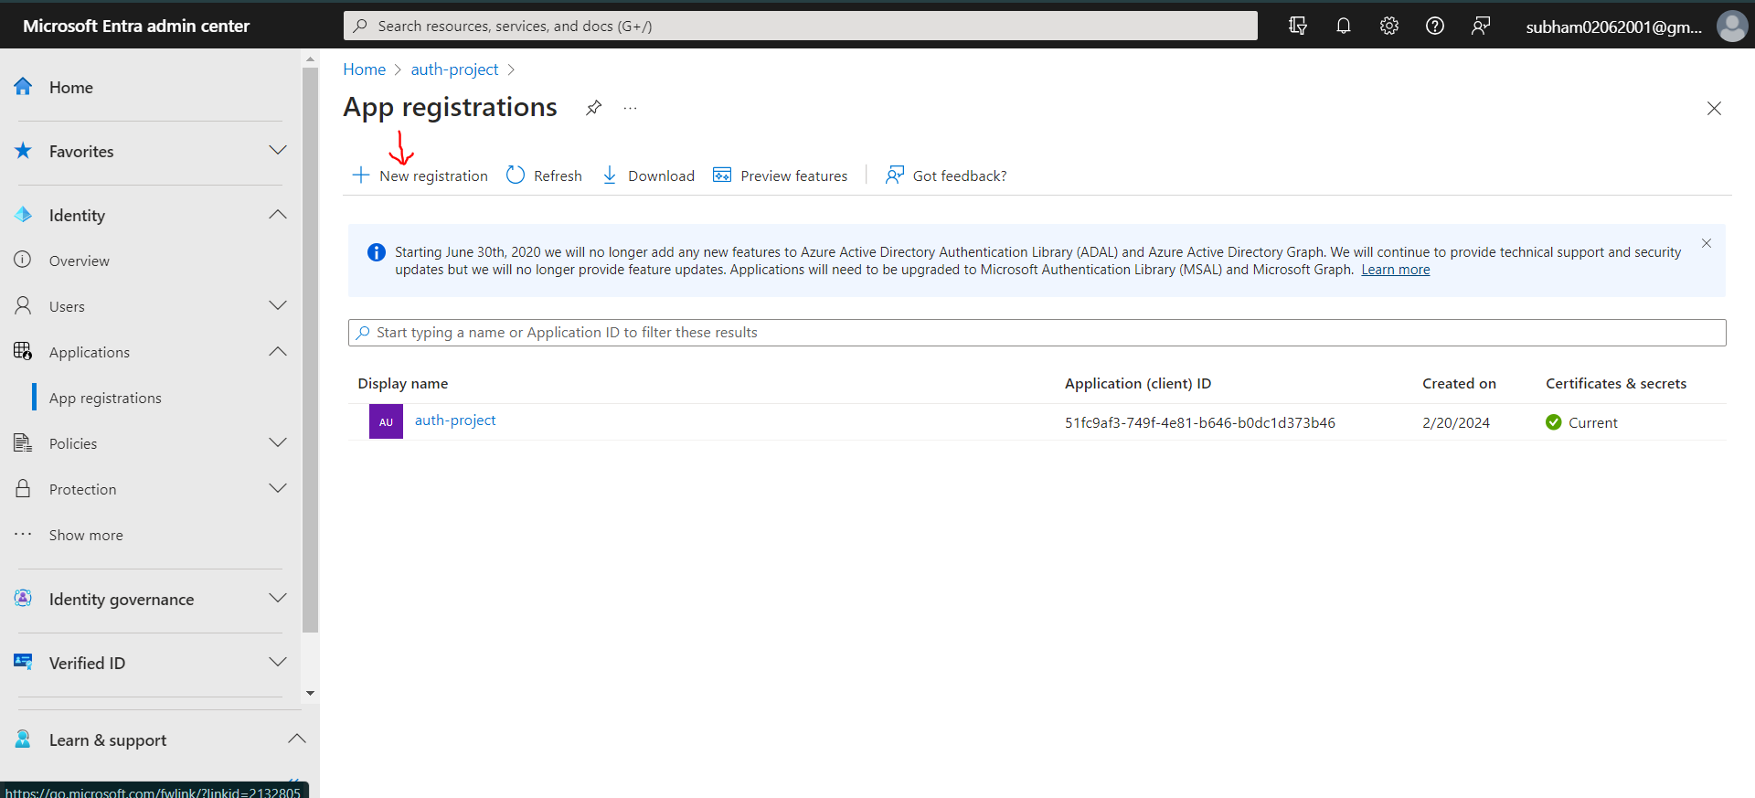
2. Note down the "Application (client) ID" and "Directory (tenant) ID" upon registration.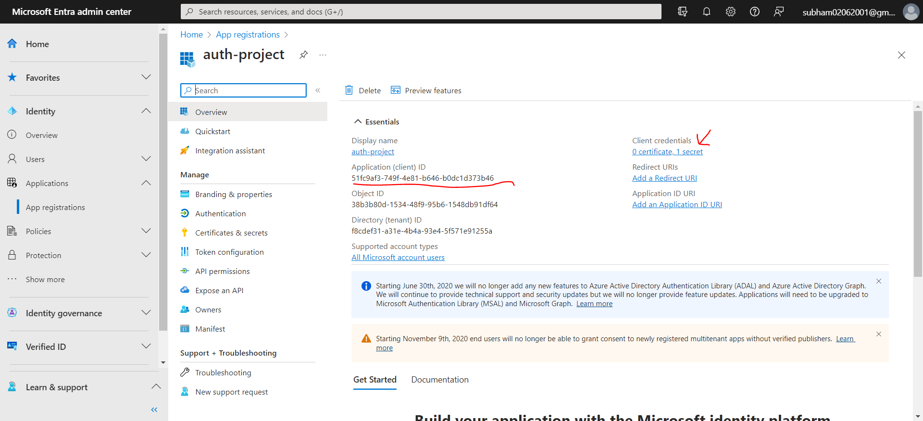

**Step 3: Generate Client Secret**

1. In the App Registration settings, go to "Certificates & Secrets."
2. Create a new client secret and note down the generated secret value.

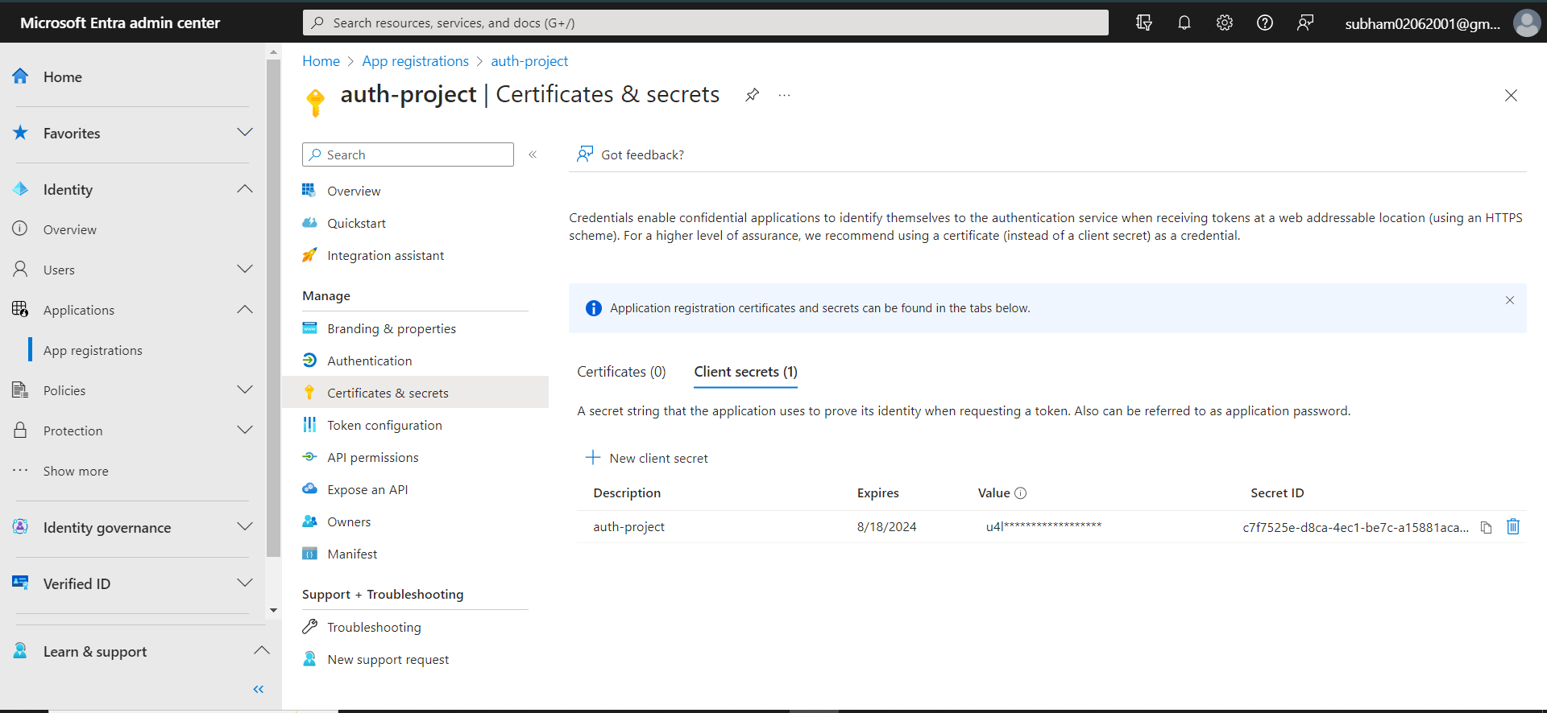

**Step 4: Configure Authentication Redirect URIs**

1. Under App Registration in the Azure portal, navigate to "Authentication."

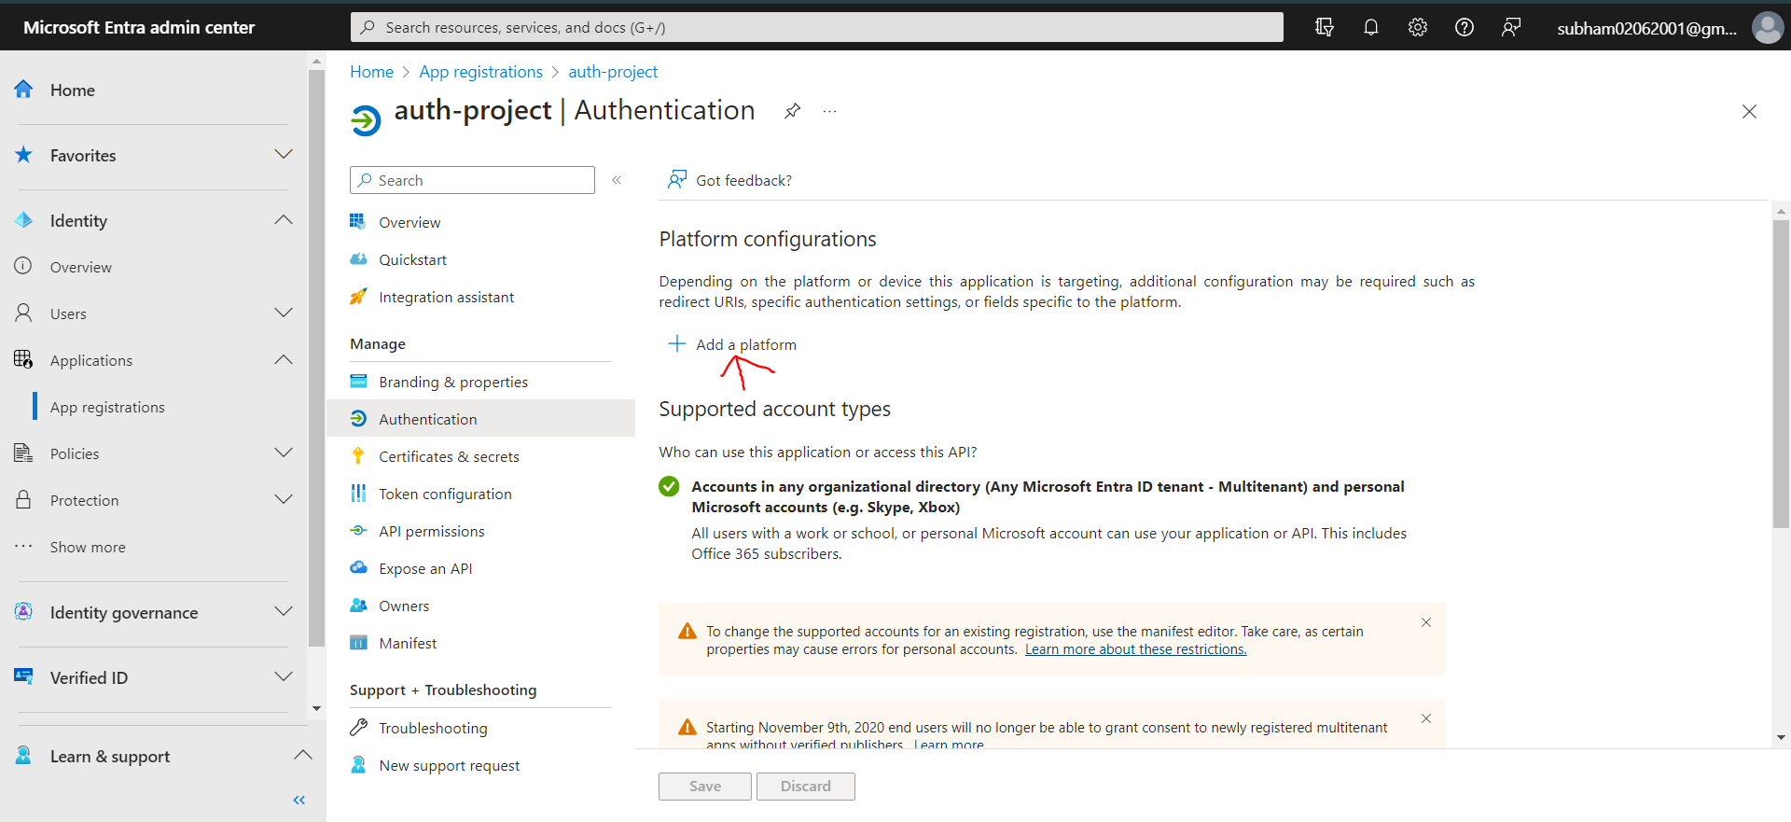

1. Configure the redirect URIs where Microsoft will send authentication responses 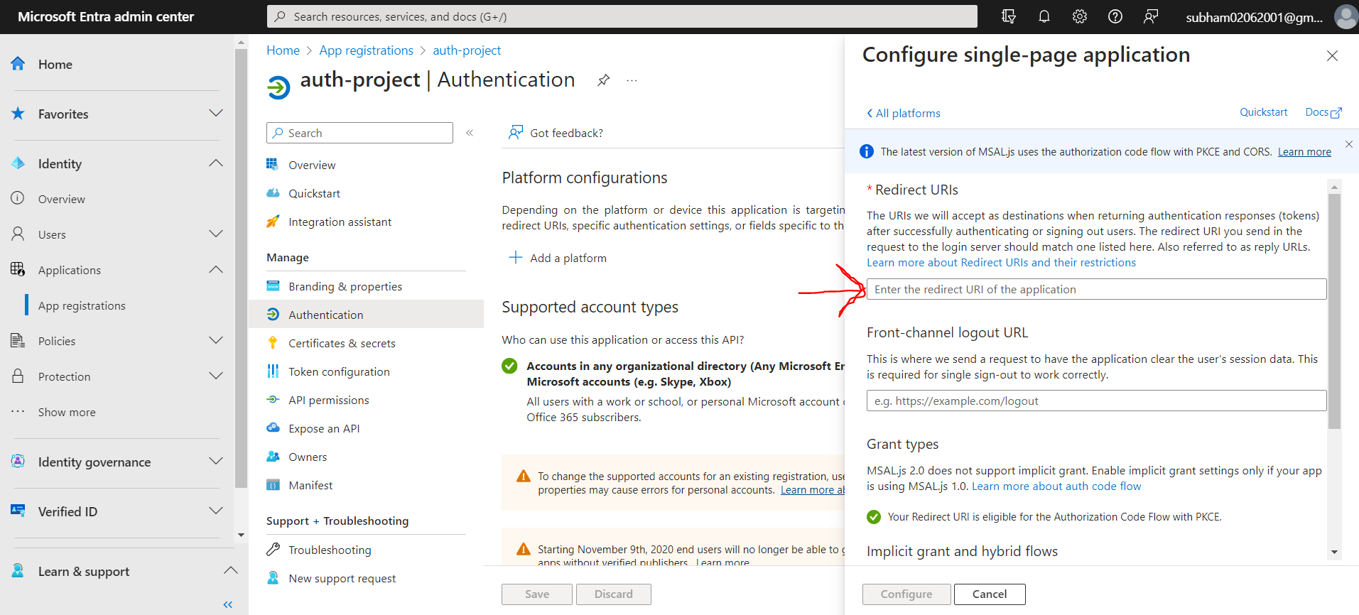

**Step 5: Configure Microsoft Identity in Auth0**

1. Return to the Auth0 Dashboard.
2. Navigate to "Authentication" > "Social" > "Microsoft."

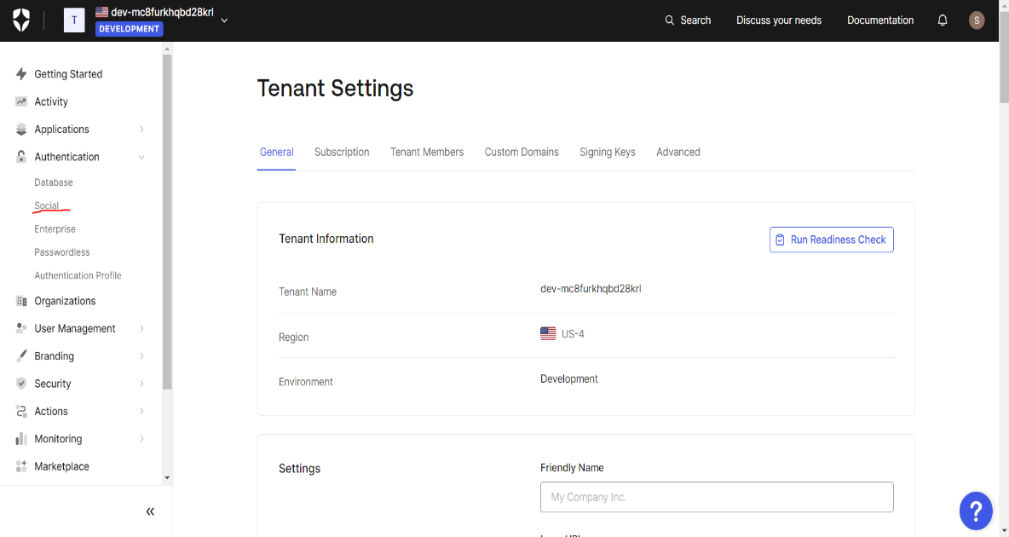

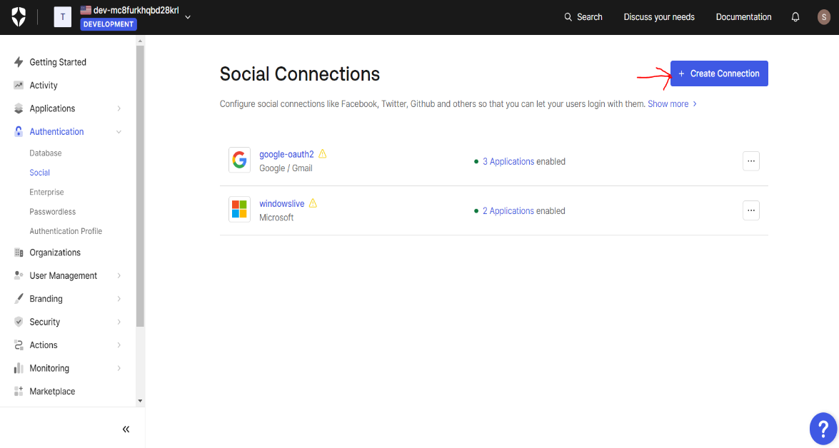

1. Enable the Microsoft connection and provide the Application (client) ID, Directory (tenant) ID, and Client Secret obtained from Azure.

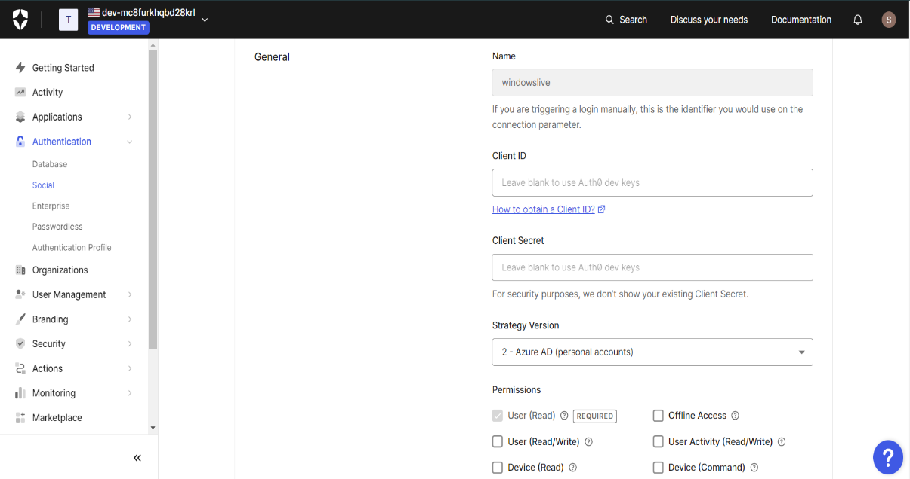

**Step 6: Test Connection in Auth0**

1. Use the Auth0 Dashboard to test the Microsoft connection to ensure successful integration**.**

**Key Configurations for Auth0:**

1. **Client ID:**
   * *Definition:* The Client ID is a unique identifier assigned to each Auth0 application.
   * *Purpose:* It serves as a public identifier for the application and is used during the authentication process to associate the request with the correct Auth0 application.
   * *Implementation:* Developers need to include the Client ID in the application's configuration to establish a secure connection with Auth0.
2. **Client Secret:**
   * *Definition:* The Client Secret is a confidential key known only to the application and Auth0.
   * *Purpose:* It is used to authenticate the application with Auth0 during the process of obtaining tokens. This ensures that only authorized applications can interact with Auth0 on behalf of the users.
   * *Implementation:* Developers must securely store and manage the Client Secret on the server-side, preventing exposure to unauthorized entities.
3. **Allowed Callback URLs:**
   * *Definition:* These are the URLs to which Auth0 can redirect users after successful authentication.
   * *Purpose:* Specifying allowed callback URLs prevents attackers from redirecting users to malicious endpoints after authentication. It ensures that the authentication response is directed only to trusted locations.
   * *Implementation:* Developers configure these URLs in the Auth0 Dashboard to define the valid callback destinations for their application.

**Key Configurations for Microsoft Identity:**

1. **Application (client) ID:**
   * *Definition:* The Application ID (also known as the Client ID) is a unique identifier assigned to an application registered in Azure Active Directory (Azure AD).
   * *Purpose:* It uniquely identifies the application when interacting with Microsoft Identity services, establishing a connection between the application and the Azure AD instance.
   * *Implementation:* Developers obtain this ID from the Azure portal after registering their application.
2. **Directory (tenant) ID:**
   * *Definition:* The Directory ID (also known as the Tenant ID) is a unique identifier for the Azure AD tenant associated with the application.
   * *Purpose:* It specifies the Azure AD instance to which the application belongs, ensuring correct routing of authentication requests within the specified tenant.
   * *Implementation:* Developers retrieve this ID from the Azure portal after registering the application, and it is used as a parameter in authentication requests.
3. **Client Secret:**
   * *Definition:* The Client Secret is a secure key used for authenticating the application with Azure AD.
   * *Purpose:* It ensures that only authorized applications can request tokens and access resources on behalf of users. It acts as a shared secret between the application and Azure AD.
   * *Implementation:* Developers generate a Client Secret in the Azure portal during the application registration process, and it must be securely stored on the server-side.

**Integrating Auth0 with Microsoft Identity involves several steps to ensure a seamless and secure authentication process. Here's a detailed guide on the steps required:**

**1. Create an Auth0 Account and Application:**

* Sign up for an Auth0 account if not already done.
* In the Auth0 Dashboard, create a new application.
* Note down the Client ID and Client Secret provided by Auth0 for the application.

**2. Set Up Microsoft Identity in the Azure Portal:**

* Log in to the Azure portal (<https://portal.azure.com/>).
* Navigate to "Azure Active Directory" > "App registrations."
* Create a new app registration for your application.
* Note down the Application (client) ID, Directory (tenant) ID, and create a Client Secret.

**3. Configure Authentication Redirect URIs:**

* In the Azure portal, under your app registration, navigate to "Authentication."
* Configure the Redirect URIs where Microsoft Identity will send authentication responses. Ensure these match the callback URLs configured in Auth0.

**4. Configure Microsoft Identity in Auth0:**

* In the Auth0 Dashboard, navigate to "Connections" > "Social" > "Microsoft."
* Enable the Microsoft connection.
* Provide the Application (client) ID, Directory (tenant) ID, and Client Secret obtained from the Azure portal.

**5. Test the Connection:**

* Use the Auth0 Dashboard to test the Microsoft connection to ensure successful integration.
* Verify that authentication requests initiated by Auth0 are correctly processed by Microsoft Identity.

**6. Update Web Application Configuration:**

* In your web application's authentication configuration, set Auth0 as the primary authentication provider.
* Ensure the application is configured to redirect users to Auth0 for authentication.

**7. Implement Login and Registration UI:**

* Develop the frontend interfaces for login and registration within your web application.

**App.js**

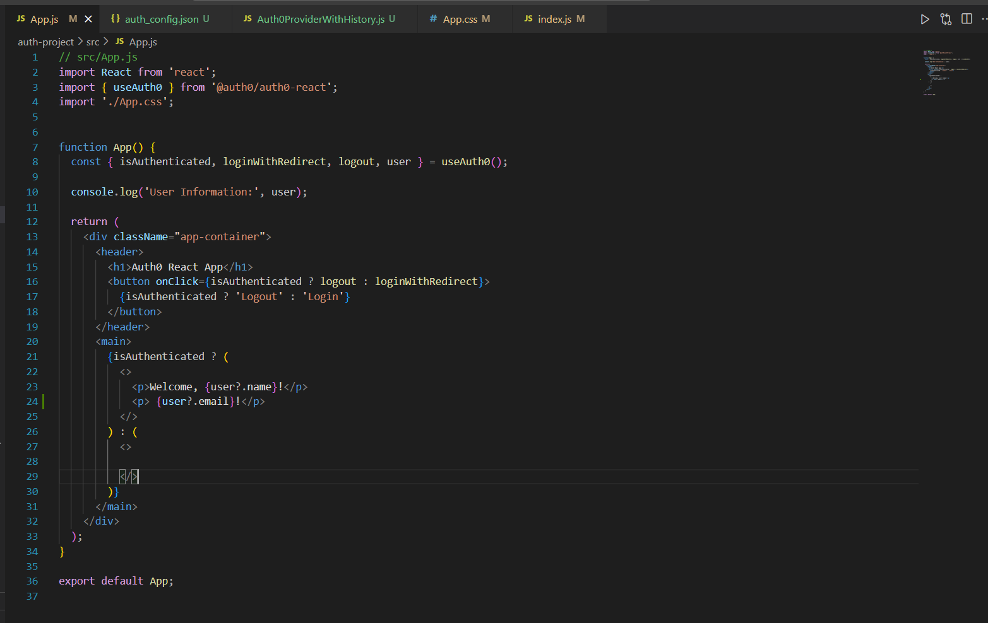  
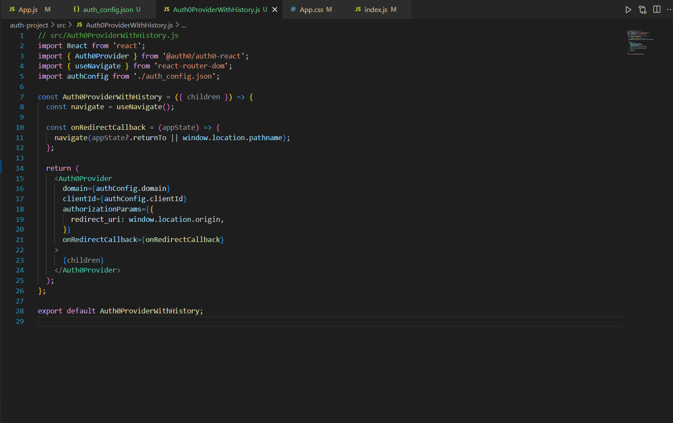

**AuthProviderHistory.js**

**Index.js**

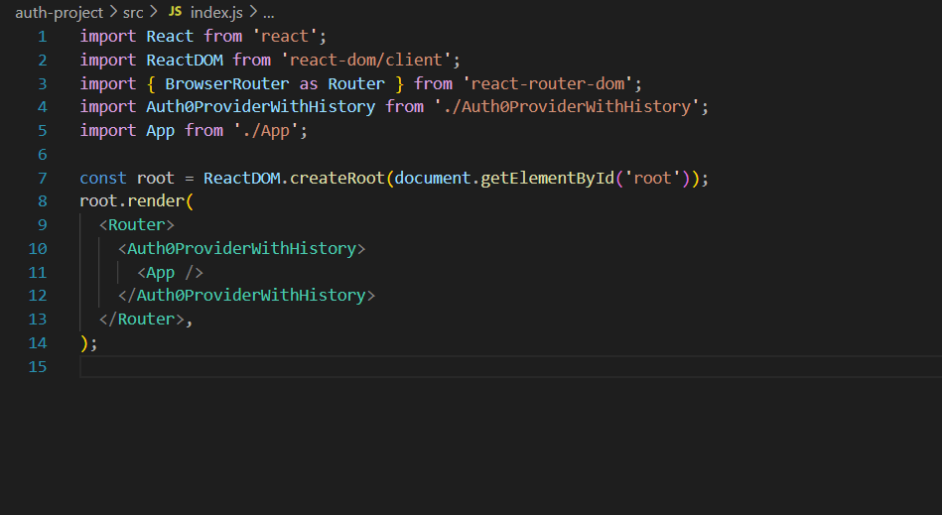

**auth_config.json**

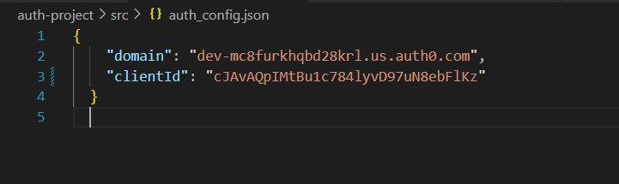

**UI**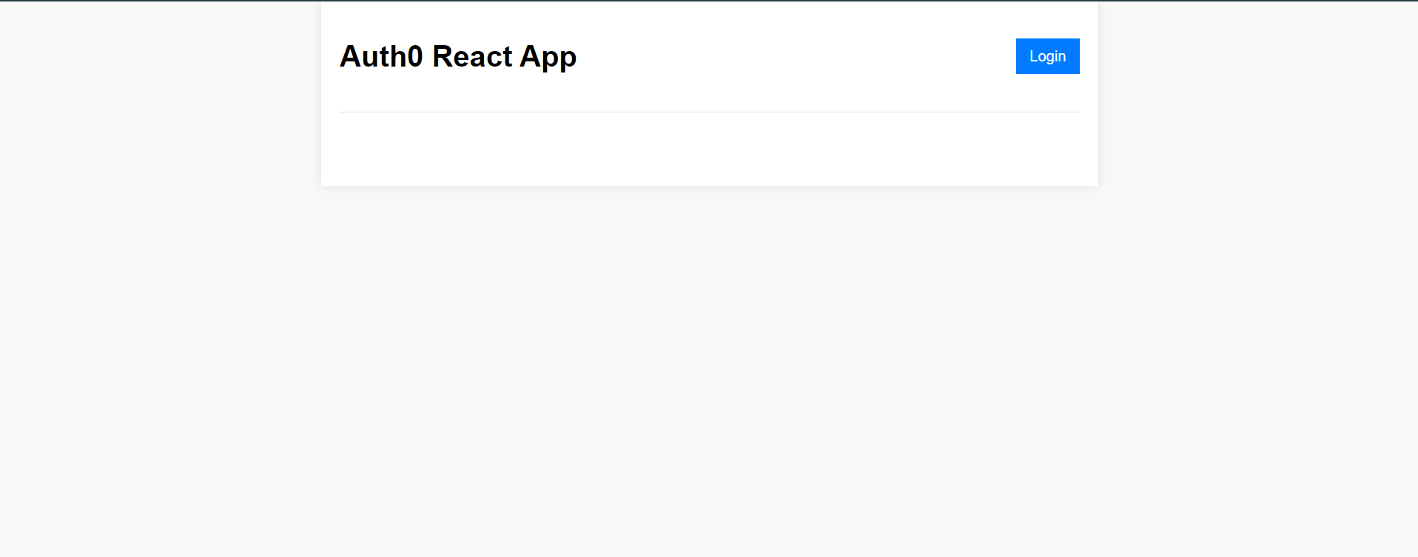

* Implement logic to initiate the authentication flow when users attempt to log in or register.

**8. Securely Manage Auth0 and Microsoft Identity Tokens:**

* Implement logic on the server-side to securely handle and validate the tokens received from Auth0 and Microsoft Identity during the authentication process.

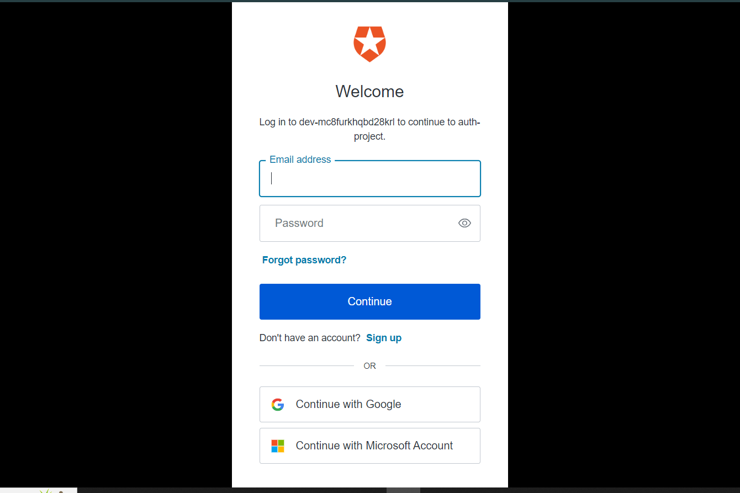

* Use these tokens to identify and authorize users within your application.

**9. Test the End-to-End Flow:**

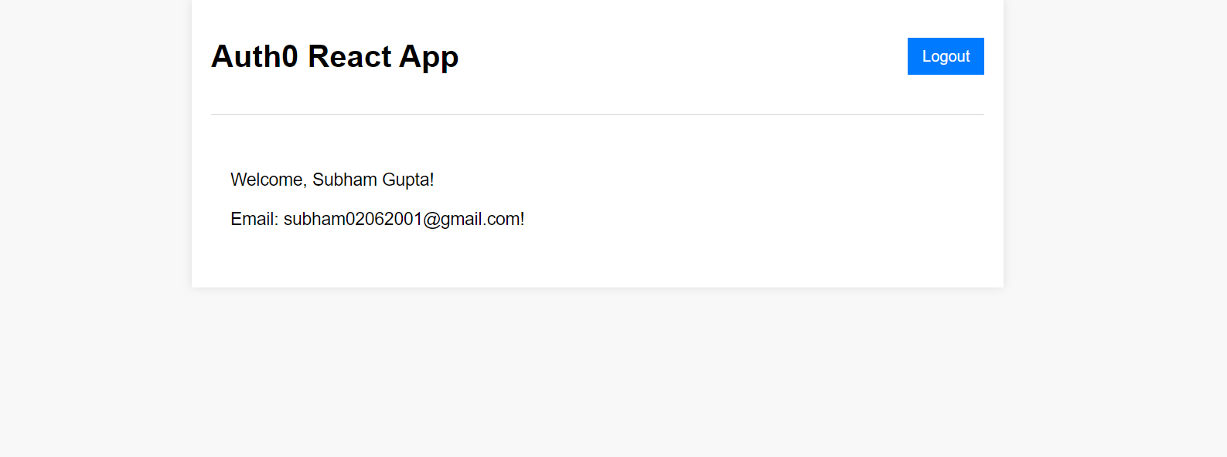

* Test the entire authentication flow from your web application, including login, registration, and logout.
* Ensure that users can successfully authenticate using their Microsoft accounts.

**10. Document the Configuration:**

* Document the key configurations, including Client IDs, Client Secrets, and Redirect URIs for both Auth0 and Microsoft Identity.
* Maintain detailed documentation for future reference and for onboarding new developers.

**11. Prepare for Production:**

* Ensure that the application is configured securely for production use.
* Monitor and manage any necessary updates or changes to configurations.

**Conclusion:** In conclusion, successfully setting up Auth0 and Microsoft Identity for our web application's authentication is a big achievement. This process ensures that our authentication solution is both secure and user-friendly. We went through detailed steps, configuring essential elements like Client IDs, Client Secrets, and Redirect URIs, to build a strong foundation for smooth integration.

By using Auth0 as the main authentication provider and Microsoft Identity as the identity provider, we've created a straightforward authentication process. This not only improves how users interact with our application but also makes our application more secure.

Our documentation provides developers with a useful guide, detailing each step and important configurations for future work. The user guide makes it easy for end-users to navigate our login and registration features, ensuring a positive experience.

During the live demo, we showed how everything works together, emphasizing the successful collaboration between Auth0 and Microsoft Identity. Sharing insights about challenges faced and overcome provides valuable lessons for future development.

To sum up, Auth0 and Microsoft Identity together create a dependable and effective authentication solution. This lays the groundwork for a secure and user-friendly web application. Our commitment is to adhere to best practices and deliver a superior authentication experience for both developers and end-users.

**References:**

* Auth Docs(<https://auth0.com/docs>)
* Microsoft Identity Docs (<https://learn.microsoft.com/en-us/entra/identity-platform/>)