1. Launch the PaymentPage.html file directly in a browser

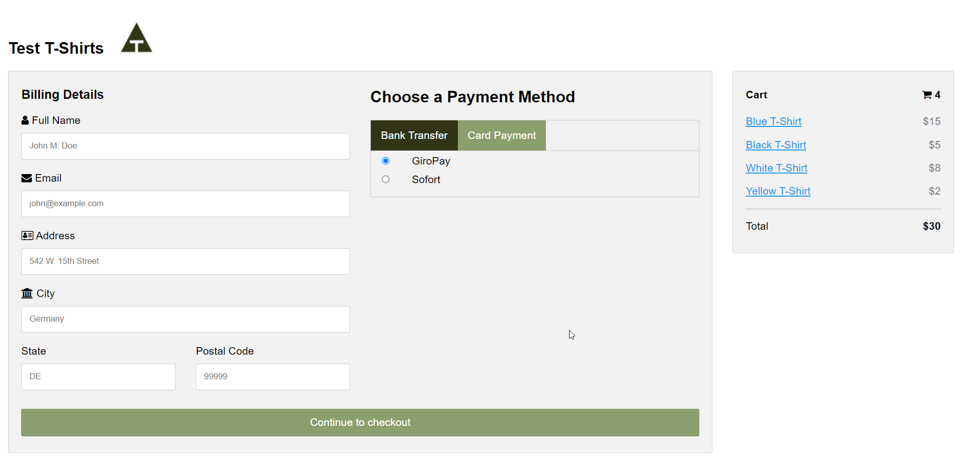

1. Please provide the mandatory fields

* Full Name
* Email
* Address
* Postal Code

Else, the page will throw error while submitting the form.

* Alert to enter full name

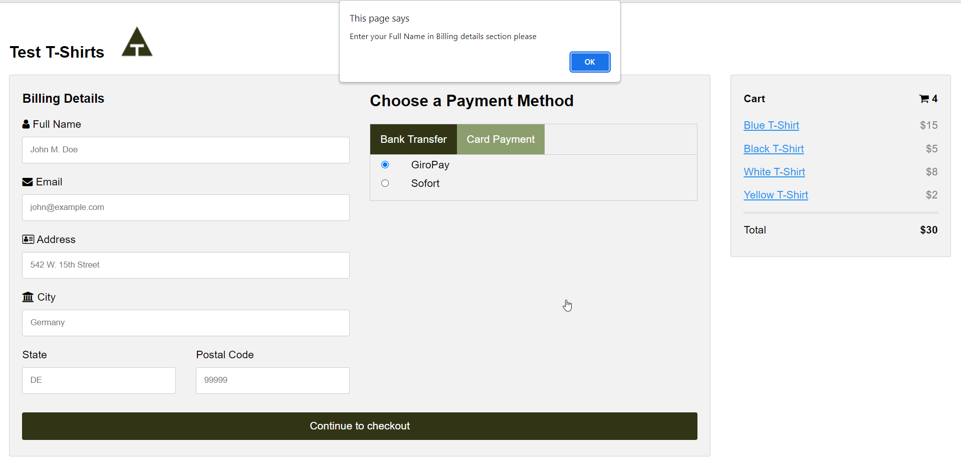

* Alert to enter email address

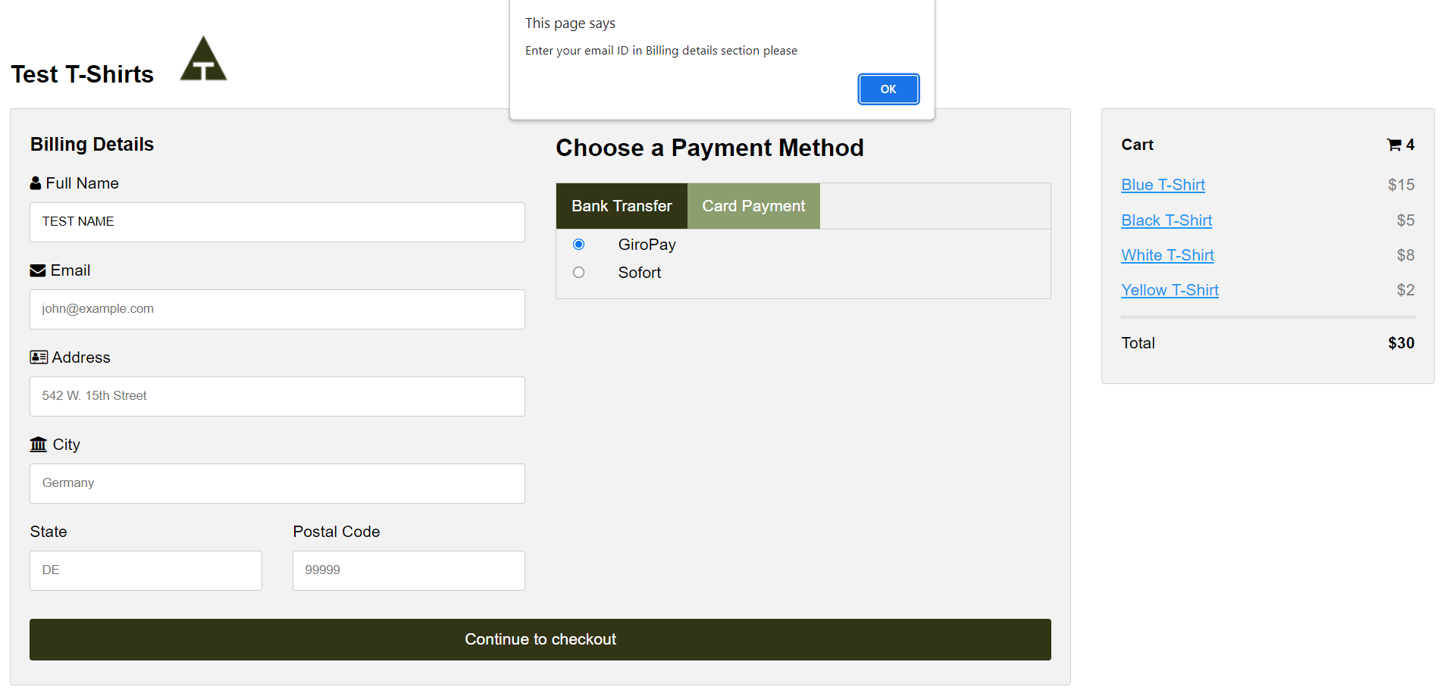

* Alert to enter address

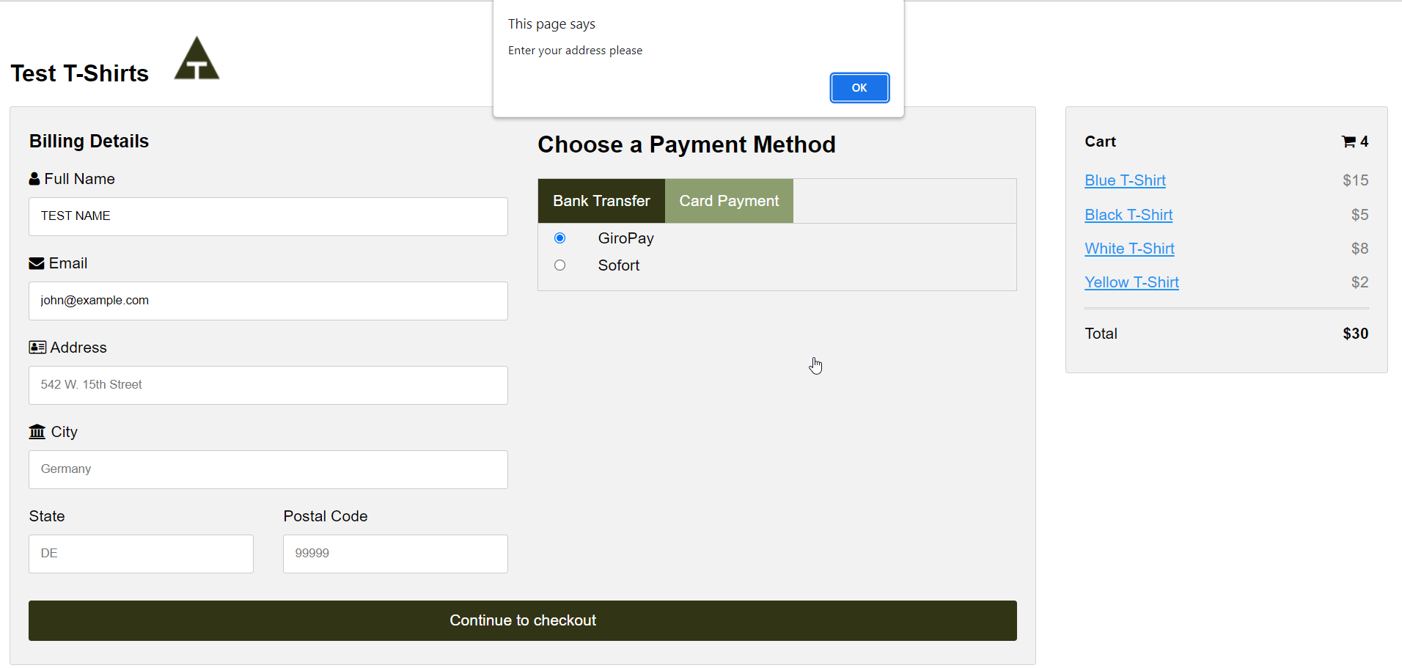

* Alert to enter postal code

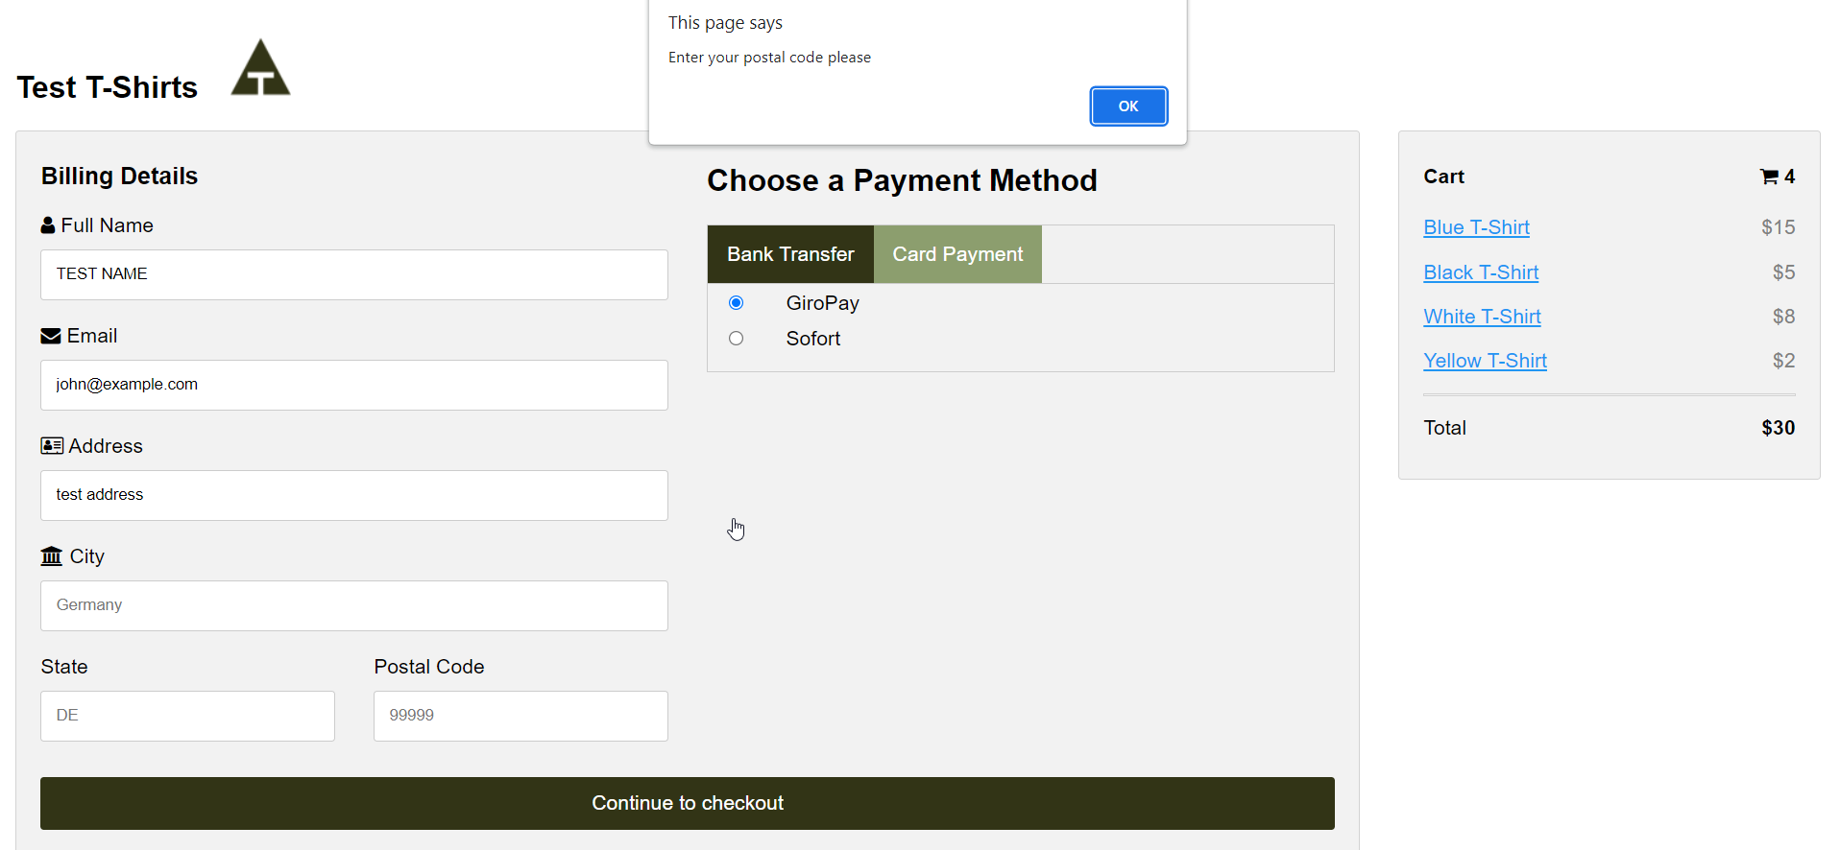

1. The default payment option is set to GiroPay bank transfer. Since there are no servers connected, the payment is authorized automatically.

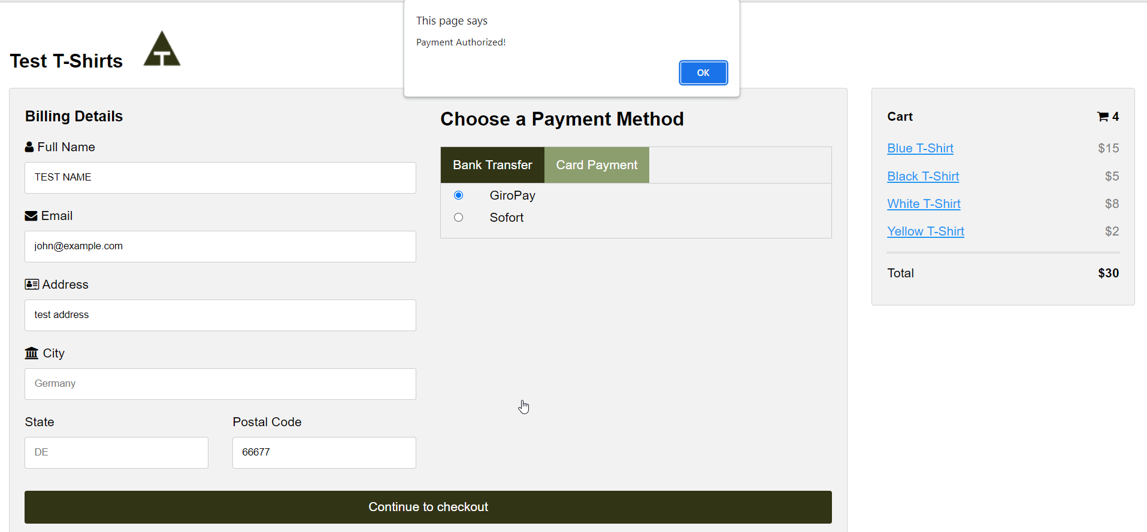

1. The page has some basic check for card payments.

* The card holder name is auto populated when we type in the full name.

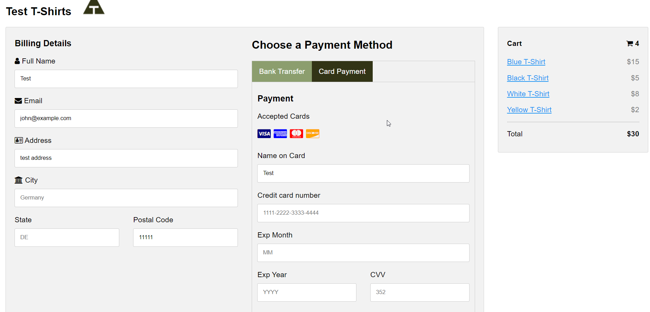

* The credit card number is mandatory when we use card payment method. Also, the card number should contain 16 characters.

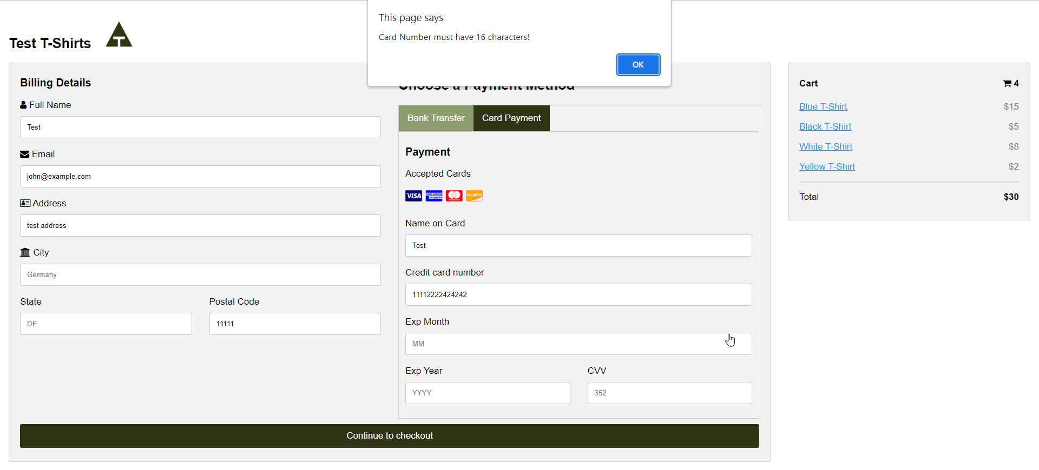

* Expiry Month and Year fields are mandatory. The Expiry details should be in future.

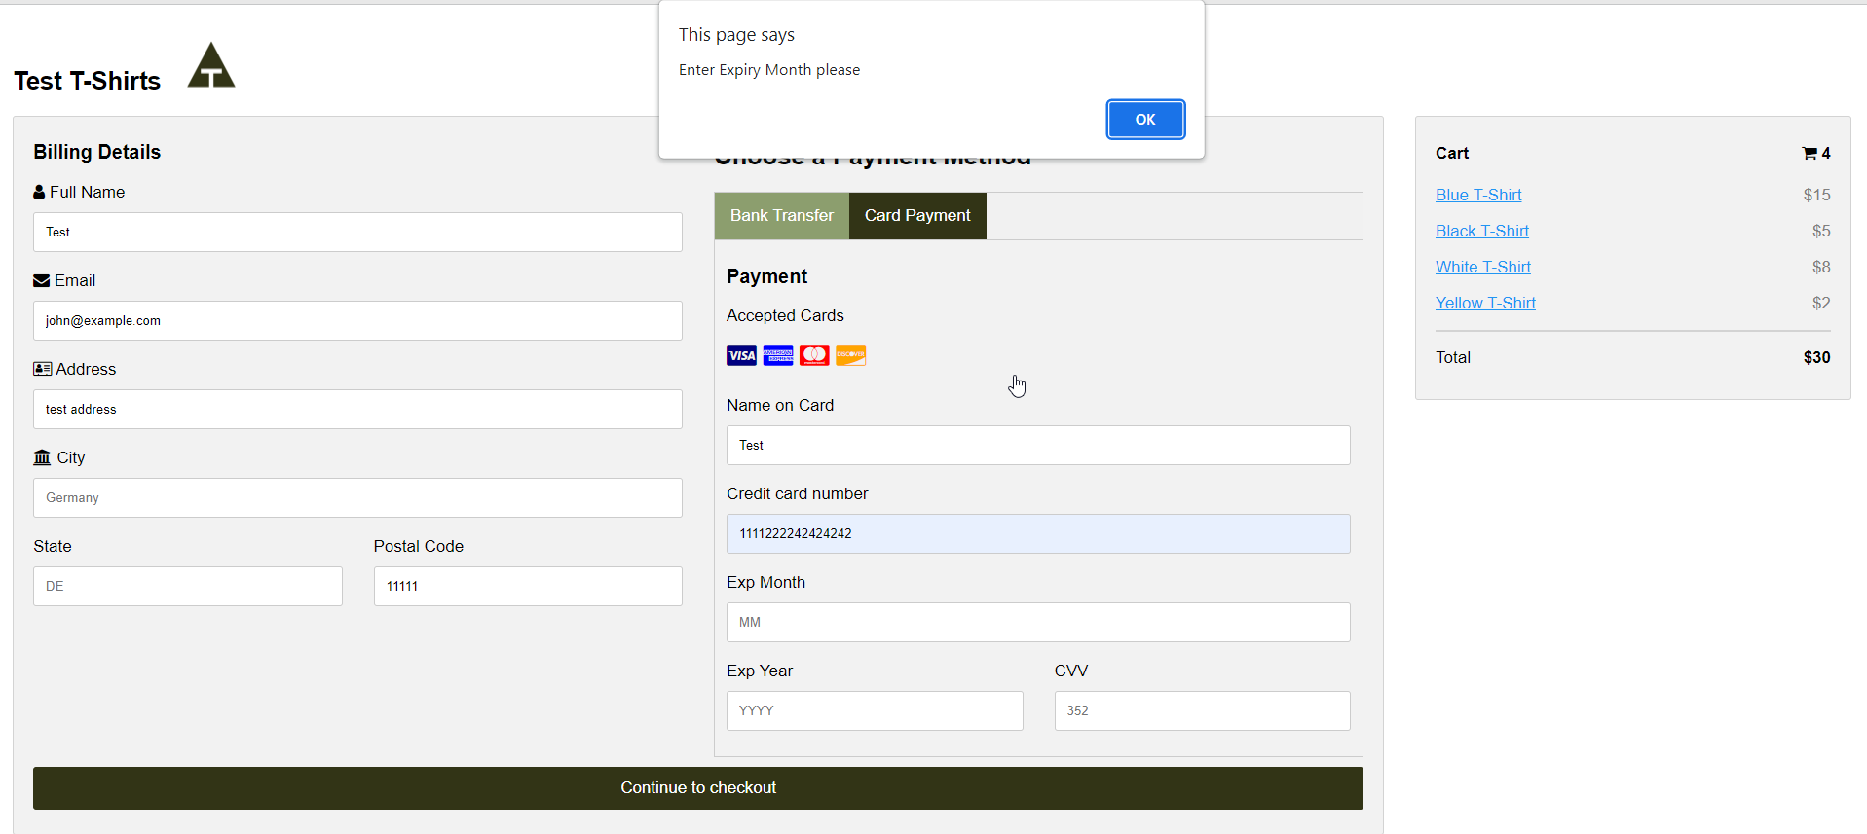

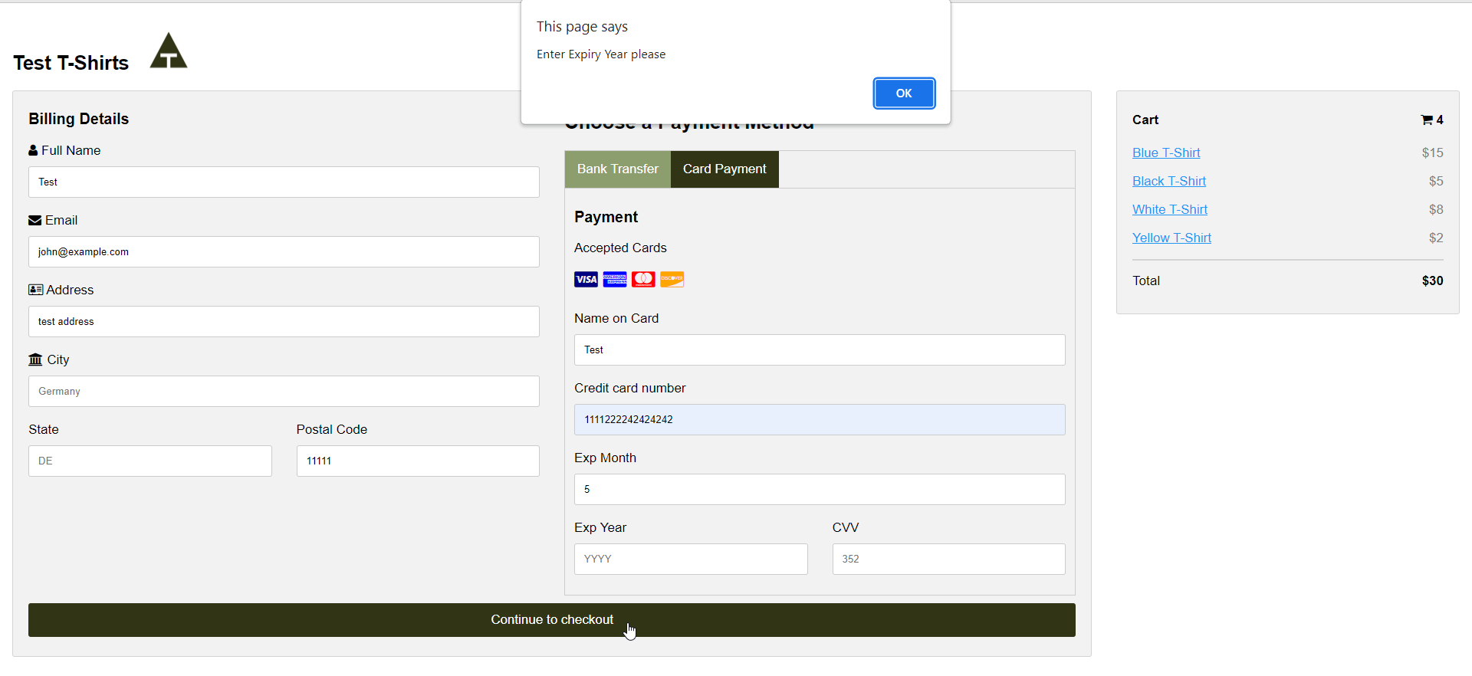

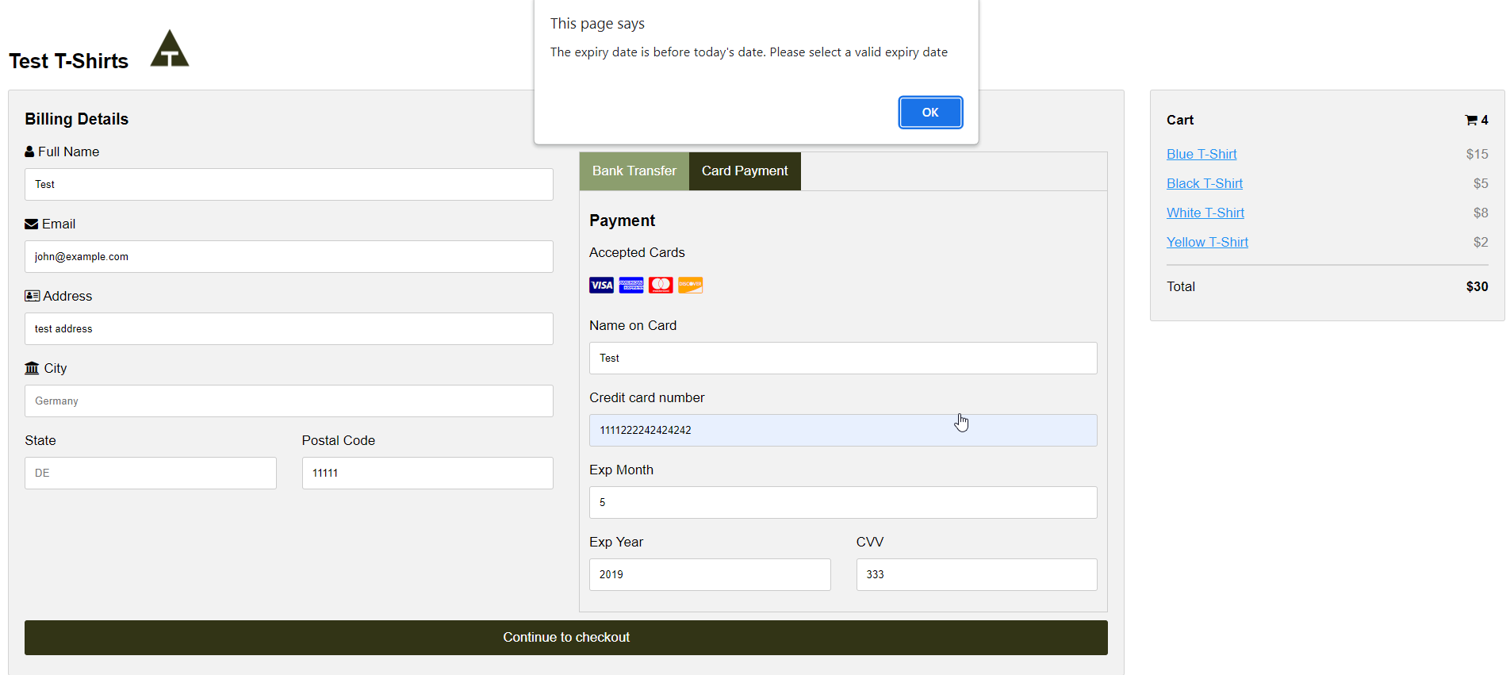

* The expiry month should be a valid month

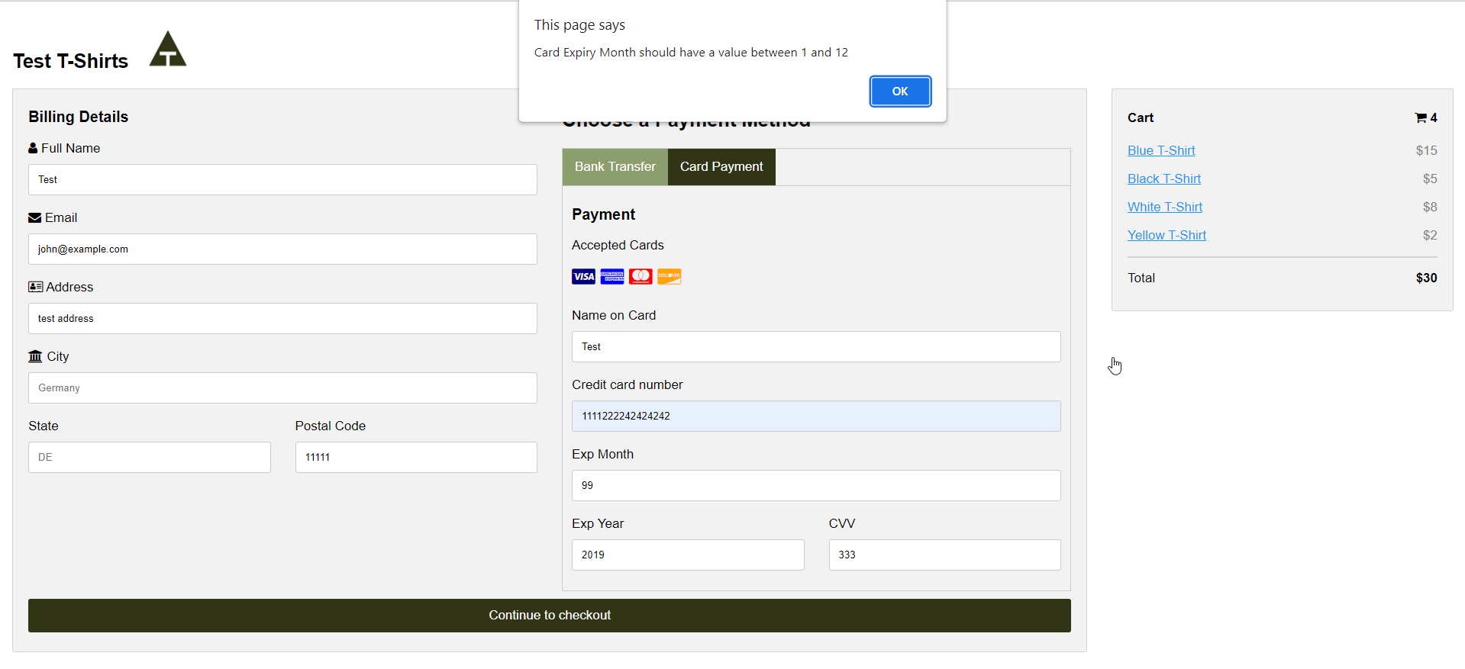

* CVV is a mandatory field.

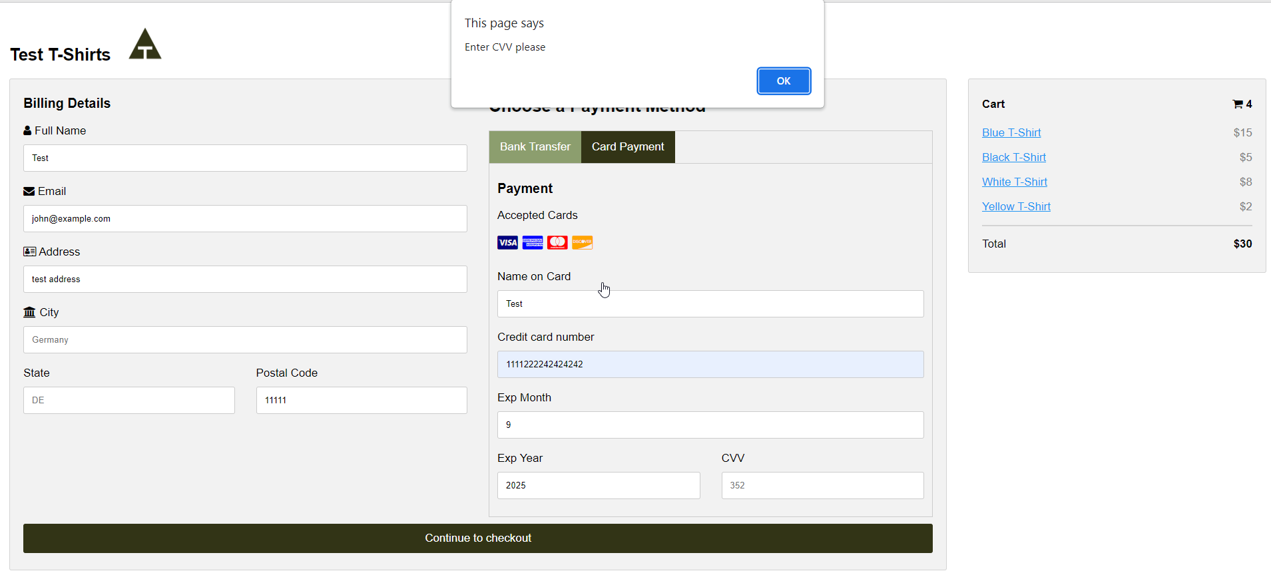

1. When all the details are populated properly, the payment gets authorized.

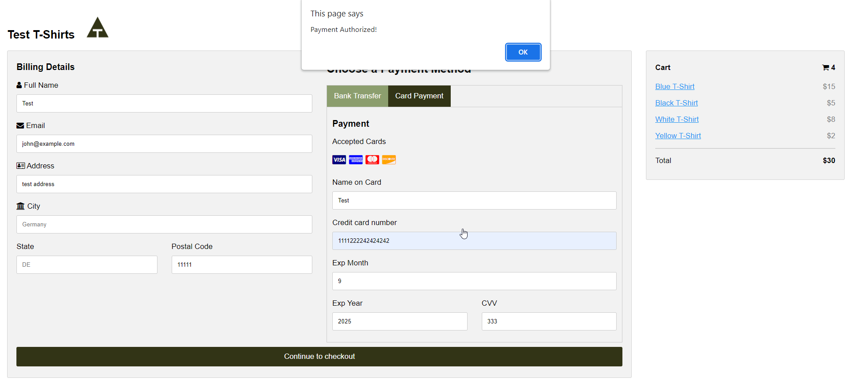

1. The page will be reloaded when we click on ok button

