psiog | Learning & Development
IMPACT pSiddhi 3.0
Mid-Term Submission Document
Common template for all tracks (Custom · Data · Platform) and all semesters, including pSiddhi Lite | Covers development up to end of Week 9

1. Participant & Project Identification
Topic ID (as finalised by L&D) | S4-I-18
Topic Title | Smart Facility Management Platform
Participant Name | Subhiksha Thirunavukkarasu
Employee ID | P399
Track | ☑ Custom ☐ Data ☐ Platform
Semester & Category | Semester 4 — Integration Mastery (Capstone): E2E Integration with IoT, ML/AI Core, Azure Deployment, QA Mandatory
Participation Type | ☑ Regular ☐ pSiddhi Lite
Approved Budget Ceiling | ₹2,500 (fixed)
Mid-Term Review Window | Week 10 (13-Jul-26 to 17-Jul-26)

2. Approved Proposal Recap

2.1 Problem Statement (as approved)
Facility management at Psiog Digital runs reactively: equipment telemetry exists but is not turned into intelligence, so preventable HVAC/electrical failures become emergencies, space utilization is invisible, energy runs unoptimized, and maintenance follows the calendar instead of equipment condition. The business needs a platform that ingests IoT sensor data, applies ML for failure prediction and anomaly detection, and surfaces decisions through a management portal.

2.2 Proposed Solution Summary (as approved)
FacilityIQ — four integrated layers within the ₹2,500 budget: (1) IoT ingestion — simulated HVAC/Energy/Occupancy devices into Azure IoT Hub/Functions/Blob; (2) ML analytics — Random Forest, Isolation Forest and Gradient Boosting failure/fault models plus unsupervised anomaly detection, tracked in MLflow; (3) a 4-screen management portal (Streamlit on Azure App Service); (4) Power BI analytics dashboards. AI is the decision engine: 3 failure-prediction scenarios and Gemini-generated natural-language guidance.

2.3 Core Tools & AI Components (as approved)
Azure IoT Hub, Azure Functions, Azure Blob Storage, Azure App Service (all free tier); Databricks Community + MLflow; scikit-learn + PyCaret; Streamlit; Power BI Desktop; Gemini 2.5 Flash API (₹400 provision); Ollama + Llama; GitHub + Actions CI; Pytest + Selenium; Great Expectations.

3. Progress Against Approved Plan (up to Week 9)
ID | Planned Deliverable (per approved proposal) | Planned Window (eg:Week 4) | Status | Evidence ID(s)
D-01 | Azure setup (IoT Hub, Functions, Blob, App Service); unified telemetry schema design; HVAC-domain IoT device simulators | Week 4 | Partial | EV-04, EV-06
D-02 | Simulators expanded to Energy and Space domains; ingestion operational across all 3 domains; telemetry routed to Blob storage landing zone | Week 5 | Done | EV-04, EV-06
D-03 | Data pipeline from landing zone to analytics tables; feature engineering for HVAC failure prediction (rolling windows, trend slopes) | Week 6 | Done | EV-04, EV-05
D-04 | HVAC compressor failure prediction model (Random Forest) trained and validated on held-out devices, >85% accuracy; tracked in MLflow | Week 7 | Done | EV-04
D-05 | Electrical fault detection (Isolation Forest) and motor degradation (Gradient Boosting) models; unsupervised anomaly detection pipeline | Week 8 | Done | EV-04, EV-02
D-06 | Management portal Screens 1 (Health Overview) and 2 (Equipment Detail) live, connected to ML model outputs; mid-term documentation | Week 9 | Done | EV-01, EV-02, EV-03
D-07 | QA embedded weekly: unit + integration tests, model accuracy tests, CI on every push (per proposal QA strategy Wks 4-9) | Weeks 4–9 | Done | EV-05
D-08 | Ahead of plan: role-based login (4 roles), portal Screens 3 (Maintenance Scheduling) and 4 (AI Predictive Intelligence) with live Gemini narratives, live weather API integration | (Wk 11-12 scope pulled in) | Done | EV-01, EV-03

3.1 Overall Mid-Term Self-Assessment
RFP-defined Week 10 checkpoint (summarise in 2–3 lines) | IoT ingestion operational across 3 domains; 3 ML models trained with accuracy metrics; portal with 2 functional screens; initial AI predictions on sample data; all unit/integration tests passing; mid-term docs on Moodle.
% of checkpoint completed (honest estimate) | 90% — every checkpoint item is working end-to-end. The only gap: telemetry lands in Azure Blob directly rather than through IoT Hub, because the corporate subscription RBAC does not allow IoT Hub creation (IT request raised; device-client code already built and unit-tested).
Is the current working state demonstrable live at the review? | ☑ Yes, end-to-end ☐ Yes, partially ☐ No, screenshots/recording only

4. Evidence Pack (entire mid-term period)

4.1 Evidence Index
Evidence ID | Caption — what does this prove? | Deliverable ID(s) | Verifiable link (if any)
EV-01 | Role-based login working: 4 roles (viewer/technician/manager/admin) with per-role screen access; admin panel shows user registry and system status | D-06, D-08 | https://github.com/subhikshathirunavukkarasu0503/facilityiq
EV-02 | Portal Screen 1 live: fleet health KPIs, ML-ranked alerts with plain-language explanations, live Chennai weather via Open-Meteo API with derived HVAC cooling-load index | D-05, D-06 | http://localhost:8501 (live at review)
EV-03 | Screens 2, 3 and 4 live: per-asset telemetry charts + model gauges; AI-optimized maintenance work orders with cost avoidance; Gemini-generated asset narrative (source-labelled) | D-06, D-08 | https://github.com/subhikshathirunavukkarasu0503/facilityiq
EV-04 | 3 ML models trained with measured held-out metrics: HVAC RF F1 0.997, Motor GBM F1 0.974, Electrical IsolationForest recall 1.00; confusion matrices; 14,784-record lake | D-01, D-02, D-03, D-04, D-05 | https://github.com/subhikshathirunavukkarasu0503/facilityiq/tree/main/models
EV-05 | Measured QA: pytest coverage 88% (target >80%); 79 tests across unit/integration/model/UI layers; GitHub Actions CI green with coverage gate --cov-fail-under=80 | D-03, D-07 | https://github.com/subhikshathirunavukkarasu0503/facilityiq/actions
EV-06 | Azure data lake live on corporate subscription: storage account fiqlake28091, container 'telemetry', 196 blobs (full 3-domain lake); commit history on GitHub | D-01, D-02 | https://github.com/subhikshathirunavukkarasu0503/facilityiq/commits/main
— | (not used) | — | —
— | (not used) | — | —

4.2 Evidence Blocks (paste screenshots here)
EV-01 — Role-based login & admin panel (RBAC working)
What this proves | Working login gate rejects bad credentials; each role sees only its permitted screens; admin panel lists users/roles and system state — proves auth + RBAC delivered.
Deliverable ID (Sec 3) | D-06, D-08
Date captured | 19-Jul-2026
Verifiable link | https://github.com/subhikshathirunavukkarasu0503/facilityiq
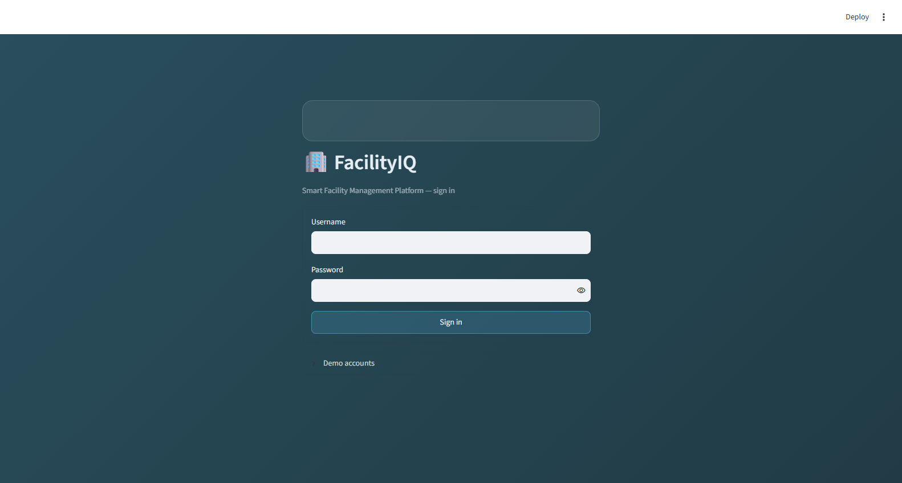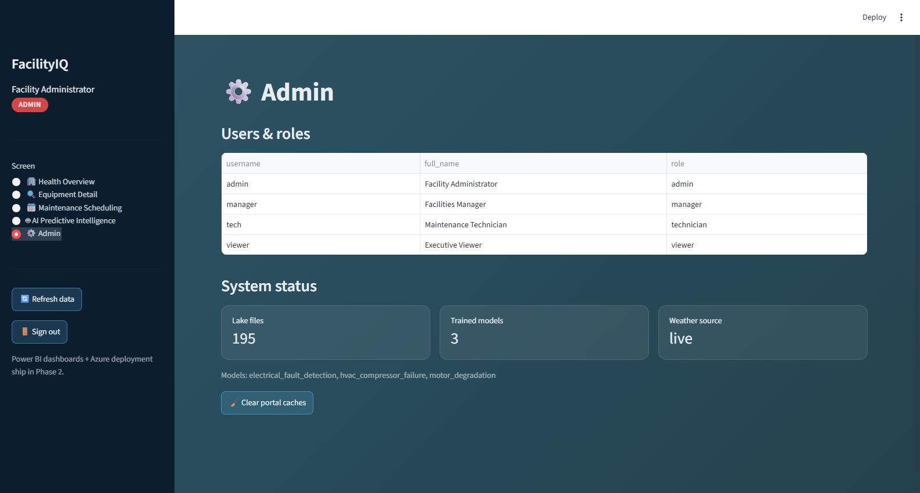

EV-02 — Screen 1 — Facility Health Overview with live weather API
What this proves | Screen 1 renders live: 9 monitored assets, 3/1/5 green/yellow/red split matching simulator ground truth, ranked alerts with explanations, live Open-Meteo weather feeding the HVAC cooling-load index.
Deliverable ID (Sec 3) | D-05, D-06
Date captured | 19-Jul-2026
Verifiable link | Live demo at review
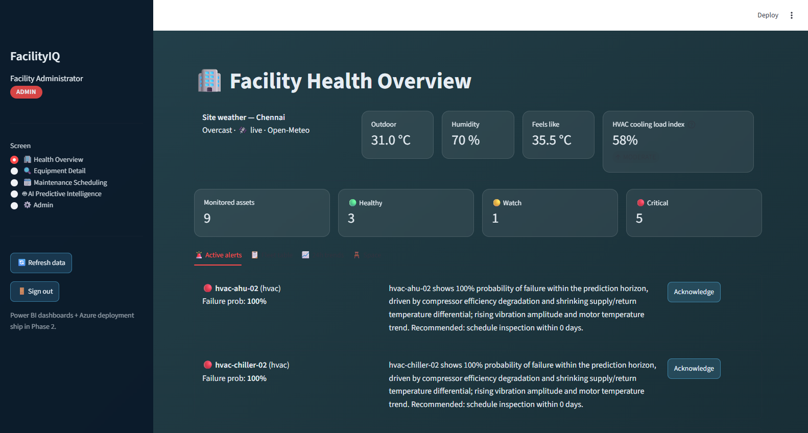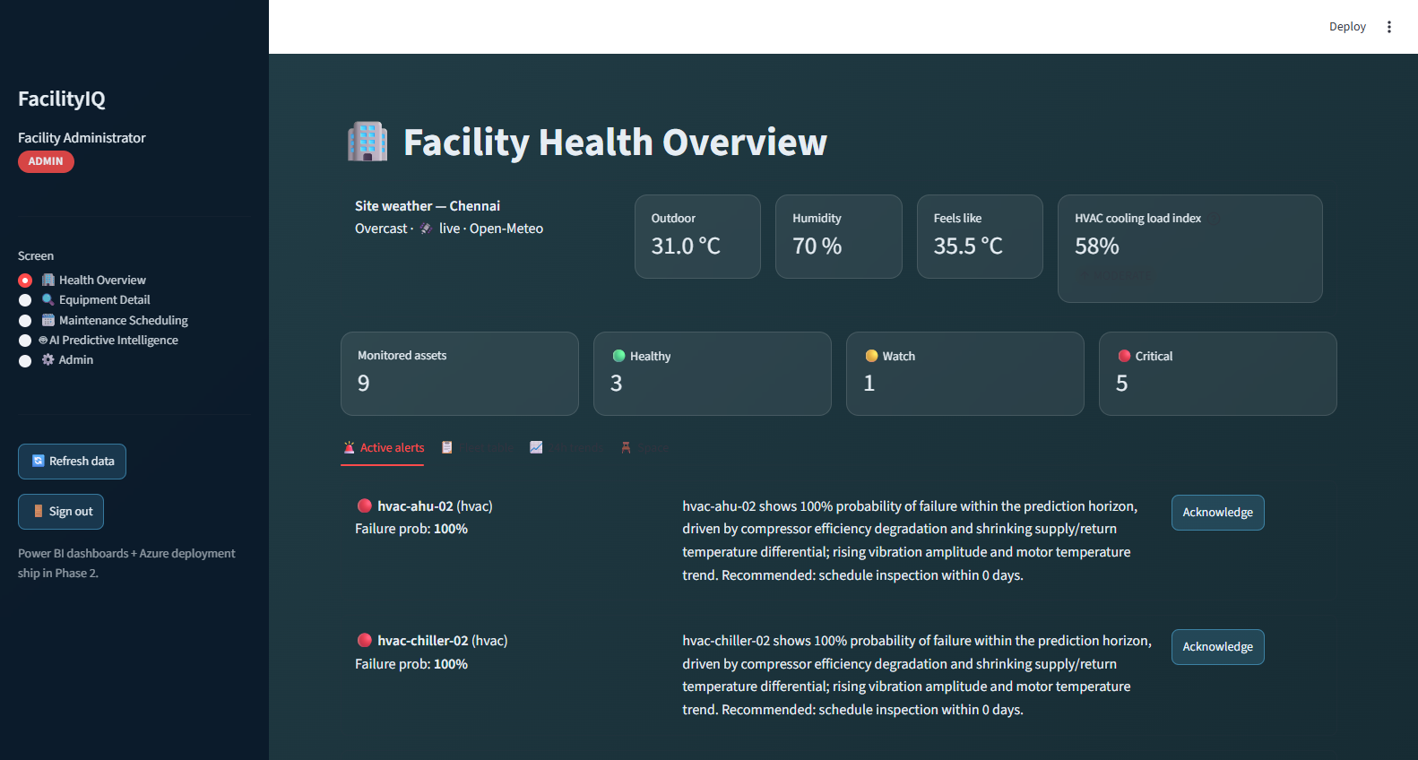

EV-03 — Screens 2–4 — Equipment Detail, Maintenance, Gemini AI
What this proves | Screen 2 telemetry + model gauges for a degrading chiller; Screen 3 AI-ranked work orders with ₹ cost avoidance and what-if delay risk; Screen 4 live Gemini narrative (source-labelled 'Gemini', cached for demo resilience).
Deliverable ID (Sec 3) | D-06, D-08
Date captured | 19-Jul-2026
Verifiable link | https://github.com/subhikshathirunavukkarasu0503/facilityiq
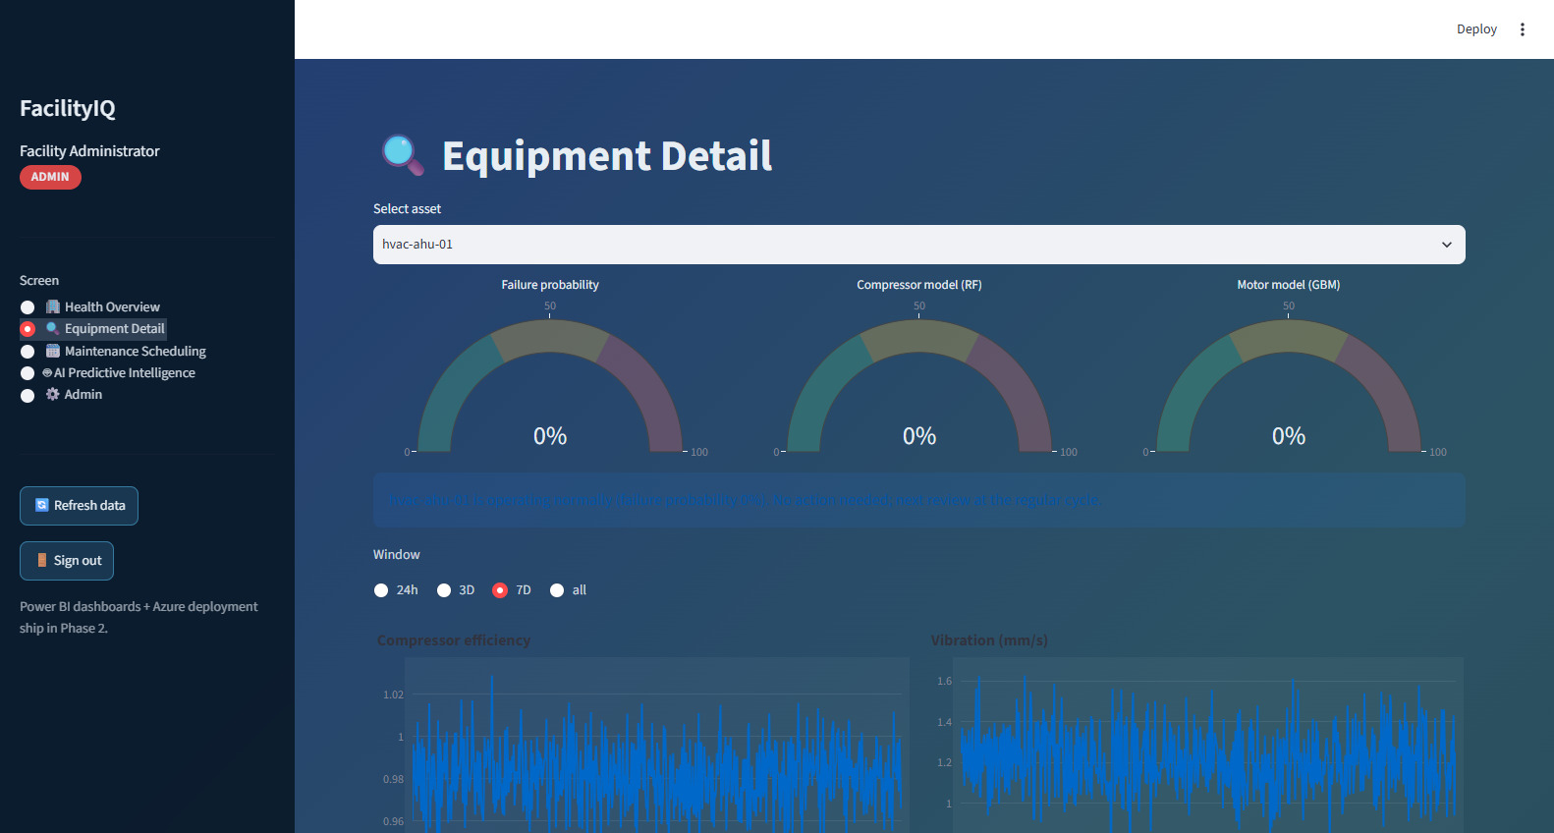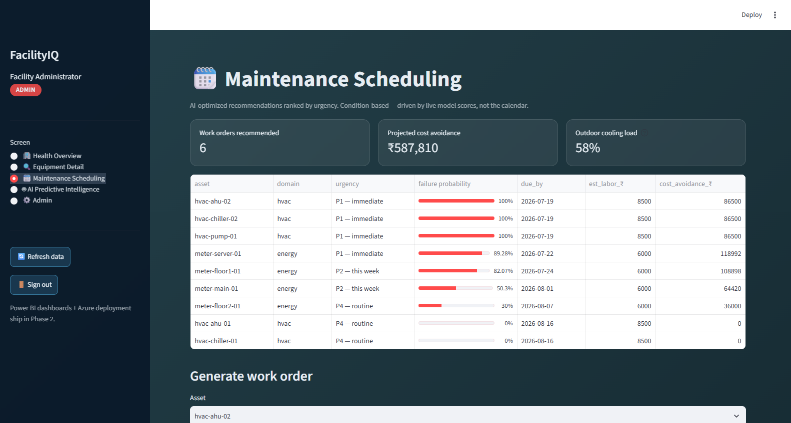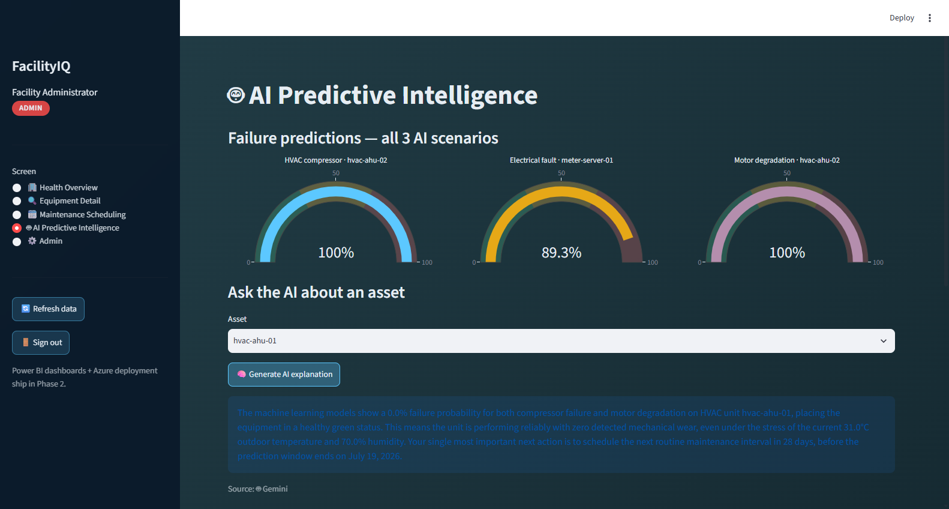

EV-04 — ML model accuracy — 3 models, measured held-out metrics
What this proves | Measured model quality on held-out devices (grouped split — no device leaks between train/test): HVAC RF F1 0.997, Motor GBM F1 0.974, Electrical anomaly recall 1.00. Confusion matrices below. Lake: 195 files, 14,784 records.
Deliverable ID (Sec 3) | D-01–D-05
Date captured | 19-Jul-2026
Verifiable link | https://github.com/subhikshathirunavukkarasu0503/facilityiq/tree/main/models
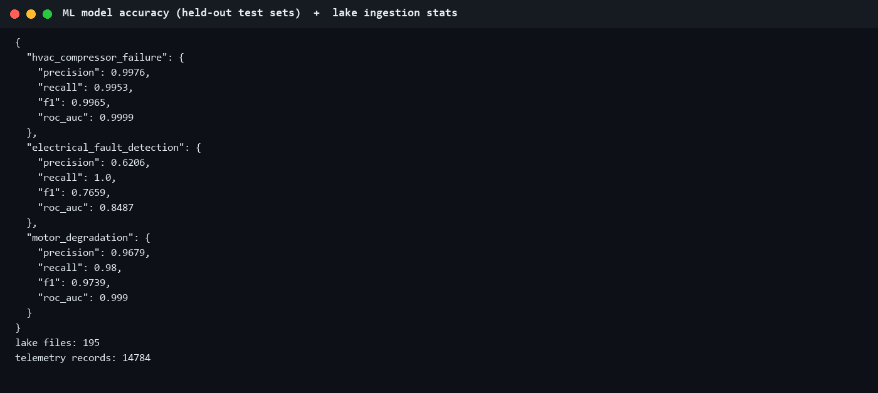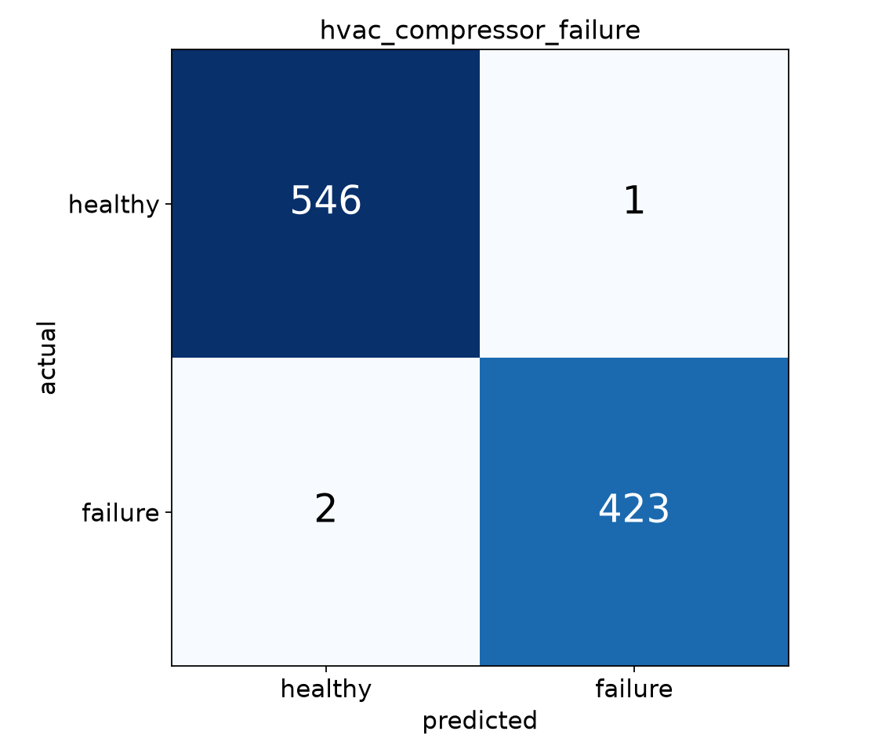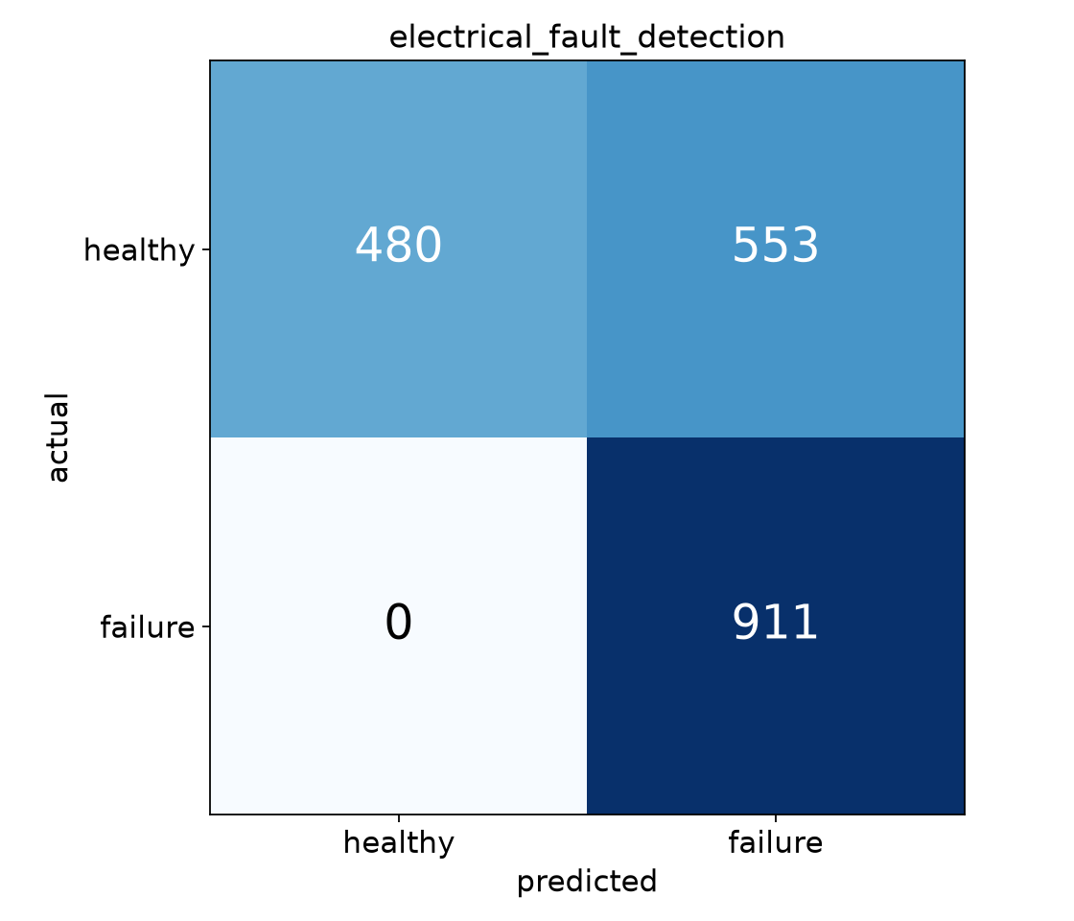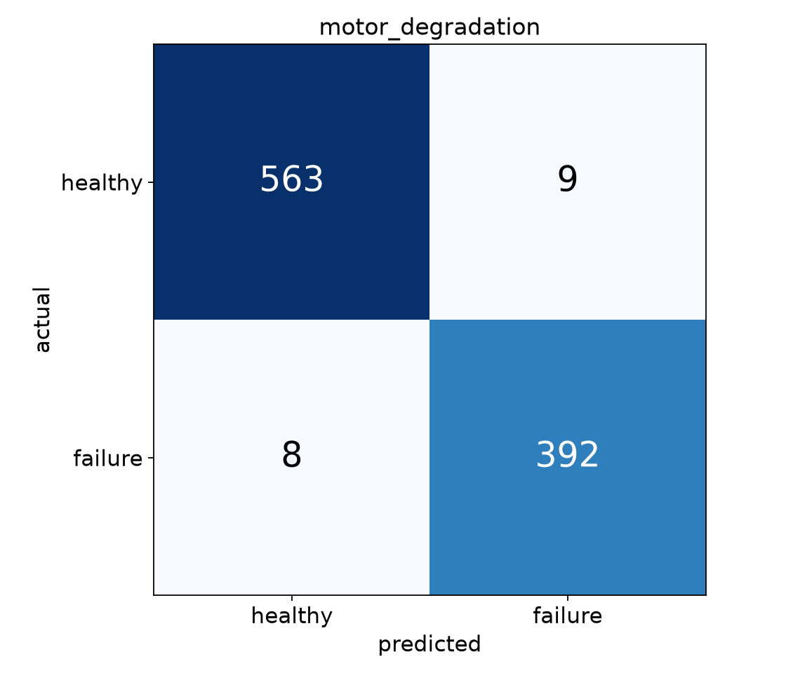

EV-05 — QA — 88% measured coverage + green CI with 80% gate
What this proves | Coverage measured by pytest-cov: 88% (675 stmts), 79 tests passing. GitHub Actions runs the full suite with a hard 80% coverage gate on every push — latest runs green.
Deliverable ID (Sec 3) | D-07
Date captured | 19-Jul-2026
Verifiable link | https://github.com/subhikshathirunavukkarasu0503/facilityiq/actions
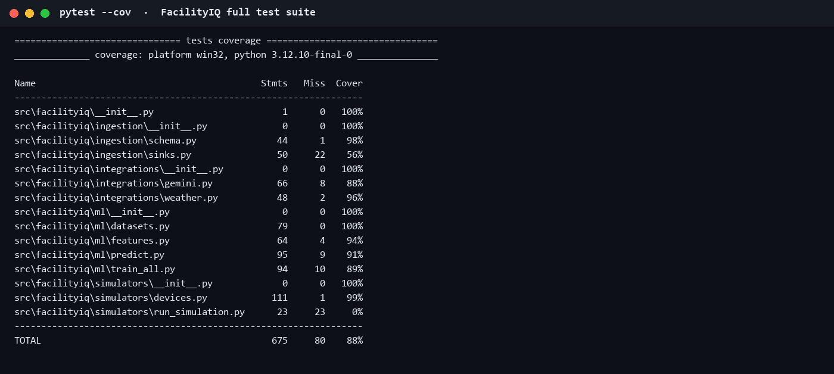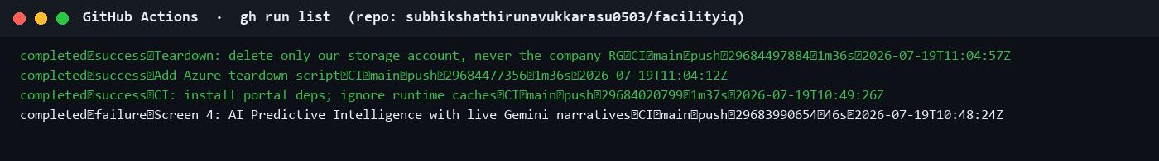

EV-06 — Azure Blob data lake + repository history
What this proves | Azure Blob data lake live on the pSiddhi subscription (RG rg-pSiddhi3.0-2026-01-sem4-Subhiksha): 196 telemetry blobs across hvac/energy/occupancy. Git history shows incremental delivery.
Deliverable ID (Sec 3) | D-01, D-02
Date captured | 19-Jul-2026
Verifiable link | https://github.com/subhikshathirunavukkarasu0503/facilityiq/commits/main
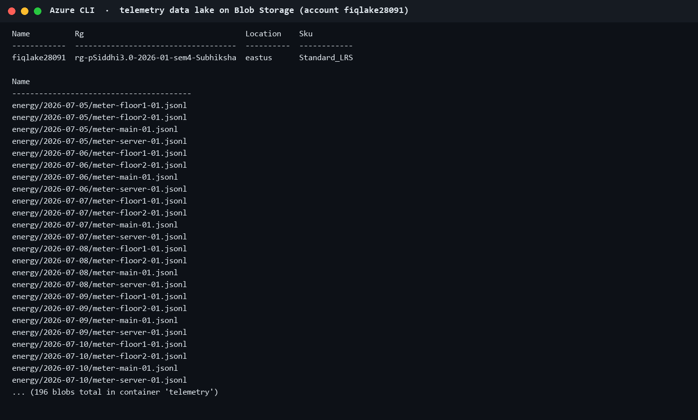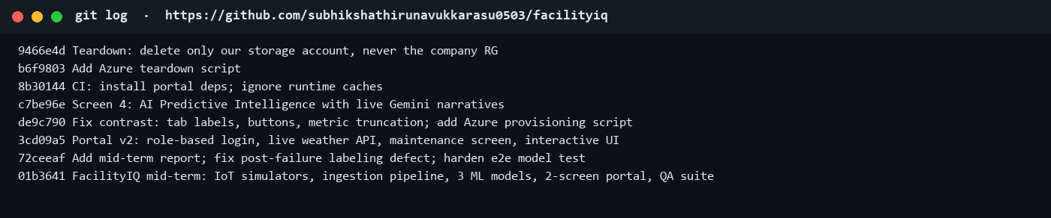

5. Working Demo & Repository Links
Code repository URL (GitHub/GitLab) | https://github.com/subhikshathirunavukkarasu0503/facilityiq (public — directly verifiable by L&D)
Latest commit ID + date (as of submission) | ef8f542 — 19-Jul-2026 (evaluation fixes pushed post-review; original mid-term commit 9466e4d)
Deployed / hosted URL (if any) | https://facilityiq-subhiksha.streamlit.app (Streamlit Community Cloud, free tier; Azure App Service pending IT-created plan)
Demo video or recording link (optional) | N/A
Notebook / dashboard / other artefact links | Model metrics: https://github.com/subhikshathirunavukkarasu0503/facilityiq/tree/main/models · CI: https://github.com/subhikshathirunavukkarasu0503/facilityiq/actions · Mid-term report: https://github.com/subhikshathirunavukkarasu0503/facilityiq/blob/main/docs/midterm_report.md

6. QA Progress (up to Week 9)
Test Type (per approved QA strategy) | Tests written / run so far | Coverage achieved (measured) | Target (per proposal) | Evidence ID(s)
Unit tests (Pytest) | 48 written / 48 passing (schema 9, simulators 10, features 5, auth 9, weather 6, Gemini 5, misc 4) | 88% overall statement coverage (pytest-cov) | >80% code coverage | EV-05
Integration tests (Pytest + fixtures) | 8 written / 8 passing (simulator→validation→lake, 3-domain landing, end-to-end simulate→featurize→score) | Included in 88% measured figure | All integration points tested | EV-05
Model accuracy tests (scikit-learn metrics + MLflow) | 7 written / 7 passing — accuracy floors encoded as tests (F1≥0.85, anomaly recall≥0.90) | HVAC F1 0.997 · Motor F1 0.974 · anomaly recall 1.00 | >85% F1, >90% anomaly detection | EV-04, EV-05
UI / E2E (Streamlit AppTest + Selenium) | 8 AppTest UI tests passing (login, RBAC, every screen renders, sign-out); Selenium script drives login + all 5 screens headless (screenshot evidence in this doc was produced by it) | Included in suite runs | 5 E2E scenarios (full set due Wk 14-15) | EV-01, EV-05

7. Tool & Budget Reconciliation
Tool / Service (approved) | Approved tier & cost | Used by Wk 9? | Actual cost (₹) | Reason if changed / not yet used
Azure IoT Hub | Free tier / ₹0 | ☐ Yes ☑ No ☐ Partial | 0 | Corporate RBAC grants IoT Hub *Data* Contributor only — cannot create the hub. IT request raised; device-client code built and tested. Telemetry meanwhile lands in Blob directly (proposal risk #3 fallback).
Azure Functions | Free tier / ₹0 | ☐ Yes ☑ No ☐ Partial | 0 | Depends on IoT Hub routing — Phase 2 (Wk 11-12).
Azure Blob Storage | Free tier / ₹0 | ☑ Yes ☐ No ☐ Partial | 0 (Standard_LRS, <₹5/mo) | Live: account fiqlake28091, 196 blobs.
Azure App Service | Free tier / ₹0 | ☐ Yes ☑ No ☐ Partial | 0 | Plan creation blocked by RBAC (Website Contributor only) — with IT; portal demoed locally per proposal risk #6 fallback.
Databricks Community + MLflow | Free / ₹0 | ☐ Yes ☐ No ☑ Partial | 0 | MLflow used (local tracking). Databricks swapped for local pandas/scikit-learn pipeline — POC data volume doesn't need Spark (proposal risk #5 fallback exercised proactively).
scikit-learn + PyCaret | Free / ₹0 | ☐ Yes ☐ No ☑ Partial | 0 | scikit-learn carries all 3 models. PyCaret dropped — added no value over direct scikit-learn and bloats the environment.
Power BI Desktop | Free / ₹0 | ☐ Yes ☑ No ☐ Partial | 0 | Planned Wk 13 per approved timeline — not a Wk 4-9 deliverable.
Streamlit Community | Free / ₹0 | ☑ Yes ☐ No ☐ Partial | 0 | Portal framework — 5 screens live.
Gemini 2.5 Flash API | Free tier + ₹400 | ☑ Yes ☐ No ☐ Partial | 0 (free tier) | Google retired gemini-2.5-flash for new API keys; switched to the gemini-flash-latest alias. Responses disk-cached to stay inside the free tier — ₹400 provision likely unneeded.
Ollama + Llama 4 Scout | Free / ₹0 | ☐ Yes ☑ No ☐ Partial | 0 | Not needed — Gemini free tier + caching covered development; kept as offline fallback.
GitHub (+ Actions CI) | Free / ₹0 | ☑ Yes ☐ No ☐ Partial | 0 | Private repo, CI green with 80% coverage gate.
Pytest + Selenium | Free / ₹0 | ☑ Yes ☐ No ☐ Partial | 0 | 79 tests; Selenium drives the live portal headless.
Great Expectations | Free / ₹0 | ☐ Yes ☑ No ☐ Partial | 0 | Planned Wk 15 per approved QA timeline; schema-validation layer already enforces data quality at ingestion.
Domain (optional) | Paid / ₹450 | ☐ Yes ☑ No ☐ Partial | 0 | Optional per proposal — will not purchase.
Groq API (L&D approval condition) | Free tier / ₹0 | ☑ Yes ☐ No ☐ Partial | 0 | Added per the L&D approval condition to include Groq alongside Gemini: second narrative provider (llama-3.3-70b-versatile) with a provider selector on the AI screen and automatic Gemini→Groq→cache→template failover.

7.1 Budget Summary
Approved budget ceiling | ₹2,500
Estimated spend at approval | ₹1,850
Actual spend till Week 9 | ₹0
Buffer remaining | ₹2,500 (full ceiling intact)
Anticipated spend before Week 17 | ₹0–₹400 (possible paid Gemini usage for final-phase narrative volume; storage <₹5/mo, deleted after demo)

8. Deviations from Approved Proposal
Item | Approved plan | Actual implementation | Reason for change
IoT Hub ingestion path | Simulators → Azure IoT Hub → Functions → Blob | Simulators → validated local lake → Azure Blob (az CLI sync); IoT Hub device-client code built and unit-tested but not connected | Corporate subscription RBAC does not permit IoT Hub creation (IoT Hub Data Contributor role only). IT request raised — this was proposal risk #3, whose approved fallback is exactly 'direct Blob upload'.
ML compute platform | Databricks Community Edition (Spark) | Local pandas + scikit-learn pipeline; MLflow tracking retained | POC telemetry volume (≈15K records) does not warrant Spark; avoids proposal risk #5 (Community cluster timeouts). PyCaret dropped for the same simplicity reason.
Gemini model version | Gemini 2.5 Flash | gemini-flash-latest alias | Google retired 2.5 Flash for newly created API keys (mid-2026); alias tracks the current free-tier flash model.
L&D approval condition — Groq | Proposal listed Gemini (+ local Ollama); L&D approval added the condition to include Groq | Groq integrated as a peer narrative provider: OpenAI-compatible REST client, llama-3.3-70b-versatile, provider picker on Screen 4, auto-failover Gemini→Groq→cache→template; unit tests cover the failover routing | Compliance with the L&D approval condition (flagged at mid-term evaluation; resolved immediately after).
Scope pulled forward | Screens 3-4, auth in Weeks 11-12 | Role-based login (4 roles), Screens 3 & 4 with live Gemini narratives, and a live weather API (Open-Meteo) already delivered | Mid-term demo benefits; also de-risks Phase 2. No approved scope was displaced.

9. What Is NOT Completed Yet + Plan for Weeks 11–16
Pending item (be specific) | Why it is pending | Plan to complete (target week)
IoT Hub live streaming (device client → hub → routing) | Hub creation requires IT (RBAC) — request raised; client code ready | Wk 11 (immediately after IT provisions F1 hub)
Azure Functions telemetry routing + alerts | Depends on IoT Hub | Wk 11-12
Portal deployment to Azure App Service | App Service plan creation blocked by RBAC; IT request raised (F1 free plan) | Wk 12-13 (fallback: Streamlit Community Cloud, free)
Power BI dashboards ×3 (Equipment Health, Energy, Space) | Scheduled Wk 13 in approved plan; analytics datasets already exportable | Wk 13
Scale test 10K+ records via Locust + full Selenium E2E suite | Scheduled Wk 14-15 in approved plan; 14.7K records already flow through the batch pipeline | Wk 14-15
Great Expectations data-quality suite + full regression | Scheduled Wk 15 | Wk 15

10. Risks & Blockers
Risk / Blocker | Status (Open / Mitigated / Realised) | Mitigation taken so far | Impact on remaining timeline / support needed
NEW — Corporate Azure RBAC blocks IoT Hub & App Service plan creation | Open — L&D/IT support needed NOW | Blob-direct ingestion fallback live (196 blobs); device-client code pre-built; free-tier-only request drafted for IT | No timeline impact if hub exists by Wk 11. ASK: create F1 IoT Hub + F1 App Service plan in rg-pSiddhi3.0-2026-01-sem4-Subhiksha.
Model accuracy <85% on simulated data (proposal risk #1) | Mitigated | Grouped train/test split, steady-state fault classes added after QA caught a labeling defect; F1 0.997 / 0.974 achieved | None.
Azure free-tier limits / cost overrun (proposal risk #2) | Mitigated | Everything free-tier; actual spend ₹0; teardown script in repo removes the storage account after final demo | None. Office-subscription cost consciously kept at ~₹0.
Gemini API availability during demo (proposal risk #4) | Mitigated (partially realised: Google retired 2.5 Flash) | Switched to gemini-flash-latest; all narratives disk-cached; deterministic template fallback keeps portal functional offline | None.
Databricks Community cluster timeout (proposal risk #5) | Avoided | Descoped Databricks — local scikit-learn pipeline (disclosed in Section 8) | None.

11. Declaration & Pre-Submission Checklist
☑ All fields in Section 1 match my L&D Final Decision record exactly (correct Topic ID, no original/corrected mismatch).
☑ Section 3 lists every deliverable my approved proposal committed for Weeks 4–9, each with a D-ID and a status.
☑ Every "Done" or "Partial" status in Section 3 points to at least one Evidence ID in Section 4.
☑ Every evidence block in Section 4 has a specific caption, a pasted full-size screenshot, and a verifiable link where applicable.
☑ The repository link in Section 5 is accessible to the L&D team and the stated commit exists.
☑ Section 6 coverage figures are measured (tool output attached as evidence), not estimated.
☑ Section 7 lists every tool from my approved proposal, including ones I did not use.
☑ Section 8 discloses every deviation, including advisories I chose not to act on.
☑ Section 9 is consistent with Sections 3 and 4 — no contradictions.
☑ I have deleted all grey italic instruction text.
☑ I have not renamed, deleted, or reordered any section of this template.
☑ Document is saved as [TopicID]_[ParticipantName]_MidTermDoc.docx and uploaded to Moodle before the deadline.
Declaration: I confirm that all progress claims, evidence, costs, and coverage figures in this document are true and reflect my own individual work.
Participant signature / name | Subhiksha Thirunavukkarasu
Date of submission | 19-Jul-2026
Submission deadline: End of Week 9 / start of the Week 10 review window (13-Jul-26), as per programme schedule. Late or incomplete documentation may affect your mid-term evaluation score.

