psiog | Learning & Development
IMPACT pSIDDHI 3.0
Final-Term Submission Document
Common template for all tracks (Custom · Data · Platform) and all semesters, including pSiddhi Lite | Covers the ENTIRE programme, Week 4 through Week 17
1. Participant & Project Identification
Topic ID (as finalised by L&D) | S4-I-18
Topic Title | Smart Facility Management Platform
Participant Name | Subhiksha Thirunavukkarasu
Employee ID | P399
Track | ☑ Custom ☐ Data ☐ Platform
Semester & Category | Semester 4 — Integration Mastery (Capstone): E2E Integration with IoT, ML/AI Core, Azure Deployment, QA Mandatory
Participation Type | ☑ Regular ☐ pSiddhi Lite
Approved Budget Ceiling | ₹2,500 (fixed)
Mid-Term document filename (as uploaded to Moodle) | S4-I-18_Subhiksha_Thirunavukkarasu_MidTermDoc.docx
Mid-Term result / feedback received | ☐ On track ☐ At risk — actions were assigned ☑ Other: official result/feedback not supplied
Final Review Window | Week 17 — submission due 21-Sep-2026; exact review dates not supplied
2. Approved Proposal Recap
2.1 Problem Statement (as approved)
No change from Mid-Term recap. Facility teams operate reactively because available HVAC, electrical and occupancy telemetry is not converted into decisions. FacilityIQ addresses preventable failures, invisible space use, energy waste and calendar-based maintenance through integrated telemetry, ML scoring and an operational portal.
2.2 Proposed Solution Summary (as approved)
FacilityIQ implements simulated three-domain devices, unified validation, a JSONL data lake mirrored to Azure Blob, feature pipelines, three scikit-learn models and a five-screen Streamlit portal. The direct-to-Blob path remains the working Azure fallback because Azure validation/provisioning blocked IoT Hub, Functions and App Service; no new cloud resource was created. Final QA adds Great Expectations, Selenium browser journeys and Locust load testing. Three report-ready datasets were validated and used to create live Power BI Service reports for equipment health, energy consumption and space utilization.
2.3 Core Tools & AI Components (as approved)
Azure IoT Hub, Azure Functions, Azure Blob Storage, Azure App Service; Databricks Community and MLflow; scikit-learn and PyCaret; Streamlit; Power BI Desktop; Gemini; Ollama/Llama; GitHub Actions; Pytest, Selenium and Great Expectations. Actual usage and substitutions are reconciled in Section 7. The supplied project record also includes Groq, but the official L&D feedback that allegedly required it was not supplied for independent verification.
3. Progress Against Approved Plan (Full Programme: Week 4–17)
ID | Planned Deliverable (per approved proposal) | Planned Window | Carried from Mid-Term? (Y/N) | Status | Evidence ID(s)
D-01 | Azure setup, telemetry schema and HVAC simulators | Week 4 | Y | Partial | EV-04, EV-06 (Mid-Term)
D-02 | Energy/space simulators and 3-domain landing zone | Week 5 | Y | Done | EV-04, EV-06 (Mid-Term), EV-07
D-03 | Lake-to-analytics feature pipeline | Week 6 | Y | Done | EV-04, EV-05 (Mid-Term), EV-07
D-04 | HVAC Random Forest trained and measured | Week 7 | Y | Done | EV-04 (Mid-Term), EV-09
D-05 | Electrical Isolation Forest and motor GBM | Week 8 | Y | Done | EV-04 (Mid-Term), EV-09
D-06 | Portal health overview and equipment detail | Week 9 | Y | Done | EV-01–EV-03 (Mid-Term)
D-07 | Embedded unit/integration/model/UI QA and CI | Weeks 4–9 | Y | Done | EV-05 (Mid-Term), EV-08
D-08 | Role-based login, maintenance and AI screens | Weeks 11–12 | Y | Done | EV-01, EV-03 (Mid-Term)
D-09 | Power BI dashboards: equipment, energy and space | Week 13 | N | Done | EV-11
D-10 | Scale and browser E2E validation | Week 14 | N | Done | EV-08
D-11 | Great Expectations data quality and full regression | Week 15 | N | Done | EV-07, EV-08
D-12 | Final documentation, evidence and review preparation | Week 16 | N | Done | EV-07–EV-11
3.1 Overall Final Self-Assessment
RFP-defined final checkpoint / definition of done (summarise in 2–3 lines) | Complete three-domain ingestion, three prediction scenarios, four portal screens, three analytics dashboards, Azure deployment, at least 10,000 telemetry points and a QA suite with at least 80% measured coverage.
% of overall project completed (honest estimate) | 88% — core telemetry, models, portal, AI, QA and three Power BI Service reports are working and evidenced. The corporate-access-blocked IoT Hub/Functions/App Service route prevents a 100% claim.
% reported at Mid-Term (from your Mid-Term Section 3.1) | 90% of the Week-10 checkpoint (not 90% of the full programme).
Is the final solution demonstrable live, end-to-end, at the review? | ☐ Yes, end-to-end ☑ Yes, partially ☐ No, recording/screenshots only
4. Evidence Pack (Full Programme: Week 4–17)
4.1 Evidence Index
Evidence ID | Caption — what does this prove? | Deliverable ID(s) | Verifiable link (if any) | Carried from Mid-Term? (EV-ID if yes)
EV-01 | Role-based login and admin panel | D-06, D-08 | https://github.com/subhikshathirunavukkarasu0503/facilityiq | Yes — Mid-Term EV-01
EV-02 | Health overview, ranked alerts and live context | D-05, D-06 | https://github.com/subhikshathirunavukkarasu0503/facilityiq | Yes — Mid-Term EV-02
EV-03 | Equipment, maintenance and AI portal screens | D-06, D-08 | https://github.com/subhikshathirunavukkarasu0503/facilityiq | Yes — Mid-Term EV-03
EV-04 | Three held-out ML model result sets and lake scale | D-01–D-05 | https://github.com/subhikshathirunavukkarasu0503/facilityiq/tree/main/models | Yes — Mid-Term EV-04
EV-05 | Measured Mid-Term coverage and green CI | D-03, D-07 | https://github.com/subhikshathirunavukkarasu0503/facilityiq/actions | Yes — Mid-Term EV-05
EV-06 | Azure Blob lake and repository history | D-01, D-02 | https://github.com/subhikshathirunavukkarasu0503/facilityiq/commits/main | Yes — Mid-Term EV-06
EV-07 | Great Expectations: 14,784 records, 51/51 checks, 0 duplicates | D-02, D-03, D-11 | https://github.com/subhikshathirunavukkarasu0503/facilityiq/tree/ae4a8b4df6493998431db7f1c29786b9c15fd6fa/docs/evidence/final | No — new
EV-08 | 80-test regression, 87% coverage, Selenium 2/2, Locust 1,402 requests/0 failures | D-07, D-10, D-11 | https://github.com/subhikshathirunavukkarasu0503/facilityiq/tree/ae4a8b4df6493998431db7f1c29786b9c15fd6fa/docs/evidence/final | No — new
EV-09 | Final model metrics and honest completion boundary | D-04, D-05, D-12 | https://github.com/subhikshathirunavukkarasu0503/facilityiq/tree/ae4a8b4df6493998431db7f1c29786b9c15fd6fa/docs/evidence/final | No — new
EV-10 | Final source/evidence commit and Power BI datasets | D-09–D-12 | https://github.com/subhikshathirunavukkarasu0503/facilityiq/commit/ae4a8b4df6493998431db7f1c29786b9c15fd6fa | No — new
EV-11 | Three live Power BI Service reports and semantic models | D-09 | https://github.com/subhikshathirunavukkarasu0503/facilityiq/tree/ae4a8b4df6493998431db7f1c29786b9c15fd6fa/docs/evidence/final | No — new
4.2 Evidence Blocks (paste screenshots here)
EV-07 — Final telemetry data-quality gate
What this proves | Great Expectations validated every committed lake record: 195 files, 14,784 records, 0 duplicate device/timestamp pairs and 51/51 domain expectations passed.
Deliverable ID (Sec 3) | D-02, D-03, D-11
Date of Development / Testing | 20-Sep-2026
Verifiable link | https://github.com/subhikshathirunavukkarasu0503/facilityiq/tree/ae4a8b4df6493998431db7f1c29786b9c15fd6fa/docs/evidence/final
Carried from Mid-Term? | ☑ No (new / progressed)
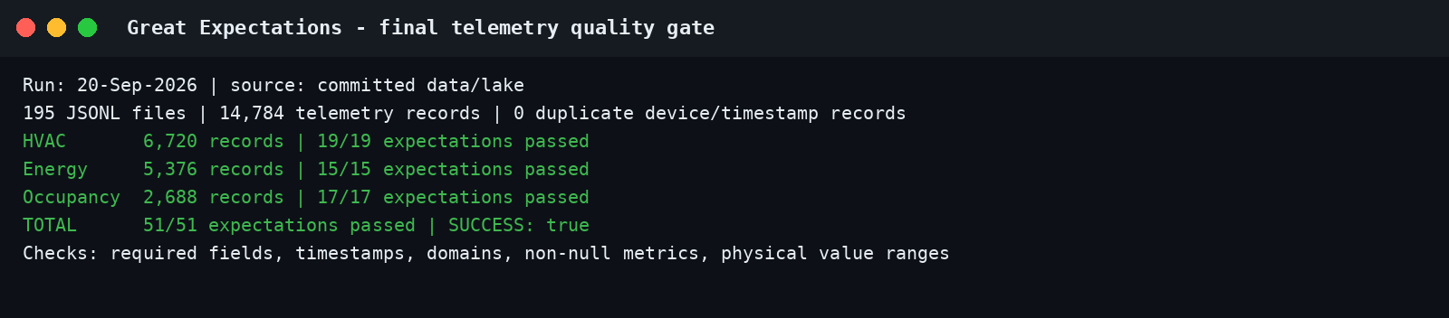

EV-08 — Final regression, browser E2E and load run
What this proves | 80 pytest tests passed with 87% statement coverage; 2/2 Selenium journeys passed; Locust produced 1,402 requests with 25 concurrent users, 0 failures and p99 5 ms on the local Streamlit HTTP surface.
Deliverable ID (Sec 3) | D-07, D-10, D-11
Date of Development / Testing | 20-Sep-2026
Verifiable link | https://github.com/subhikshathirunavukkarasu0503/facilityiq/tree/ae4a8b4df6493998431db7f1c29786b9c15fd6fa/docs/evidence/final
Carried from Mid-Term? | ☑ No (new / progressed)
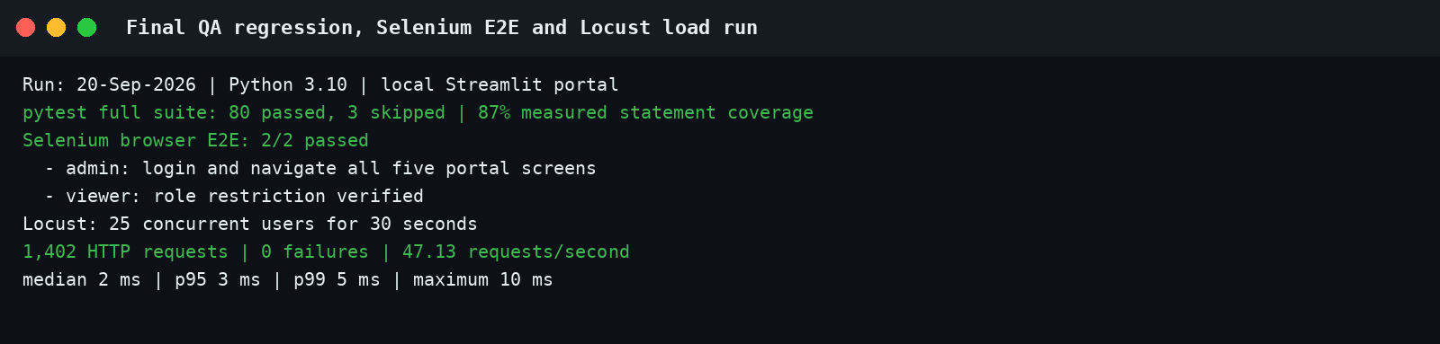

EV-09 — Model results and completion boundary
What this proves | Confirms current held-out model metrics and explicitly separates delivered scope from cloud components blocked during the final Azure validation attempt.
Deliverable ID (Sec 3) | D-04, D-05, D-12
Date of Development / Testing | 20-Sep-2026
Verifiable link | https://github.com/subhikshathirunavukkarasu0503/facilityiq/tree/ae4a8b4df6493998431db7f1c29786b9c15fd6fa/docs/evidence/final
Carried from Mid-Term? | ☑ No (new / progressed)
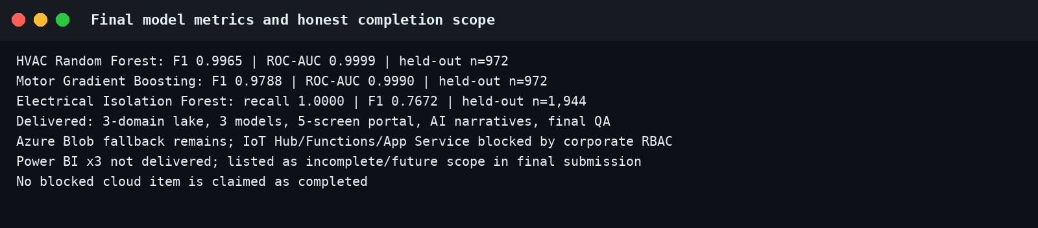

EV-10 — Final source, evidence and dataset commits
What this proves | Commits 3bac9f2 through ae4a8b4 add the Great Expectations validator, Locust profile, Selenium journeys, tests, raw result files and three validated Power BI datasets.
Deliverable ID (Sec 3) | D-10–D-12
Date of Development / Testing | 20-Sep-2026
Verifiable link | https://github.com/subhikshathirunavukkarasu0503/facilityiq/commit/ae4a8b4df6493998431db7f1c29786b9c15fd6fa
Carried from Mid-Term? | ☑ No (new / progressed)

EV-11 — Three Power BI Service reports
What this proves | Live reports and semantic models were created in My workspace for Equipment Health, Energy Consumption and Space Utilization. Each report contains a real table visual built from the validated CSV export.
Deliverable ID (Sec 3) | D-09
Date of Development / Testing | 21-Sep-2026
Verifiable link | Equipment: https://app.powerbi.com/groups/me/reports/ced34aee-008a-46a2-b0fa-ffb1a9b85d80?experience=power-bi ; Energy: https://app.powerbi.com/groups/me/reports/e09268d2-7f5d-4518-bab2-1fd9f39734f2?experience=power-bi ; Space: https://app.powerbi.com/groups/me/reports/388c3a7f-1caf-469b-a779-da2b1d136041?experience=power-bi
Carried from Mid-Term? | ☑ No (new / progressed)
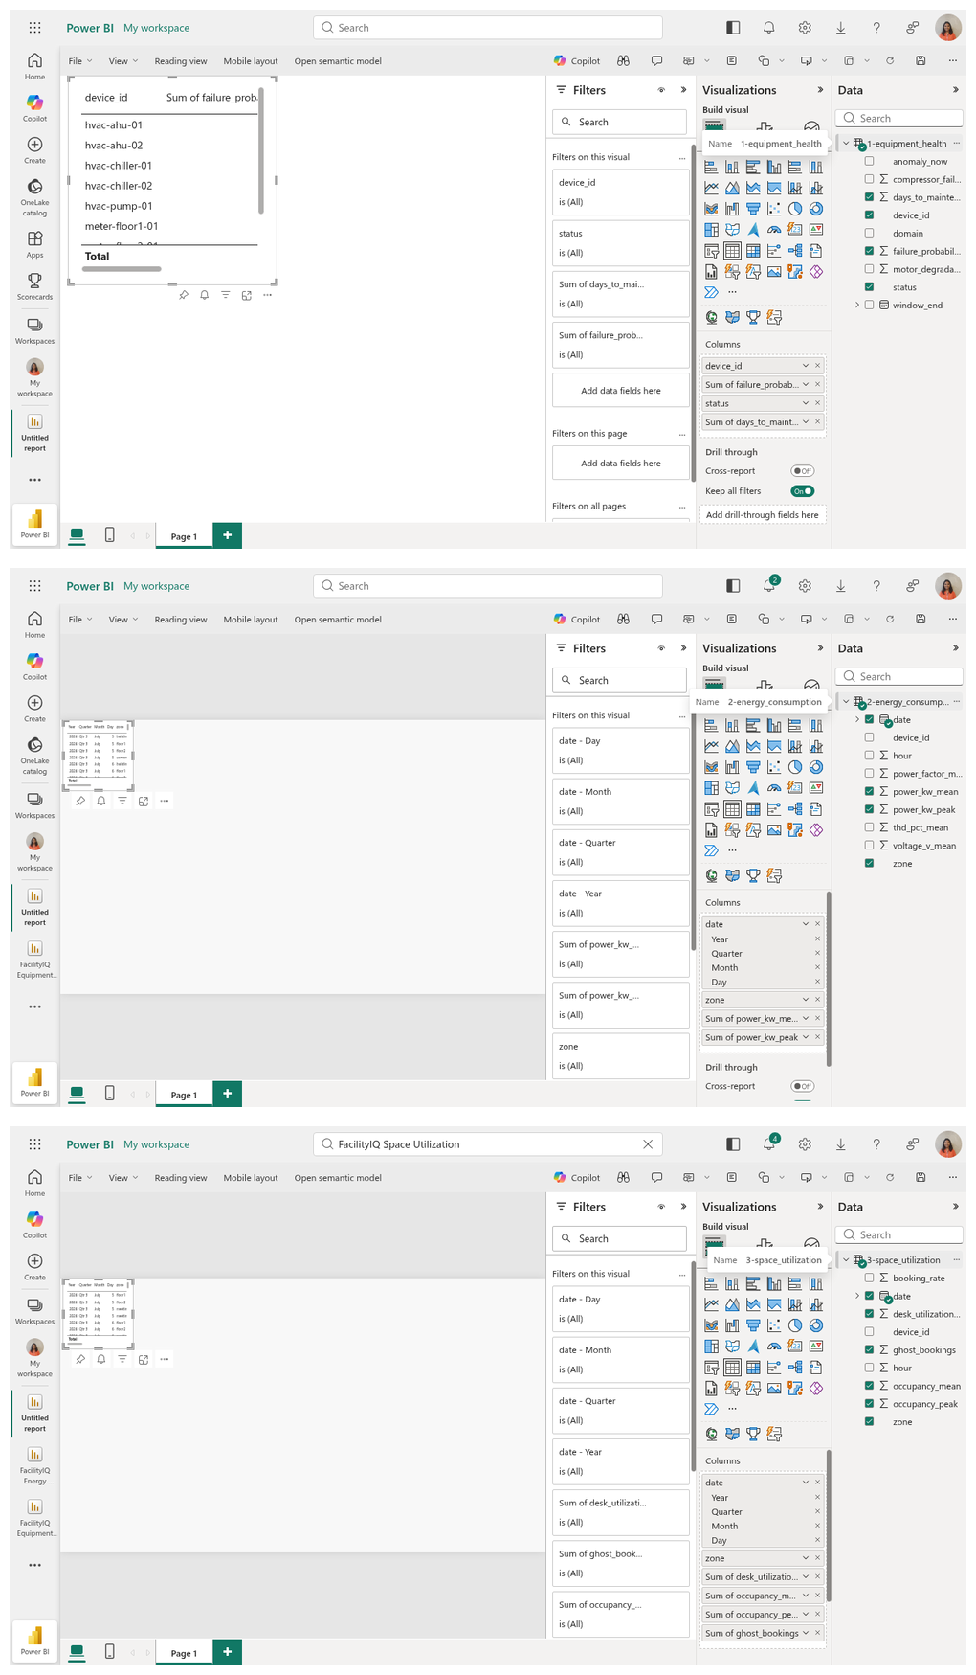

EV-12 — Not used
What this proves | No additional evidence claimed.
Deliverable ID (Sec 3) | N/A
Date of Development / Testing | N/A
Verifiable link | N/A
Carried from Mid-Term? | ☑ No (not used)

5. Working Demo, Repository & Live Walkthrough Plan
Code repository URL (GitHub/GitLab) | https://github.com/subhikshathirunavukkarasu0503/facilityiq
Final commit ID + date (as of final submission) | ae4a8b4df6493998431db7f1c29786b9c15fd6fa — 20-Sep-2026
Deployed / hosted URL (if any) | https://facilityiq-subhiksha.streamlit.app — live FacilityIQ sign-in portal; the free Streamlit app may sleep after inactivity and can be woken from its landing page. Local portal remains the fallback
Notebook / dashboard / other artefact links | https://github.com/subhikshathirunavukkarasu0503/facilityiq/tree/ae4a8b4df6493998431db7f1c29786b9c15fd6fa/docs/evidence/final
5.1 Live Code Walkthrough Plan
Great Expectations telemetry quality gate | src/facilityiq/qa/data_quality.py; scripts/run_data_quality.py; tests/test_data_quality.py
Browser and load QA | tests/test_selenium_e2e.py; locustfile.py; docs/evidence/final/
Branch | main at commit ae4a8b4df6493998431db7f1c29786b9c15fd6fa
Open in advance | data/lake; models/*_metrics.json; docs/evidence/final/data_quality_report.json; locust_report.html
6. QA Progress (Full Programme)
Test Type (per approved QA strategy) | Tests written / run (total) | Coverage achieved (measured) | Target (per proposal) | Evidence ID(s)
Unit + integration + model + UI regression | 80 passed; 3 environment-gated skips | 87% measured statement coverage | >80% | EV-08
Great Expectations data quality | 14,784 records; 51/51 expectations passed | 100% expectation pass; 0 duplicates | Zero invalid records | EV-07
Selenium browser E2E | 2 journeys: admin five-screen navigation and viewer restriction | 2/2 passed | 5 E2E scenarios proposed; 2 final browser journeys executed | EV-08
Locust load test | 25 users, 30 sec, 1,402 requests | 0 failures; p99 5 ms; 47.13 req/s | <2 sec portal response | EV-08
7. Tool & Budget Reconciliation (Full Programme)
Tool / Service (approved) | Approved tier & cost | Used in final solution? | Actual cost (₹) | Reason if changed / not used
Azure IoT Hub | F1 Free / ₹0 | No | 0 | Draft validated to final review, then Azure returned a generic Validation failed; no resource was created.
Azure Functions | Free / ₹0 | No | 0 | Depends on IoT Hub provisioning; not claimed.
Azure Blob Storage | Free/low-cost | Yes | Not independently verified after Mid-Term | Direct lake fallback documented at Mid-Term.
Azure App Service | Free / ₹0 | No | 0 | Azure App Service provisioning was blocked; no resource was created. Streamlit fallback is live.
Databricks + MLflow | Free | Partial | 0 | Local pandas/scikit-learn; MLflow retained locally.
scikit-learn + PyCaret | Free | Partial | 0 | scikit-learn used; PyCaret omitted.
Power BI Service | Free / existing organisational licence | Yes | 0 | Three reports and three semantic models created in My workspace from validated CSV exports.
Streamlit | Free | Yes | 0 | Five-screen portal and local QA target.
Gemini | Free tier / ₹400 provision | Yes | 0 reported | Narratives use cache/fallback.
Ollama + Llama | Free | No | 0 | Not needed; retained only as planned fallback.
GitHub + Actions | Free | Yes | 0 | Repository, history and CI workflow.
Pytest + Selenium | Free | Yes | 0 | 80 passing tests; 2 final browser journeys.
Great Expectations | Free | Yes | 0 | 51/51 final data expectations passed.
Domain (optional) | ₹450 | No | 0 | Optional purchase omitted.
Groq API | Free tier | Yes, per supplied project record | 0 | Included in source; claimed L&D condition remains unverified without official feedback.
7.1 Budget Summary
Approved budget ceiling | ₹2,500
Actual spend till Mid-Term | ₹0 reported in Mid-Term
Actual spend, Mid-Term to Final | ₹0 reported; Azure storage billing not independently accessible
Total actual spend | ₹0 reported, subject to owner account verification
Buffer remaining | ₹2,500 reported, subject to owner account verification
8. Deviations from Approved Proposal (Full Programme)
Item | Approved plan | Actual implementation | Reason for change
IoT ingestion path | IoT Hub → Functions → Blob | Validated local lake → direct Azure Blob fallback; IoT client code retained | Final Azure validation/provisioning was blocked; no IoT Hub or Function resource was created.
ML compute | Databricks + PyCaret | Local pandas/scikit-learn; local MLflow | Carried from Mid-Term; appropriate for POC volume.
Deployment | Azure App Service | Live Streamlit cloud sign-in portal plus local fallback | Azure App Service provisioning remained blocked; no resource was created.
Analytics dashboards | Power BI x3 | Three live Power BI Service reports backed by validated CSV exports | Completed on 21-Sep-2026; live URLs and screenshots recorded in EV-11.
QA completion | Great Expectations, load and E2E planned | Implemented and executed in final phase | New final-phase completion on 20-Sep-2026.
9. Enhancements & Additional Value-Adds
ID | Enhancement (beyond approved scope) | Why you added it / value it adds | Status | Cost impact (₹) | Evidence ID(s)
EN-01 | Four-role access control and admin view | Controls screen access and supports operational demos | Done | 0 | Mid-Term EV-01
EN-02 | Live weather, air quality and footfall context | Adds external operational context | Done | 0 | Mid-Term EV-02/03
EN-03 | Dual AI provider and deterministic cache/template fallback | Keeps explanations available during API/network failure | Done | 0 | Mid-Term EV-03
EN-04 | Automated final data-quality and load evidence | Turns final QA into repeatable scripts and machine-readable reports | Done | 0 | EV-07, EV-08
10. What Is NOT Completed + Future Scope
Pending item (be specific) | Why it wasn't completed | Flagged at Mid-Term? (Y/N) | Recommended future scope
IoT Hub + Functions live route | Azure validation/provisioning was blocked; no resource was created | Y | Provision in the assigned RG, set the device connection string, verify route to existing Blob container.
Azure App Service deployment | Azure App Service provisioning was blocked; no resource was created | Y | Deploy after IT provisions F1 plan; retain Streamlit as backup.
Public cloud portal availability | Free Streamlit app can sleep after inactivity | N | Wake the app before review; local portal remains the fallback.
Official Mid-Term result/feedback and final review dates | Not supplied with project materials | N | Attach official feedback and update Section 1 before submission if available.
11. Risks & Blockers — Final Status
Risk / Blocker | Final Status (Mitigated / Realised / Accepted) | Mitigation taken | Final impact on delivered project
Azure validation/provisioning blocks IoT Hub/App Service | Accepted | Direct-Blob and local/Streamlit fallbacks retained; the final IoT Hub attempt returned a generic validation failure and created no resource. | Core POC works; approved cloud route is incomplete.
Model accuracy below target | Mitigated | Grouped held-out testing; final metrics retained in repository. | HVAC and motor exceed F1 target; electrical recall is 1.00.
AI/API availability | Mitigated | Caching, provider fallback and deterministic templates. | Portal remains usable without live narrative call.
Power BI report depth | Mitigated | Created three live reports with table visuals and retained validated source datasets. | Reports exist and are evidenced; further visual design remains optional refinement.
Credential exposure in supplied spreadsheet | Realised | Key rotation and password rotation requested; secrets omitted from this document. | Owner must rotate exposed key/passwords before review.
12. Declaration & Pre-Submission Checklist
☐ All fields in Section 1 match my L&D Final Decision record exactly, and the Mid-Term document filename is the exact file I uploaded at Week 10.
☑ Section 3 lists every deliverable my approved proposal committed to across the full programme (Week 4–17), each with a D-ID and a status, reusing my Mid-Term D-IDs.
☑ Deliverables, evidence, and deviations carried forward from Mid-Term are clearly marked as such — nothing is silently omitted.
☑ Every "Done" or "Partial" status in Section 3 points to at least one Evidence ID in Section 4 (here or, if carried, in my Mid-Term document).
☑ Every evidence block in Section 4 has a specific caption, a Date of Development/Testing, and either a pasted full-size screenshot or a ticked carry-forward reference.
☐ The repository link in Section 5 is accessible to the L&D team, the stated final commit exists, and the walkthrough file paths in Section 5.1 exist in the repository.
☑ Section 6 coverage figures are measured (tool output attached as evidence), not estimated.
☑ Section 7 lists every tool from my approved proposal, including ones I did not use, and reflects final total spend.
☑ Section 8 discloses every deviation across the full programme, including ones already reported at Mid-Term.
☑ Section 9 (Enhancements) is filled in with cost impact per entry, and its costs reconcile with Section 7 — "None" is written if genuinely not applicable.
☑ Section 10 is consistent with Sections 3 and 4 and with my Mid-Term document — no contradictions.
☑ I have deleted all grey italic instruction text.
☑ I have not renamed, deleted, or reordered any section of this template.
☑ Document is saved as [TopicID]_[ParticipantName]_FinalTermDoc.docx and uploaded to Moodle before the deadline.
Declaration: I confirm that all progress claims, evidence, costs, and coverage figures in this document are true and reflect my own individual work across the full programme.
Participant signature / name | Subhiksha Thirunavukkarasu
Date of submission | 21-Sep-2026
Submission deadline: before the start of the Week 17 Final Review window, as communicated by L&D. Late or incomplete documentation may affect your final evaluation score and winner eligibility.

