# TCR Innovation project

DV with Py internship program

project name: Data analysis and visualization on IMDb Movies

Group Member’s Name: Subhash kumar Mahato , Rita Pradhan, Mamta Prajapati

batch_name: DV with python sept. Batch

____________________________________________________________________

#importing python libraries.

import pandas as pd

import seaborn as sns

import matplotlib.pyplot as plt

imdb_df = pd.read_csv('./IMDB-Movie-Data.csv') #reading imdb dataset csv file

imdb_df.head(100).style.background_gradient(axis=0, cmap='YlOrRd') #displaying top 100 data

output:

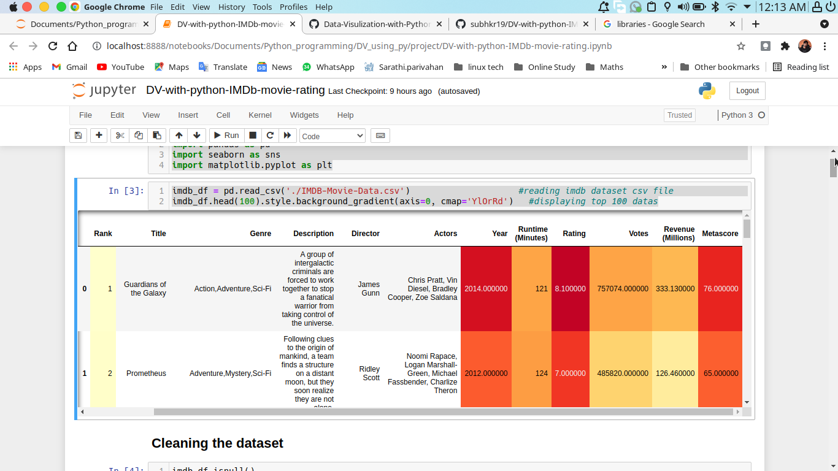

**Cleaning the dataset**

imdb_df.isnull()

Output:

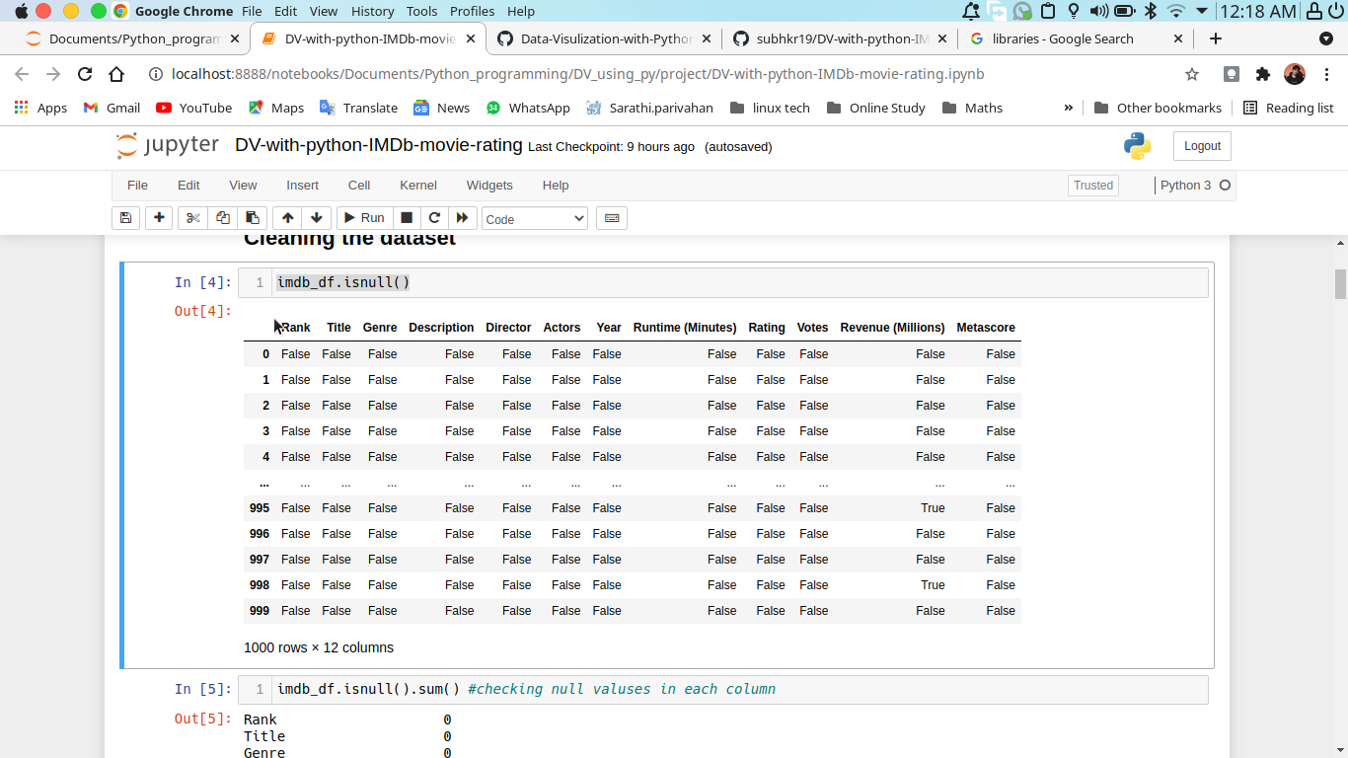

imdb_df.isnull().sum() #checking null valuses in each column

Output:

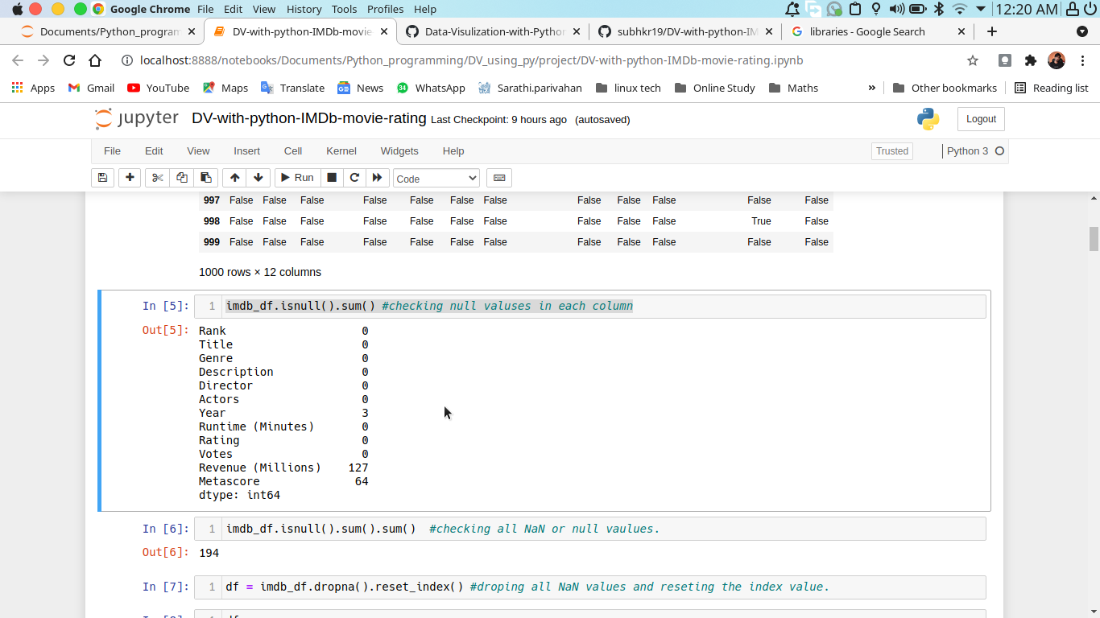

imdb_df.isnull().sum().sum() #checking all NaN or null vaulues.

Output:

194

df = imdb_df.dropna().reset_index() #droping all NaN values and reseting the index value.

Output:

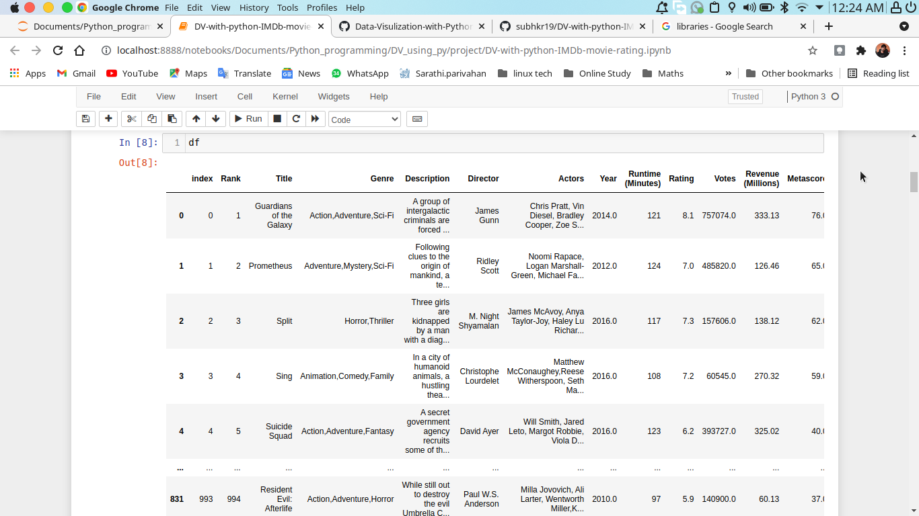

df.isnull().sum().sum() #checking is there any null value or not

Output:

0

df.describe() #Stastical details of the dataset.

Ou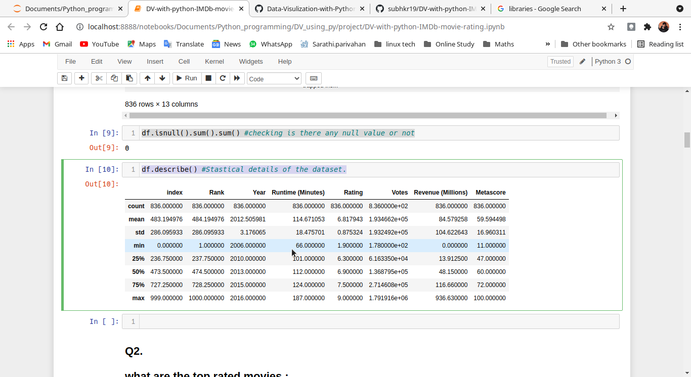tput:

**Q2.**

**what are the top rated movies :**

df_sorted = df.sort_values('Rating',ascending=False) #sorting the DataFrame in decending order according to the movie's rating

**Top 10 rating movies and their Director names**

top10_movie = df_sorted.head(10)[['Title','Rating','Runtime (Minutes)','Director']].set_index('Title')

top10_movie

output:

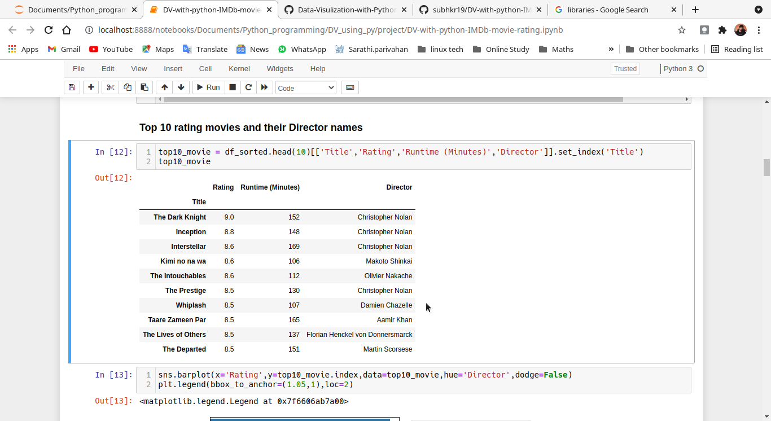

sns.barplot(x='Rating',y=top10_movie.index,data=top10_movie,hue='Director',dodge=False)

plt.legend(bbox_to_anchor=(1.05,1),loc=2)

output:

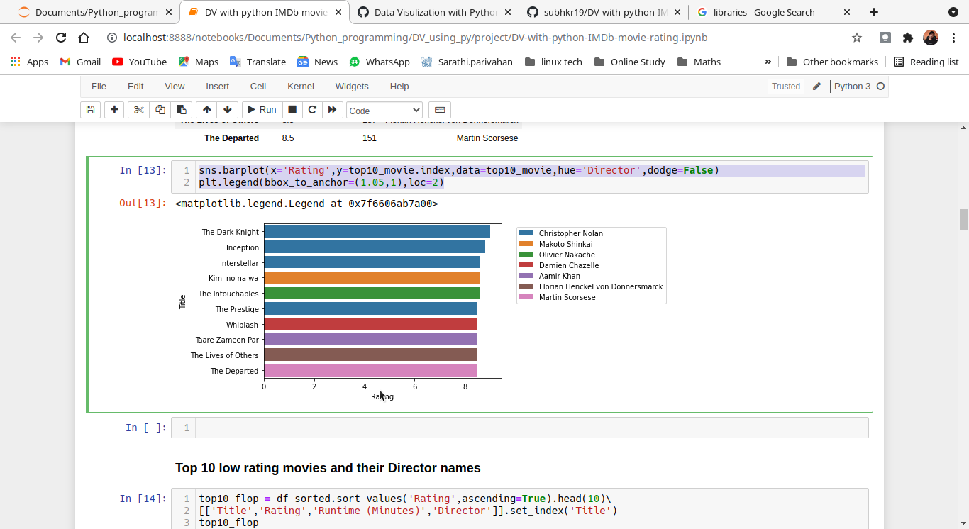

**Top 10 low rating movies and their Director names**

top10_flop = df_sorted.sort_values('Rating',ascending=True).head(10)\

[['Title','Rating','Runtime (Minutes)','Director']].set_index('Title')

top10_flop

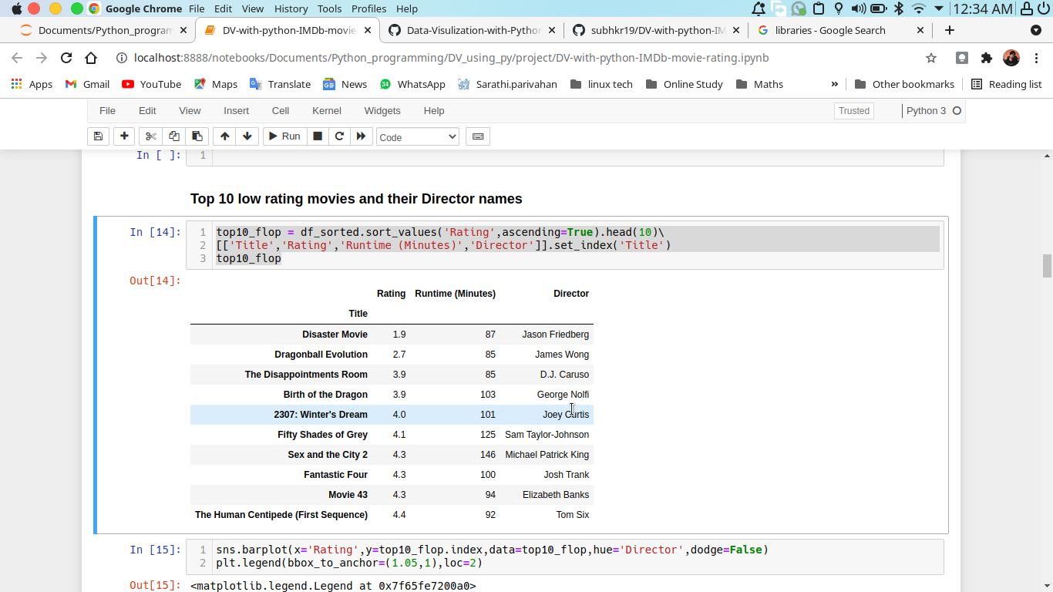

sns.barplot(x='Rating',y=top10_flop.index,data=top10_flop,hue='Director',dodge=False)

plt.legend(bbox_to_anchor=(1.05,1),loc=2)

Output:

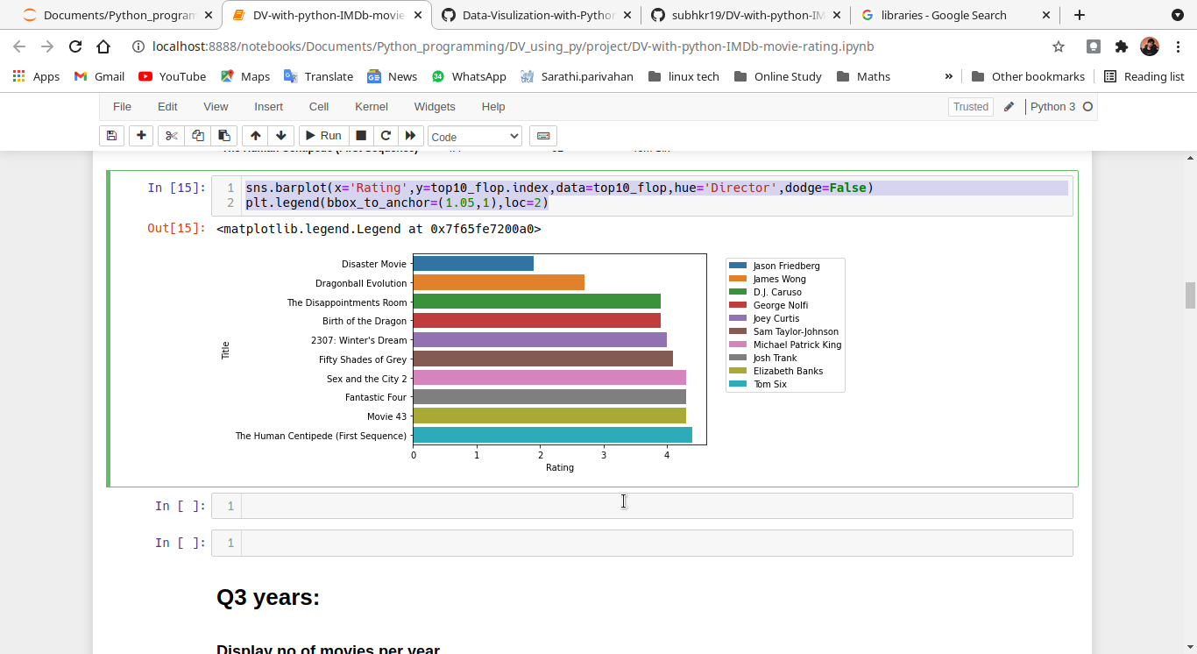

**Q3 years:**

**Display no of movies per year**

movie_per_year = df['Year'].value_counts()

movie_per_year

Output:

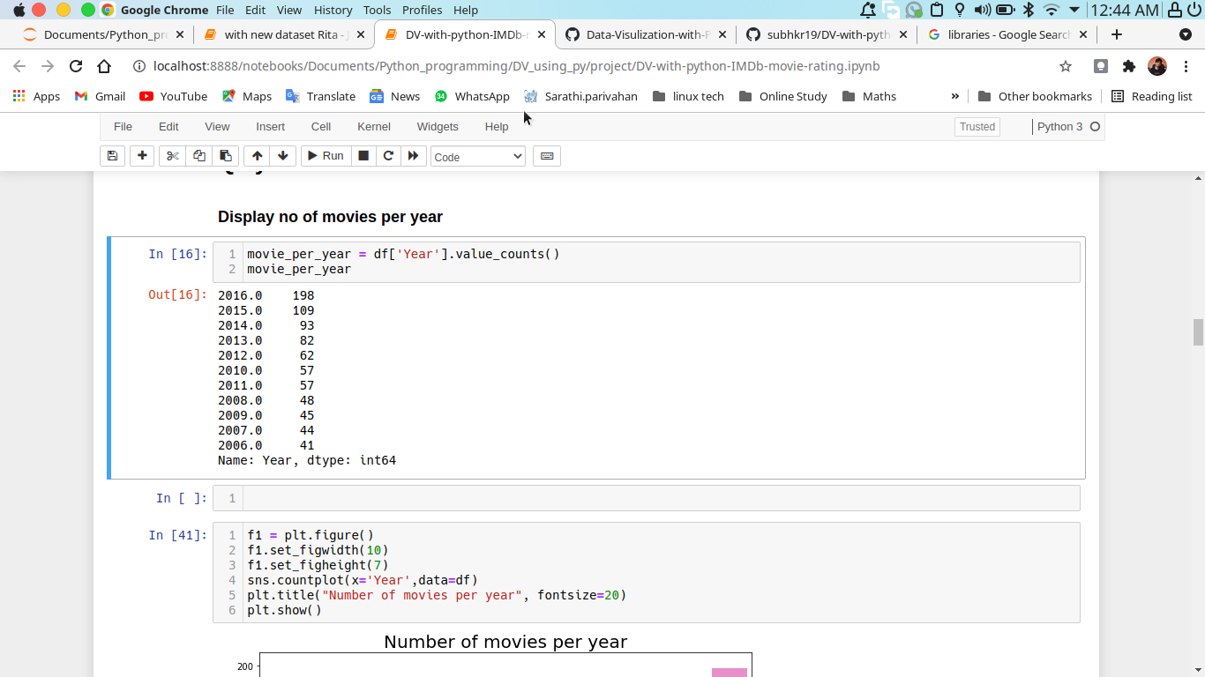

f1 = plt.figure()

f1.set_figwidth(10)

f1.set_figheight(7)

sns.countplot(x='Year',data=df)

plt.title("Number of movies per year", fontsize=20)

plt.show()

output:

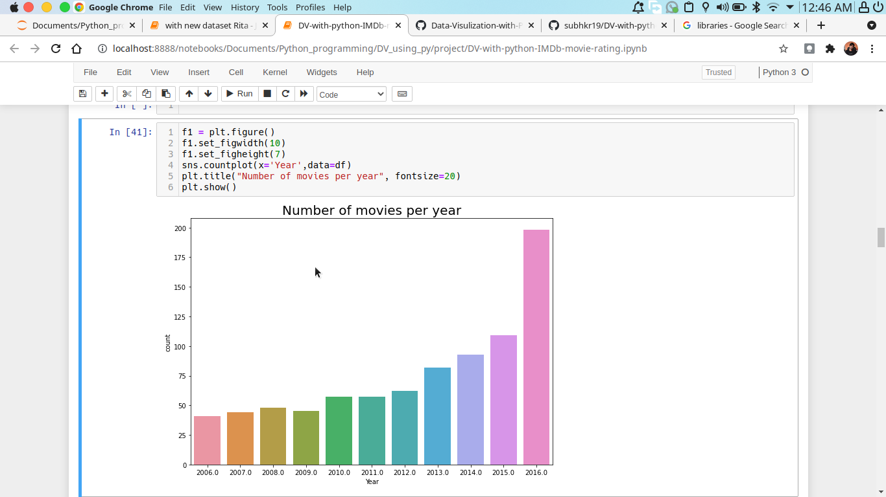

**Q4 Duration**

**sort movies based on duration.**

df_sorted_duration = df.sort_values('Runtime (Minutes)',ascending=False)

df_sorted_duration[['Title', 'Runtime (Minutes)', 'Revenue (Millions)']].set_index('Title')

output:

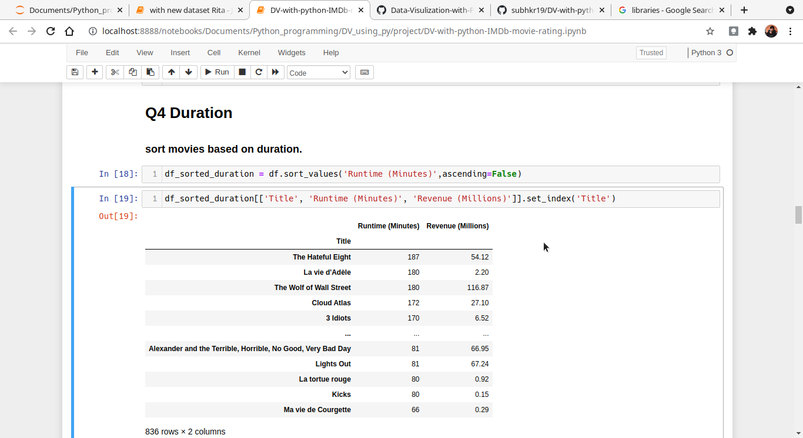

**Q5 Genre**

**how many movies made of each Genre**

df.pivot_table(index='Genre', aggfunc='count')[['index']] #displaying the average value of the each Genre.

Output:

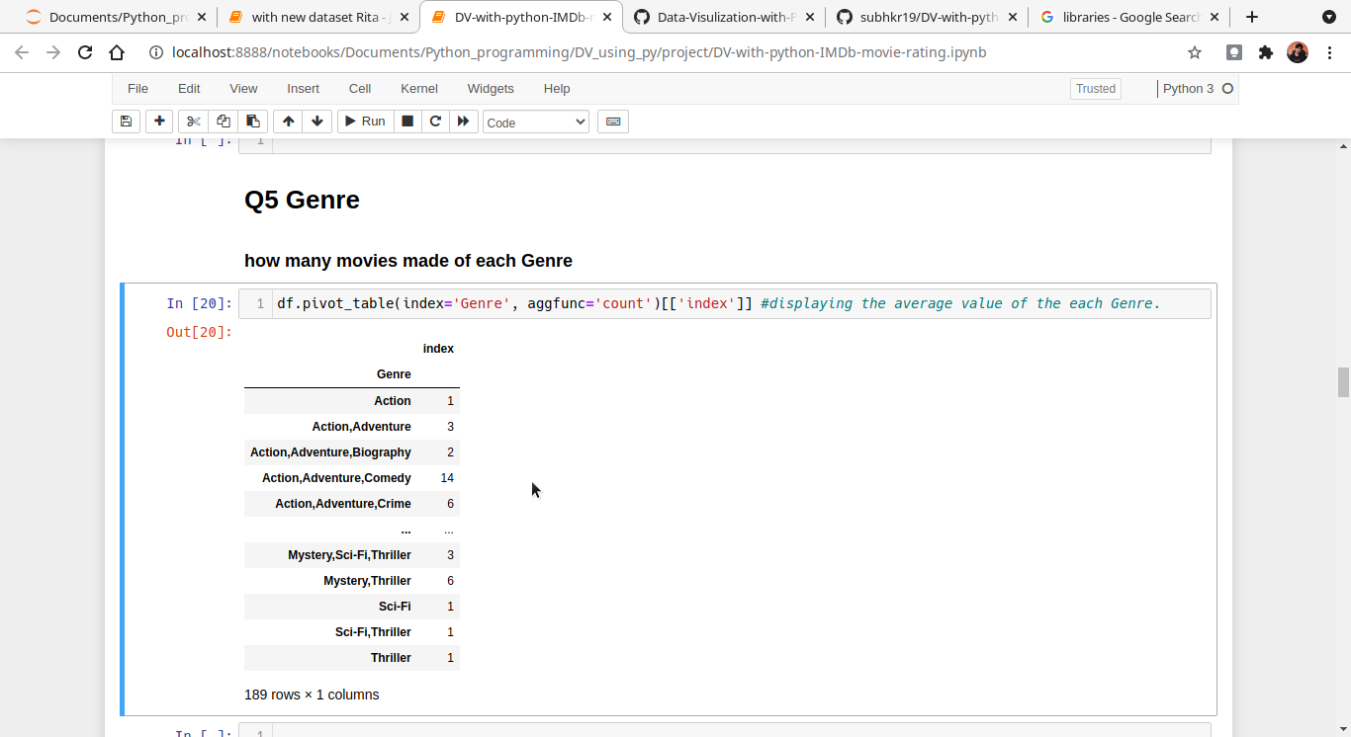

**Display movie details made of Genre is equal to comedy**

df[df['Genre'].isin(['Comedy'])]

output:

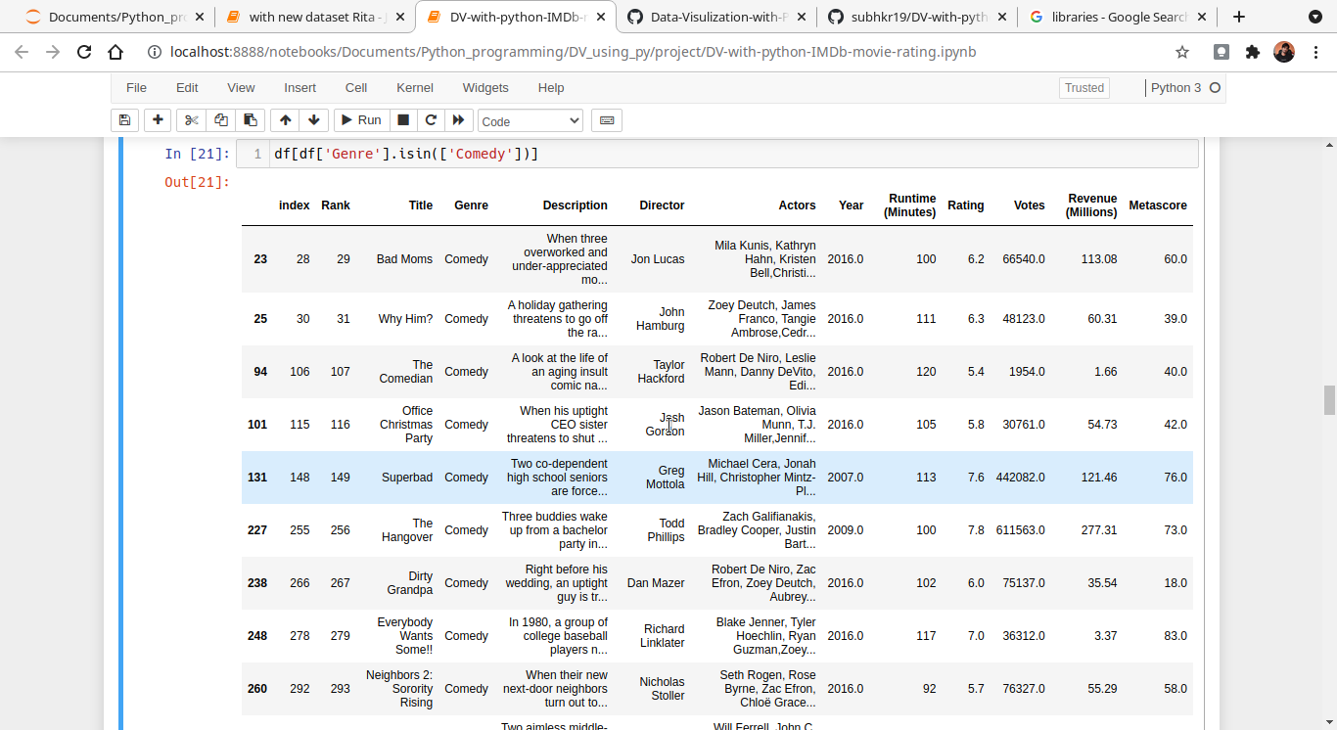

genre_df = df[df['Genre'].isin(['Comedy', 'Action', 'Sci-Fi', 'Drama', 'Horror','Action,Thriller', 'Drama,Thriller', 'Horror,Thriller', 'Crime,Drama,Mystery'])]

genre_df['Genre'].value_counts()

output:

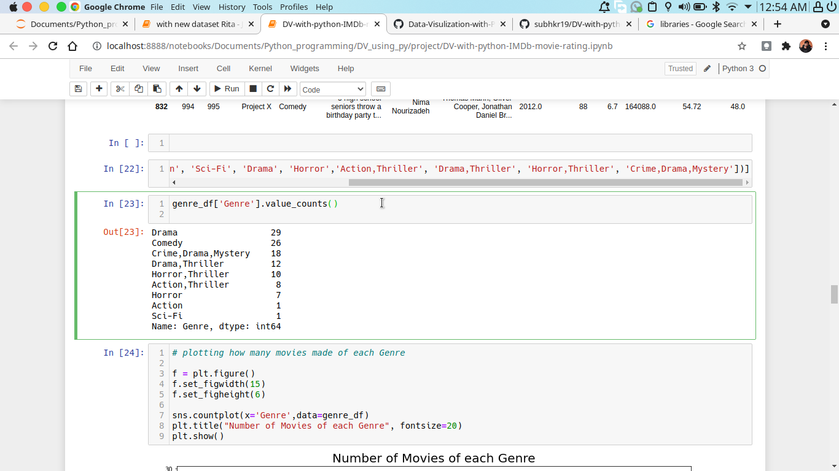

# plotting how many movies made of each Genre

f = plt.figure()

f.set_figwidth(15)

f.set_figheight(6)

sns.countplot(x='Genre',data=genre_df)

plt.title("Number of Movies of each Genre", fontsize=20)

plt.show()

Output:

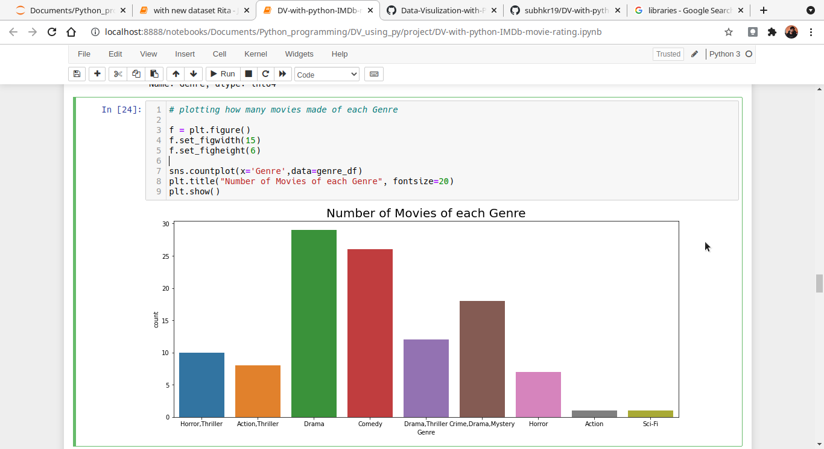

**Q6 voted**

**Top voted movies**

top_voted_movies = df.nlargest(5, 'Votes')[['Title','Votes','Rating']].set_index('Title') #top 5 voted movies Name and their Ratings

top_voted_movies

output:

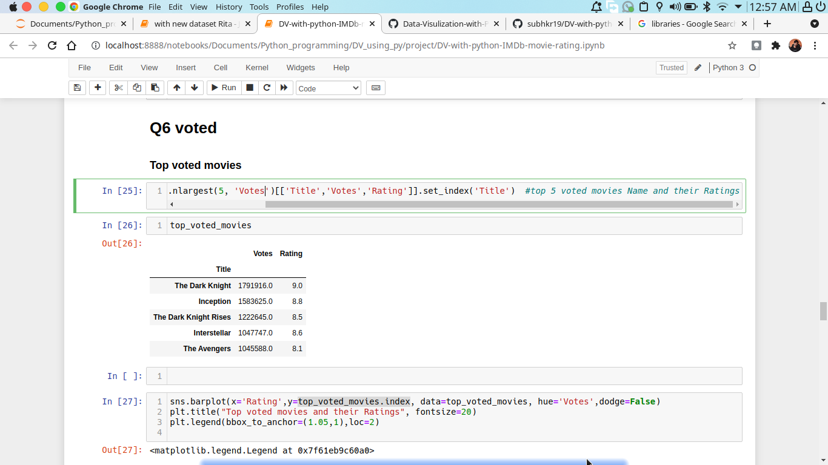

sns.barplot(x='Rating',y=top_voted_movies.index, data=top_voted_movies, hue='Votes',dodge=False)

plt.title("Top voted movies and their Ratings", fontsize=20)

plt.legend(bbox_to_anchor=(1.05,1),loc=2)

output:

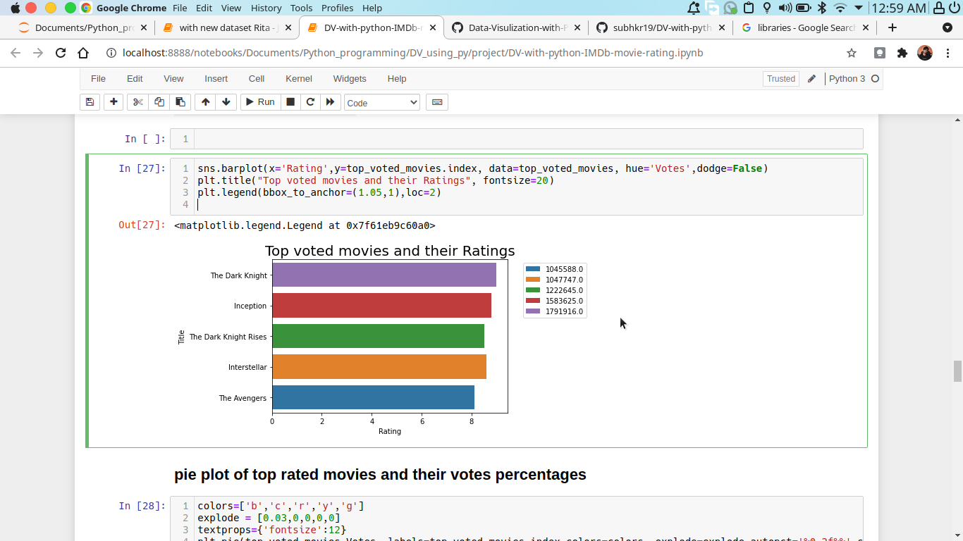

**pie plot of top rated movies and their votes percentages**

colors=['b','c','r','y','g']

explode = [0.03,0,0,0,0]

textprops={'fontsize':12}

plt.pie(top_voted_movies.Votes, labels=top_voted_movies.index,colors=colors, explode=explode,autopct='%0.2f%%',startangle=90,textprops=textprops)

plt.show()

Output:

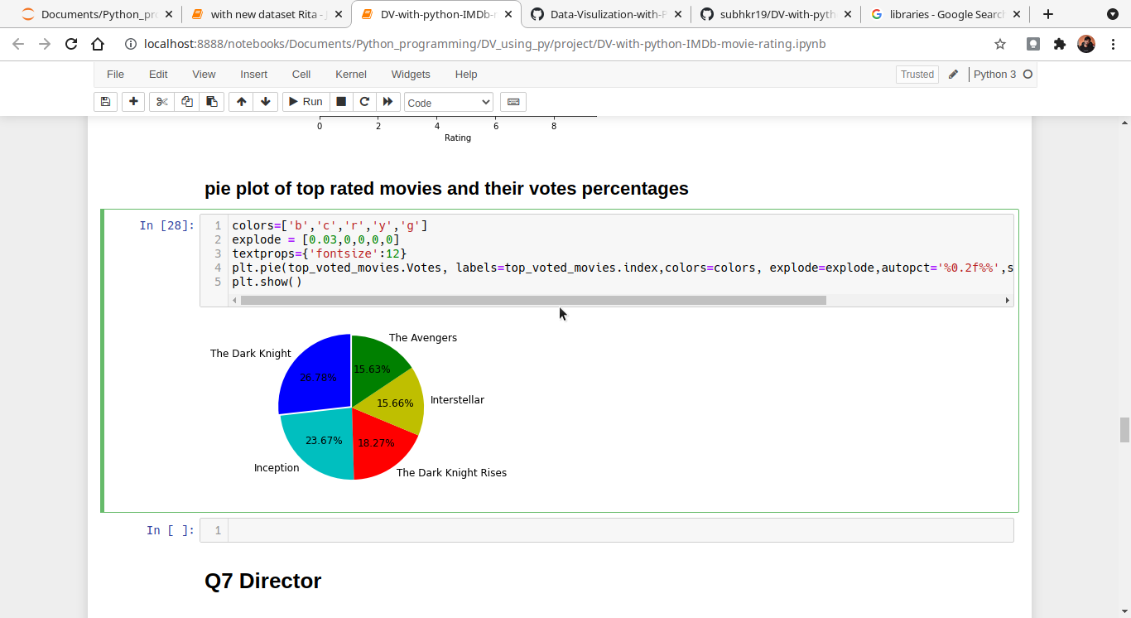

**Q7 Director**

**Average rating and revenue of each Director.**

df.pivot_table(index='Director', aggfunc='mean')[['Rating', 'Revenue (Millions)']]

output:

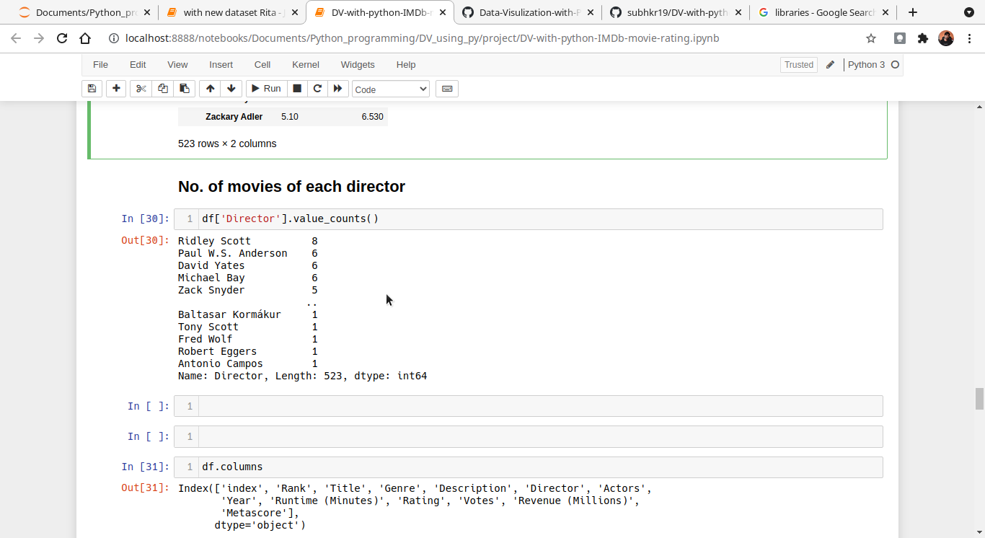

**Q8 Actor**

**Display & count movies name by each actor**

df.pivot_table(index=['Actors'], aggfunc='count')

output:

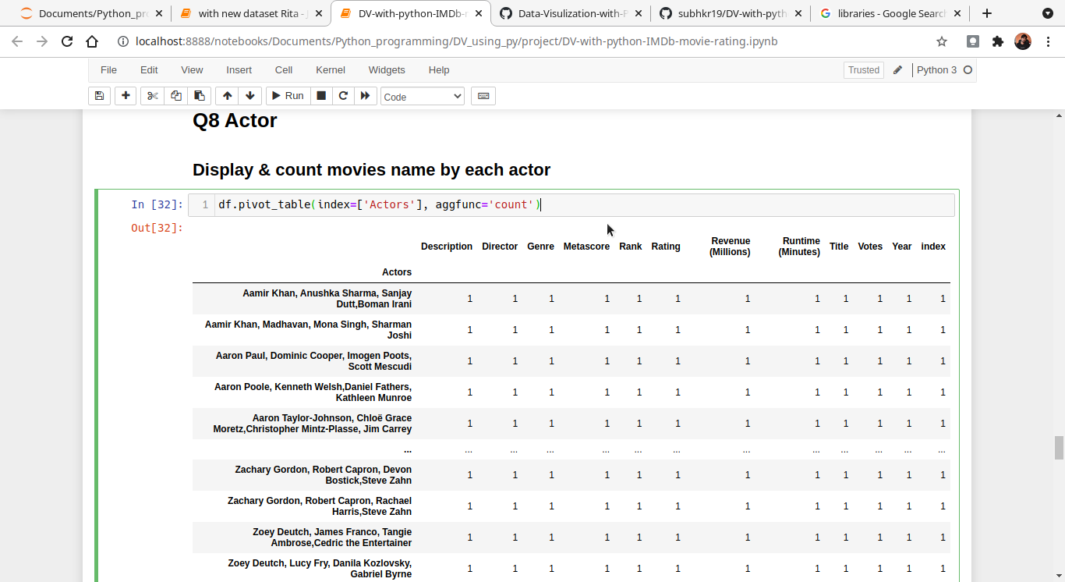

grp = df.groupby(by='Actors').get_group('Aamir Khan, Anushka Sharma, Sanjay Dutt,Boman Irani') #displaying all movies detaisl of actor name is Aamir khan

grp

output:

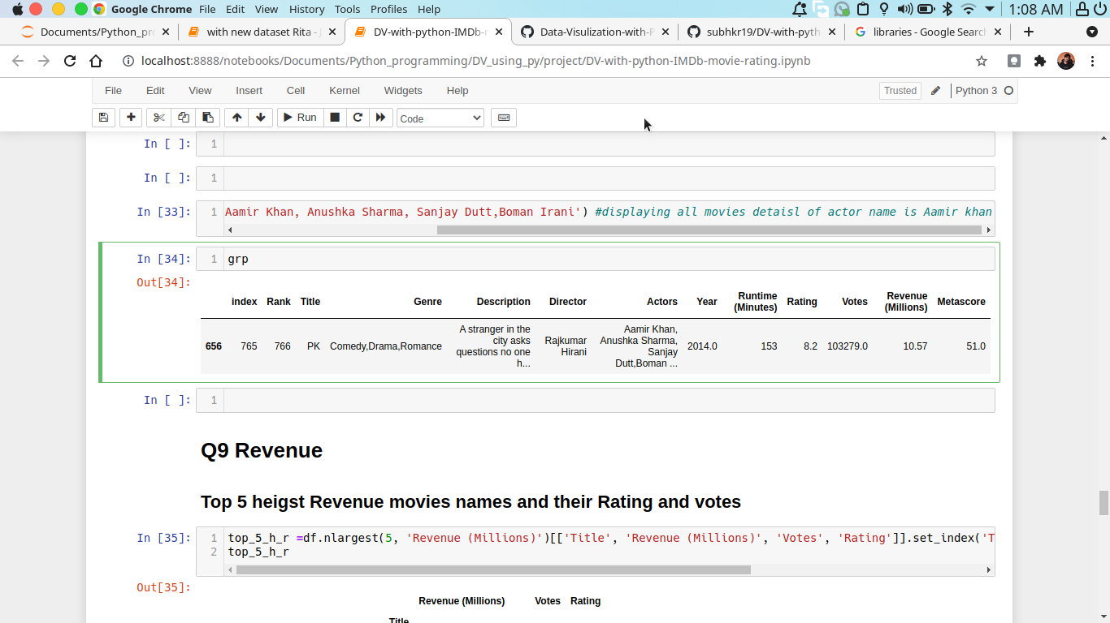

**Q9 Revenue**

**Top 5 heigst Revenue movies names and their Rating and votes**

top_5_h_r =df.nlargest(5, 'Revenue (Millions)')[['Title', 'Revenue (Millions)', 'Votes', 'Rating']].set_index('Title') #top 5 voted movies Name and their Ratings

top_5_h_r

Output:

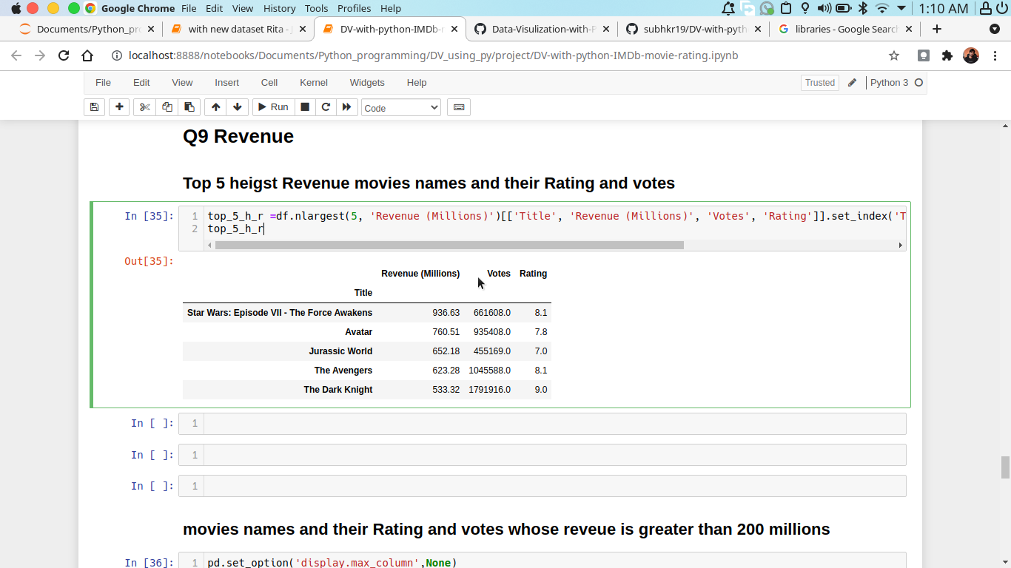

**movies names and their Rating and votes whose reveue is greater than 200 millions**

pd.set_option('display.max_column',None)

pd.set_option('display.max_rows',None)

df[df['Revenue (Millions)']>200][['Title', 'Revenue (Millions)', 'Votes', 'Rating']].style.background_gradient(axis=0, cmap='YlOrRd')

output:

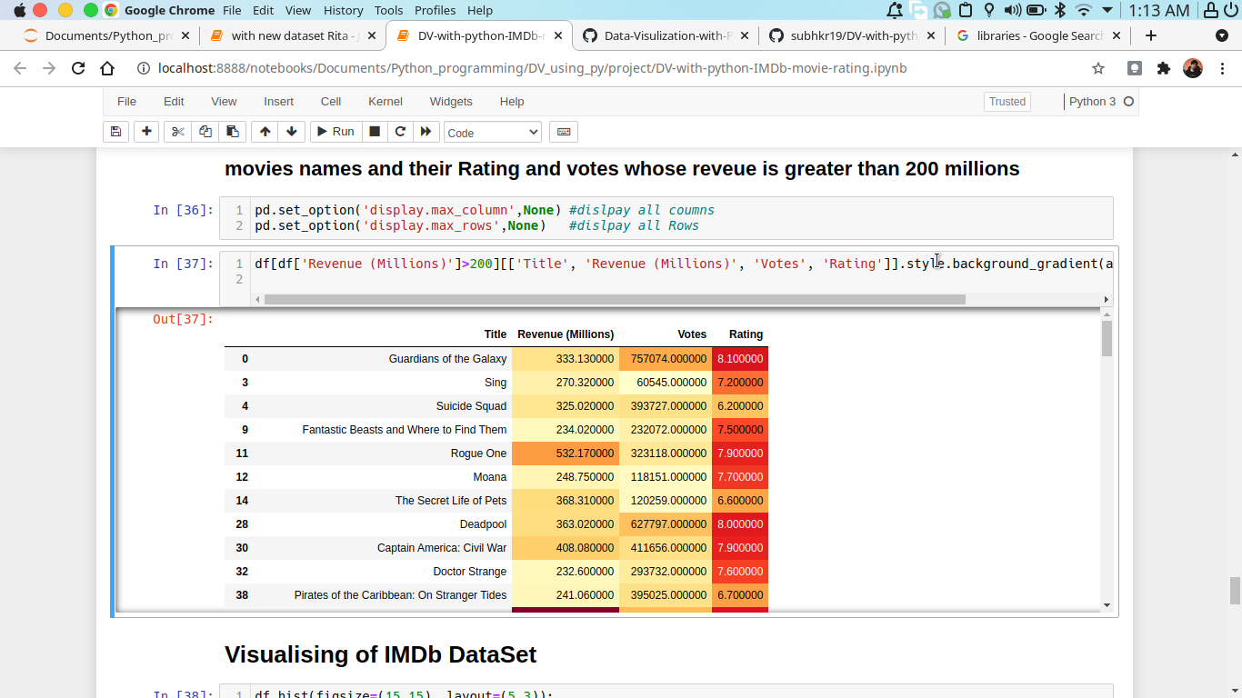

**Visualising of IMDb DataSet**

df.hist(figsize=(15,15), layout=(5,3));

output:

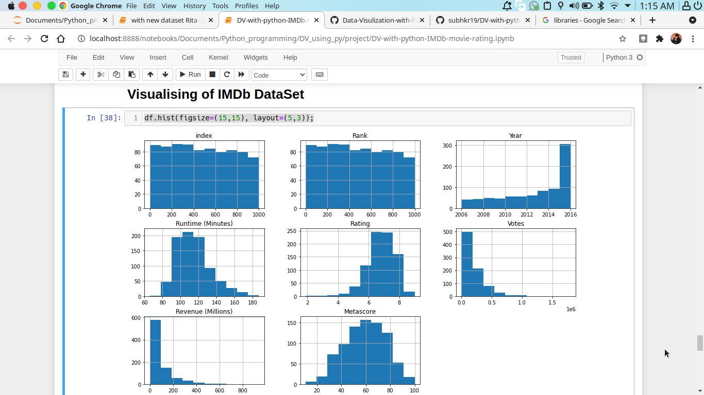

df.plot(kind='box', subplots=True, layout=(5,3), figsize=(15,15))

plt.show()

output:

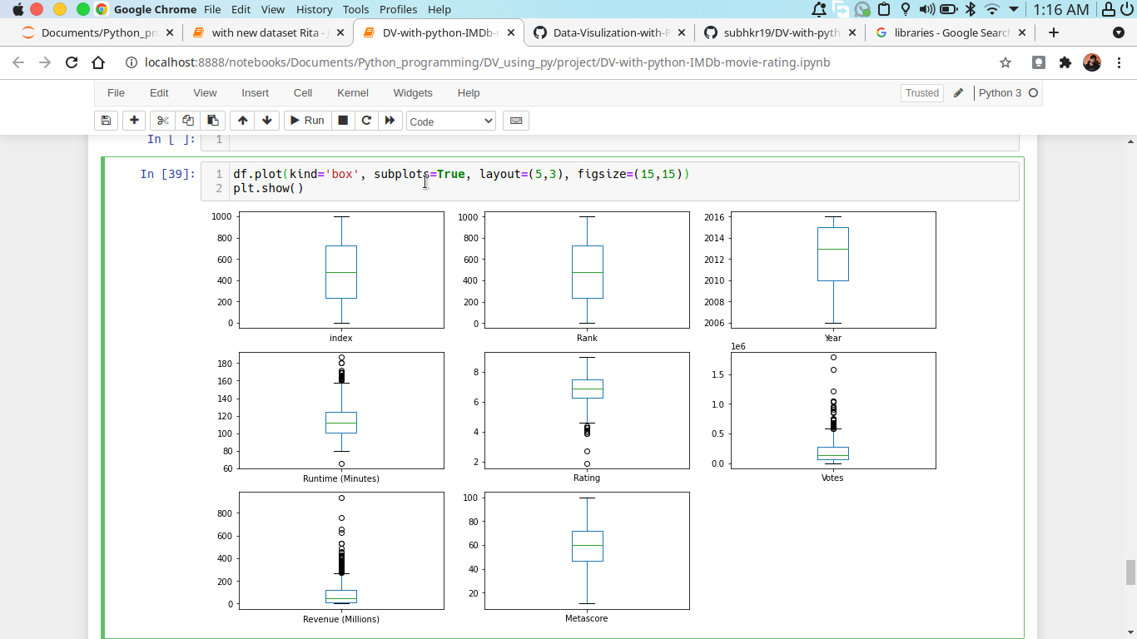

sns.pairplot(data=df)

output:

