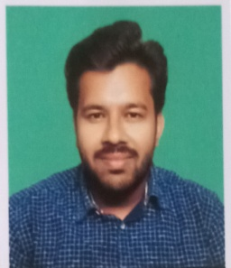**RESUME**

**SUBHO YADAV**

+91 90072-59485 / +91 62890-41619

Email ID: [subhoyadav16@gmail.com](mailto:subhoyadav16@gmail.com)

**OBJECTIVE**

To seek challenging avenues, where my knowledge and experience can grow and enhance with the organization’s growth and enhancements and to continue with the achievements of organizational goals along with the betterment of career prospects

**EDUCATIONAL QUALIFICATIONS**

* Pursued B.sc in Computer Science from University Of Kalyani in 2022

Marks: **85.68%**

* Passed 12th (10+2) with Physics , Chemistry & Mathematics from CISCE (Council for Indian School Certificate Examination) in 2019

Marks: **85%**

* Passed 10th from CISCE (Council for Indian School Certificate Examination) in 2017

Marks: **84.5%**

**SKILLS AND PROJECTS**

* Intermediate level java , c ++ , c programmer
* Experience with Microsoft Office Package
* Project on Online Examination Management System using HTML,CSS AND PHP using SQL database

**WORK EXPERIENCE**

Fresher

**STENGTHS AND HOBBIES**

* Decent speaking skills in English and Hindi Language
* Honest and Punctual
* Good at teamwork
* Self-motivated and enthusiastic
* Travelling , reading books

**PERSONAL DETAILS**

Father’s Name: Ram Prabesh Yadav

Date of Birth: 16-05-2000

Address: Halisahar East Kabirajpara Battalla H.K Bhatta Rd. Post

Hazinagar Pin: 743135

Bank Account & IFSC: 0210000100338499 , PUNB0021000