1. In the below elements which of them are values or an expression? eg:- values can be integer or string and expressions will be mathematical operators.

\*

'hello'

-87.8

-

/

6

Ans 1: -values are ‘Hello’, -87.8,6 and expressions are +, /, -, \*

2. What is the difference between string and variable?

Ans 2: - string are the value type and variable which store the value line int, string,

3. Describe three different data types.

Ans 3: -

List-

* It is a one of data type.
* It is mutable.
* List is identified by [] brackets.

Tuple: -

* It is a one of data type.
* It is immutable.
* Tuple is identified by ()

Dictionary: -

* It is one of data type
* It is mutable.
* Dictionary is identified by {}.
* It contains value in key and value.

4. What is an expression made up of? What do all expressions do?

Ans.Expression is made up of operator and operands that is use to produce some other value like + symbol of arithmetic operator uses to add two variable which contain value.

5. This assignment statements, like spam = 10. What is the difference between an expression and a statement?

Ans: - Expression contains value, containers and mathematical operator.Statement is just a command it executed like print

6. After running the following code, what does the variable bacon contain?

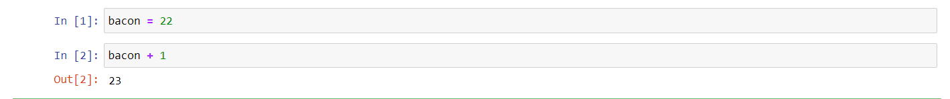

Ans6: - variable bacon contain 23

7. What should the values of the following two terms be?

'spam' + 'spamspam'

'spam' \* 3

Ans7: - 'spam' + 'spamspam' = ‘spamspamspam’

'spam' \* 3 = ‘spamspamspam’

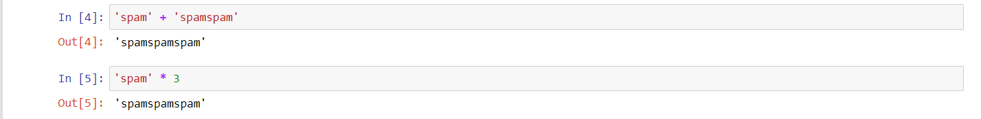8. Why is eggs a valid variable name while 100 is invalid?

Ans8. Eggs is a valid variable name while 100 is invalid because we cannot start variable with number.

9. What three functions can be used to get the integer, floating-point number, or string version of a value?

Ans: -str (), int (), float ()

10. Why does this expression cause an error? How can you fix it?

'I have eaten ' + 99 + ' burritos.'

Ans 10: -this expression add integer with string but it causes error because integer value cannot add with string value.