1.What are the two values of the Boolean data type? How do you write them?

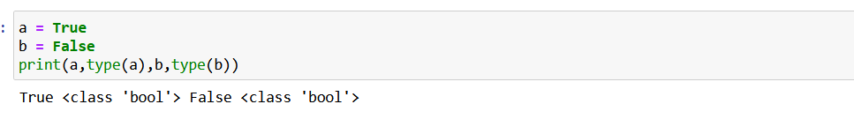

2. What are the three different types of Boolean operators?

Ans: - three different type of boolean operator is and ,or and not.

3. Make a list of each Boolean operator's truth tables (i.e. every possible combination of Boolean values for the operator and what it evaluate ).

Ans.

* **Truth Table for and operator**
  + True and True is True
  + True and False is False
  + False and True is False
  + False and False is False
* **Truth Table for or operaotor**
  + True or True is True
  + True or False is True
  + False or True is True
  + False or False is False
* **Truth Table for not operator**
  + *True not is False*
  + *False not is True*

4. What are the values of the following expressions?

(5 > 4) and (3 == 5)

not (5 > 4)

(5 > 4) or (3 == 5)

not ((5 > 4) or (3 == 5))

(True and True) and (True == False)

(not False) or (not True)

Ans:-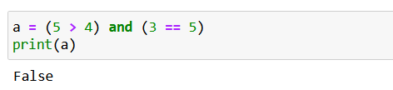

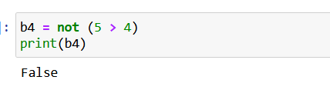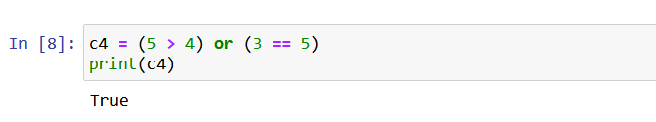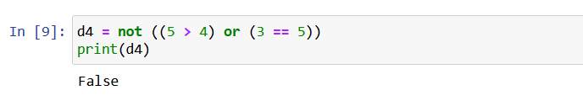

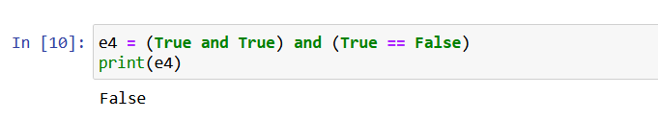

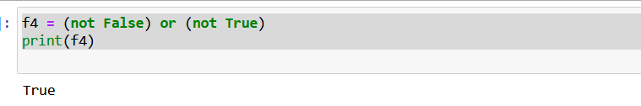

5. What are the six comparison operators?

Ans:-Six comparison operator are **l**ess than ( < ), less than or equal to ( <= ), greater than ( > ), greater than or equal to ( >= ), equal to ( == ), and not equal to ( != ).

6. How do you tell the difference between the equal to and assignment operators? Describe a condition and when you would use one.

Ans:- Assignment to is use for assign a value in variable. Equal to is use for comparing two values .

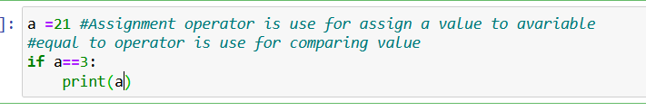

7. Identify the three blocks in this code:

spam = 0

if spam == 10:

print('eggs')

if spam > 5:

print('bacon')

else:

print('ham')

print('spam')

print('spam')

Ans:-

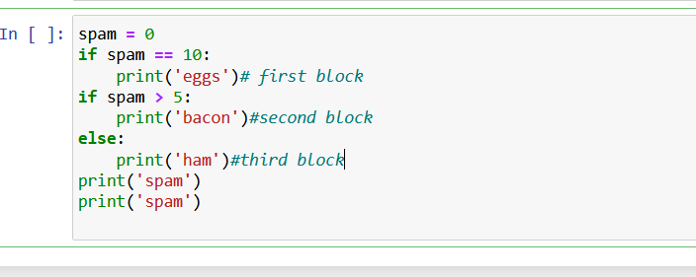

8. Write code that prints Hello if 1 is stored in spam, prints Howdy if 2 is stored in spam, and prints Greetings! if anything else is stored in spam.

Ans:-

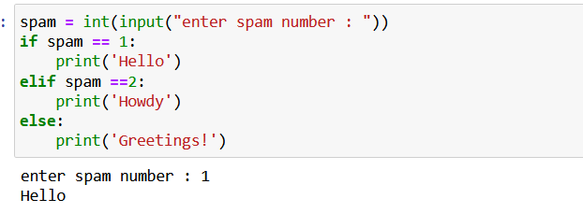

9.If your programme is stuck in an endless loop, what keys you’ll press?

Ans:-For ending a infanite loop clt+c keys press.

10. How can you tell the difference between break and continue?

Ans:-Break is use in a condition where we want to get out of the loop when a condition is satisfied. Continue is use when we want to skip a output when condition is satisfied.

11. In a for loop, what is the difference between range(10), range(0, 10), and range(0, 10, 1)?

Ans

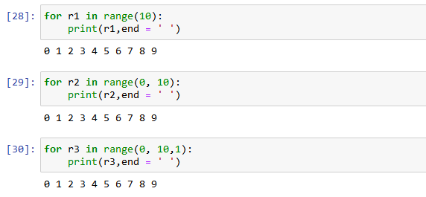

* The *range(10)* call range from 0 to 9
* The *range (0,10)* tells the loop to start at 0 and end with 9
* The *range(0,10,1)* tells the loop to increase by 1 on each iteration

12. Write a short program that prints the numbers 1 to 10 using a for loop. Then write an equivalent program that prints the numbers 1 to 10 using a while loop.

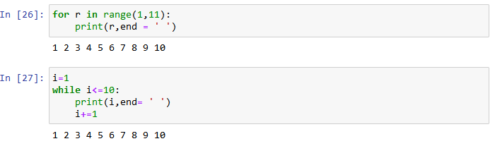

13. If you had a function named bacon() inside a module named spam, how would you call it after importing spam?

Ans: This function can be called with spam.bacon()