**Change Request Form**

|  |  |
| --- | --- |
| **Project Name** | Campus Management Software for World Skill Center (WSC) |
| **Package Number** | PKG 0111 |
| **Tender Number** | OSDA/WSC/Goods/M7-2022 |
| **Impacted Module** | Human Resources Management System (HRMS) |
| **Date** | 19-04-2023 |
| **Status** | Open |

| **Scope of Work** |
| --- |
| * Sanctioned Post Management (Recruitments, Promotions, Transfers, * Retirements, etc.) * Staff Profile including Educational qualification, Training, achievements etc.) * Bio-Metric Attendance (Face recognition) * Annual Increments. * Annual Internal Performance Review System. * Disciplinary cases. * Performance Management System * Promotion of employees including MACP * Court cases monitoring etc. |

|  |  |
| --- | --- |
| **Additional Scope Change** | Employee Re-engagement |
| **Business Department** | Human Resources Management System (HRMS) |
| **Description** | 1. Employee will fill the re-engagement application form and forward it to HR. 2. HR, will forward it to reporting authority. 3. The reporting authority will review the performance and forward it to department head. 4. Post verification by department head, the application form will be forwarded to Director Admin 5. Post approval by Director Admin, it will be forwarded to the HR 6. Finally, HR will create a job offer for the renewal contract |

|  |
| --- |
| **Business Process** |

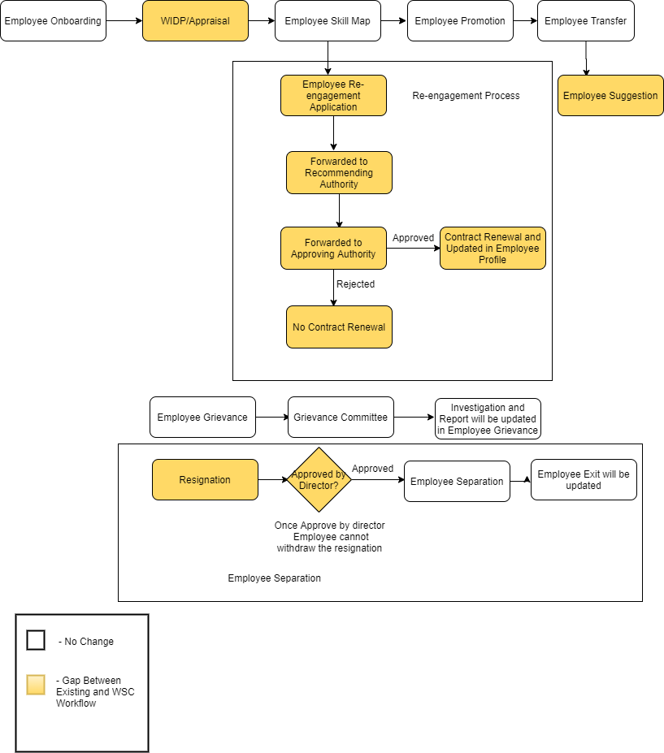

| **Reason for Change** |
| --- |
| During the discussion of HRMS requirements, WSC SME's brought up the need for employee re-engagement that isn't specified in the scope of work | |

| **Impacted Screens** | |
| --- | --- |
| No. Of New Screens to be developed | 2 |
| No. Of Screens to be modified | 1 |

| **Schedule Impact** | **Remarks** |
| --- | --- |
| None | The schedule will be controlled by putting in more effort.There will, however, be additional cost incurred |

| Budget Impact |
| --- |
| The estimated cost for the additional scope will be Rs 300000/- (three lakhs only) |

| Decision | | | | |
| --- | --- | --- | --- | --- |
|  |  |  |  |  |
|  |  | Approved |  | Rejected |
|  |  |  |  |  |
|  |  | Approved with modifications |  | Deferred |
|  |  |  |  |  |
| *Additional Comments* | | | | |
|  | | | | |

__________________________________ ________________________________

Approver’s Printed Name Date

__________________________________

Title

__________________________________

Signature

*Note:*

|  |  |  |  |  |
| --- | --- | --- | --- | --- |
| **Status** | Open | In Review | Approved | Rejected |