**Change Request Form**

|  |  |
| --- | --- |
| **Project Name** | Campus Management Software for World Skill Center (WSC) |
| **Package Number** | PKG 0111 |
| **Tender Number** | OSDA/WSC/Goods/M7-2022 |
| **Impacted Module** | Human Resources Management System (HRMS) |
| **Date** | 19-04-2023 |
| **Status** | Open |

| **Scope of Work** |
| --- |
| * Sanctioned Post Management (Recruitments, Promotions, Transfers, * Retirements, etc.) * Staff Profile including Educational qualification, Training, achievements etc.) * Bio-Metric Attendance (Face recognition) * Annual Increments. * Annual Internal Performance Review System. * Disciplinary cases. * Performance Management System * Promotion of employees including MACP * Court cases monitoring etc. |

|  |  |
| --- | --- |
| **Additional Scope Change** | Recruitment Process |
| **Business Department** | Human Resources Management System (HRMS) |
| **Description** | Following are the stages of recruitment process:  **Recruitment Exam Declaration**  Recruitment Exam Declaration helps to you to declare exam for recruitment process.  **Recruitment Exam Center Allocation**  Recruitment Exam Center Allocation helps user to allocate exam center for different exam.  **Admit Card Generation**  Admit card will be generated at each step of selection process for selected candidates.  **Recruitment Entrance Exam Result Publication**  It helps to publish result for different exam declaration and on the basis of this again admit card will be generated.  **Job Offer**  Job Offer is given to selected candidates after interview and selection which states the offered salary package, designation, grade, department, number of days entitled for leave among other information.  **Appointment Letter**  Appointment Letter will be generated for the candidate who has accepted the Job Offer |

|  |
| --- |
| **Business Process** |

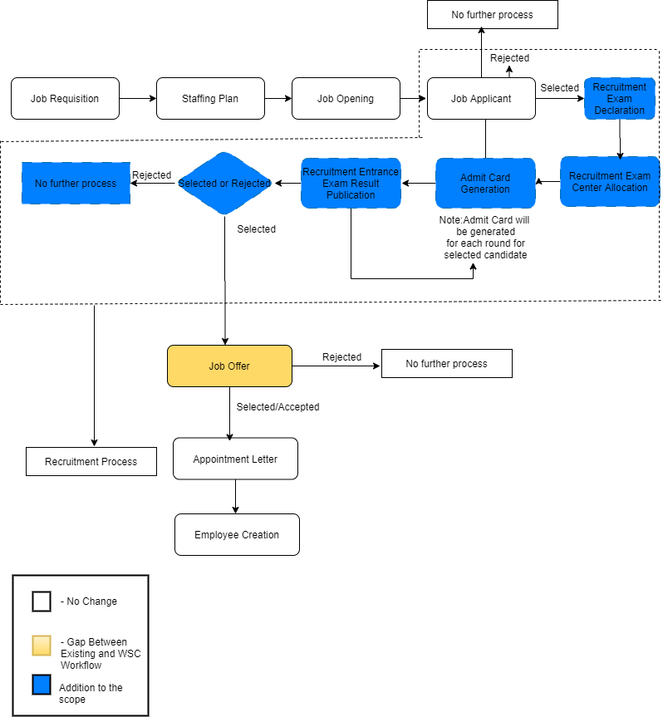

| **Reason for Change** |
| --- |
| The recruitment process explained is an elaborate process including exam center allocation, generating admit card, result publication which is not specified in the request for proposal document | |

| **Impacted Screens** | |
| --- | --- |
| No. Of New Screens to be developed | 5 |
| No. Of Screens to be modified | 2 |

| **Schedule Impact** | **Remarks** |
| --- | --- |
| None | The schedule will be controlled by putting in more effort.There will, however, be additional cost incurred |

| Budget Impact |
| --- |
| The estimated cost for the additional scope will be Rs 500000/- (five lakhs only) |

| Decision | | | | |
| --- | --- | --- | --- | --- |
|  |  |  |  |  |
|  |  | Approved |  | Rejected |
|  |  |  |  |  |
|  |  | Approved with modifications |  | Deferred |
|  |  |  |  |  |
| *Additional Comments* | | | | |
|  | | | | |

__________________________________ ________________________________

Approver’s Printed Name Date

__________________________________

Title

__________________________________

Signature

*Note:*

|  |  |  |  |  |
| --- | --- | --- | --- | --- |
| **Status** | Open | In Review | Approved | Rejected |