**Change Request Form**

|  |  |
| --- | --- |
| **Project Name** | Campus Management Software for World Skill Center (WSC) |
| **Package Number** | PKG 0111 |
| **Tender Number** | OSDA/WSC/Goods/M7-2022 |
| **Impacted Module** | Students Management Module |
| **Date** | 19-04-2023 |
| **Status** | Open |

| **Scope of Work** |
| --- |
| * Students Profile.: Personal Information, Contact Details, Academic Details * Issue of Identity Card.  * Biometric Attendance (Face recognition) * Hostel Management (Hostel seat allotment, attendance, fees etc) * Scholarships.  * Rewards and achievements.  * Students’ Evaluation/remarks of Faculty.  * Students Exams records of all 6 semesters * Parent Enquiry/Alert/Messaging Management.  * Messaging System  * Students Grievance System etc. |

|  |  |
| --- | --- |
| **Additional Scope Change** | Entrance exam process |
| **Business Department** | Admission |
| **Description** | Following are the stages of the entrance exam process:  **Center selection master:** This will have details of the exam center such as address details and total capacity  **Entrance exam declaration**: Entrance exam declaration card will include the details for declaring the entrance exam for the student applicants  **Admit card generation**: Admit card will have the details of individual student applicants records such as their exam data, time, venue, course details, etc  **Entrance exam result publication**: Entrance exam evaluation process includes the result publish process of every student applicant who has applied for the the entrance examination  **Rank card publication**: Rank card publication card represents the process of giving ranks to the eligible student applicants for admission |

|  |
| --- |
| **Business Process** |

Entrance exam process

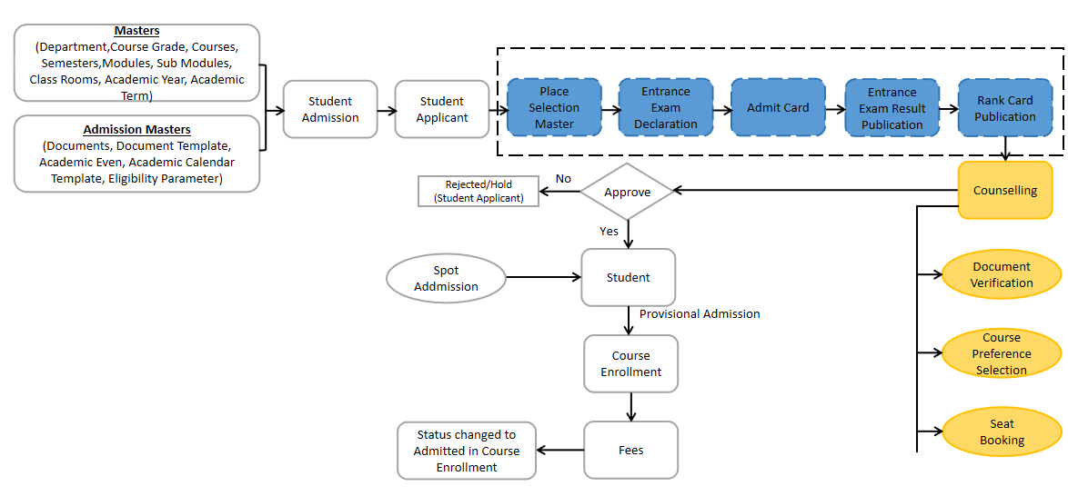

| **Reason for Change** |
| --- |
| While discussing the requirements for Students Management module, we identified that the business feature of counselling stated is not included in the scope of work | |
|  | |
|  | |

| **Impacted Screens** | |
| --- | --- |
| No. Of New Screens to be developed | 7 |

| **Schedule Impact** | **Remarks** |
| --- | --- |
| None | The schedule will be controlled by putting in more effort.There will, however, be additional cost |

| Budget Impact |
| --- |
| The estimated cost for the additional scope will be Rs 600000/- (Six lakhs only) |

| Decision | | | | |
| --- | --- | --- | --- | --- |
|  |  |  |  |  |
|  |  | Approved |  | Rejected |
|  |  |  |  |  |
|  |  | Approved with modifications |  | Deferred |
|  |  |  |  |  |
| *Additional Comments* | | | | |
|  | | | | |

__________________________________ ________________________________

Approver’s Printed Name Date

__________________________________

Title

__________________________________

Signature

*Note:*

|  |  |  |  |  |
| --- | --- | --- | --- | --- |
| **Status** | Open | In Review | Approved | Rejected |