**Change Request Form**

|  |  |
| --- | --- |
| **Project Name** | Campus Management Software for World Skill Center (WSC) |
| **Package Number** | PKG 0111 |
| **Tender Number** | OSDA/WSC/Goods/M7-2022 |
| **Impacted Module** | Academic System |
| **Date** | 19-04-2023 |
| **Status** | Open |

| **Scope of Work** |
| --- |
| * Class occurrence monitoring * Faculty Workload / Lesson Plan** ** * Class Attendance of students (Face recognition or any other automated * mode).**   ** * Results Analysis after declaration of results by WSC * Students Feedback mechanism on quality of teaching learning * Internship, Training, Apprentice * Re-Admission Process after discontinuing in studies * Students Back paper tracking etc. |

|  |  |
| --- | --- |
| **Additional Scope Change** | Assignments (provided by instructors and submitted by students) |
| **Business Department** | School of Engineering (SOE) |
| **Description** | An assignment is a task or piece of academic work that is created by the instructor to give the students the chance to practise, study, and show what they have learned. To designate the assignment as finished, the students submit it. |

|  |
| --- |
| **Business Process** |

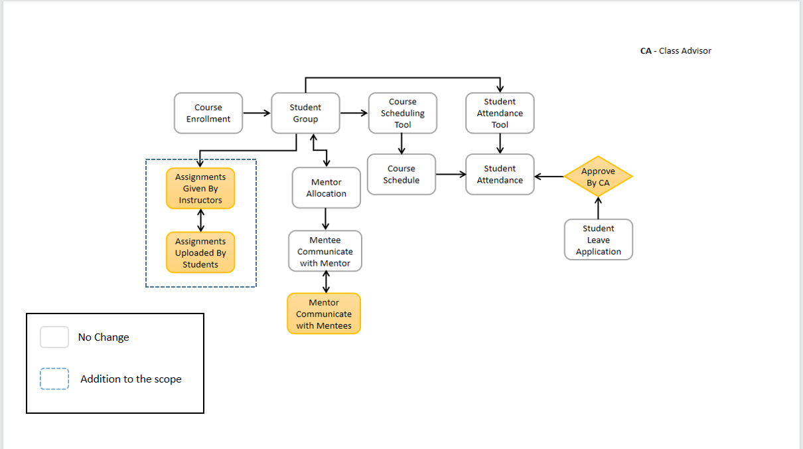

| **Reason for Change** |
| --- |
| The business features of assignments (provided by instructors and submitted by students), which are not available in the ERP system and are not pre-defined in the scope of WSC, were expressed during training sessions with Academy trainers and faculties | |

| **Impacted Screens** | |
| --- | --- |
| No. Of New Screens to be developed | 2 |

| **Schedule Impact** | **Remarks** |
| --- | --- |
| None | The schedule will be controlled by putting in more effort.There will, however, be additional costs |

| Budget Impact |
| --- |
| The estimated cost for the additional scope will be Rs 200000/- (Two lakhs only) |

| Decision | | | | |
| --- | --- | --- | --- | --- |
|  |  |  |  |  |
|  |  | Approved |  | Rejected |
|  |  |  |  |  |
|  |  | Approved with modifications |  | Deferred |
|  |  |  |  |  |
| *Additional Comments* | | | | |
|  | | | | |

__________________________________ ________________________________

Approver’s Printed Name Date

__________________________________

Title

__________________________________

Signature

*Note:*

|  |  |  |  |  |
| --- | --- | --- | --- | --- |
| **Status** | Open | In Review | Approved | Rejected |