**Change Request Form**

|  |  |
| --- | --- |
| **Project Name** | Campus Management Software for World Skill Center (WSC) |
| **Package Number** | PKG 0111 |
| **Tender Number** | OSDA/WSC/Goods/M7-2022 |
| **Impacted Module** | Academic System |
| **Date** | 19-04-2023 |
| **Status** | Open |

| **Scope of Work** |
| --- |
| Academic System   * Class occurrence monitoring * Faculty Workload / Lesson Plan  * Class Attendance of students (Face recognition or any other automated * mode).    * Results Analysis after declaration of results by WSC * Students Feedback mechanism on quality of teaching learning * Internship, Training, Apprentice * Re-Admission Process after discontinuing in studies * Students Back paper tracking etc. |

|  |  |
| --- | --- |
| **Additional Scope Change** | Training of Trainers (TOT) |
| **Business Department** | School of Engineering (SOE) and Academy |
| **Description** | Following are the stages of the training of trainers process:  **Candidate list creation**  This allows the user to enter and maintain records of candidates who are eligible for the ToT program in the system.  **Course selection**  This allows the user to create and maintain records of course(s) that will be under the ToT program.  **Module creation**  This allows the user to create and maintain records of module(s) that will be under the ToT program.  **Sub-module creation**  This allows the user to create and maintain records of sub-module(s) that will be under the ToT program.  **Candidate selection**  This allows the user to select candidates for a ToT program from the records maintained in the candidates list.  **ToT reporting**  This allows the user to mark a candidate as present after they have reported on the day of reporting.  **Student record creation**  This allows the user to create a record of a candidate as a student under the ToT program which will later be used to do program enrollment.  **Course enrollment**  This allows the user to enroll a candidate with a record as a student into a course for their training.  **Module enrollment**  This allows the user to enroll a candidate with a record as a student into a module for their training.  **Scheduling of classes**  This allows the user to schedule the classes for a module under the ToT program.  **Recording attendance in every class**  This allows the user to record attendance of candidates during each class under the ToT program.  **Exam declaration**  This allows the user to declare an exam fro various program in accordance with the ‘Academic Calendar’ template which was used during the start of each session.  **Attendance sheet**  Attendance sheets allows the user to maintain and mark attendance of students present in the examination room.  **Score sheet**  Score sheets are used to record the marks obtained by each student in an examination. The score sheet includes the name of the student, marks obtained in each subject and the total marks achieved by the student.  **Criteria wise evaluation**  Criteria wise evaluation allows to create an evaluation for a particular assessment criteria in a course for a student enrolled in that course  **Continuous evaluation**  It is used to assess the assessment criteria done for a course for an individual student.  **Generate Certificate**  This allows the user to generate a certificate for the candidates after they have met all the criterias required for a certificate. |

|  |
| --- |
| **Business Process** |

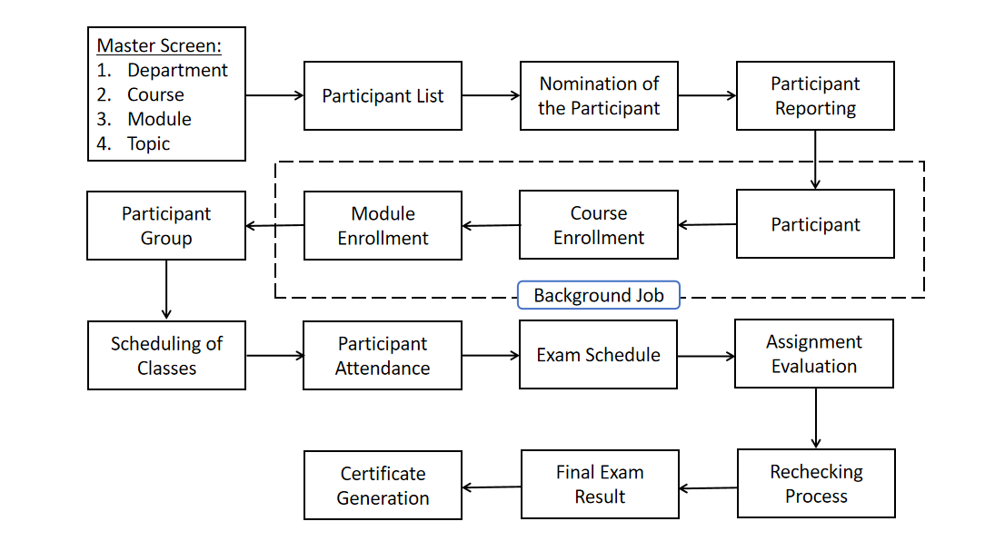

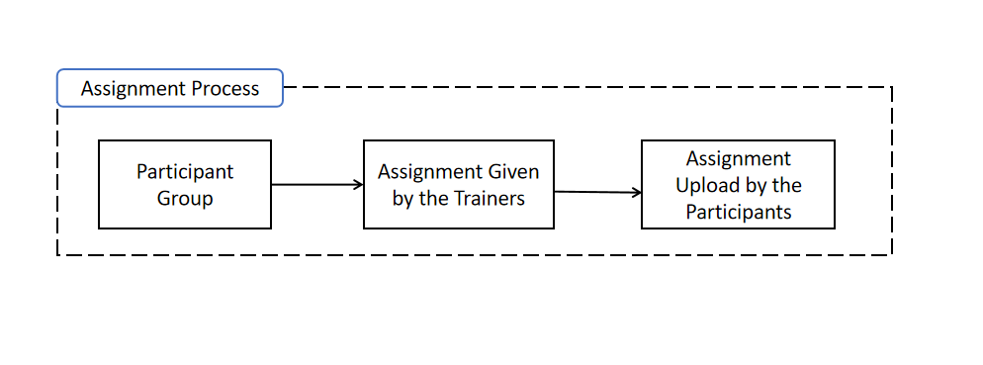

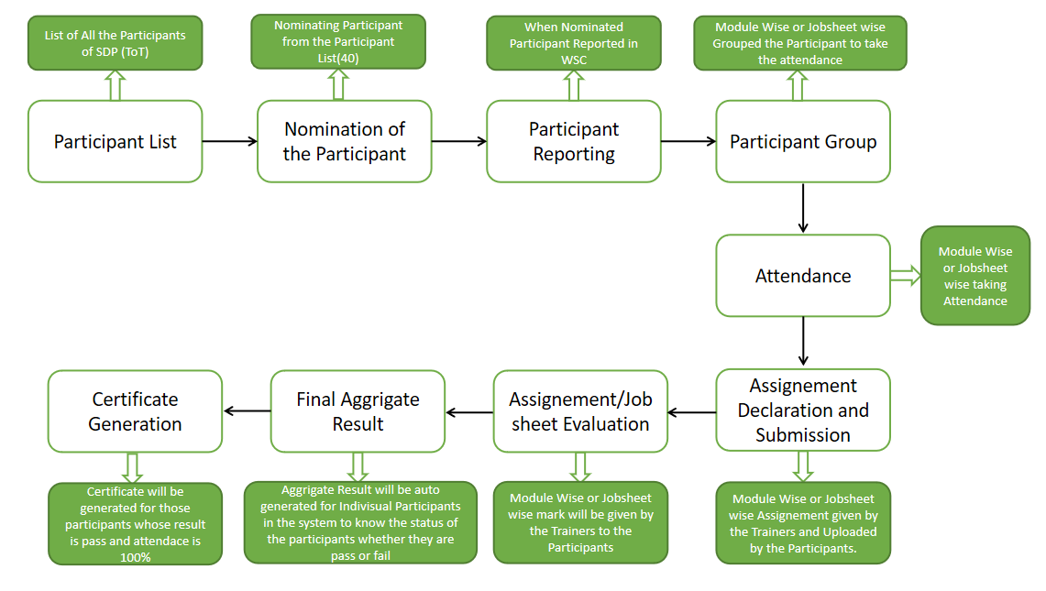

| **Reason for Change** |
| --- |
| Training of trainers business feature as explained by School of Engineering and Academy WSC SME’s has not been defined in the scope of work | |

| **Impacted Screens** | |
| --- | --- |
| No. Of New Screens to be developed | 16 |
| No. Of Screens to be modified | 5 |

| **Schedule Impact** | **Remarks** |
| --- | --- |
| None | The schedule will be controlled by putting in more effort.There will, however, be additional cost |

| Budget Impact |
| --- |
| The estimated cost for the additional scope will be Rs 1100000/- (Eleven lakhs only) |

| Decision | | | | |
| --- | --- | --- | --- | --- |
|  |  |  |  |  |
|  |  | Approved |  | Rejected |
|  |  |  |  |  |
|  |  | Approved with modifications |  | Deferred |
|  |  |  |  |  |
| *Additional Comments* | | | | |
|  | | | | |

__________________________________ ________________________________

Approver’s Printed Name Date

__________________________________

Title

__________________________________

Signature

*Note:*

|  |  |  |  |  |
| --- | --- | --- | --- | --- |
| **Status** | Open | In Review | Approved | Rejected |