**Meeting Minutes**

|  |  |
| --- | --- |
| **Project Name** | Campus Management Application at WSC |
| **Meeting Place** | WSC , 17th Floor |
| **Meeting Date** | 17-Apr-2023 |
| **Meeting Time** | 4:30pm |
| **Meeting Duration** | 45 mins |
| **Meeting Topic** | Issue of Identity Card & Internship, Training, Apprentice |

**In Attendance (WSC)**

|  |  |
| --- | --- |
| **Attendee’s Name** | **Department** |
| Anil Das | Administration (Admission) |

**In Attendance (SOUL)**

|  |  |
| --- | --- |
| **Attendee’s Name** | **Department** |
| Sharmistha Panda | SOUL |

**Points Discussed**

The following points were discussed :

1. WSC does not have an apprenticeship program
2. Internship Program details are :

1. Singapore Internship Program (SIP) : WSC students are sent to Singapore to do their internship program.
   1. The selection process / criteria :

* Attendance - 10%
* Class Assessment of 1st semester
* Technical skill weightage - 70%
* Communication skill weightage - 20%
  1. Students undergo the internship program before the second semester
  2. The strength of the students for the internship program is not fixed
  3. The duration of the internship program is 6 months. Students get paid by the companies offering the internship program

1. Student Exchange Program (SEP): Students from Singapore visit India to learn about the WSC students programme and the curriculum. Additionally, they study cultural aspects . There is no selection process. The duration of the programme is not fixed.
2. Student Internship Program (SIP): It is a combination of the SIP and SEP programme.
3. The training offered could be short-term. External students / candidates are given an opportunity to attend training at WSC. **The SOP has not been finalized yet by WSC stakeholders.**
4. Issue of Identity card: Identity card template / photo sharedwith SOUL

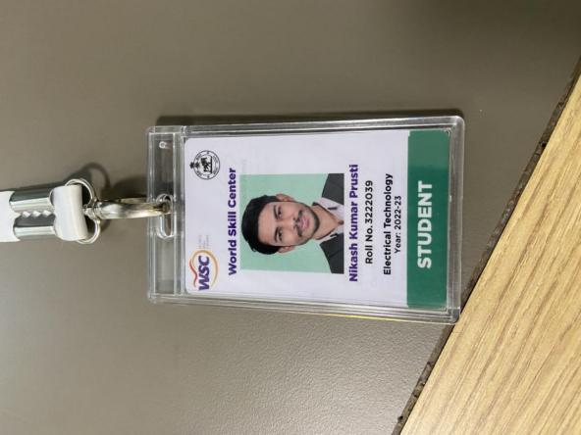 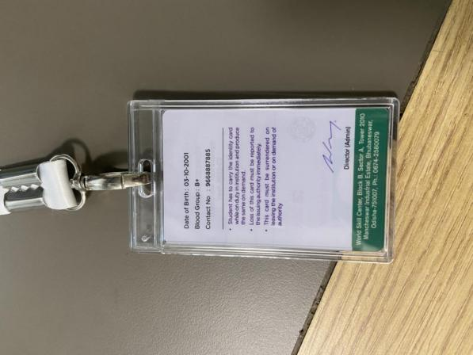

Action Item

WSC SME’s / Stakeholders to share the student training programme finalized / approved SOP