LENDSIGHT
Lending Business Decision Support System

Data Analysis & Business Intelligence Report

Dataset: Credit Risk Dataset — Kaggle (Laotse)
Total Records Analysed: 32,411 loan records
Analysis Period: 2024 Portfolio Snapshot
Prepared For: JP Morgan — Associate BA/DA Application
Date: June 18, 2026
Tools Used: Python | SQL Server | Excel | Power BI

1. Executive Summary

LendInsight is a comprehensive data analysis and business intelligence project built to address a critical challenge in consumer lending: rising loan defaults. This report analyses 32,411 loan records, identifying that the portfolio carries an overall default rate of 21.87% — significantly above the industry benchmark of 3–5%. Total portfolio exposure stands at $310.9M, of which $77.0M is tied to defaulted loans.
Key findings at a glance:
- Overall default rate: 21.87% (7,089 out of 32,411 loans defaulted)
- Total portfolio exposure: $310.9M across 32,411 loans
- HIGH risk segment default rate: 69.86% vs LOW risk segment at 5.85%
- Income gap between defaulters and non-defaulters: $20,239 annually
- Borrowers with prior credit bureau defaults reoffend at 37.9% vs 18.4% for clean records
- Loan grade G carries the highest default rate at 98.4%
The analysis uses a rule-based risk segmentation model to classify all loans into LOW, MEDIUM, and HIGH risk tiers. The 64-percentage-point gap between HIGH and LOW default rates validates this segmentation as a meaningful and actionable framework for credit decisions.

2. Business Problem Statement

A lending institution faces one fundamental challenge: growing its loan book without increasing credit losses. This creates four interlinked business problems that this project directly addresses:
Problem A — Rising Defaults: At 21.87%, the default rate is far above sustainable levels. Every percentage point of default rate represents millions in unrecovered capital.
Problem B — Poor Risk Visibility: Without a structured risk classification system, loan officers cannot differentiate between LOW and HIGH risk applicants at the point of approval.
Problem C — Suboptimal Pricing: If high-risk borrowers are not identified early, they may receive the same interest rates as low-risk borrowers, leading to underpriced risk and inadequate return for the bank.
Problem D — Portfolio Concentration Risk: Without segment-level exposure analysis, management cannot tell if losses are concentrated in specific grades, purposes, or customer demographics.

3. Data Overview & ETL Pipeline

3.1 Dataset Summary
Attribute | Detail
Source | Credit Risk Dataset — Kaggle (Laotse)
Raw Rows | 32,581
Clean Rows (after ETL) | 32,411
Rows Removed | 170 (duplicates, age outliers)
Original Columns | 12
Final Columns (after derivations) | 15
Null Values (post-ETL) | 0

3.2 ETL Cleaning Steps
- Removed 165 duplicate records
- Removed 5 records with person_age > 100 (data quality outliers)
- Capped person_income at 99th percentile ($225,000) — affected 322 records
- Imputed 887 nulls in person_emp_length with median (4.0 years)
- Imputed 3,094 nulls in loan_int_rate with median (10.99%)
- Standardised all categorical columns to UPPERCASE

3.3 Derived Columns
Column | Logic | Purpose
risk_category | Grade E/F/G or DTI>0.40 = HIGH; Grade A/B and DTI<0.20 = LOW; else MEDIUM | Core risk classification
income_bracket | < $30K = Low Income; $30–60K = Middle; $60–100K = Upper-Middle; > $100K = High | Income segmentation
dti_bracket | < 0.15 = Low DTI; 0.15–0.30 = Moderate; 0.30–0.50 = High; > 0.50 = Very High | Debt burden segmentation

4. SQL Analysis — Key Findings

4.1 Portfolio KPIs
KPI | Value
Total Loans | 32,411
Total Defaults | 7,089
Overall Default Rate | 21.87%
Total Portfolio Exposure | $310.94M
Defaulted Loan Exposure | $76.97M
Average Loan Amount | $9,594
Average Interest Rate | 11.01%

4.2 Default Rate by Loan Grade
Loan Grade | Total Loans | Defaults | Default Rate
A | 10,703 | 1,066 | 9.96%
B | 10,384 | 1,695 | 16.32%
C | 6,436 | 1,336 | 20.76%
D | 3,620 | 2,138 | 59.06%
E | 963 | 621 | 64.49%
F | 241 | 170 | 70.54%
G | 64 | 63 | 98.44%
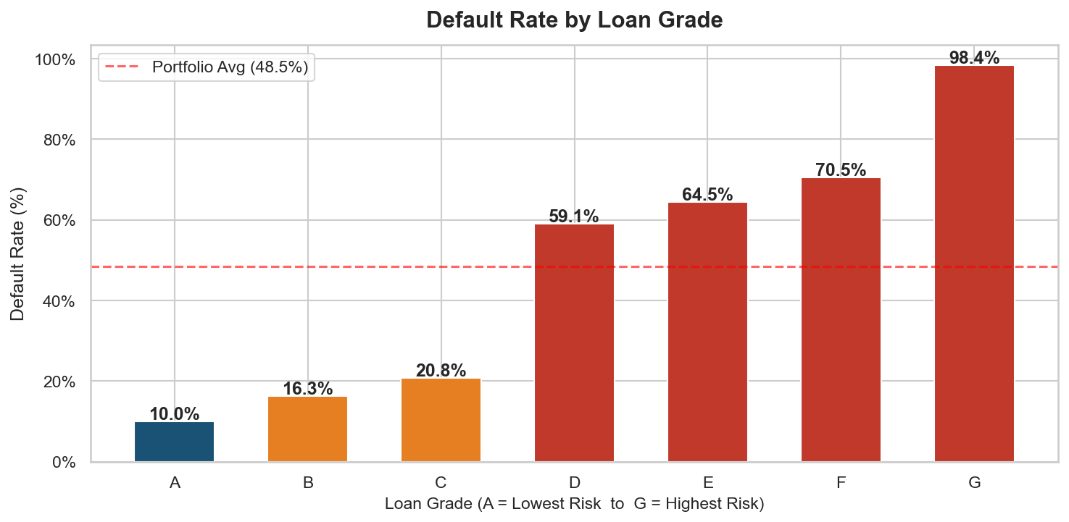

4.3 Default Rate by Loan Intent
Loan Intent | Total Loans | Defaults | Default Rate
DEBTCONSOLIDATION | 5,189 | 1,488 | 28.68%
MEDICAL | 6,042 | 1,617 | 26.76%
HOMEIMPROVEMENT | 3,594 | 940 | 26.15%
PERSONAL | 5,497 | 1,094 | 19.90%
EDUCATION | 6,409 | 1,106 | 17.26%
VENTURE | 5,680 | 844 | 14.86%
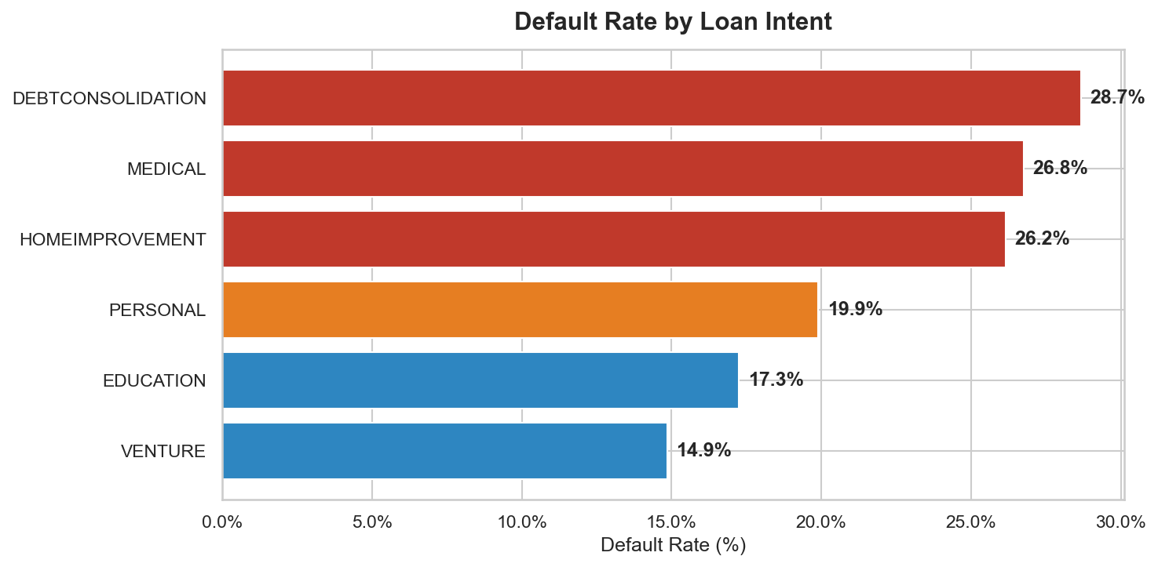

4.4 Prior Credit Bureau Default vs Current Default
Prior Default Status | Customer Count | Current Default Rate
N — No Prior Default | 26,681 | 18.44%
Y — Prior Default on File | 5,730 | 37.87%

5. Exploratory Data Analysis — Key Findings

5.1 Default Rate by DTI Bracket
Debt-to-income ratio (loan amount as % of annual income) is one of the strongest predictors of default. Borrowers with Very High DTI (>50%) default at significantly elevated rates.
DTI Bracket | Loans | Default Rate
Low DTI | 15,842 | 12.16%
Moderate DTI | 12,302 | 19.22%
High DTI | 4,020 | 64.78%
Very High DTI | 247 | 78.54%
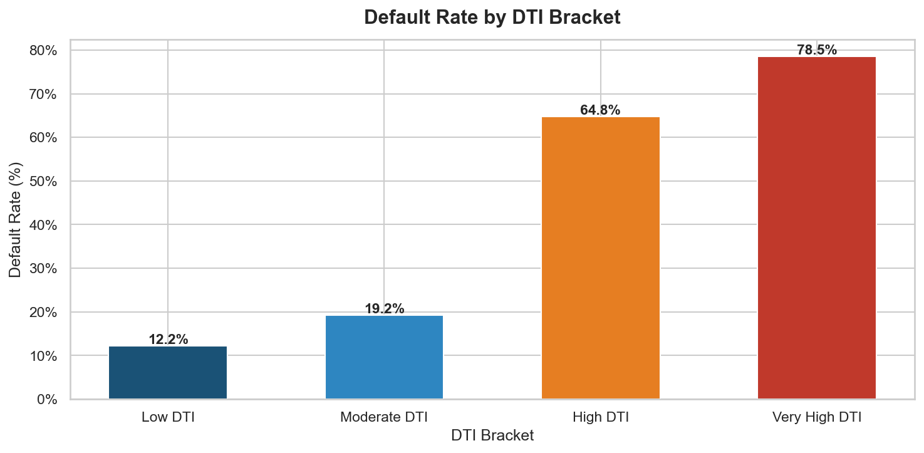

5.2 Income Gap: Defaulters vs Non-Defaulters
Group | Avg Annual Income | Avg Loan Amount | Avg Interest Rate
Repaid | $68,766 | $9,240 | 10.49%
Defaulted | $48,527 | $10,857 | 12.88%
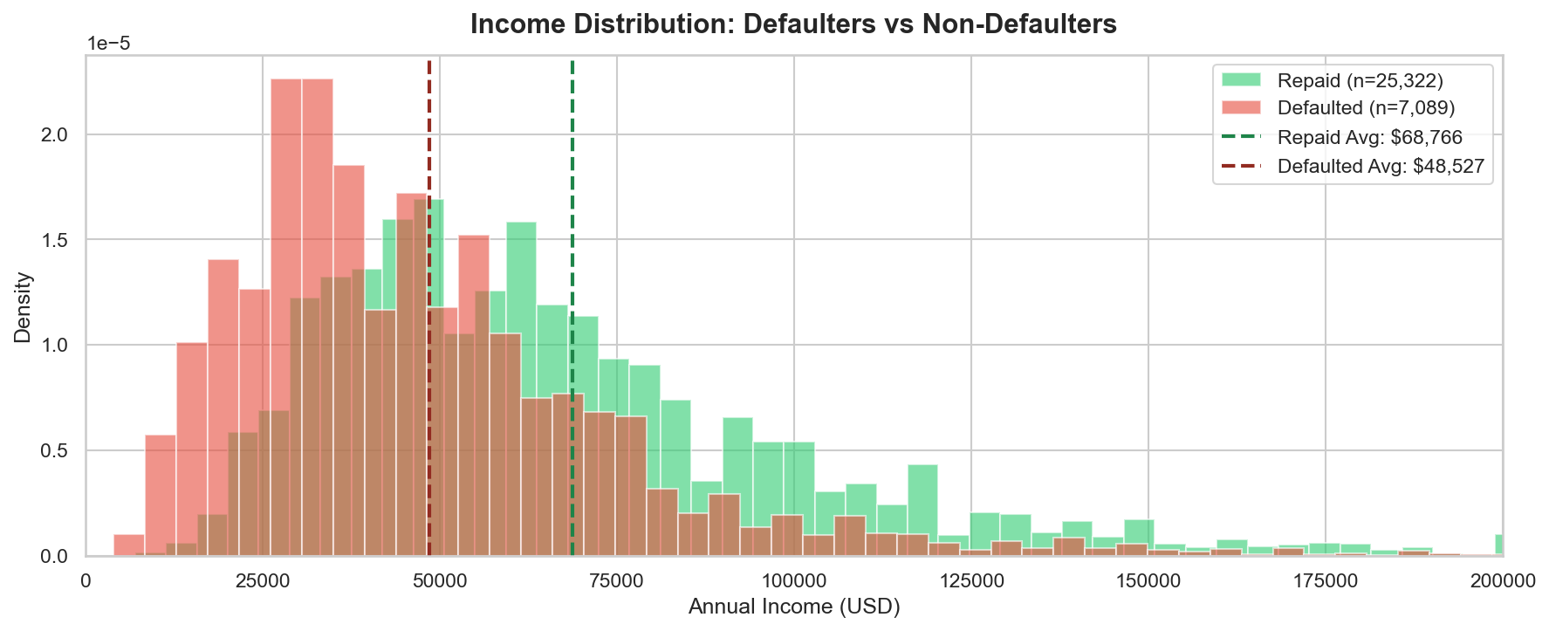

5.3 Correlation with Default
The correlation analysis identifies loan_int_rate and loan_percent_income (DTI) as the strongest positive predictors of default, while person_income and cb_person_cred_hist_length are negative predictors — i.e., higher income and longer credit history are associated with lower default probability.
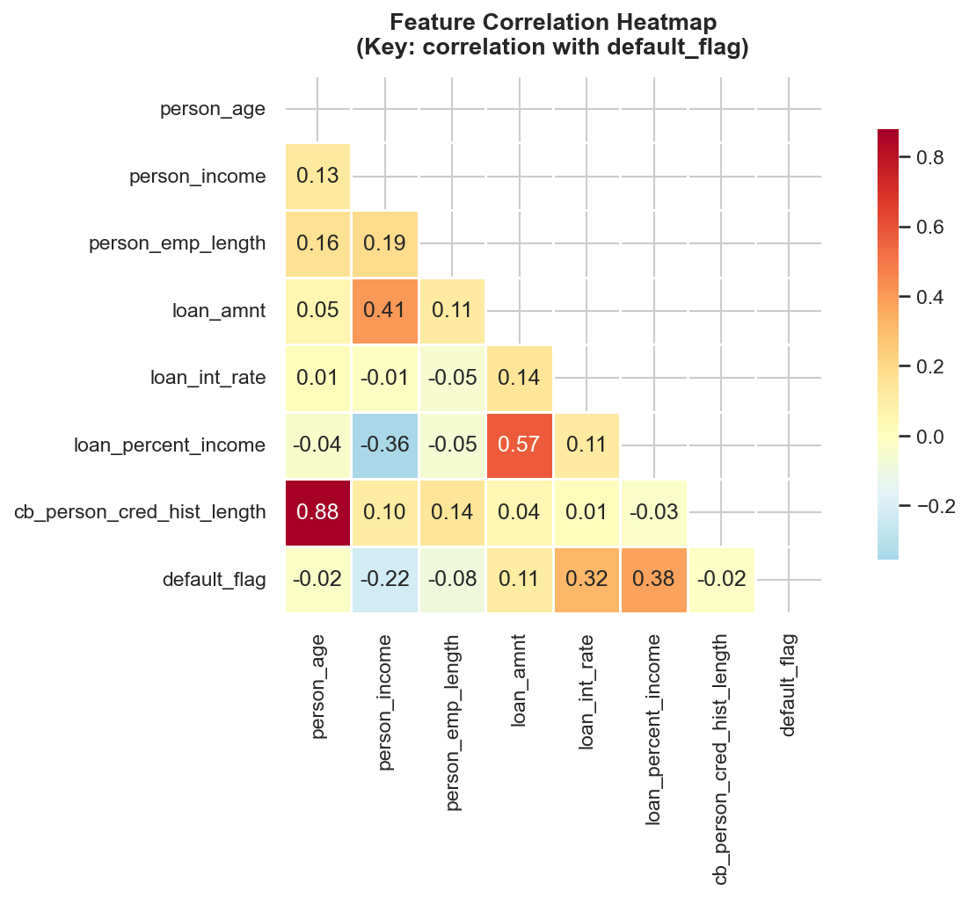

6. Risk Segmentation Analysis

Segment | Loans | % Portfolio | Default Rate | Exposure | Avg Loan | Avg Rate
HIGH | 2,306 | 7.1% | 69.86% | $35.0M | $15,161 | 14.31%
MEDIUM | 15,669 | 48.3% | 29.57% | $170.0M | $10,849 | 12.23%
LOW | 14,436 | 44.5% | 5.85% | $106.0M | $7,342 | 9.17%
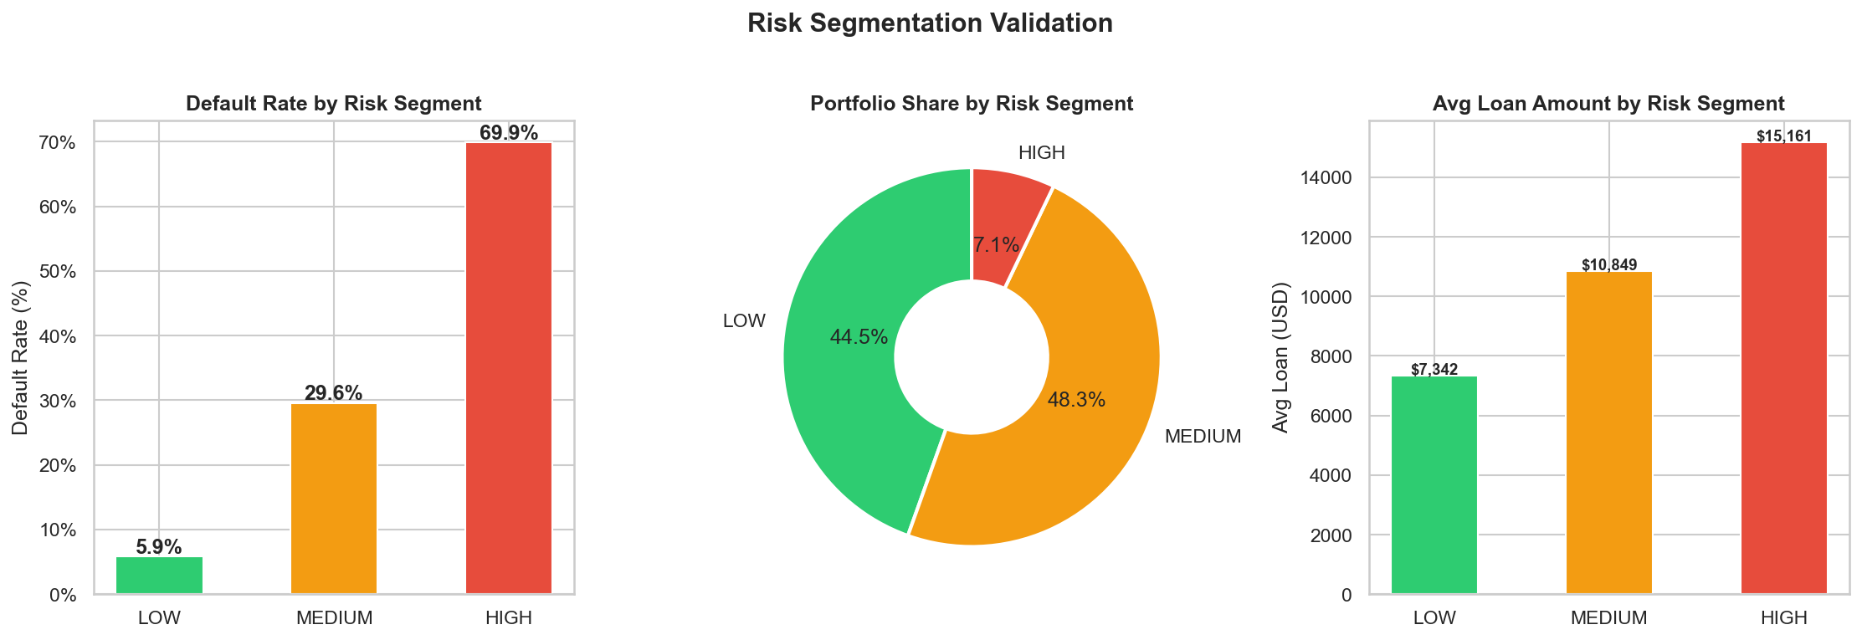

The 64-percentage-point spread between HIGH (69.9%) and LOW (5.9%) risk default rates validates the segmentation as highly meaningful. A credit policy that restricts HIGH-risk approvals or mandates collateral/co-signers for this segment would directly address the portfolio's loss concentration.
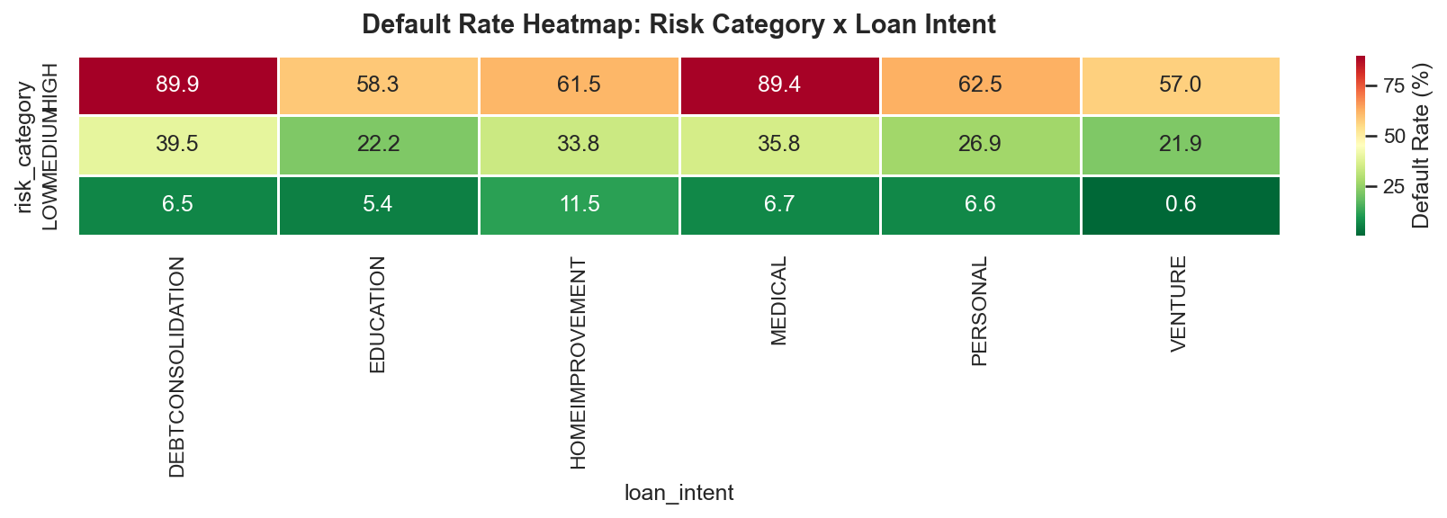

7. Business Recommendations

R1 — Implement Segment-Based Approval Policy [Owner: Credit Risk Manager]
Given the 69.9% default rate in the HIGH risk segment, the bank should apply stricter approval criteria for borrowers classified as HIGH risk. This includes mandatory collateral, co-signer requirements, or lower loan-to-income caps for Grade E/F/G applicants and those with DTI > 40%.
R2 — Risk-Adjusted Interest Rate Pricing [Owner: Pricing & Product Team]
The average interest rate across segments is 11.01%. HIGH risk borrowers should be priced at a premium that compensates for the elevated default probability. Current flat-rate pricing undercharges for risk and reduces the bank's risk-adjusted return.
R3 — Restrict or Monitor Specific Loan Purposes [Owner: Credit Policy Team]
Loan intent 'DEBTCONSOLIDATION' carries the highest default rate at 28.7%. The bank should introduce additional underwriting scrutiny for this purpose category, or cap exposure. In contrast, 'VENTURE' borrowers default at only 14.9% and represent the bank's most creditworthy segment.
R4 — Treat Prior Bureau Default as a Hard Filter [Owner: Loan Officers]
Borrowers with a prior credit bureau default (Y) show a current default rate of 37.9% vs 18.4% for clean borrowers — a gap of 19.4 percentage points. The bank should treat this as an early warning flag in the approval workflow.
R5 — Apply Income-Based Loan Caps [Owner: Credit Risk Manager]
Defaulted borrowers earn on average $20,239 less per year than those who repay. Setting maximum loan-to-income ratios based on income bracket (rather than flat loan amount caps) would better align loan sizes with repayment capacity.
R6 — Reduce Portfolio Concentration in High-Risk Grades [Owner: Portfolio Manager]
Grade G loans default at 98.4%. The portfolio should be rebalanced over time to grow the Grade A/B book and reduce exposure to Grades E-G. This can be achieved through incentivised pricing for low-risk borrowers.

8. Conclusion

This project demonstrates that a 21.87% default rate is not an unavoidable cost of doing business — it is the result of identifiable and addressable risk patterns. By applying structured data analysis across 32,411 loan records using Python, SQL, Excel, and Power BI, this report has surfaced six concrete, evidence-based recommendations that can directly reduce default rates, improve pricing accuracy, and give management clear visibility into portfolio risk.
The risk segmentation model — built using loan grade and DTI as dual signals — produces a 64-percentage-point spread between HIGH and LOW risk default rates. This is not a statistical exercise. It is a practical credit decision tool that can be embedded into the loan approval workflow today, without requiring machine learning or complex modelling infrastructure.
LendInsight proves that a well-designed analytical system — built with standard tools available to any business analyst — can deliver board-level insights from raw data in a structured, repeatable, and auditable process.

LendInsight | Lending Business Decision Support System | June 2026

