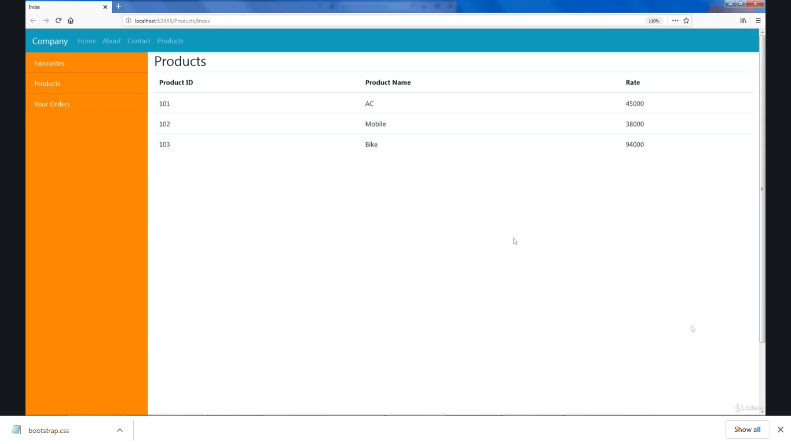

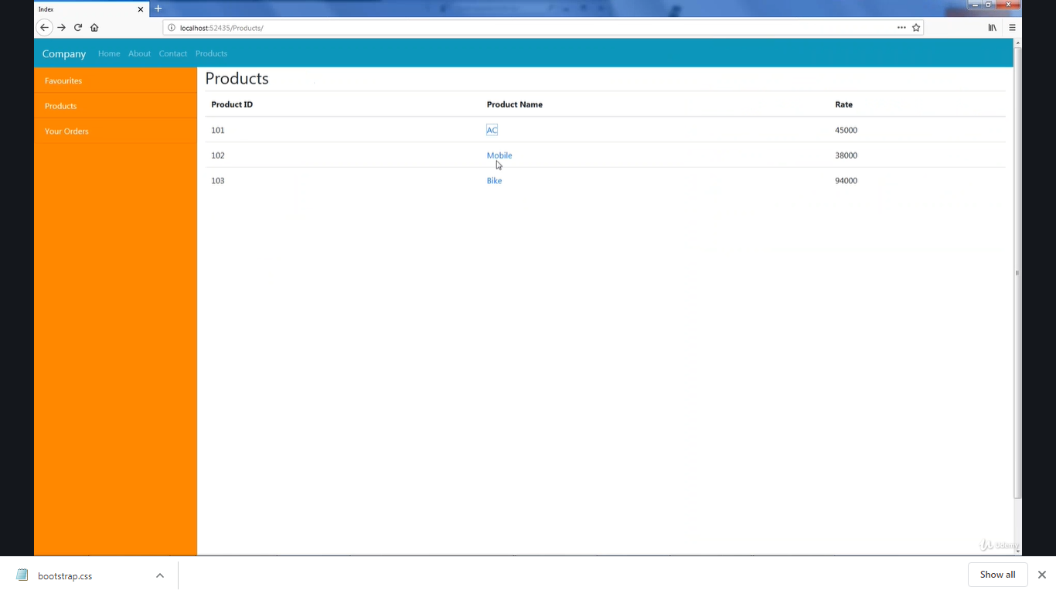

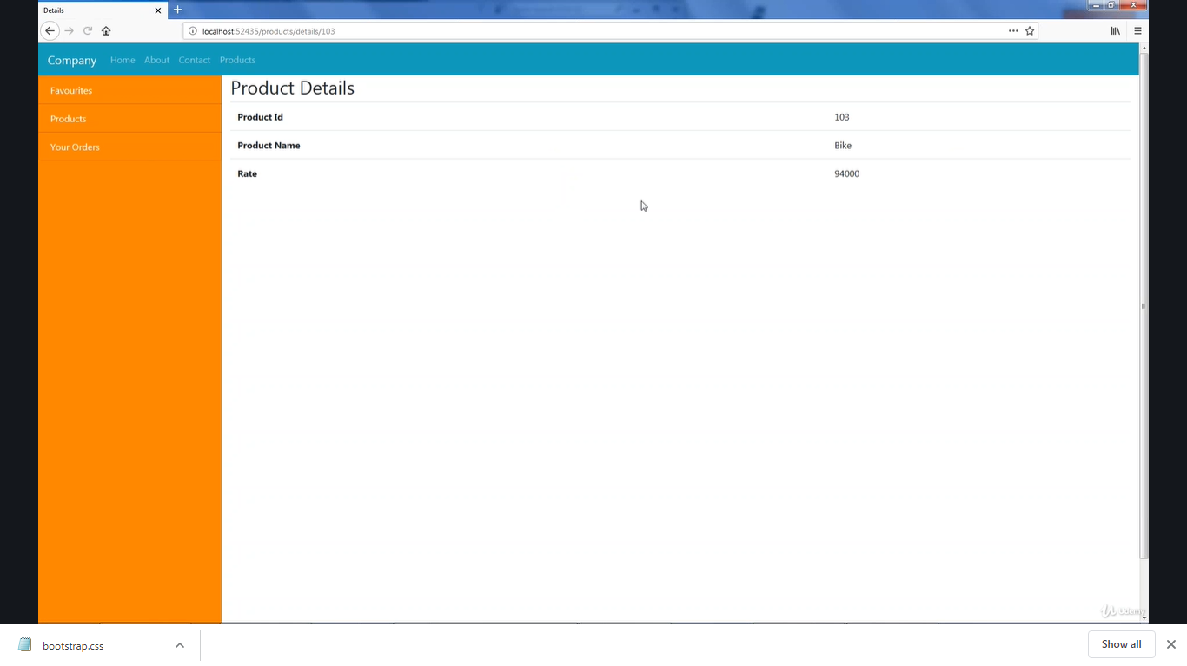

Please do the assignment as per the screen shots above.

Create a partial view with name _Sidebar and use @Html.Partial method to render the _Sidebar partial view in _Layout.cshtml page.

Read the Urls of the screen shot to understand the names of the controller and action methods.