DAY 5:
TASK 1 :
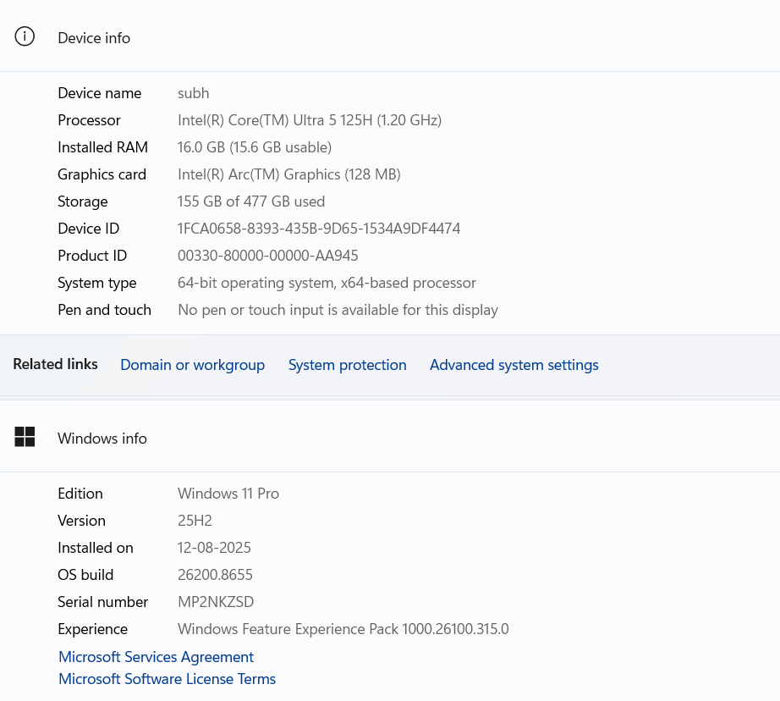

TASK 2:
Route A: Creating a Bootable USB Drive :
This method is best if you want to install Linux directly onto a physical computer.
1. Download the Components
- The ISO: Download the latest LTS (Long Term Support) desktop ISO from the official Ubuntu website or Fedora website.
- The Flashing Tool: Download and install balenaEtcher (works on Windows, Mac, and Linux) or Rufus (Windows only).
2. Flash the Drive (Using balenaEtcher)
- Insert a spare USB flash drive (minimum 8GB) into your computer. Note: This will erase all data on the USB.
- Open balenaEtcher.
- Click Flash from file and select the Linux ISO you downloaded.
- Click Select target and choose your USB flash drive.
- Click Flash!
- Windows or macOS may ask for administrator permission. Grant it, and wait for the progress bar to reach 100% and validate.

Route B: Running it via VirtualBox (No USB Required)
This is the safest method if you just want to test Linux inside your current operating system without altering your computer.

1. Download VirtualBox
- Download and install Oracle VM VirtualBox along with its Extension Pack from the official website.
2. Set Up the Virtual Machine (VM)
- Open VirtualBox and click the blue New button.
- Name your VM (e.g., "Ubuntu Linux").
- In the ISO Image field, click the dropdown, select Other..., and browse to the Linux ISO file you downloaded.
- VirtualBox will often recognize the OS and suggest "Unattended Installation." If you want to experience the normal installer, check the box for Skip Unattended Installation, then click Next.
- Allocate Hardware:
  - Give it at least 4096 MB (4GB) of RAM.
  - Allocate at least 2 CPUs for smooth performance. Click Next.
- Virtual Hard Disk: Leave it at "Create a Virtual Hard Disk Now" and set the size to at least 25 GB. Click Next, then Finish.
3. Start the Installation :
- Select your new VM from the left panel and click the green Start arrow.
- The VM will boot directly into the Linux ISO, just like a real computer booting from a USB.
- Select Try or Install Ubuntu (or Fedora's Live environment) and follow the on-screen prompts to complete the virtual installation

TASK 3 :
Step 1: Change the Desktop Wallpaper
- Click the Apple Menu ( logo) in the top-left corner of your screen and select System Settings (or System Preferences on older macOS versions).
- Scroll down the left sidebar and click on Wallpaper.
- Browse through the available categories (Dynamic Wallpapers, Light/Dark Desktop, Colors, or your own Photos).
- Click on any wallpaper image you like. macOS will instantly apply it to your desktop.
Step 2: Adjust System Language to Hindi or Gujarati
- While still in System Settings, look at the left sidebar and click on General.
- On the right side, click on Language & Region.
- Under the Preferred Languages section at the top, click the + (Plus) button.
- A search bar will pop up. Type Hindi Gujarati into the bar.
- Select the language from the list and click Add.
- macOS will immediately ask you a prompt: "Would you like to use [Language] as your primary language?"
- Click Use [Selected Language].
Step 3: Apply the Changes
- The language you just added will move to the top of your "Preferred Languages" list.
- Important: For the entire operating system, apps, and menus to update to Hindi or Gujarati, you will need to restart your Mac. Click the Apple Menu and select Restart to complete the process.

TASK 4 :
Step 1: Install Ubuntu & Create the 'gamer' Account
If you are currently setting up a fresh Ubuntu installation (via a virtual machine or physical hardware):
- Proceed through the standard installation steps (Language, Keyboard Layout, and Installation Type).
- When you reach the "Who are you?" setup screen, fill out the details as follows:
  - Your name: Gamer
  - Your computer's name: ubuntu-pc (or anything you prefer)
  - Pick a username: gamer
  - Choose a password: Set a secure password.
- Complete the installation and restart the machine.
💡 Already installed Ubuntu? If you have already installed Ubuntu with a different primary user, open your terminal (Ctrl + Alt + T) and run the following command to add the user: sudo adduser gamer
Step 2: Enable Automatic Login
By default, Ubuntu requires a password at startup. To bypass the login screen automatically for the gamer account:
Method A: Using the Graphical Settings UI (Recommended)
- Log into the system with an administrative account.
- Open the Settings app (click the top-right system menu and select the gear icon).
- Scroll down the left sidebar and click on System, then select Users (on some older Ubuntu versions, Users is directly in the main left sidebar).
- Click the Unlock button at the top right and enter your administrator password.
- Select the gamer account from the user list.
- Toggle the Automatic Login switch to ON.

Method B: Using the Configuration File (Terminal)
If you prefer configuring it via text files or are running a minimal setup:
- Open the terminal and open the GDM display manager config file:
Bash
sudo nano /etc/gdm3/custom.conf
- Look for the [daemon] section.
- Remove the # (comment symbol) from the following lines and edit them to match the gamer username:
Plaintext
AutomaticLoginEnable = true
AutomaticLogin = gamer
- Save and exit (Press Ctrl + O, Enter, then Ctrl + X).
Step 3: Verifying and Capturing the Screen
Because you have enabled Automatic Login, the system will skip the login screen entirely on a normal reboot.
To see the login screen showing the username (e.g., if you log out manually):
- Click the top-right corner of the Ubuntu desktop, select the power icon, and click Log Out.
- You will be taken to the GDM display manager screen showing the user Gamer.
- To capture this screen:
  - If using a Virtual Machine (like VirtualBox): Use your host OS shortcut (Windows Key + Shift + S on Windows or Cmd + Shift + 4 on Mac) to capture the VM window showing the login screen.
  - If using physical hardware: Since the OS print-screen tools don't run on the raw login screen, you can snap a photo with an external camera or phone to document the successful setup.

TASK 5 :
Step 1: Prepare What You Need
- A laptop that meets Windows 10 system requirements.
- A USB flash drive (8 GB or larger).
- A stable internet connection (recommended).
- A backup of any important data.
Step 2: Create a Bootable Windows 10 USB
- Download the Windows 10 Media Creation Tool from Microsoft's website.
- Run the tool.
- Select Create installation media.
- Choose your preferred language, edition, and architecture (64-bit for most laptops).
- Select USB flash drive and let the tool create the installer.
Step 3: Boot from the USB
- Insert the USB drive into the laptop.
- Restart the computer.
- Enter the boot menu (commonly F12, F9, Esc, or another key depending on the manufacturer).
- Select the USB drive.
Step 4: Start Windows Setup
- Choose your language, time, and keyboard layout.
- Click Install Now.
- Enter a product key if prompted, or choose I don't have a product key if you plan to activate later.
- Select the correct Windows edition.
- Accept the license terms.
Step 5: Choose Installation Type
Select:
Custom: Install Windows only (advanced)
This option allows you to manage partitions.
Step 6: Partitioning Tips
Option A: Clean Installation (Recommended)
If you are completely reinstalling Windows:
- Delete the existing Windows-related partitions on the target drive.
- Continue until you see Unallocated Space.
- Select the unallocated space.
- Click Next.
Windows will automatically create the required system partitions.
Option B: Keep a Separate Data Partition
Example layout:
- EFI/System partitions (created automatically)
- C: Windows – 100–200 GB
- D: Data – Remaining space
This makes future reinstalls easier because personal files can remain on the data partition.
Notes
- Use NTFS for Windows partitions.
- SSD users generally do not need to manually align partitions—Windows handles this automatically.
- Leave recovery and EFI partitions intact unless performing a complete clean installation.
Step 7: Install Windows
Windows will:
- Copy files
- Install features
- Restart several times
Do not remove the USB until installation is complete (or remove it after the first restart if the system attempts to boot from USB again).
Step 8: Complete Initial Setup
Choose:
- Region
- Keyboard layout
- Wi-Fi network
- Microsoft account or local account
- PIN
Step 9: Privacy Settings
Consider reviewing these options:
- Disable advertising ID (optional).
- Turn off optional diagnostic data if you prefer minimal telemetry.
- Disable location if not needed.
- Disable inking and typing personalization if you don't use those features.
- Disable tailored experiences if you prefer.
- Review app permissions (camera, microphone, contacts, etc.).
You can change these later in Settings > Privacy.
Step 10: Windows Update
After reaching the desktop:
- Open Settings > Update & Security > Windows Update.
- Check for updates.
- Install all available updates.
- Restart if required.
- Repeat until no further updates are available.
Step 11: Install Drivers
Check:
- Graphics
- Wi-Fi
- Bluetooth
- Audio
- Touchpad
- Webcam
Windows Update often installs these automatically, but you can also download the latest drivers from your laptop manufacturer's support website.
Step 12: Install Essential Software
Examples:
- Web browser
- Office suite
- PDF reader
- Antivirus (Windows Security is enabled by default)
- Cloud storage software (if desired)
Step 13: Verify Activation
Go to:
Settings > Update & Security > Activation
Confirm that Windows is activated.

Suggested Final Checklist
- ✔ Windows installed
- ✔ Drivers installed
- ✔ Windows fully updated
- ✔ Privacy settings reviewed
- ✔ Activation confirmed
- ✔ Restore point created
- ✔ Backup solution configured
Follow-up portion of your request
You asked me to "follow the guide and note any steps that were unclear or missing." I can't actually perform the installation on a physical laptop, so I can't honestly report firsthand observations from following it.
However, based on reviewing the guide, here are a few areas that could use additional clarification:
- Boot menu/BIOS key: The correct key varies by manufacturer (e.g., Dell, HP, Lenovo, ASUS), so users may need to look up the correct key for their model.
- UEFI vs. Legacy BIOS: The guide assumes UEFI mode, which is recommended for modern systems. Older laptops may have different firmware settings.
- Secure Boot and TPM: Most Windows 10 installations don't require changing these settings, but some older or custom configurations might.
- BitLocker: If reinstalling on a drive protected by BitLocker, the recovery key may be needed before making changes.
- Partition deletion warning: It's important to emphasize that deleting partitions permanently removes all data on those partitions.
- Internet requirement: While Windows 10 can often be installed offline, connecting to the internet during or after setup simplifies activation, driver installation, and updates.

