Subhradip Barik
Topic: Scope, Hoisting, Control Structures, Regex, Numbers

- If we execute this Javascript, what will the browser's console show?

var text = 'outside';
function logIt(){
console.log(text);
var text = 'inside';

};
logIt();
output : undefined

- Write a regular expression to reverse the first and last name

var name = "subhradip barik"
var rev_name = name.replace(/^(\w+)\s(\w+)$/,"$2 $1")
console.log(rev_name);


- Write a Regular expression to validate email address

const fun = (email)=>{
var reg = /^[^\s@]+@[^\s@]+\.[^\s@]+$/
return reg.test(email);
}

data1 = "subhradip.barik@kreeti.com";
data2 = "subhradipbarik2206@gmail.com";

console.log(fun(data1))
console.log(fun(data2))

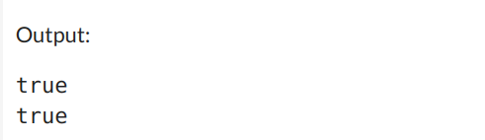

- Find the Output
var x = 100;
console.log(x);

function test(){
var x = 250;
console.log(x);

if (x > 100) {
let x = 350;
console.log(x);
}

console.log(x);
}

test();
console.log(x);
output:
100
250
350
250
100

- What is the difference of output between these two expressions? Give your reasons for it:
  - 12 == “12”
it will give true because it will only check the value not the data type.
  - 12 === “12”
it will give false because both value and data types will be checked
  - Number(12) === 12
it will give true because Number(12) is a int type and 12 is also int.

- What is NaN?

NaN stands for "Not a Number" and is a special value in JavaScript that represents an undefined or unrepresentable numeric value.

