Subhradip Barik ( js assignment - 1 )

// Write a program that declares a variable using var, let, and const and prints the value to the console.

var a = 10
let b= 20
const c = 30
console.log(a)
console.log(b)
console.log(c)

// Write a program that reassigns a value to a variable declared with let and prints the new value to the console.

let a =10
const fun =()=>{
a = 20
}
fun()
console.log(a)

// Write a program that tries to reassign a value to a variable declared with const and prints the message to the console

const a =10
const fun =()=>{
a = 20
}
fun()
console.log(a)

reason : TypeError: Assignment to constant variable is not possible .

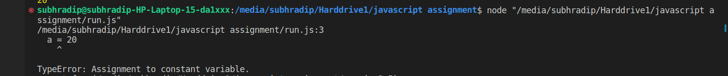

// Write a program to declare a const, let, var variable within an if statement and try to access the variable outside the if block, what is the result?

a = 20
if(a>10){
var one = 1
const two = 2
let three = 3
}

console.log(one)
console.log(two)
console.log(three)

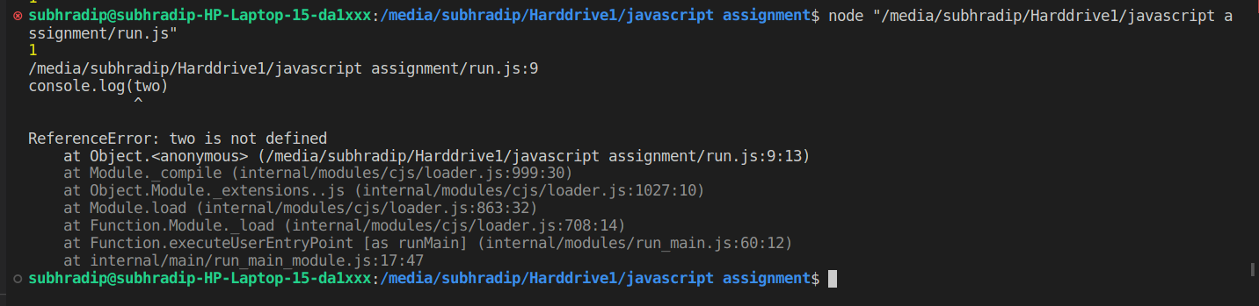

reason : for variable declared with var it will print the value, but for let and const it will give error as these two are block scope variables.

// Write a program that concatenates two or more strings and prints the result to the console.

str1 = "Kreeti"
str2 ="Technologies"
str3 = "Pvt"
str4 = "Ltd"

ans = str1.concat(" ",str2," ",str3," ",str4)

console.log(ans)

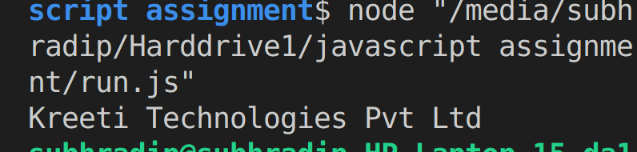

// Write a program that takes a string as input and prints the length of the string to the console.

var inp = prompt("input any string")

console.log(inp.length)

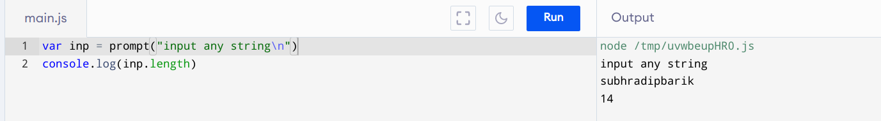

// Write a program that converts a string to uppercase and prints the result to the console.

let text = "Hello World!";
let result = text.toUpperCase();
console.log(result)

