JS Assignment - 4 (Arrays and their built in methods)

- Given a string “Azad Ram Madiha Yash”. Return a string with the first letter of every word from the string. (Use built in methods).

var input = "Azad Ram Madiha Yash"
var ans = input.split(" ").map(x => x.charAt(0)).join();
console.log(ans)


- Given an array [1, -4, 12, 0, -3, 29, -150]. Calculate the sum of all positive numbers (use built in array methods).

const arr = [1, -4, 12, 0, -3, 29, -150];


const sum = arr.reduce((acc, curr) => {
if (curr > 0) {
return acc + curr;
} else {
return acc;
}
}, 0);

console.log(sum);

- Given an array [1, 2, 3, 4, 5]. Create a new array with the square of each element(use built in array methods).

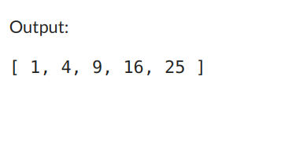
const arr = [1, 2, 3, 4, 5];

const squaredArr = arr.map((num) => num * num);

console.log(squaredArr);

- Given an array [{ id: 2100, name: 'President Jacqueline' }, { id: 2114, name: 'Vice-president James' }, { id: 3016, name: 'House-captain Otis' }, { id: 4818, name: 'Prefect Finneas' }]. Create an array containing just the id of every individual. (write two solution one using iterator and another using built-in method)
using iterator:
const arr = [{ id: 2100, name: 'President Jacqueline' }, { id: 2114, name: 'Vice-president James' },
{ id: 3016, name: 'House-captain Otis' }, { id: 4818, name: 'Prefect Finneas' }];

const idArr = [];

for (let i = 0; i < arr.length; i++) {
idArr.push(arr[i].id);
}

console.log(idArr);

using built in function

const arr = [{ id: 2100, name: 'President Jacqueline' }, { id: 2114, name: 'Vice-president James' }, { id: 3016, name: 'House-captain Otis' }, { id: 4818, name: 'Prefect Finneas' }];

const idArr = arr.map((obj) => obj.id);

console.log(idArr);

