Operating Systems Lab 2026
Assignment Set 1

Objectives
- Linux installation
- To understand occurrence of race condition in OS
- To learn some useful commands ps, kill, cat, chmod, ls, pwd, man etc.
- To learn the use of some basic system calls getpid(), getppid(), fork()

A1
Question:
Learn the use of ps, kill, cat, chmod, ls, pwd, man etc. commands. Try to be conversant with all the possible options for each command. Try to use man command to know the details of a command. Example: $ man ps
Code:

1. pwd (Print Working Directory)
pwd

2. ls (List Directory Contents)
ls
ls -l
ls -a
ls -la

3. cat (Display File Contents)
cat file.txt
cat -n file.txt

4. chmod (Change File Permissions)
chmod 755 file.txt
chmod u+x script.sh

5. ps (Process Status)
ps
ps -ef
ps aux

6. kill (Terminate Process)
kill PID
kill -9 PID

7. man (Manual Pages)
man ps
man ls

Ouput:

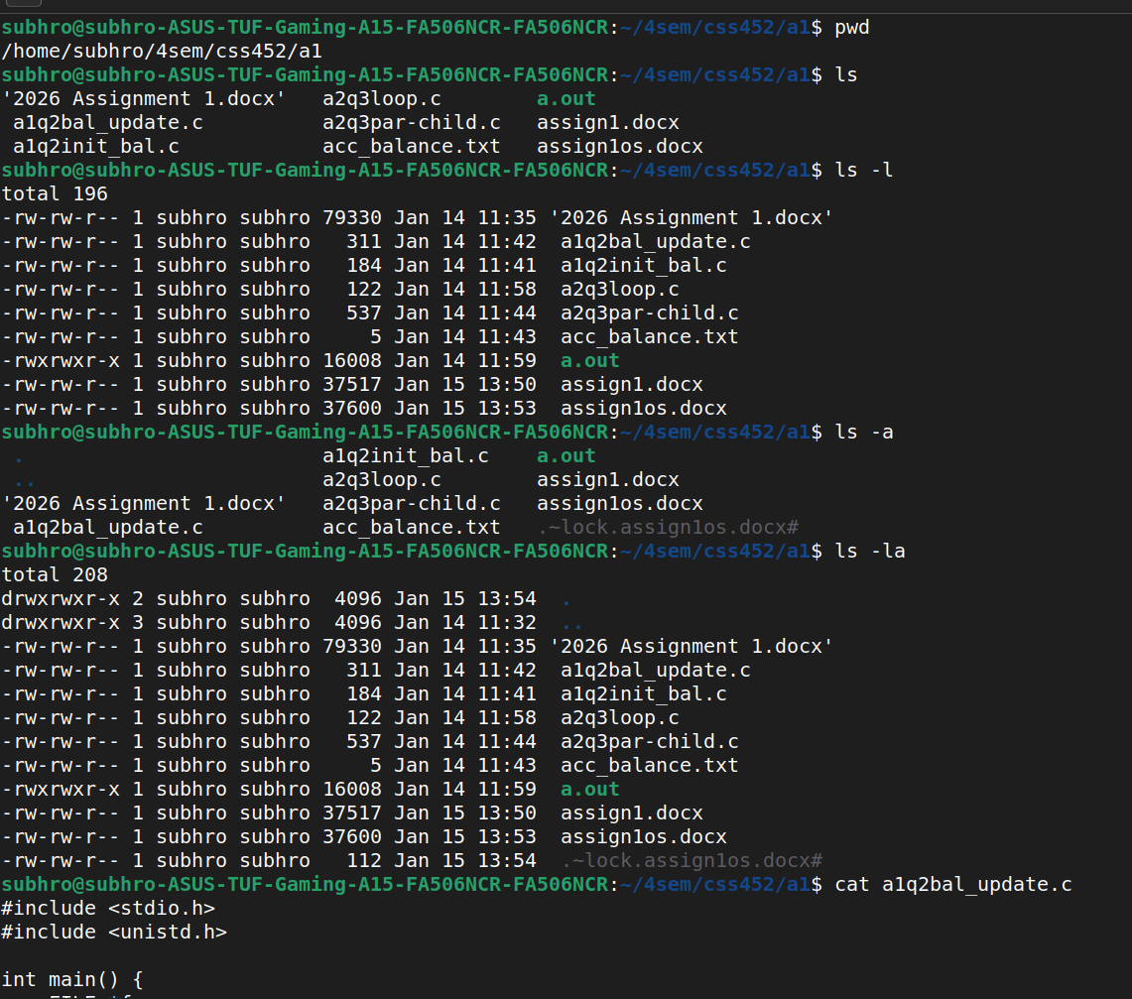
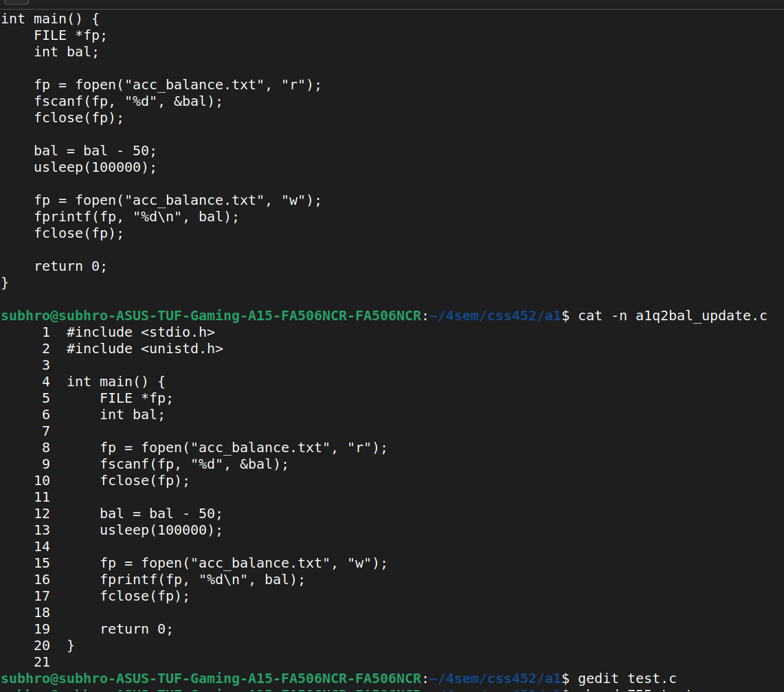

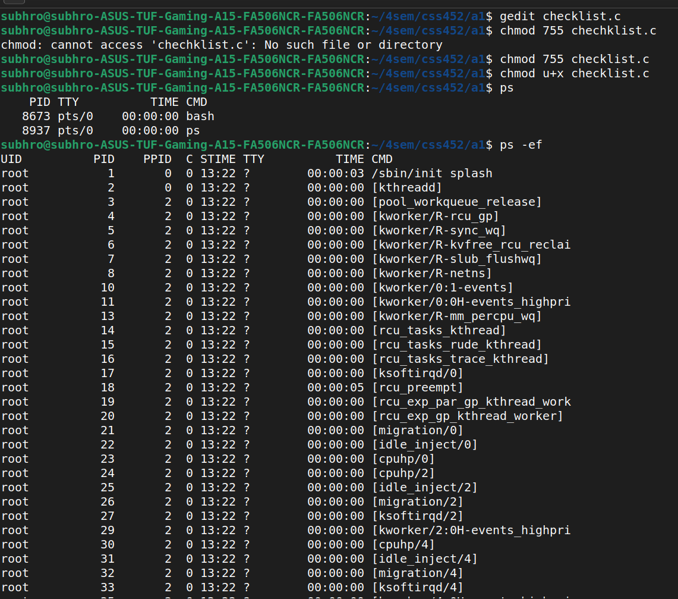
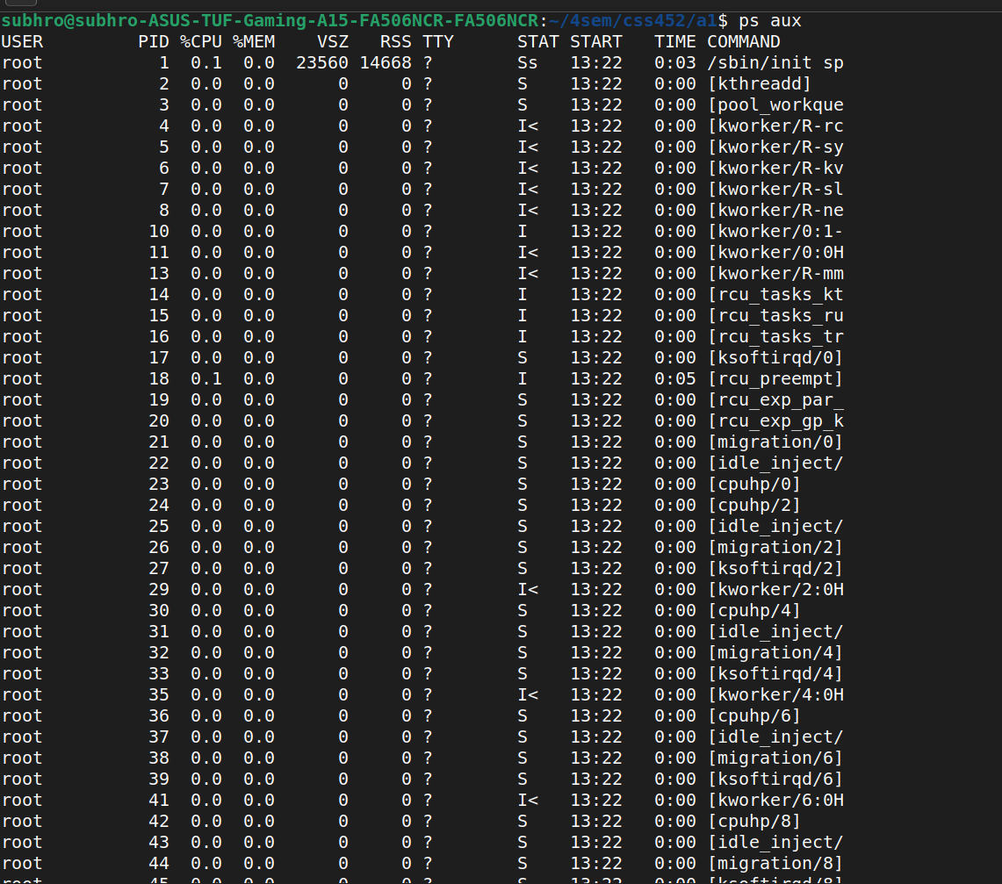
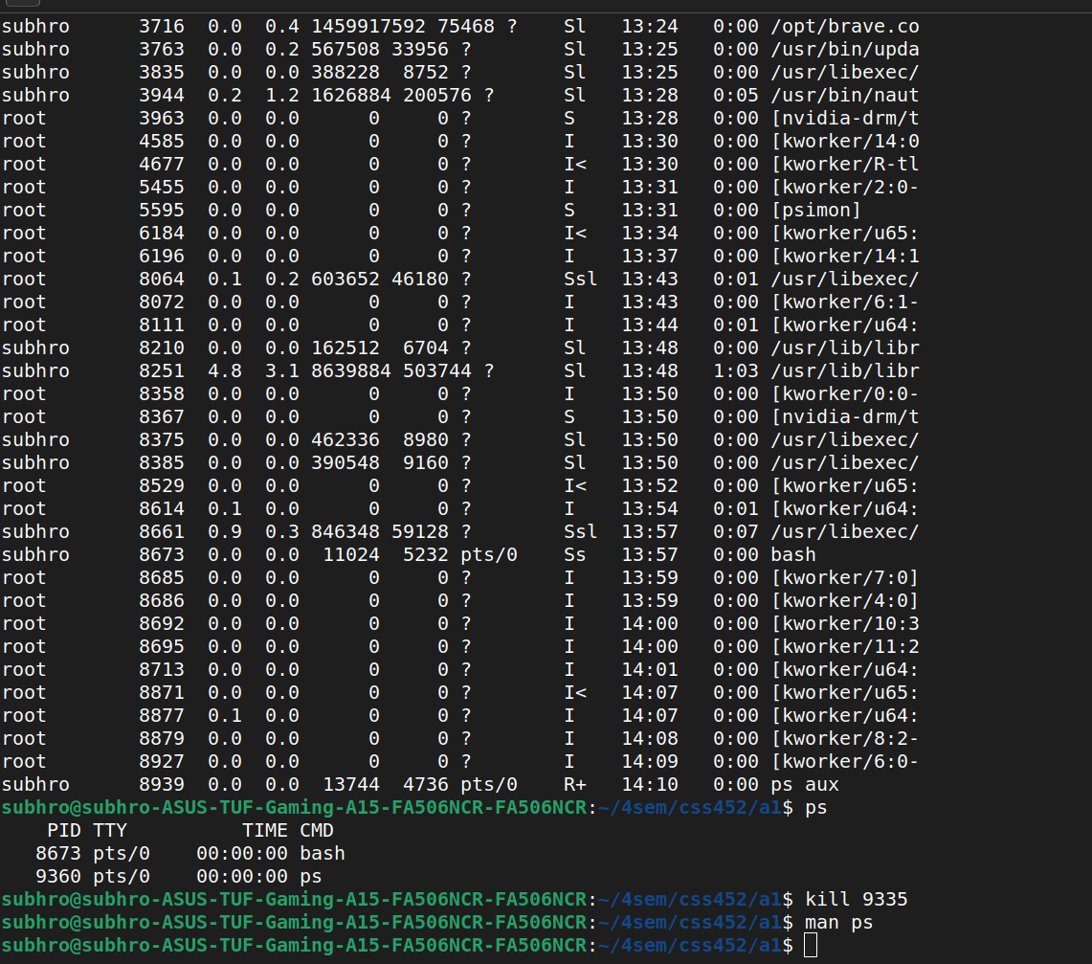

A2
Question:
Execute the balance update code discussed in the class and have a feel of race condition in OS. Create the acc_balance.txt file by executing the init_balance process. Create multiple bal_update processes and let them run simultaneously in background. Show the anomalous outcome using cat and provide terminal snapshots.
Code:
Race Condition Demonstration
File name: a1q2init.c
#include <stdio.h>
#include <stdlib.h>

int main() {
FILE *fp = fopen("acc_balance.txt", "w");
if (fp == NULL) {
perror("File open error");
exit(1);
}

fprintf(fp, "%d\n", 1000);
fclose(fp);

printf("Account initialized with balance = 1000\n");
return 0;
}

File name: a1q2bal.c
#include <stdio.h>
#include <stdlib.h>
#include <unistd.h>

int main() {
FILE *fp;
int balance;

fp = fopen("acc_balance.txt", "r");
if (fp == NULL) {
perror("File open error");
exit(1);
}

fscanf(fp, "%d", &balance);
fclose(fp);

balance = balance + 100;

sleep(1);

fp = fopen("acc_balance.txt", "w");
if (fp == NULL) {
perror("File open error");
exit(1);
}

fprintf(fp, "%d\n", balance);
fclose(fp);

printf("Updated balance: %d\n", balance);
return 0;
}

Output :
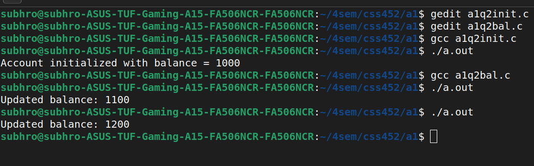

A3
Question:
Write a code where the parent process creates a child process using fork(). The child and parent should print their PIDs, parent PID, group ID, and print 'Bye' before termination.
Code:
#include <stdio.h>
#include <unistd.h>
#include <sys/types.h>
#include <stdlib.h>

int main() {
pid_t pid;

pid = fork();

if (pid < 0) {
perror("Fork failed");
exit(1);
}

if (pid == 0) {
printf("Child running... mypid %d myparent pid %d mygroupid %d\n",
getpid(), getppid(), getpgrp());
printf("Bye\n");
} else {
printf("Parent running... mypid %d myparent pid %d mygroupid %d\n",
getpid(), getppid(), getpgrp());
printf("Bye\n");
}

return 0;
}
Output :
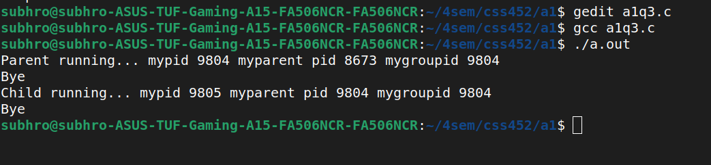

A4
Question:
Write one process executing an infinite loop and another process infinitely calling malloc(). Run both in background. Use ps command to observe CPU and memory usage. Provide at least three snapshots.
Code:
File name: a1q4_cpu.c
(Infinite loop – CPU intensive)
#include <stdio.h>

int main() {
int pid = fork();
printf("pid : %d\n",pid);
while (1) {
}
return 0;
}

File name: a1q4_mem.c
(Infinite malloc – Memory intensive)
#include <stdio.h>
#include <stdlib.h>
#include <unistd.h>

int main() {
int pid = fork();
printf("pid : %d\n",pid);
while (1) {
malloc(1024 * 1024);
sleep(1);
}
return 0;
}
Output :
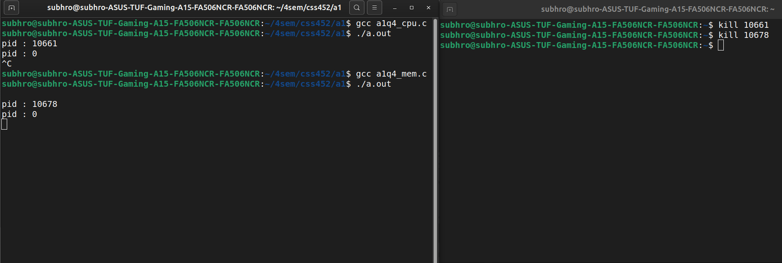

A5
Question:
Write a code where parent creates a child process and both run infinite loops. Terminate child to show zombie process and terminate parent to show orphan process using ps snapshots.
Code:
#include <stdio.h>
#include <unistd.h>
#include <sys/types.h>
#include <stdlib.h>

int main() {
pid_t pid;

pid = fork();

if (pid < 0) {
perror("Fork failed");
exit(1);
}

if (pid == 0) {
while (1) {
sleep(1);
}
} else {
while (1) {
sleep(1);
}
}

return 0;
}
Snapshots:
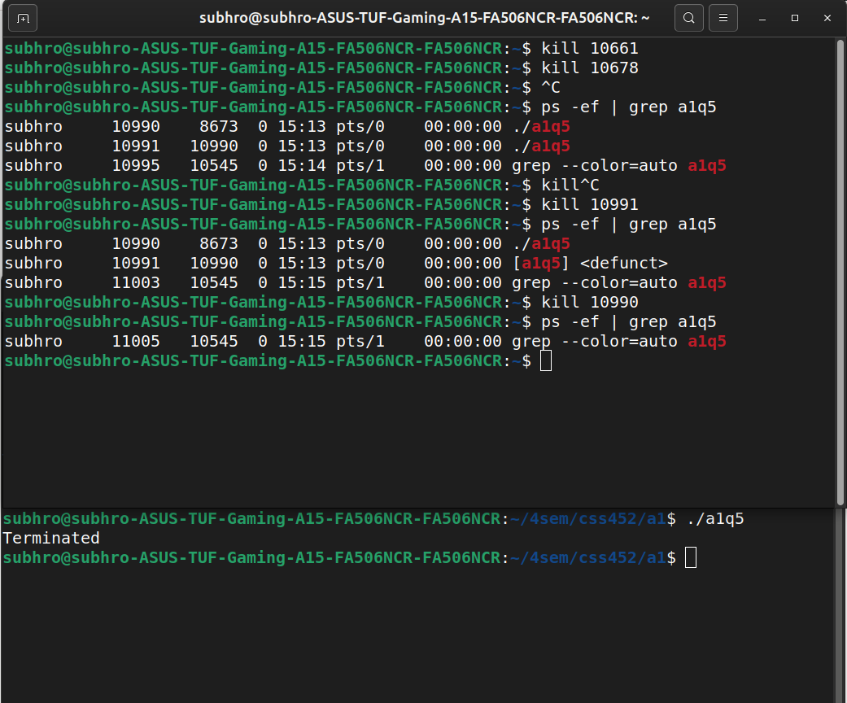

A6
Question:
Write a utility program that executes ps aux and ps -ef using system() call, redirects output to files, parses them and reports process statistics.
Code:
#include <stdio.h>
#include <stdlib.h>
#include <string.h>

int main() {
FILE *fp;
char line[1024];
int total = 0, running = 0, terminals = 0;

system("ps aux > ps_aux.txt");
system("ps -ef > ps_ef.txt");

fp = fopen("ps_aux.txt", "r");
if (fp == NULL) {
perror("File open error");
exit(1);
}

fgets(line, sizeof(line), fp);

printf("CPU intensive processes (CPU > 10%%):\n");
while (fgets(line, sizeof(line), fp)) {
total++;

char user[50], tty[50];
int pid;
float cpu, mem;

sscanf(line, "%s %d %f %f %*s %*s %*s %*s %s",
user, &pid, &cpu, &mem, tty);

if (cpu > 10.0)
printf("PID: %d CPU: %.2f\n", pid, cpu);

if (strcmp(tty, "?") != 0)
terminals++;

if (strstr(line, " R "))
running++;
}
fclose(fp);

fp = fopen("ps_ef.txt", "r");
if (fp == NULL) {
perror("File open error");
exit(1);
}

fgets(line, sizeof(line), fp);

printf("\nMemory hungry processes (MEM > 10%%):\n");
while (fgets(line, sizeof(line), fp)) {
int pid;
float mem;

if (sscanf(line, "%*s %d %*s %*s %*s %*s %f",
&pid, &mem) == 2) {
if (mem > 10.0)
printf("PID: %d MEM: %.2f\n", pid, mem);
}
}
fclose(fp);

printf("\nProcess statistics:\n");
printf("Total processes: %d\n", total);
printf("Running processes: %d\n", running);
printf("Number of terminals: %d\n", terminals);

return 0;
}
Snapshots:
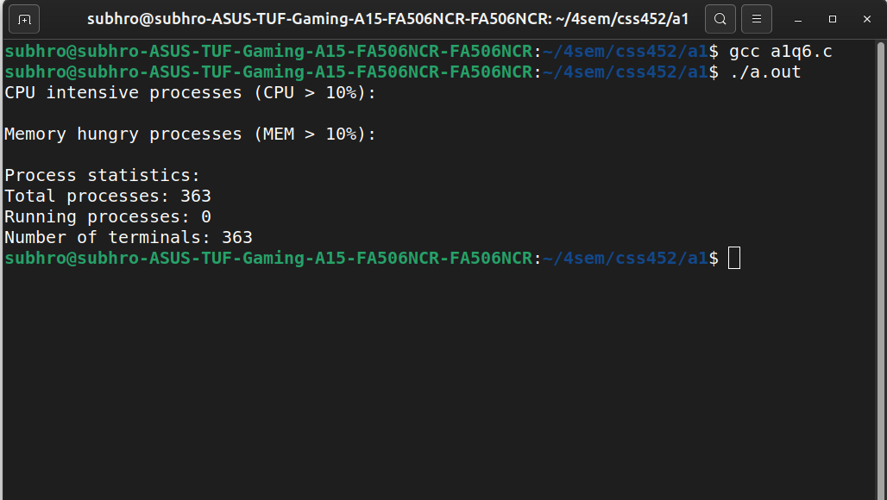

A7
Question:
Run lscpu command and find number of CPU cores. Use man lscpu to understand all displayed information.
Code:

Command to display CPU details
lscpu

Command to understand lscpu output
man lscpu

Output :
