It is backbone of search engine to discover new or updated content on web
- First it starts by collecting few relevant web pages
- Then follow the links in that page and gather content and so on
- 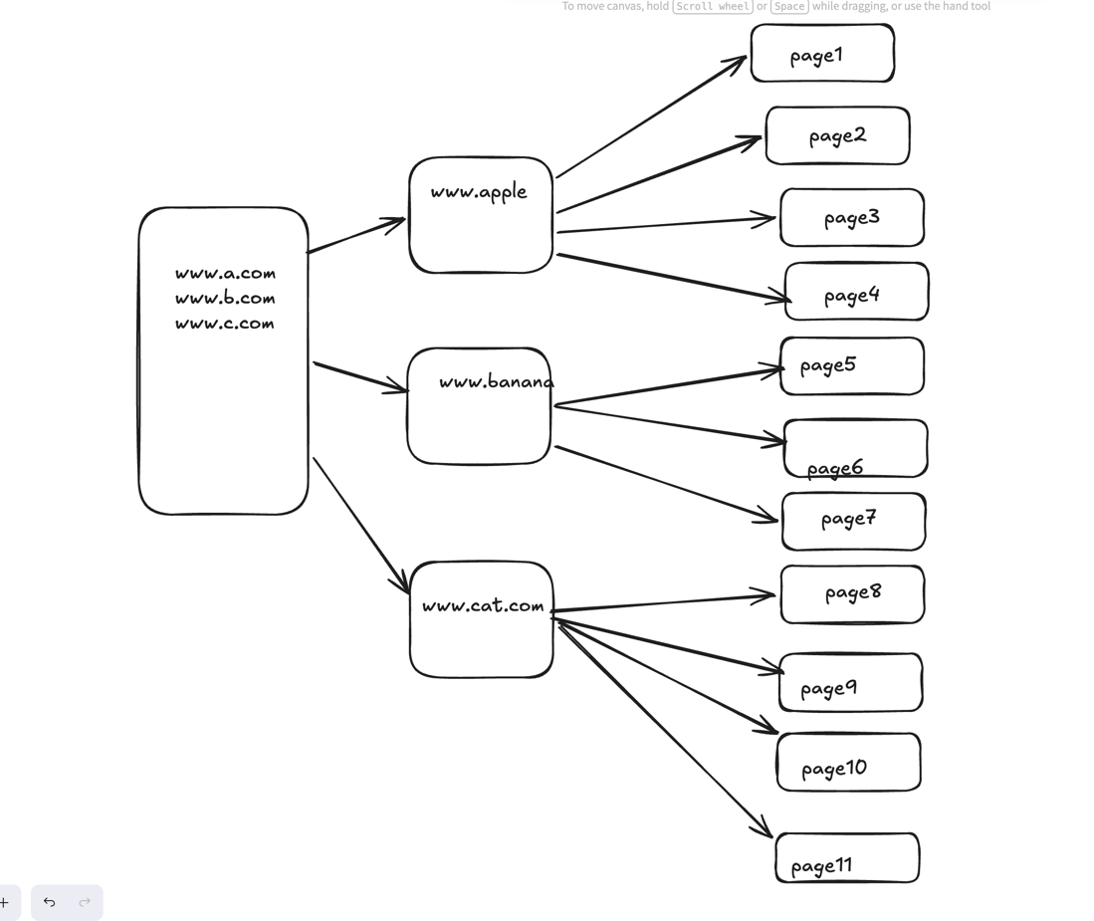

Use cases
- Search engine indexing
- Web Archieving
- Web Mining
- Web monitoring

Algo of web crawler
- Given a set of url ,so download all web pages addressed in the url
- Extract url from the downloaded pages
- Add those new url to the list of url to be downloaded and repeat the process

This is a simple case. But in real world app, web crawler is complex

For the simplicity of design
- Purpose of the crawler is Search engine indexing
- 1 billion pages/month to be collected
- Content type - HTML only
- We can consider newly added and editted web pages
- We need to store the html pages crawled for 5 years
- Pages with duplicate content will be ignored

Non-FR
- Scalabilities
- Robustness- Crawler should handle all the edge cases , like - unresponsiveness.
Bad html, malicious link etc
- Politeness - crawler should not make too many request to the site within a short interval of time
- Extensibility - System should be flexible enough to accommodate the fute changes, if any

Back of the envelope calculation

1 day = 24*3600 seconds ~ 10^5 seconds
QPS = 10^9 / 10^5 *30 ~300
Peak QPS = 2*300 = 600
Avg web page size = 500 kb
1 billion page size = 500 *10^3 *10^9 =500 TB / mnth
We have to keep these data for 5 years

Db size = 500 *10^12 * 12*5 = 3E16 ~ 30 pb

High level design

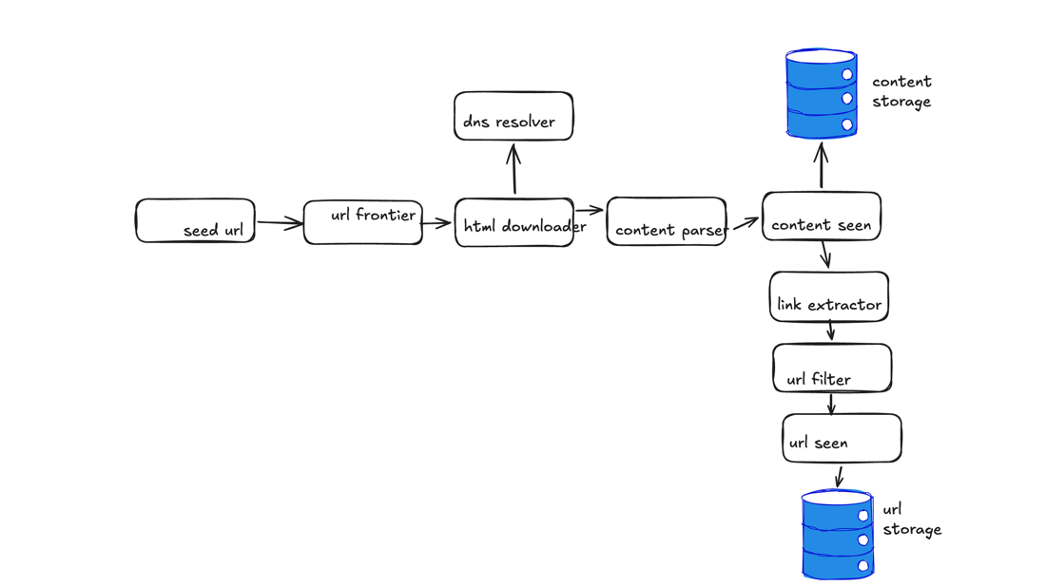

- Seed url - entry point. So need to choose good seed url
  - Locality, as diff country has diff websites
  - Topics
- Url frontier - queue
- Html downloader - download pages from internet
- DNS resolver - to download web pages, url must be translated into ip addresses
- Content parser -
- Content seen - compare by hash values of the pages
- Content storage - both disk and memory can be used
- Url extractor
- Url filter - to filter out blocked url
- Url seen - bloom filter or hash table
- Url storage

Choose of traversal BFS vs DFS

Here dfs will be eliminated , as going deep to the url wont solve the purpose
So bfs is the technique here

Spider trap - is a web page that cause crawler into infinite loop
Filter these site , usually , this type of website has many links

