URL Shortener

WHat is it : - It is a svc which convert the long url to the short version

- How it works - there is a long url e.g https://www.abc.com/q=books&c=systemdesign&id=123 , once this url is passed to url shortener svc, it will generate a short form of it e.g https://bitly.com/3tr54e

If you click on the short url , it will redirect me to the original url location and get the query
- Traffic volum - 100 million ul /day
- How short the url would be - As short as possible
- What char are allowed in the shortened url - all the chars from A-Z , a-z and 0-9
- Can it be deleted or updated - for simplicity , it cant be deleted or updated

Functional Requirement
- Create short url
- Redirect the short url to long url

No functional Requirement
- Availability
- Scalability
- Low latency
- consistancy

Back of the envelope Calculation

Lets calculate QPS
1 day = 24*3600 sec = 86400 ~ 10^5 sec
Per day 100*10^6

QPS = 100 * 10^6 /10^5 = 1,000

Assuming read:write ops = 10:1
So read ops /sec = 10000

Assuming it will run for 10 years = 100 *10^6 *365*10 records = 365 billions

If each record size is 100 bytes , then the DB will store 365 *10^9 *100 = 3E13 ~ 30 TB
API end points
- To create a short url
  - Post - api/v1/data/shorten
- To get the short url
  - Get - api/v1/shorturl
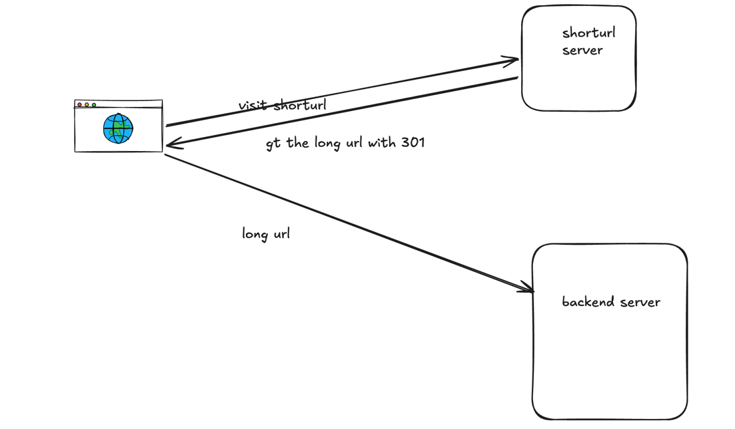

Design

More intuitive way is the HashMap
Key - short url
Value - long url

- In case of get call, hashmap will serve the value which is the long url as per its key
- In case of Post call
  - Long url is being passed to the hash function
  - Its hash value is being calculated
  - Then stored it in hasmap or the key-value storage
To store the key, value in production , we can use Redis, because
- Low latency
- Handles massive trafic
- Built-in expiration support
- Reduce the load on db
But Redis should not be the only storage, because it is a cache so may be durability will be questionable
Also to store the entire data set, it could be more expensive

Hash value calculation

- Total no of chars - a-z, A-Z, 0-9
  - 26+26+10 = 62
  - As per our requirement, system must support 365 billion records
  - i.e we have to find the length of the url , by using the 62 char , we can b able to generate >=365 billons record
  - If n = 5 , 62^5 ~ 1 billion , if n =7 , 3.5 trillions
  - So we can take the url length, minimum =7
  - To generate the hash , we can use any algo like - MD5, CRC32 or SHA-1
- Hash collision -
  - In case of hash collision append a constant string to the long url and pass it again for hash calculation
  - So here DB query can be expensive, so we can use Bloom filter to eliminate the process
    - Bloom filter
      - Bloom filter is a space efficient probabilistic technique to test if an element is member of set of not.
