INTERNSHIP REPORT
On

( Garments Management )

Submitted to Biju Patnaik University of Technology
in partial fulfillment of the requirements for the degree in
Master in Computer Application



Submitted By

Subhrasmita Ojha
Master in Computer Application
Regd. No. :

INSTITUTE OF MANAGEMENT AND INFORMATION TECHNOLOGY
Cuttack

CERTIFICATE

This is to certify that the application entitled Online Shopping Portal is a bonafide record of independent work done by Subhrasmita Ojha (Reg. No.1705102025:) under my supervision during June 2019 to October 2019 at Ashirbad Consultancy, submitted to the Department of Computer Applications, Institute of Management And Information Technology, Cuttack, Odisha in partial fulfillment for the award of the degree of Master in Computer Application in session 2017-2020 and that the application has not previously formed the basis for the award of any other degree, Diploma, Associate ship, Fellowship or other title.

Date: 1st November, 2019

Ashirbad Consultancy
( Center for S/w Development & Training )
At : Madhupatna, PO : Madhupatna
Dist : Cuttack, PIN : 753010, Odisha
DECLARATION

I hereby declare that the application entitled “Online Shopping Portal” submitted to the Department of Computer application, Institute of Management And Information Technology, Cuttack, Odisha in partial fulfillment for the award of the degree of Master in Computer Application in session 2017-2020 is an authentic record of my own work carried out at Ashirbad Consultancy and that the application has not previously formed the basis for the award of any other degree.

Subhrasmita Ojha
(Reg. No.:1705102025 )

TABLE OF CONTENTS

Sl.No | Contents | Page No
01 | Introduction
02 | Objective
03 | System Analysis
04 | Identification of Need
05 | Preliminary Investigation
06 | Feasibility Study
07 | Software Requirement Specification (SRS)
08 | Software Engineering Paradigm Applied
09 | Data model, class diagram, ERD, DFD
10 | System Design
11 | Modularization Details
12 | Data integrity and constraints
13 | Features of Technology applied
14 | User Interface Design
15 | Reports
16 | Coding
17 | Sample Project coding
18 | Comments and description
19 | Code efficiency
20 | Error Handling
21 | Validation Checks
22 | Testing
23 | Testing techniques
24 | Testing strategies
25 | System Security measures
26 | Database/data security
27 | Creation of user profile and access rights
28 | Cost Estimation of the project
29 | PERT chart, Gantt chart
30 | Future scope of the project
31 | Bibliography
32 | Glossary

Title of the Project : Online Shopping Portal.
Client : Be-You Boutique, Cuttack

Application area : Distribution of Garments by a distribution point
using Java EE and SQL-Server.

Introduction

Online Shopping Portal is the process of recording and reporting the transaction of garments of a distributor and preparation of the stock statistics reports, purchase & sales statistics reports etc. These reports will help to get the information about the entire inventory of the distributor.
Also apart from the inventory system, there are accounts related works which includes the detailed and summery ledger of the different companies i.e. who supply garments to the company, the people and agencies who owe money to the company and are interested in the financial position of the company, which has to be communicated to them. Thus assessing the financial performance of a business is very important. Typically this performance is assessed for a specified period.
Be-You Boutique deals in the distribution of various types garments and dress materials. It is a very difficult process to handle all its underlying inventory positions, ageing and financial transactions to prepare the related stock informative reports and financial reports as needed. It also faces a lots of difficulties to find out its account payable and receivable statements as on date when required. Some of the other problem areas are managing stocks, finding stock related analysis and reports, and the underlying Financial Transactions. The company requires a complete financial solution, companies listing and Accounts receivables and Account payables for a smooth financial management. In fact what the company needs is to keep track of all its customer\company payments, payments given to transporters, while transporting stock from one location to another location, bank transactions, customer outstanding reports and other financial statements as required by the senior officials.

Objective
The objective of the system is to online the transactions. It maintains a stock master register for this purpose, which contains the details of the products. The records of daily transaction are maintained in another register, referred to as the stock ledger. On receiving orders it is verified against stock available, if products are available, then the outstanding details of the customer/company is checked if the company is satisfied with the verified data a product issue is performed along with an issue note. At the end of the day a summary of reports, comprising all transactions. It takes a lot of time to determine the availability of stocks at any point of time, since it is being updated only at the end of the day.
The company needs a financial solution to look after the complexity involved in the accounts section along with stock management and customer/company order processing. The objectives of the software solution is to automate the underlying business process.
In addition to automation of the above business process the solution should also be able to generate all the financial reports like , Customers/companys outstanding, profit and loss statement etc. as the company may require. The reports can be generated quarterly, half yearly or yearly. It should also be able to generate the financial reports between a starting and an end date.

System Analysis
Here requirements for both the system and the software are documented and reviewed with the customer as well as companies. More focus is given on the software. The analyst interacts and understands the different functionalities, performance of the software. During the design phase requirements are translated into a representation of the software that can be coded. Here focus is given on the different attributes of a program – Data structures, Software Architecture, interface representation and Algorithm details. The design is documented. Then a SRS – System Requirement Specification report is prepared and given to the company.
Systems analysis is an important phase of the System Development Life Cycle. Hence we thoroughly observed the existing system, learn about their problems, define customer’s\company’s needs & requirements and evaluated some alternative solution.

Preliminary Investigation
Preliminary Investigation of our system included collection of user needs, defining all such areas to be computerized & suggesting some feasible solution towards fulfillment of user requests. In our preliminary investigation we discussed much details of the functional parts and the daily business activities of the client. We communicated with the concerned persons & noted their requirements. In our initial observations we found the following areas that needed to be computerized.
Getting the inventory of any particular company or product through manual method is time consuming and some times becomes incorrect. Getting the statistics of receipt of item of any particular company or as a whole is difficult. getting the statistics of issue of item of any particular dealer or as a whole is difficult. Getting the ageing of different dealer and products is difficult. To keep the track of accounts details of different dealers and retailers .To keep the track of account details of companies the company deals with .
While investigating the existing system, we found a lot of activities that needed to be computerized / automated. All the paper work carried while investigating, showed the complicacies and size of the project. Our very next step was to individualize their requirements and put them into categories or groups. These categories / groups represented a department or an activity or a set of activities that needed to be automated.

Feasibility Study
The project to be designed is actually beneficial or not from various angles is examined here. For example if there are no technical persons to operate the project, whether the development cost exceeds the budget allocated by the company, whether there are system resources available or not to implement the solution. For all such reasons a Feasibility study is performed to determination weather or not the enterprise software solution is worth doing. The process followed in making this documentation is called a feasibility study. Project specifications can only be finalized if analysis confirms positive results from feasibility study. Thus since the feasibility study may lead to the conferment of large resources, it become necessary that it should be conducted completely and that no fundamental errors of judgments are made. In a quest to justify our systems requirements specifications, we carried the following types of feasibility studies.

Technical Feasibility:

Technical Feasibility is defined as the availability of suitable technology and system resources to support the enterprise software solution and adequate expertise to develop the solution. Also it must be possible to implement the solution within a reasonable time. The Client has already well-equipped systems. The existing PC’s comprised of efficient processors, with appropriate size of RAM and Hard disk as well as printers. All these available hardware met the hardware requirements of our proposed system. We were also provided with most of the software required.

Economic Feasibility:
Economic Feasibility Analysis in the most frequently used technique for evaluating the effectiveness of a proposed system. It is more commonly known as COST / BENEFIT Analysis; the procedure to determine the benefits and savings that are expected from a proposed system and compare them with costs. If benefits outweigh costs, decision is taken to design and implement the system. Otherwise, further justification or alternative in the proposed system will have to be made if it is to have a chance of being approved. This is an ongoing effort that improves in accuracy at each phase of the system life cycle. The existing system had every thing except the network between the individual stand-alone systems. The expenses needed to establish the network would be worth spending, as it would in all means benefit the overall functioning of the organization.

Operational Feasibility:

Operational Feasibility is defined as the suitability of the solution from the standpoint of the people who will have to use that solution. In context of our proposed system we covered the following issues under operational feasibility
What changes will be brought with the system?
The proposed system is targeted towards faster and secured data processing. Large sets of records maintained manually and stored in files and folders would be replaced by convenient and secured way of processing. Not only the proposed project will benefit the existing system, but also it will make the system robust with higher degree of overall performance and productivity.
What Organizational Structures are disturbed?
Basically there is least or approximately nil disturbance, needed to be brought about in the existing organizational structure, for our proposed project to be fully operational.

Do we posses the technical expertise and is the schedule reasonable?

The technical persons available at the client site are well versed with general-purpose softwares available. There would be less training effort required for the technical staff to operate on our proposed system. Hence, little time would be wasted (after the implementation & testing), for our project to be fully operational.
The company is having existing PC’s comprised of efficient processors, with appropriate size of RAM and Hard disk as well as printers. All these available hardware met the hardware requirements of our proposed system. It is also having a well-networked infrastructure. Also the cost/benefit analysis determines the benefits and savings that are expected from a proposed system and compare them with costs. And here the benefits outweigh costs, in such situation decision is taken to design and implement the system. The company is also having some skilled manpower having the operational knowledge of PCs. So the proposed system is feasible in every angle.

Software Requirement Specification
Taking all the factors and alternatives proposed by our team into considerations the management decided to computerise the existing "Inventory Automation & Accounts System”. The system, is to be designed using J2SE with SQL Server-2000 as the repository to provide persistence. The particular selection of language and backend is with a target to develop a robust application.

The proposed system performing the fact findings targets the following objectives.
- Acquisition of dress material products lfrom different sources
- Issue of the garments to different retailers & customers.
- Claims of garments by different customers
- Return of garments by different customers
- Accounts management for issue on credits
- Handling customer enquiries.
- Regular reports for management and other users.
- Analysis in the requirement of new inventory.

To meet all the above requirements the system functionally carries out the following operations:
  - Allows to create and record the details of supplier details.
  - Allows the create and record the garments products details
  - Allows to create and record the details of retailers with the complete information to whom garments products are issued.
  - Allows to record receipt of garments products from different suppliers.
  - Allows to post order of the requirement of garments products to different suppliers.
  - Allows to issue garments products to different customers and retailers.
  - The system to meet the statistics of the information at different levels of the organisation, targets a set of valuable reports, such as:
    - Supplier list details.
    - Garments products details available in stock.
    - List of garments products
    - Supplier wise purchase Register.
    - Retailer wise issue Register
    - Product wise Issue Register.
    - Purchase/Receipt Register
    - Account payable and receivable register.
- Allows to take the backup and restoration of data on data loss.
- Allows to alter the authentication specifications such as User id and password.

Software Engineering Paradigm applied
Software process model is a road map or framework for the tasks that are required to build high-quality software. Thus we can define this as the foundation for Software Engineering. The software process defines a systematic disciplined quantifiable approach to the development, operations and maintenance of the software. The key process areas form the basis for management control of software projects and establish the contest in which technical methods are applied, work products (modules, documents, data, reports, forms etc.) are produced, milestones are established, quality is ensured, and changes is properly managed.
As selection of a software process depends mostly on the problem domain or the type and size of the Project, it became a real tough task for us to select a particular path / process out of a range of software processes modules available. In our Project, we had a range of tasks and a varied set of objectives that spread over different domains viz, Stock Management, Processing of Sales Orders & Purchase Orders, Raising and Managing Customer orders, Managing the Stock to avoid Stock out costs and the details of Finance requirement to meet all the needs. Also generating information for the top-level management personals. Working out a suitable process model for such a system was a difficult task.
Initially considering the size of the project and information availability we were inclined to adopt RAD – Rapid Application Development Model, as it would have helped in obtaining prototypes in increments. But as we started dividing the whole project into modules and tasks, we learnt that using prototyping model (as Software Engineering Paradigm) would be more complicating & time consuming. The reason behind it was the size of modules, which would have consumed a lot more time using prototype model than other models.
The software design principle followed here is RAD Rapid Application Development model with short development cycle. As the requirements are well understood and project scope is constrained the RAD process enables a development team to create a fully functional system within very short time period. The requirements gathering process is intensified and focused specifically pm software to understand the nature of the programs to built. The software engineer must be understand the information domain for the software, as well as required function; behavior performance and interfacing for both systems and software are documented and reviewed with the customer. This system view is essential when software must interface with other documents such as hardware, people & database. System engineering and analysis encompasses requirements gathering at the system level with a small amount of top level of analysis business level and at the business area level. The Phases of RAD models are:
1. Business Modeling:
The information and data flows among different business entities i.e. the different modules of the application are modeled here. Also the business functions are identified and the processes that are required to implement the business functions are defined. All the inputs, outputs and information flow among different entities are also identified.
2. Data Modeling:
The various data objects required to support the information flow among different models are modeled here. The relationships between data objects are also defined. Different levels of data flow diagrams are designed
3. Process Modeling:
The entire data objects models were transferred to achieve the information flow. The different processes required, for adding, modifying, deleting or retrieving to or from a data object is defined. The relationships between the data objects are also defined. Input and Output data objects are the indication for the application of process model to implement RAD.
4. Application Generation:
Here the actual coding of the business functionalities are designed by using fourth generation techniques. To reuse existing programs, reuse components may also be created. We have selected as per the client requirements Java EE and SQL Server.
5. Testing:
As in RAD, more emphasis is given on the reuse of components, many of the program components have already been tested which reduces the overall testing time. All other components and their interfaced are tested.

Class diagrams

COMPANY

1. cCODE VARCHAR 10 COMPANY CODE
2. cNAME VARCHAR 50 COMPANY NAME
3. LOCALITY VARCHAR 40 LOCALITY
4. CITY VARCHAR 45 CITY
5. STATE VARCHAR 40 STATE
6. CONPER VARCHAR 50 CONTACT PERSON
7. LISENCE VARCHAR 50 LISENCE NUMBER
8. LDATE DATE TIME - LISENCE DATE
9. cTYPE VARCHAR 15 COMPANY TYPE
10. VATNO VARCHAR 20 VAT NUMBER
11. PHONE VARCHAR 15 PHONE NUMBER
12. FAX VARCHAR 15 FAX NUMBER
13. EMAIL VARCHAR 40 EMAIL
14. WEBSITE VARCHAR 40 WEBSITE

Submit(), Find(), Reset()

Add( ), Next( ), Prior( ), Save( ), Delete( ),Update( ), Close( )

PRODUCT

1. CCODE VARCHAR 10 COMPANY CODE
2. CNAME VARCHAR 50 COMPANY NAME
3. PCODE VARCHAR 10 PRODUCT CODE
4. PNAME VARCHAR 40 PRODUCT NAME
5. SIZE VARCHAR 30 SIZE
6. CATEGORY VARCHAR 50 CATEGORY
7. UNIT VHARCHAR 20 UNIT
8. PPRICE NUMERIC (8,2) UNIT P. PRICE
9. SPRICE NUMERIC (8,2) MAXIMUM R. PRICE
10. TAXSLAB NUMERIC (5,2) TAXSLAB
11. LOCATION VARCHAR 20 LOCATION
12. OPSTOCK NUMERIC - OPENING STOCK
13. MSTOCK NUMERIC - MARGINAL STOCK

Submit(), Find(), Reset()

ORDER TO COMPANY

1. ORDNO VARCHAR 10 ORDER NUMBER
2. VDATE DATETIME - DATE
3. CCODE VARCHAR 10 COMPANY CODE
4. CNAME VARCHAR 50 COMPANY NAME
5. LOCALITY VARCHAR 40 LOCALITY
6. CITY VARCHAR 40 CITY
7. STATE VARCHAR 40 STATE
8. PCODE VARCHAR 20 PRODUCT CODE
9. PNAME VARCHAR 40 PRODUCT NAME
10. SIZE VARCHAR 30 SIZE
11. CATEGORY VARCHAR 50 CATEGORY
12. PRICE NUMERIC (10,2) PRICE
13. QUANTITY NUMERIC (10,2) ORDER QUANTITY
14. AMOUNT NUMERIC (10,2) AMOUNT

Submit(), Find(), Reset()

RETAILER

- RCODE VARCHAR 10 RETAILER CODE
- RNAME VARCHAR 50 RETAILER NAME
- LOCALITY VARCHAR 40 LOCALITY
- CITY VARCHAR 40 CITY
- STATE VARCHAR 40 STATE
- CONTPER VARCHAR 50 CONTACT PERSON
- LISENCE VARCHAR 20 LISENCE NUMBER
- VDATE DATETIME - LISENCE DATE
- RTYPE VARCHAR 15 RETAILER TYPE
- VATNO VARCHAR 15 VAT NUMBER
- PHONE VARCHAR 20 PHONE NUMBER
- FAX VARCHAR 20 FAX NUMBER
- EMAIL VARCHAR 40 EMAIL
- WEBSITE VARCHAR 40 WEBSITE

Submit(), Find(), Reset()

PURCHASE

- PURCHASENO VARCHAR 10 PUR. INVOICE
- PDATE DATETIME - PURCHASE DATE
- ORDERNO VARCHAR 10 ORDER NUMBER
- ODATE DATETIME - ORDER DATE
- CCODE VARCHAR 10 COMPANY CODE
- CNMAE VARCHAR 50 COMPANY NAME
- LOCALITY VARCHAR 40 LOCALITY
- CITY VARCHAR 40 CITY
- STATE VARCHAR 40 STATE
- BILTYPE VARCHAR 20 BILLTYPE
- PCODE VARCHAR 20 PRODUCT CODE
- PNAME VARCHAR 40 PROCDUCT NAME
- PRICE NUMERIC (8,2) PURCHASE PRICE
- QTY NUMERIC - PURCHASEQTY
- AMOUNT NUMERIC (8,2) AMOUNT
- TAXAMT NUMERIC (8,2) TAX AMOUNT
- NETAMT NUMERIC (8,2) NET AMOUNT
- SIZE VARCHAR (20) SIZE
- CATEGORY VARCHAR (20) CATEGORY

Submit(), Find(), Reset()

PURCHASE MASTER

- PURNO VARCHAR 10 PURCHASE NO
- PDATE DATETIME - PURCHASE DATE
- ORDNO VARCHAR 10 ORDER NUMBER
- ODATE DATETIME - ORDER DATE
- CCODE VARCHAR 10 COMPANY CODE
- CNMAE VARCHAR 10 COMPANY NAME
- LOCALITY VARCHAR 40 LOCALITY
- CITY VARCHAR 40 CITY
- STATE VARCHAR 40 STATE
- BILTYPE VARCHAR 20 BILLTYPE
- TOTAMT NUMERIC (8,2) TOTAL AMOUNT
- TOTTAX NUMERIC (8,2) TOTAL TAX
- TOTNET NUMERIC (8,2) TOTAL NET AMOUNT

Submit(), Find(), Reset()

ORDER FROM

- ORDERNO VARCHAR 10 ORDER NUMBER
- VDATE DATETIME - ORDER DATE
- RCODE VARCHAR 10 RETAILER CODE
- RNAME VARCHAR 50 RETAILER NAME
- LOCALITY VARCHAR 40 LOCALITY
- CITY VARCHAR 40 CITY
- STATE VARCHAR 40 STATE
- PCODE VARCHAR 20 PRODUCT CODE
- PNAME VARCHAR 40 PRODUCT NAME
- CATEGORY VARCHAR 50 CATEGORY
- SIZE VARCAHR 30 SIZE
- PRICE NUMERIC (8,2) SALE PRICE
- ORDERQTY NUMERIC - QUANTITY
- AMOUNT NUMERIC (8,2) AMOUNT

Submit(), Find(), Reset()

SALE DETAILS

- SALENO VARCHAR 10 SALE INVOICE NO
- SDATE DATETIME - SALE INVOICE DATE
- ORDERNO VARCHAR 10 ORDER NO
- ODATE DATETIME - ORDER DATE
- RCODE VARCHAR 10 RETAILER CODE
- RNAME VARCHAR 50 RETAILER NAME
- LOCALITY VARCHAR 40 LOCALITY
- SIZE VARCHAR 40 SIZE
- CATEGORY VARCHAR 40 CATEGORY
- BILTYPE VARCHAR 20 BILLTYPE
- PCODE VARCHAR 20 PRODUCT CODE
- PNAME VARCHAR 40 PRODUCT NAME
- SPRICE NUMERIC (8,2) SALE PRICE
- SQTY NUMERIC - SALE UANTITY
- AMOUNT NUMERIC (8,2) AMOUNT
- TAXAMT NUMERIC (8,2) TAX AMOUNT
- NETAMT NUMERIC (8,2) NET AMOUNT

Submit(), Find(), Reset()

SALE MASTER

1. SALENO VARCHAR 10 SALE INVOICE NO
2. SDATE DATETIME - SALE INVOICE DATE
3. ORDERNO VARCHAR 10 ORDER NO
- VDATE DATETIME - ORDER DATE
- RCODE VARCHAR 10 RETAILER CODE
- RNAME VARCHAR 50 RETAILER NAME
- LOCALITY VARCHAR 40 LOCALITY
- CITY VARCHAR 40 CITY
- STATE VARCHAR 40 STATE
- BILTYPE VARCHAR 20 BILLTYPE
- TOTAMT NUMERIC (8,2) TOTAL AMOUNT
- TOTTAX NUMERIC (8,2) TOTAL TAX
- TOTNET NUMERIC (8,2) TOTAL NET AMOUNT

Submit(), Find(), Reset()

PAYMENT DETAILS

- PMTNO VARCHAR 10 PAYMENT NUMBER
- PDATE DATETIME - PAYENT DATE
- CNAME VARCHAR 50 COMPANY NAME
- LOCALITY VARCHAR 40 LOCALITY
- CITY VARCHAR 40 CITY
- STATE VARCHAR 40 STATE
- PMTMODE VARCHAR 20 PAYMENT MODE
- CHDFNO VARCHAR 15 CHQUE/DRAFT NO
- CHDFDATE DATETIME - CHQUE/DRAFT DT.
- BANKNAME VARCHAR 50 BANK NAME
- AMOUNT NUMERIC (8,2) AMOUNT

Submit(), Find(), Reset()

RECEIPT DETAILS

- RPNO VARCHAR 10 RECEIPT NUMBER
- PDATE DATETIME - RECEIPT DATE
- RNAME VARCHAR 50 RETAILER NAME
- LOCALITY VARCHAR 40 LOCALITY
- CITY VARCHAR 40 CITY
- STATE VARCHAR 40 STATE
- RPMODE VARCHAR 20 RECEIPT MODE
- CHDFNO VARCHAR 15 CHQUE/DRAFT NO
- CHDFDATE DATETIME - CHQUE/DRAFT DATE
- BANKNAME VARCHAR 40 BANK NAME
- AMOUNT NUMERIC (8,2) AMOUNT

Submit(), Find(), Reset()

ER-Diagram of the System

Be-You Boutique
Retailer
Issue
Purchase
Receipt
Payment
Stock
Company
Has
To
Update
From
Pays
Receives
Update

DFD of the System.

Online Shopping Portal
Inventory analysis report
Sales ,purchase & statistics report
Accounts information
Sales information
Purchase Information
Accounts Reports

“0 Level” DFD

Order Placement
Final Order

Verification Of Order
Purchase from Company

Stock Updation

Order verification
Order Register
Purchase File

Issue Of Product
Issue
Order To Company
Order From Retailer

1- Level DFD

Receipt from Retailer
Updation of
Stock
Product

Stock Report
Updation of
Stock

Payment Verification
Payment File

Receipt Verification
Receipt File
Purchase

Issue File

Accounts

Accounts

2nd - Level DFD

System Design
Modularisation Details
01.System Setup
- Master file maintenance
- Transaction Recording ( Inventory )
- Transaction Recording ( Accounts )
- Stock Statistics Reports
- Purchase Statistics Reports
- Sales Statistics Reports
- Input Tax Reports
- Output Tax Reports
- General Accounts Reports

Each module is further subdivided into sub-modules, and functionalities as detailed below:
01.SystemSetup
01.1. System Setup.
02. Master file maintenance
02.01: Organization:
This module captures the details of the organization implementing the particular system.
02.01: Company Master:
Each and every Company from which The Omni Garments Mall receives garments products will be recorded here with a unique code. List option will be provided to take a list of existing companies in the sequence of company code.
02.02 : Product Master :

Each and every Product that the said organization makes transaction will be recorded here with a unique product ID. List option will be provided to take a list of products Company wise or as a whole.
02.03 : Retailer Master :

Each and every Dealer/Party to whom the said organization makes issue of products/materials will be recorded with a unique dealer ID. It also maintains the dealer type as TIN or SRIN. List options will be provided to take a list of dealers.
03. Transaction Recording ( Inventory )
03.01 : ORDER TO COMPANY REGISTER :
Each order made to the company are to be recorded in this file that will contain an order number as the reference.
03.02 : ORDER TO COMPANY MASTER :
Each order summery will be recorded in this file. At time of any reference the order summery can be retrieved from this file.
03.03 : PURCHASE FROM COMPANY REGISTER :
Each purchase details from any company will be recorded in this file carrying a purchase reference number for any further information.

03.04 : PURCHASE FROM COMPANY MASTER :
Each purchase summary from any company will be recorded in this file carrying a purchase reference number for any further information.
03.05 : SALES TO DEALER/CUSTOMER EGISTER :
Each sale details made to a dealer/customer will be recorded in this file. Each sale transaction will carry a sale reference number for further reference.
03.06 : ORDER FROM RETAILER REGISTER :
Each order made to the retailer are to be recorded in this file that will contain an order number as the reference.
03.07 : ORDER FROM RETAILER MASTER :
Each order summery will be recorded in this file. At time of any reference the order summery can be retrieved from this file.
03.08 : SALES TO DEALER/CUSTOMER MASTER :
Each sale summery made to a dealer/customer will be recorded in this file. Each sale transaction will carry a sale reference number for further reference.
04. Transaction Recording : ( Accounts )
04.01: RECEIPT FROM DEALER/CUSTOMER :
Each receipt from a dealer/customer will be recorded in this file with a receipt reference number.
04.02 : PAYMENT TO COMPANY :
Each payment made to the company against a purchase will be recorded in this file with a payment reference number.

05. STOCK STATISTICS REPORTS
Under this category the following detail and summery report are to be generated:
05.01 : STOCK REPORT [ ALL COMPANY ]
05.02 : STOCK REPORT [ ANY COMPANY ]
05.03 : STOCK REPORT [ ANY PRODUCT ]
05.04 : STOCK LEDGER [ ALL COMPANY ]
05.05 : STOCK LEDGER [ ANY COMPANY]
06. PURCHASE STATISTICS REPORTS
Under this category the following periodical detail and summery report are to be generated:
06.01 : PURCHASE REGISTER [ ALL COMPANY ]
06.02 : PURCHASE REGISTER [ ANY COMPANY]
06.03 : PURCHASE REGISTER [ ANY PRODUCT ]

07. SALES STATISTICS REPORTS :
Under this category the following periodical detail and summery report are to be generated:
07.01 : SALES STATEMENT [ ON DATE ]
07.02 : SALES STATEMENT [ BETWEEN DATE ]
07.03 : SALES STATEMENT [ ANY COMPANY ]
07.04 : SALES STATEMENT [ ANY DEALER ]
07.05 : SALES STATEMENT [ ANY PRODUCT]

08. TAX ANALYSIS REPORTS :
Under this category the following tax reports are to be generated.
08.01 : Input Tax Register [ TIN ]
08.02 : Input Tax Register [ SRIN ]
08.03 : Output Tax Register [ TIN ]
08.04 : Output Tax Register [ SRIN ]
10. GENERAL ACCOUNTS REPORT:
Under this category the following periodical detail and summery report are to be generated:

: DEBTORS LEDGER
: CREDITORS LEDGER

Merits of Enterprise Architecture using Java-EE
CLIENT SERVER ARCHITECTURE
Client-server computing or networking is a distributed application architecture that partitions tasks or work loads between service providers (servers) and service requesters, called clients. Clients initiate communication sessions with servers which await (listen to) incoming requests.
Client-server describes the relationship between two computer programs in which one program, the client program, makes a service request to another, the server program. Standard networked functions such as email exchange, web access and database access, are based on the client-server model.
Specific types of clients software include web browsers. Specific types of servers include web servers, ftp servers, application servers, database servers, mail servers, file servers, print servers, and terminal servers.
Any network-based software system that uses client software to request a specific service, and corresponding server software to provide the service from another computer on the network.

The architecture of an application can be divided into following types:-
(1) 2-Tier Architecture
(2) 3-Tier Architecture
(3) N-Tier Architecture
(4) Enterprise Architecture
2-Tier Architecture
This approach makes a separation between application layer or application logic and data layer. In the below fig. the 1st layer is known as application layer. This results in the structure shown in figure 2:
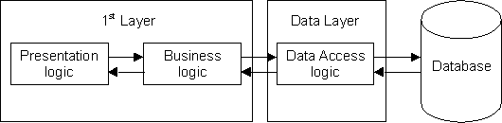
Figure2, The 2-Tier Architecture
The advantage with this architecture is that, because of two separation data can be stored on a single host and can be shared by multiple application, i.e. the resource sharing becomes more efficient. This also removes all the complexities of communicating with the database to a separate layer.
The disadvantage with the 2-Tier architecture is its maintainability because, each client point holds the complete application and the interface together, therefore even a single change in the application needs to be updated at each client architecture.

3-Tier Architecture
This architecture overcomes the limitations of a 2-Tier system. Under this architecture, the application is separated into three different layers with a set of well defined interfaces. This should then enable components in one layer to be modified without requiring changes any changes to components in other layers. For example, changing the file system from one DBMS to another, or changing the user interface from one system to another (e.g. from client/server to the web).
Under this architecture the application broken into following:-
-Presentation/User Interface Layer
-Application/Business Layer
-Data Layer

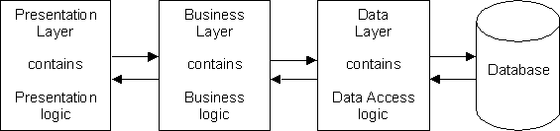
Figure 3, The 3-Tier Structure
The Presentation Layer holds the user interface for interaction with the application.
The middle layer i.e. the business layer holds the application logic i.e. basically the code called by the user through presentation layer to retrieve the desired data.
The Data Layer holds the data to be implemented by the application/business layer. The source of data may be SQL Server, Oracle, Sybase or XML documents.
The main advantage of this structure over the 2-Tier system is that all business logic is contained in its own layer and is shared by many components in the presentation layer. Any changes to business rules can therefore be made in one place and be instantly available throughout the whole application.
N-Tier Architecture
The name implies a structure which contains ‘N’ number of tiers where ‘N’ is a variable number. This is usually achieved by taking a component in one of the standard layers of the 3-Tier structure and breaking it down into subcomponents, each performing a specific low-level task.
More specifically under N-Tier architecture, the middle layer containing the application logic is functionally divided into multiple components, each one carrying a particular operation.

For example, the designers of a project have broken down each of the initial three layers into something which resembles the structure shown in figure 4:

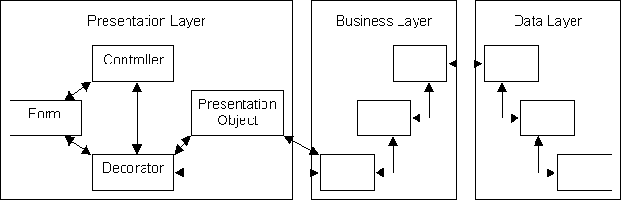
Figure 4 - Splitting 3 layers into ‘N’ layers

Enterprise Architecture
This architecture is an N-Tier architecture, but the enterprise architecture is capable to manage multiple application types whereas N-Tier is capable to deal with one application only.The application under this architecture can handle applications of different architectures.

Advantages
- In most cases, client-server architecture enables the roles and responsibilities of a computing system to be distributed among several independent computers that are known to each other only through a network. This creates an additional advantage to this architecture: greater ease of maintenance.
- All the data is stored on the servers, which generally have far greater security controls than most clients. Servers can better control access and resources, to guarantee that only those clients with the appropriate permissions may access and change data.
- Since data storage is centralized, updates to that data are easier to administer.
- It functions with multiple different clients of different capabilities.

Enterprise architecture based applications are supported by J2EE. J2EE support enterprise based applications and the implementation is carried out by the following components.

- Extended JDBC.
- Servlet
- JSPs (Java Server Pages).
- RMI (Remote Method Invocation)
- EJBs (Enterprise Java Beans)
- JNDI (Java Network Directory Interface) .
- JMS (Java Message Service)
- JM (Java Mail)
- JTA (Java Transaction API’s)

J2EE Archetecture:

The management of distributed applications is carried out by a set of components that forms the architecture of J2EE. The major components are the following.

1. Container:

A container is a runtime environment that contains and coordinates the distributed applications. The common containers are the following.
- Web Container
- EJB Container
- Applet Container
The web container contains and coordinate the management of web resources such as servlets and jsps. These containers are also known as servlets and JSP engines.
The EJB container coordinates the managements of EJB components. An EJB component is a reusable enterprise component to be implemented by enterprise applications.
An applet container manages the applets and the application client container carries out the management of standard application client.

2.Server:
A server is the component where the application is diployed and these components carries out the management of request response activities. The servers can be divided into two types.
- Web Server
- Application Server
Web servers are the servers to manage web resources such as HTML, DHTML, Servlets, JSPs etc. the common web servers are
- Java Web Server
- Tomcat Apache
- O’reilley server.
The application servers are the serves to manage the components such as html, dhtml, servlets, jsps and additionally the components such as EJBs, JMS, JM etc.
The common application servers are
- J2EE Server
- Web Logic
- Web Spare
- Pramati

3. Communication Technology:
The communication in a distributed application is carriedout by using the communication technology, such as a set of protocols. The protocols may be
i. HTTP
ii. FTP
iii. TCP/IP
iv. SSL
v. UDP

Out of these protocols the most common one is http. It is a simple stateless protocols and defines a set of methods for request response communication. http specifies a set of methods to carryout request response activities. These methods are GET, POST, HEAD, PUT, OPTION, DELETE etc.
The GET method is to carry request transmission of simple resources such as text and images.
The POST method is to carryout request response activities relating to complex information and binary information type. POST method which capable to transmit large bulk of information.

Design of Web Application:

A web application is made up of a no of components such as html, xml, .java, .jar, .jpg, .jpeg etc. the lifecycle of a web application passes through the following phases.
i. Loading
ii. Initialising
iii. Servicing
iv. Destroying

Lifecycle of Web Application

The lifecycle of J2EE is under the control of container. The container takes the responsibility of the management of the lifecycle of the web application. The phases that the lifecycle passes through are the following.
- Loading
- Instantiation
- Initialization
- Service
- Destroy
- Unavailable
During the loading phase the files that constitute the web application are loaded to the appropriate directory system of the web server.
During the instantiation phase an instance of the web application such as a servlet is created by the web container. The web container create an instance of a servlet as the response to the incoming request from the user or the instance is created at the startup of the container.
Once the instantiation is over, the initialization begins. It is carried out by the container by invoking init(). After initialization the servlet components is ready to serve the incoming request. During initialization the servlet instance is initialized by the required parameters. During this phase it may through ServletException or an unavailableException.
After initialization the service method begins. The container guarantees that before service phase the init() is completed. The service phase is implemented by service(). The method in turn may invoke doGet() or doPost().
During the destroy phase the particular servlet instance releases the resources occupied by the servlet. This phase is implemented by destroy(). During this phase the web container guarantees that the destroy() is called before the servlet is destroyed.

Under the unavailable phase the requested servlet doesn’t exist and UnavailableException is resulted against the request.

User Interface And Report Design :

Company Profile: 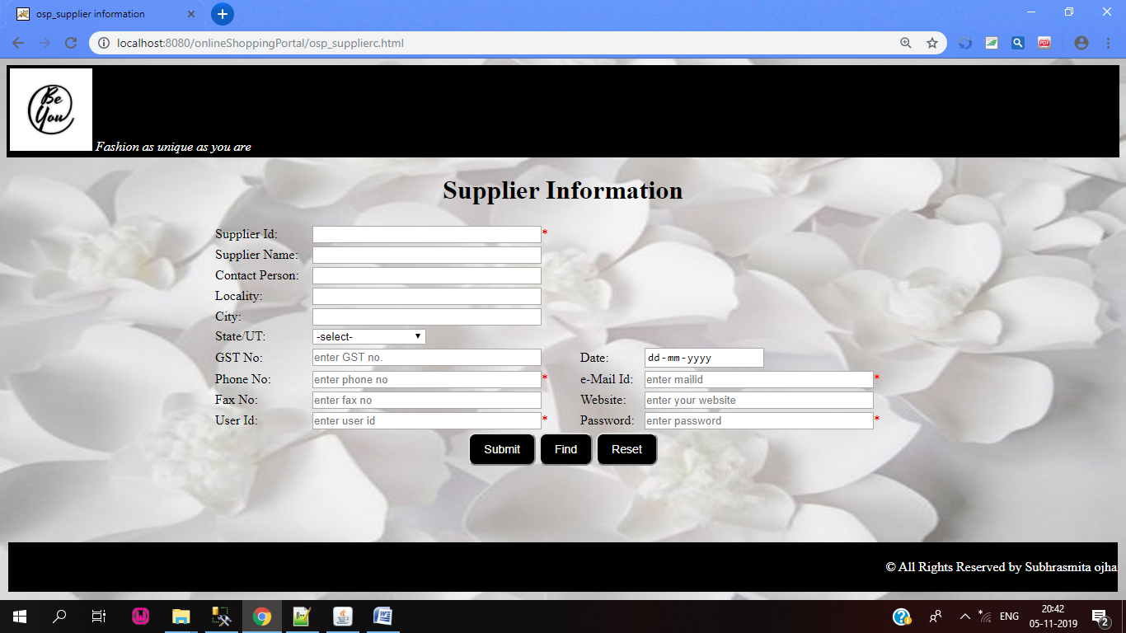

Find Page:
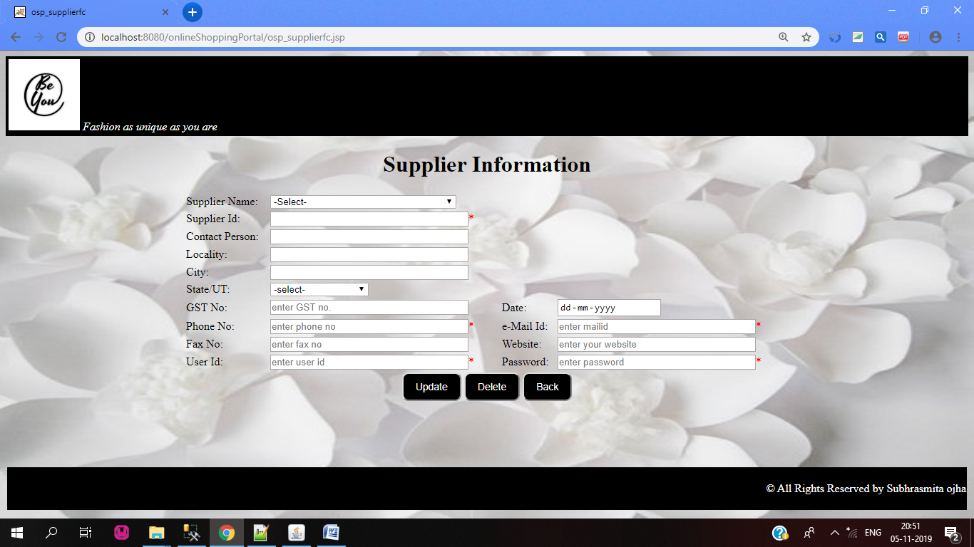

Report Page:
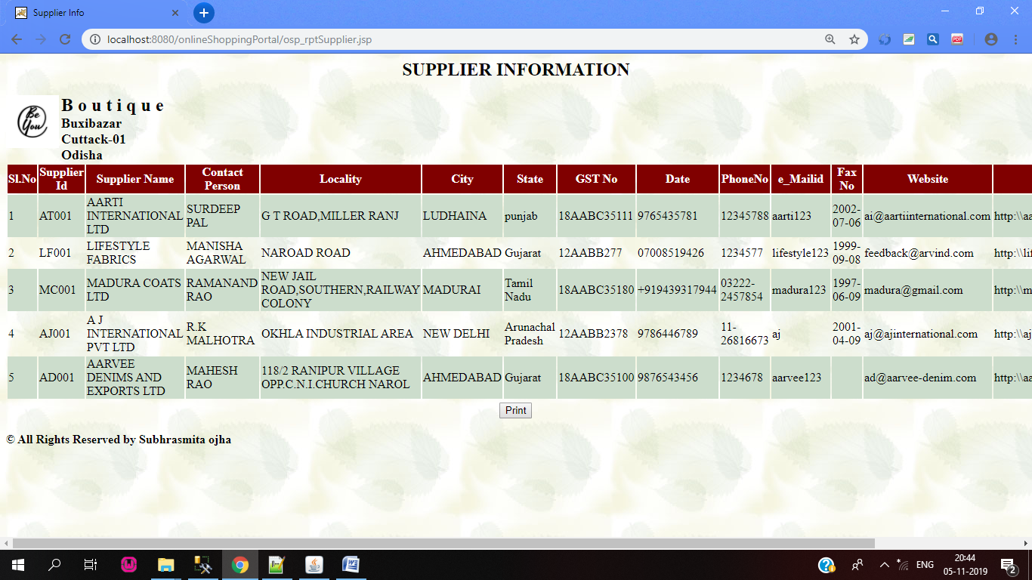

Any Report:
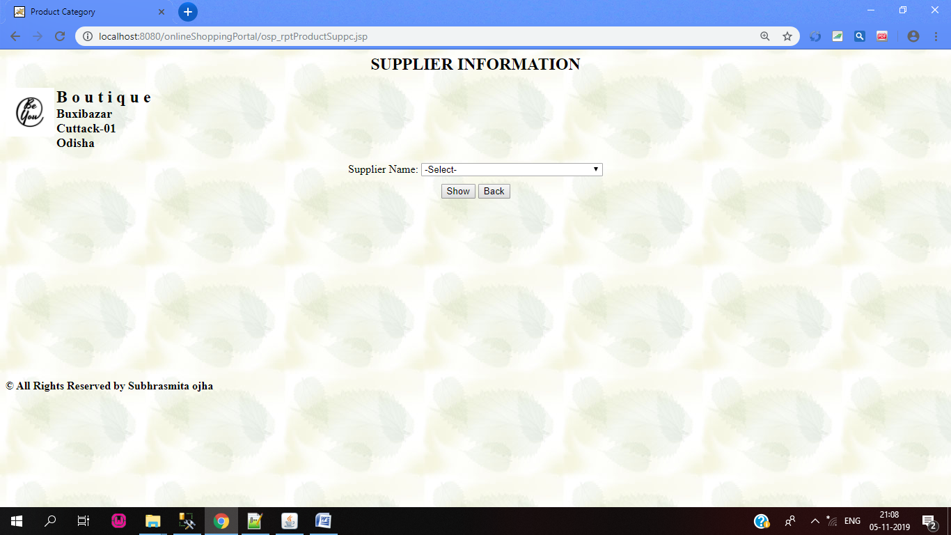

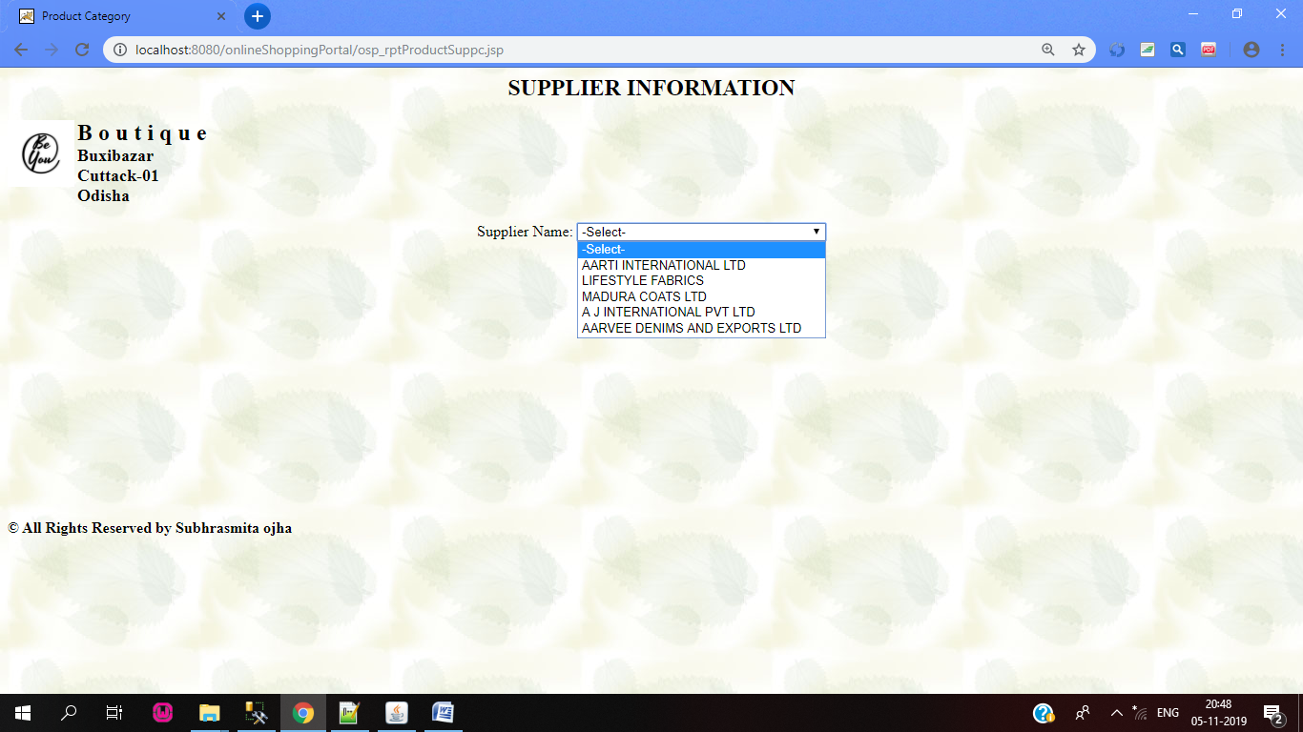

Server Page:
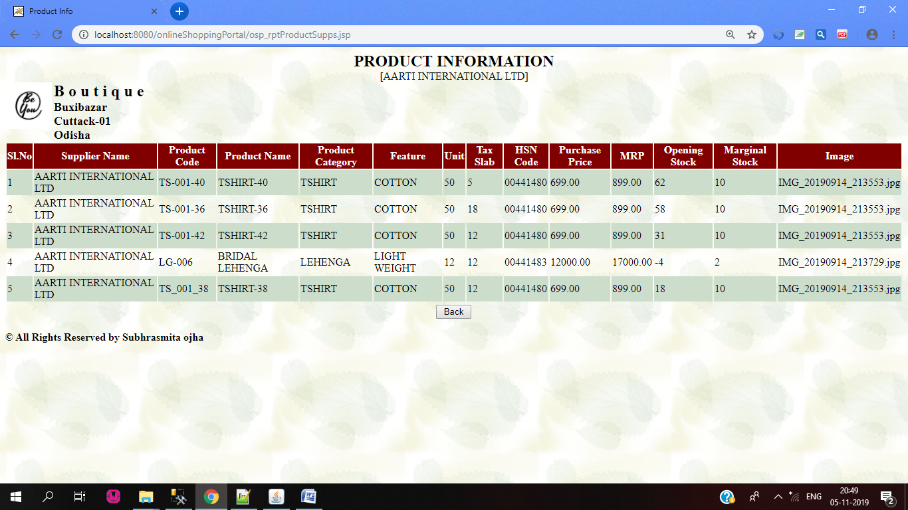

Product Information:
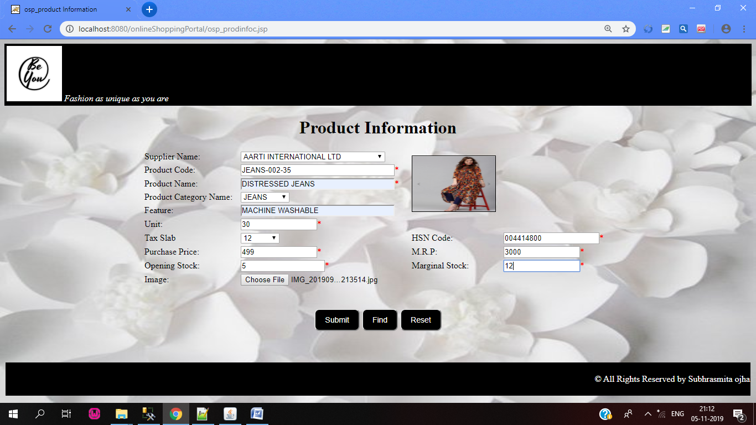

Report Page:
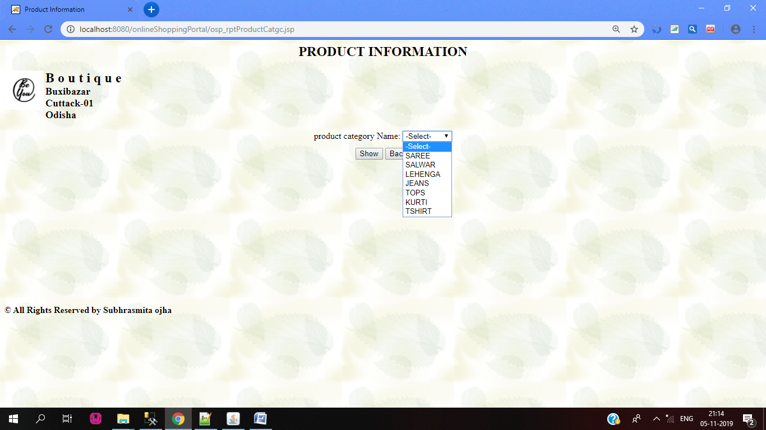

Database Report:
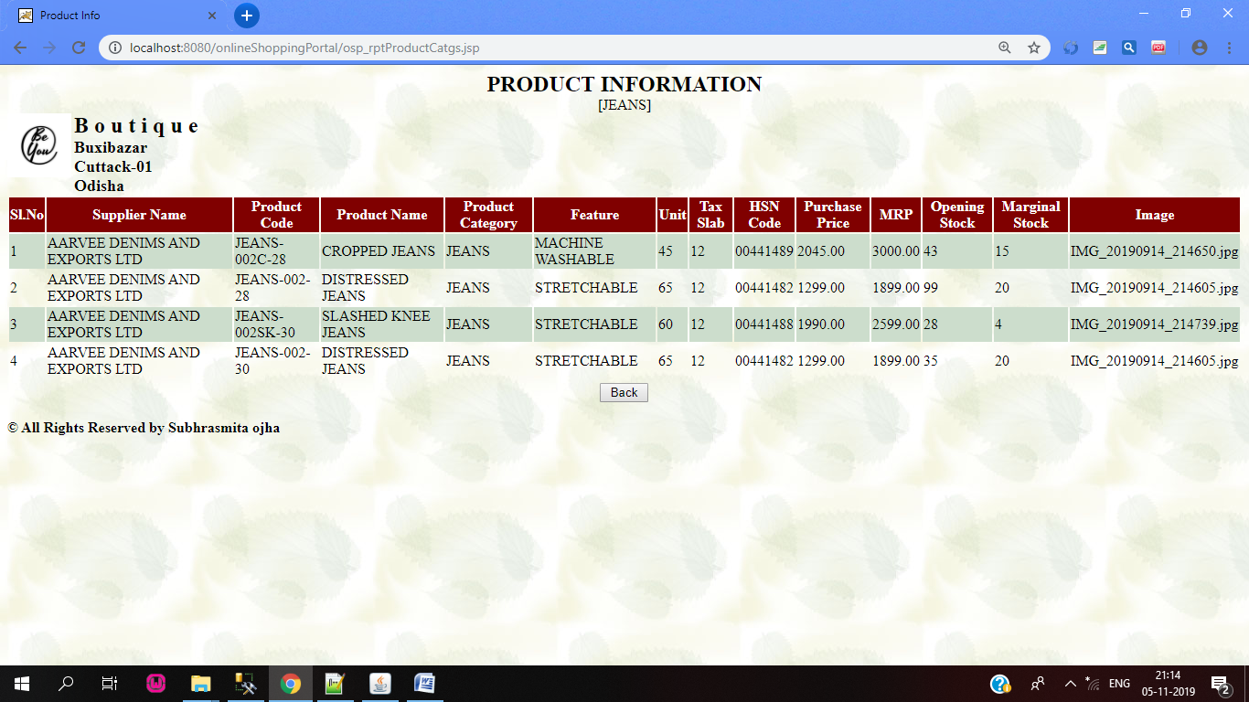

Sample Code of Project:
Coding For Client Page:
<html>
<head>
<title>osp_supplier information</title>
<link rel="stylesheet" href="style.css" type="text/css">
<script language="javascript">
function goFind(){
window.location="osp_supplierfc.jsp";
}
</script>
</head>
<body>
<div id="main-header">
<img src="ospicon.jpg" color="white" width="100px" height="100px">
<i><font color="white">Fashion as unique as you are</font></i>
</div>

<h1><center><b>Supplier Information</b></center></h1>
<form name=f1 action="osp_suppliers.jsp" method="POST">

<center>
<table width="850" border="0">

<tr>
<td>Supplier Id:</td>
<td><input type="text" name="txtsupid" title="enter the supplier id here" size="35"required><font color="red">*</font></td>
</tr>

<tr>
<td>Supplier Name:</td>
<td><input type="text" name="txtsupname" title="enter the supplier Name here" size="35"></td>
</tr>

<tr>
<td>Contact Person:</td>
<td><input type="text" name="txtcnctprsn" title="enter Your contact no." size="35"></td>
</tr>

<tr>
<td>Locality:</td>
<td><input type="text" name="txtlocality" title="enter your locality details" size="35"></td>
</tr

<tr>
<td>City:</td>
<td><input type="text" name="txtcity" title="enter your city" size="35"></td>
</tr>

<tr>
<td>State/UT:</td>
<td><select name="cmbstate">
<option value="null">-select-</option>
<option value="Andra Pradesh">Andra Pradesh</option>
<option value="Arunachal Pradesh">Arunachal Pradesh</option>
<option value="Assam">Assam</option>
<option value="Bihar">Bihar</option>
<option value="Chhattishgarh">Chhattishgarh</option>
<option value="Goa">Goa</option>
<option value="Gujarat">Gujarat</option>
<option value="Haryana">Haryana</option>
<option value="Himachal Pradesh">Himachal Pradesh</option>
<option value="Jammu Kashmir">Jammu Kashmir</option>
<option value="jharkhand">jharkhand</option>
<option value="Karnataka">Karnataka</option>
<option value="Kerala">Kerala</option>
<option value="Madhya Pradesh">Madhya Pradesh</option>
<option value="Manipur">Manipur</option>
<option value="Meghalaya">Meghalaya</option>
<option value="Mizoram">Mizoram</option>
<option value="Nagaland">Nagaland</option>
<option value="Odisha">Odisha</option>
<option value="punjab">Punjab</option>
<option value="Rajastan">Rajastan</option>
<option value="Sikkim">Sikkim</option>
<option value="Tamil Nadu">Tamil Nadu</option>
<option value="Telangana">Telangana</option>
<option value="Tripura">Tripura</option>
<option value="Uttar Pradesh">Uttar Pradesh</option>
<option value="Uttarkhand">Uttarkhand</option>
<option value="West Bengal">West Bengal</option>
</select>
</td>
</tr>

<tr>
<td>GST No:</td>
<td><input type="text" name="txtgstno" size="35" placeholder="enter GST no."></td>
<td>Date:</td>
<td><input type="date" name="dtdate" size="35"></td>
</tr>

<tr>
<td>Phone No:</td>
<td><input type="text" name="txtphno" size="35" placeholder="enter phone no" required><font color="red">*</font></td>
<td>e-Mail Id:</td>
<td><input type="email" name="emlmail" size="35" placeholder="enter mailid" required><font color="red">*</font></td>
</tr>

<tr>
<td>Fax No:</td>
<td><input type="text" name="txtfaxno" placeholder="enter fax no" size="35"></td>
<td>Website:</td>
<td><input type="url" name="urlwebsite" placeholder="enter your website" size=35"></td>
</tr>

<tr>
<td>User Id:</td>
<td><input type="text" name="txtuserid" placeholder="enter user id" size="35"><font color="red">*</font></td>
<td>Password:</td>
<td><input type="password" name="pwduser" placeholder="enter password" size="35"><font color="red">*</font></td>
</tr>

<tr height="40">
<td colspan="4" align="center">
<input type="Submit" name="btnsub" value="Submit" class="btn">
<input type="button" name="btnfind" value="Find" onclick="goFind()" class="btn">
<input type="Reset" name="btnRes" value="Reset" class="btn"></td>
</tr>

</table>
</center>
</form>
<br><br><br><br>
<table width="100%">
<tr height="60" bgcolor="black">
<td align="right" valign="middle"><font color="white">&copy All Rights Reserved by Subhrasmita ojha</font></td>
</tr>
</table>
</body>
</html>

Coding for Server page:
<%@ page language="java" import="java.sql.*" contentType="text/html" %>
<%!
String supid[],cnctprsn[],locality[],city[],state[],gstno[],phno[],faxno[],userid[],date[],email[],website[],pswd[];
int i,tot;
Statement stmtFillsupinfo,stmtsupname;
ResultSet rssupinfo,rssupname;
Connection conn;
String supname;
public void doConnect(){
try{
Class.forName("sun.jdbc.odbc.JdbcOdbcDriver");
}
catch(ClassNotFoundException cnfe){
System.out.println("unable to load Driver");
}
try{ conn=DriverManager.getConnection("jdbc:odbc:LocalServer","sa","root");
}
catch(SQLException se){
System.out.println("connection error");
}
}
%>
<%
doConnect();
try{
stmtFillsupinfo=conn.createStatement(ResultSet.TYPE_SCROLL_SENSITIVE,ResultSet.CONCUR_UPDATABLE);rssupinfo=stmtFillsupinfo.executeQuery("select * from tbl_Supplier");
rssupinfo.last();
tot=rssupinfo.getRow();
rssupinfo.last();
rssupinfo.beforeFirst();
supid=new String[tot];
cnctprsn=new String[tot];
locality=new String[tot];
city=new String[tot];
state=new String[tot];
gstno=new String[tot];
phno=new String[tot];
faxno=new String[tot];
userid=new String[tot];
date=new String[tot];
email=new String[tot];
website=new String[tot];
pswd=new String[tot];

i=0;
while(rssupinfo.next()){
supid[i]=rssupinfo.getString("supid");
cnctprsn[i]=rssupinfo.getString("cnctprsn");
locality[i]=rssupinfo.getString("locality");
city[i]=rssupinfo.getString("city");
state[i]=rssupinfo.getString("state");
gstno[i]=rssupinfo.getString("gstno");
phno[i]=rssupinfo.getString("phno");
faxno[i]=rssupinfo.getString("faxno");
userid[i]=rssupinfo.getString("userid");
date[i]=rssupinfo.getString("date");
email[i]=rssupinfo.getString("email");
website[i]=rssupinfo.getString("website");
pswd[i]=rssupinfo.getString("pswd");
i=i+1;
}
}
catch(SQLException se){
System.out.println("error-01 "+se);
}

%>
<html>
<head>
<title>osp_supplierfc</title>
<link rel="stylesheet" href="style.css" type="text/css">

<script language="javaScript">
function goBack(){
window.location="osp_supplierc.html";
}
function showsupinfo(){

var jsupid=new Array();
var jcnctprsn=new Array();
var jlocality=new Array();
var jcity=new Array();
var jstate=new Array();
var jgstno=new Array();
var jphno=new Array();
var jfaxno=new Array();
var juserid=new Array();
var jdate=new Array();
var jemail=new Array();
var jwebsite=new Array();
var jpswd=new Array();
var j,k;
j=0;

<%
i=0;
while(i<supid.length){
%>

jsupid[j]="<%=supid[i]%>";
jcnctprsn[j]="<%=cnctprsn[i]%>";
jlocality[j]="<%=locality[i]%>";
jcity[j]="<%=city[i]%>";
jstate[j]="<%=state[i]%>";
jgstno[j]="<%=gstno[i]%>";
jphno[j]="<%=phno[i]%>";
jfaxno[j]="<%=faxno[i]%>"; juserid[j]="<%=userid[i]%>";
jdate[j]="<%=date[i]%>";
jemail[j]="<%=email[i]%>";
jwebsite[j]="<%=website[i]%>";
jpswd[j]="<%=pswd[i]%>";
j=j+1;
<%
i=i+1;
}

%>

k=document.f1.cmbsupname.selectedIndex;
document.f1.txtsupid.value=jsupid[k-1];
document.f1.txtcnctprsn.value=jcnctprsn[k-1];
document.f1.txtlocality.value=jlocality[k-1];
document.f1.txtcity.value=jcity[k-1];
document.f1.cmbstate.value=jstate[k-1];
document.f1.txtgstno.value=jgstno[k-1];
document.f1.txtphno.value=jphno[k-1];
document.f1.txtfaxno.value=jfaxno[k-1];
document.f1.txtuserid.value=juserid[k-1];
document.f1.dtdate.value=jdate[k-1];
document.f1.emlmid.value=jemail[k-1];
document.f1.urlwebsite.value=jwebsite[k-1];
document.f1.pwduser.value=jpswd[k-1];

}
</script>
</head>
<div id="main-header">
<img src="ospicon.jpg" color="white" width="100px" height="100px">
<i><font color="white">Fashion as unique as you are</font></i>
</div>

<h1><center><b>Supplier Information</b></center></h1>
<form name="f1" action="osp_supplierfs.jsp" method="POST">

<center>
<table width="850" border="0">

<tr>
<td>Supplier Name:</td>
<td>
<select name="cmbsupname" onchange="showsupinfo()">
<option value="">-Select-</option>

<%
doConnect();
try{
stmtsupname=conn.createStatement();
rssupname=stmtsupname.executeQuery("Select supname from tbl_Supplier");
while(rssupname.next()){
supname=rssupname.getString("supname");
%>
<option value="<%=supname%>"><%=supname%></option>
<%
}
}
catch(SQLException se){
out.println("error");
}
%>

</select>
</td>
</tr>
<tr>
<td>Supplier Id:</td>
<td><input type="text" name="txtsupid" title="enter the supplier id here" size="35"required><font color="red">*</font></td>
</tr>

<tr>
<td>Contact Person:</td>
<td><input type="text" name="txtcnctprsn" title="enter Your contact no." size="35"></td>
</tr>

<tr>
<td>Locality:</td>
<td><input type="text" name="txtlocality" title="enter your locality details" size="35"></td>
</tr

<tr>
<td>City:</td>
<td><input type="text" name="txtcity" title="enter your city" size="35"></td>
</tr>

<tr>
<td>State/UT:</td>
<td><select name="cmbstate">
<option value="null">-select-</option>
<option value="Andra Pradesh">Andra Pradesh</option>
<option value="Arunachal Pradesh">Arunachal Pradesh</option>
<option value="Assam">Assam</option>
<option value="Bihar">Bihar</option>
<option value="Chhattishgarh">Chhattishgarh</option>
<option value="Goa">Goa</option>
<option value="Gujarat">Gujarat</option>
<option value="Haryana">Haryana</option>
<option value="Himachal Pradesh">Himachal Pradesh</option>
<option value="Jammu Kashmir">Jammu Kashmir</option>
<option value="jharkhand">jharkhand</option>
<option value="Karnataka">Karnataka</option>
<option value="Kerala">Kerala</option>
<option value="Madhya Pradesh">Madhya Pradesh</option>
<option value="Manipur">Manipur</option>
<option value="Meghalaya">Meghalaya</option>
<option value="Mizoram">Mizoram</option>
<option value="Nagaland">Nagaland</option>
<option value="Odisha">Odisha</option>
<option value="punjab">Punjab</option>
<option value="Rajastan">Rajastan</option>
<option value="Sikkim">Sikkim</option>
<option value="Tamil Nadu">Tamil Nadu</option>
<option value="Telangana">Telangana</option>
<option value="Tripura">Tripura</option>
<option value="Uttar Pradesh">Uttar Pradesh</option>
<option value="Uttarkhand">Uttarkhand</option>
<option value="West Bengal">West Bengal</option>
</select>
</td>
</tr>

<tr>
<td>GST No:</td>
<td><input type="text" name="txtgstno" size="35" placeholder="enter GST no."></td>
<td>Date:</td>
<td><input type="date" name="dtdate" size="35"></td>
</tr>

<tr>
<td>Phone No:</td>
<td><input type="text" name="txtphno" size="35" placeholder="enter phone no" required><font color="red">*</font></td>
<td>e-Mail Id:</td>
<td><input type="email" name="emlmid" size="35" placeholder="enter mailid" required><font color="red">*</font></td>
</tr>

<tr>
<td>Fax No:</td>
<td><input type="text" name="txtfaxno" placeholder="enter fax no" size="35"></td>
<td>Website:</td>
<td><input type="url" name="urlwebsite" placeholder="enter your website" size=35"></td>
</tr>

<tr>
<td>User Id:</td>
<td><input type="text" name="txtuserid" placeholder="enter user id" size="35"><font color="red">*</font></td>
<td>Password:</td>
<td><input type="password" name="pwduser" placeholder="enter password" size="35"><font color="red">*</font></td>
</tr>

<tr height="40">
<td colspan="4" align="center">
<input type="Submit" name="btnupdate" value="Update" class="btn">
<input type="submit" name="btndelete" value="Delete" class="btn">
<input type="button" name="btnback" value="Back" onclick="goBack()" class="btn"></td>
</tr>
</table>
</center>
</form>
<br><br><br><br>
<table width="100%">
<tr height="60" bgcolor="black">
<td align="right" valign="middle"><font color="white">&copy All Rights Reserved by Subhrasmita ojha</font></td>
</tr>
</table>
</body>
</html>

Comments & Descriptions :
The coding the builds the complete project is purely object oriented. Traces have been given to modularize the different functionalities of the system, such as connectivity with the data source is carried out by defining a separate method, filling of combo boxes have been done using respective methods with a target for better understanding, debugging and manageability.

Code Efficiency
The task of coding is carried out once the analysis and design is over. It depends on how well the analysis and design is done. Thus, the better the analysis and design, easier it becomes for the programmer to code. But the code has to be judged for its efficiency and worthiness. Code efficiency defines how efficient is the code generated and whether it satisfies the needs as expressed in the design, or not. Thus, it reflects the overall quality of the software. Code efficiency comes in conjunction with code optimization, total time spent on coding and validation specification. “Optimized code may not always be efficient, but efficient code always satisfies the user requirements”

When an application is created it is expected to give the best results using minimal computer resources, such as memory (RAM) and hard disk space. In order to ensure that the application uses the minimum resources, it is needed to fine-tune the application for improving its performance. The steps involved in fie-tuning an application are known as optimization. In the present system, the process of optimization started from the designing stage and continued till the development and distribution stage. The optimization was done for increasing
Execution speed,
Display speed and
Proper utility of available memory space

Error Handling
Error handling is the process to provide proper methodology to implement error detection and correction as a continuous process during the development process. This process has been applied at each phase of the software development process of the current system.. Moreover to provide run time error handling, the powerful exception handling has been applied at the points to minimize runtime failure and preserve the consistency of the system.
Validation Checks
Validation is an important part of the application being designed. This ensures the data consistency, protects accidentally deletion, modification of the data. In the system validation checking is applied both at database level and program level. At database level, while designing the tables to contain the information it has been maintained to implement validation by defining constraints for different data items in the application.
At program level proper measures and attention has been given to prevent the entry of invalid data in to the system.

Testing
Testing Techniques
System Testing
System testing is the stage, which is aimed at ensuring that the system works accurately & efficiently before live operation commences. To assure the quality of the system, the following are to be considered
Scope of Testing
Once the system has been developed the system has to be tested and if no Bugs found it is to be implemented. A good test cannot solve a bad program and testing can never prove a program is right. A good test case design that detects many errors is alarming Testing requires skill and knowledge
Testing Platforms
If the system is approved to be error free it can be implemented. Implementation includes proper training to the end user. The implemented software should be maintained for prolonged running of the software. For every dollars spend developing software we have spend at least two dollar to maintaining it.
Methods Used
Various methods include in testing the system are.

1. Unit Testing
Unit tests are at program level where the programmer himself can test at the system for known bugs. Unit testing are at involves the tests carried out on modules programs, which make up a system. This is also called as Program Testing. The Units in the system are modules and the routines that are assembled and integrated to perform a specific function. In a large System, many modules at different levels are needed, unit testing focuses first on the modules, independently of one another, to locate errors.
The Program to be tested for correctness of logic applied and should locate error in coding. For example test cases are needed to determine how the system handles if an intruder try to enter the application. User password will be encrypted and checks with the database. The Unauthorized user will be warned with a message.
Valid and invalid data should be created and the programs should be made to the process this data to catch errors. For example a student who has completed the course cannot access the lab resources and he/she cannot appear for any other tests conducted by the institute.
2. Integration Testing
Integration testing begins with a software structure that has been defined using stubs (a dummy module) that allows testing of super ordinate (calling Program) control and interface correctness. Stubs are replaced by unit tested modules or builds integration testing proceeds. For Integration testing, several factors should be considered:
Are routines to be integrated in a pure top-down manner or should build be developed to test sub function first?
In what order should major software functions be incorporated?
Is the scheduling of modules code and test consistent with the order of integration?
Is special hardware required to test certain routines?
Developed a list of all modules. Associated with each module is its unit test completion date, date of first integration, destination (e.g. build into which it will be incorporated or functional level) and a reference to required test data/result for that module.
Another important consideration during integration test planning is the amount of test software (e.g., drivers, test case generation) that must be developed to adequately test the required functionality.
3. System testing
The test plan is a product of software design. The test plan specifies the objectives of testing, test completion criteria, system Integration Planed, methods to be used on modules and particular test cases to be used.
Functional test – specify operation conditions, input values and expected results
Performance test –should be design to verify response time, throughput, primary and secondary memory utilization and traffic rates on data channels and communication channels.
Stress test-is designed to overload a system in various ways.
Structural test- are concerned with examining the internal processing logic of a software system.
Any software has to undergo robust test in each and every stage. Any shortcoming or bugs must be rectified and tested. This software has undergone the tests thoroughly. A system is tested for online responses, volume of transactions, stress, recovery from failure, and usability. Software testing is a critical element of software quality assurance and represents the ultimate review of specification, design and coding

System testing involves two types of testing, Integration testing and acceptance testing. In integration testing all the modules are integrated the interfaces between the modules are tested. Bottom up integration is the traditional strategy is to integrate the components of a software system into a functioning whole. Top Down integration starts from the main module along one or two intermediate subordinated routines in the system structure

Testing Strategies
Testing is a process of executing a program with the intent of finding an error.
A good test case is one that has a high probability of finding an as yet undiscovered error.
Successful test is one that uncovers as a yet undiscovered error.
A product can be tested in two ways,
Black box Testing
Knowing the specified function that a product has been designed to perform, tests can be conducted that demonstrate each function is fully operational.
White box Testing
Knowing the internal working of a product, tests can be conducted to ensure that the internal components have been adequately exercised. The tests of this software were conducted on the following fashion.
- Design time Data test
- Runtime data test at module level
- Test data runs after completion using dummy data
- Crash test for testing data safety.
- Demo runs with the data from the end user.
- Performance test at the peak hours of work.

System Security Measures

Database/data security
Implementation of security at database level plays a major role in the implementation of security for the application. It has properly been maintained by defining a separate user id and password. This authentication prevents mal-intentional entry to the database.
User profiles & Access rights
After a user gains access to the application, the user is ability to perform certain actions is restricted. For example, users are allowed to add new records but not delete existing ones. Users are restricted to view the data online, but not produce printed reports of critical data. Thus, permission checking enabled to check the user’s security profile to see whether that user has permission to perform a particular task.
The next step in security added in the application is an audit trial that logs all the significant actions taken by user within the application. This included logging in and out and executing any “secured object” within the application, field change auditing, that is, changes made to data records on a field-by-field basis.

Cost Estimation of the Project
The cost of a Project is estimated, keeping in account many factors like human efforts, recourses required, security and reliability provisions, size in KLOC (Kilo Lines of Codes), user interfaces, size of databases, integration, documentation and the types of reports or output produced.
In our approach to cost estimation of the system, we followed Constructive Cost Model (COCOMO) to estimate the total effort in terms of Programmers months or Persons-month. COCOMO model requires sizing information as
- Objects Points
- Function Points
- Lines of Source Code
We used Objects Points to estimate the total effort required in our project. The Object Point is an indirect software measure that is computed using counts of the number of
- Screens (at the user interface)
- Reports and
- Components likely to be required to build the application
Each Object instance (e.g. a screen or report) is classified into one of three complexity levels, i.e., Simple, Medium or Difficult, based on the number and source of the client
and server data tables that are required to generate the screen or report and the number of views or report.

Future Scope of the Project

The application currently handles management of garments products and Account payables and Receivables, Processing of Sales Orders & Purchase Orders, Raising and Managing Customer orders, Managing the Stock to avoid Stock out costs and the details of inventory requirement to meet all the needs. Also generating information for the top-level management personals and general customers also. Customer Relation Management Features like Customer Demand Analysis, Frequency Customer Transaction; Most Profitable Customer Service Details can also be integrated.

Bibliography

The following books have been referred during the preparation of this project.
- A Complete guide to HTML & Java Script.
- Black Book- Server Programming
- Java Server Pages ( Wrox Publication )
- Software Engineering by ROGER S. PRESSMAN, McGRAW-HILL INTERNATIONAL Publication.
- Software Engineering by Pankaj Jalote

Glossary
Code efficiency | How efficient is the code generated and whether it satisfies the needs as expressed in the design, or not. Thus, it reflects the overall quality of the software.
OPC | It is determined by multiplying the original no. Of object instances by the weighting factor in table given above and summing to obtain a total object point count.
Software Metrics | These are the quantitative measure of the degree to which a system component or process possesses a given attribute. In other words software metrics helps in assessing a process or product thereby checking in validity, worthiness, risks, errors, and defects, work-flows or tasks etc. The project is assessed while it is in development phase.
Feasibility | Is the determination of weather or not a project is worth doing. The process followed in making this documentation is called a feasibility study.
Technical Feasibility | Is defined as the availability of suitable technology to support the solution and adequate expertise to develop the solution.
Economic Feasibility | It is more commonly known as COST / BENEFIT Analysis; the procedure to determine the benefits and savings that are expected from a proposed system and compare them with costs.
Operational Feasibility | Is defined as the suitability of the solution from the standpoint of the people who will have to use that solution.
System Testing | Is the stage, which is aimed at ensuring that the system works accurately & efficiently before live operation commences.
Unit Tests | Are at program level where the programmer himself can test at the system for known bugs. Unit testing are at involves the tests carried out on modules programs, which make up a system. This is also called as Program Testing.
Integration Testing | It begins with a software structure that has been defined using stubs (a dummy module) that allows testing of super ordinate (calling Program) control and interface correctness.
Black Box Testing | Knowing the specified function that a product has been designed to perform, tests can be conducted that demonstrate each function is fully operational.
White Box Testing | Knowing the internal working of a product, tests can be conducted to ensure that the internal components have been adequately exercised.
Optimization | In order to ensure that the application uses the minimum resources, it is needed to fine-tune the application for improving its performance. The steps involved in fie-tuning an application are known as optimization.
Database | A database server is the key to solving the problems of information management.
Portability | Oracle software works under different operating systems. Applications developed for Oracle can be ported to any operating system with little or no modification.
Distributed Systems | Distributed systems have the same degree of user transparency and data consistency as non-distributed systems; yet receive the advantages of local database management.
Tablespace | A tablespace is a logical area of storage
Schema | A schema is a collection of objects. Schema objects are the logical structures that directly refer to the database's data. Schema objects include such structures as tables, views, sequences, stored procedures, synonyms, indexes, clusters, and database links.
Segments | A segment is a set of extents allocated for a certain logical structure.
Control File | A control file contains entries that specify the physical structure of the database.
SQLJ Translator | It self a Java program, takes as input a file of Java source code in which SQLJ clauses are embedded.

