**Image Recognition with IBM Cloud Visual Recognition**

PHASE_4

Implement the image classification process using the IBM Cloud Visual Recognition API.

Use natural language generation to create captions for the recognized images.

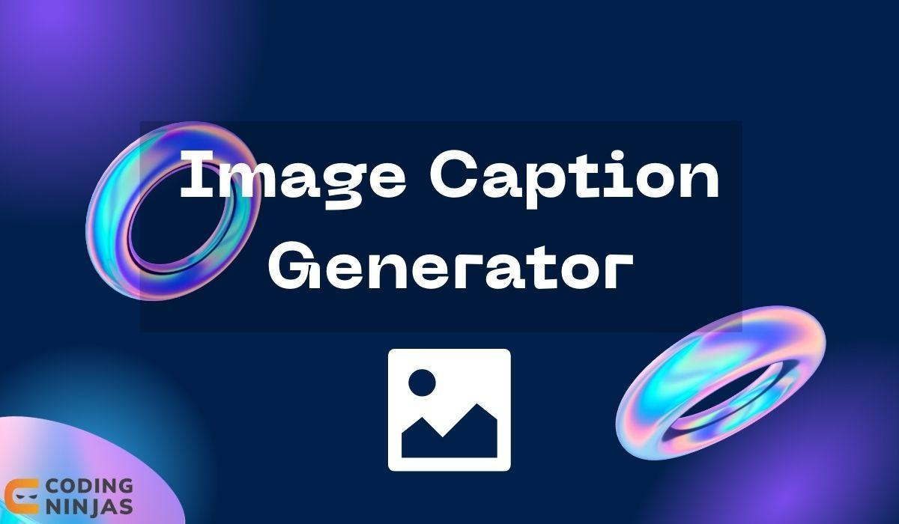



1. **Set Up IBM Cloud Visual Recognition**:

- Create an IBM Cloud account if you don't have one.

- Create a Visual Recognition service instance in the IBM Cloud.

- Get your API key and credentials for this service.

**2. Integrate IBM Visual Recognition :**

- Use the IBM Watson SDK or API to connect your application with the Visual Recognition service.

- Send images to the service for classification.

**3. Image Classification:**

- When a user uploads an image, send it to the IBM Visual Recognition service.

- Process the response to obtain classification results, which might include labels or tags describing the content of the image.

**4. Natural Language Generation:**

- Once you have the image classification results, use a natural language generation (NLG) system to create captions for the recognized images. OpenAI's GPT-3 or GPT-4 can be used for this purpose.

**Python code:**

