SMART Contact Manager
API-Based Contact Management System

Team Id: SWTID-2026-6060
Subiksha V (Team Leader) - 202400620@sigc.edu
Abirami I - 202400084@sigc.edu
Nivetha K - 202400840@sigc.edu
Sathyapriya S - 202400191@sigc.edu
Vishali V - 202400433@sigc.edu

1. Project Overview
SMART Contact Manager is a backend application used to manage and organize contact information in a centralized system. It helps users store, edit, search and delete contacts efficiently. The system is built using Node.js, Express.js and MongoDB.
2. Objectives
Provide secure user authentication
Allow CRUD operations for contacts
Store data using MongoDB
Provide fast search and filtering
Develop scalable REST APIs
3. Target Users
Students
Freelancers
Small business owners
Professionals managing networks
Event organizers

4. Technologies Used
Node.js: JavaScript runtime for backend
Express.js: Framework for REST APIs
MongoDB: NoSQL database
Mongoose: ODM for MongoDB
JWT: Authentication system
Postman: API testing tool
5. System Architecture
Client Layer – Sends API requests
Application Layer – Node.js and Express
Database Layer – MongoDB

6. Core Features
User Registration
User Login
JWT Authentication
Create Contact
View Contacts
Update Contact
Delete Contact
Search Contacts
7. Roles and Responsibilities
Register account
Login to system
Add contacts
Edit contacts
Delete contacts
Search contacts

8. Database Design
Users Collection: id, name, email, password, createdAt
Contacts Collection: id, userId, name, email, phone, notes, createdAt
9.ScreenShot:
Login: 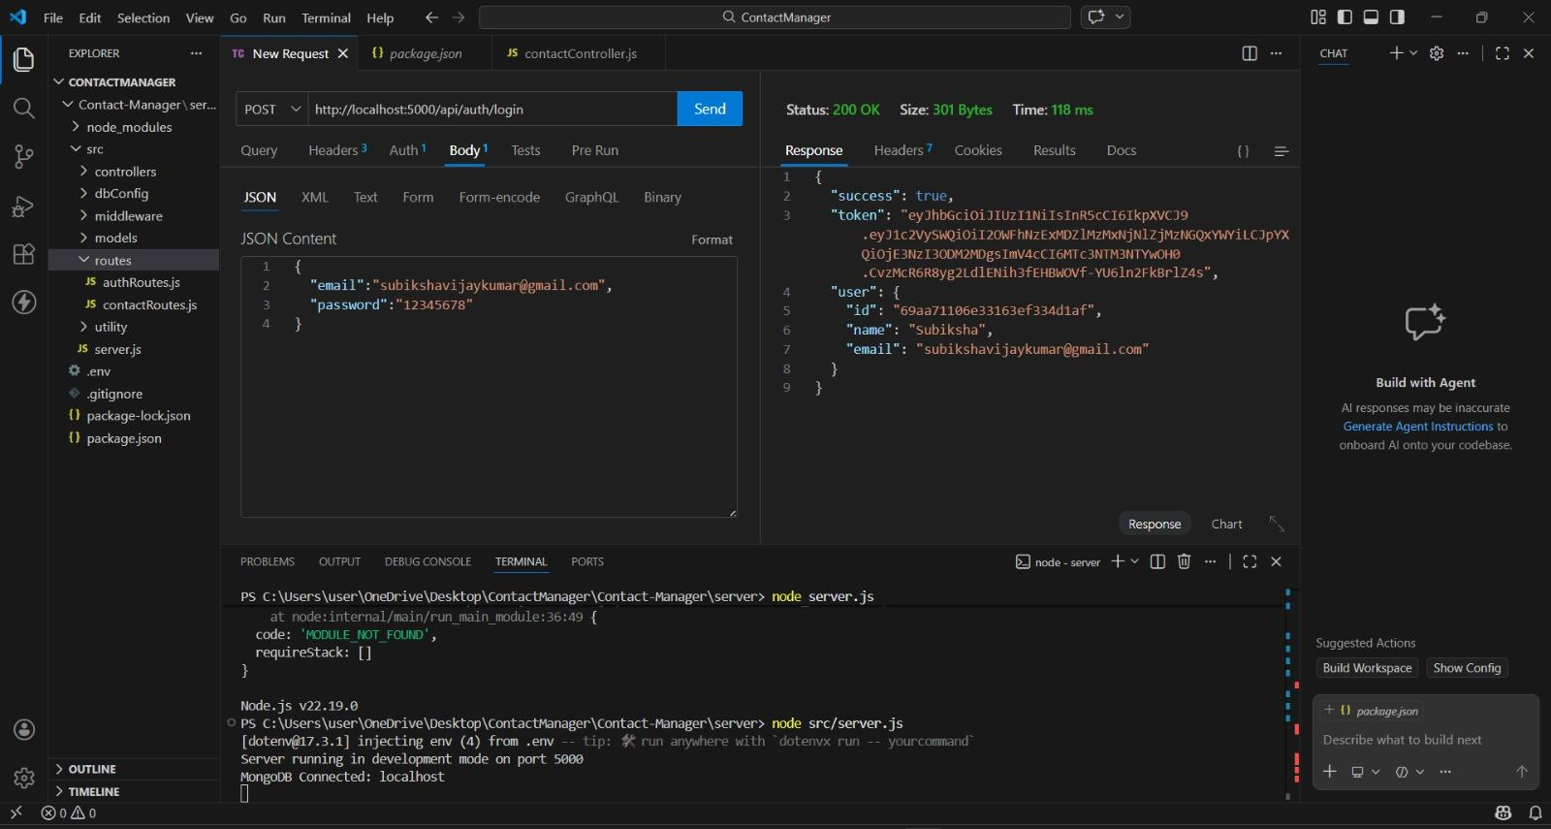

Create:
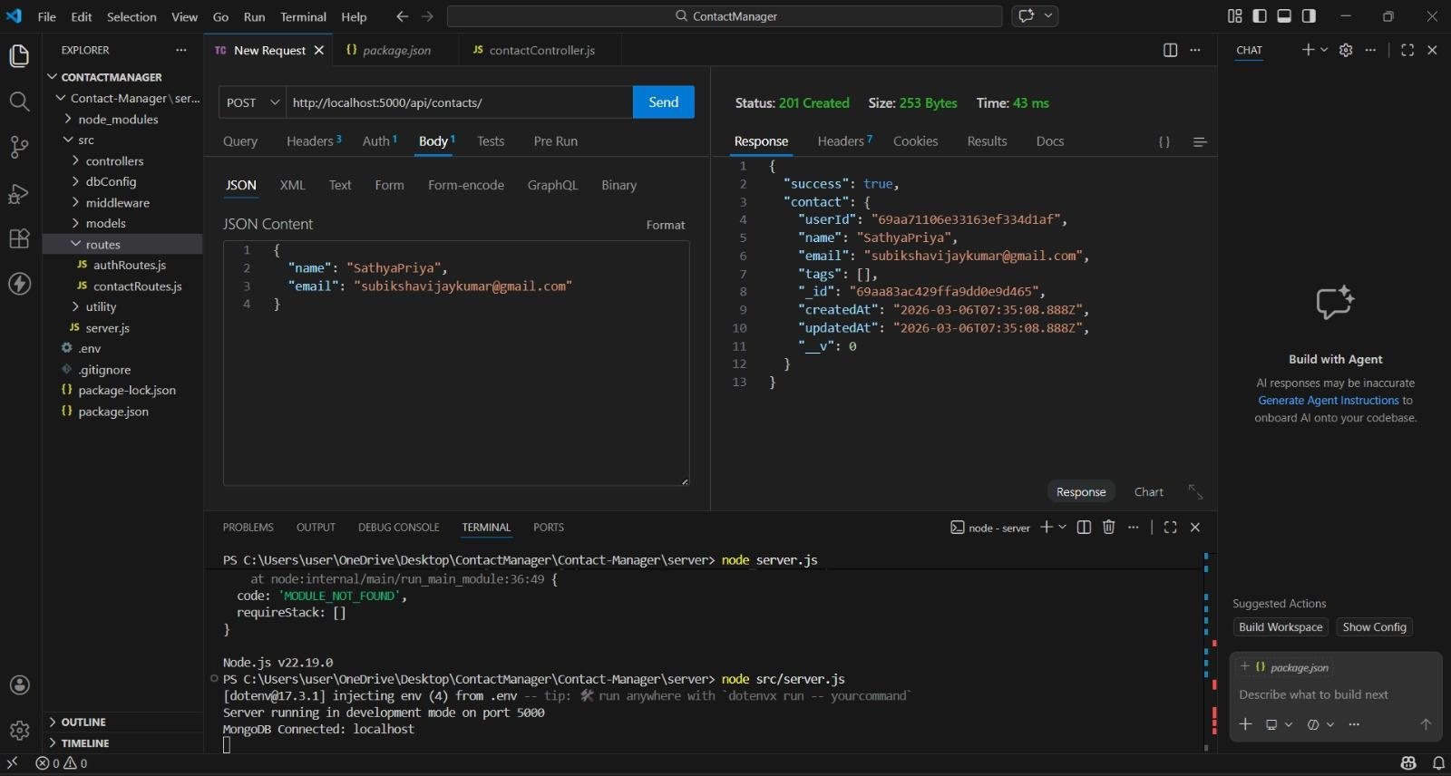

Update:
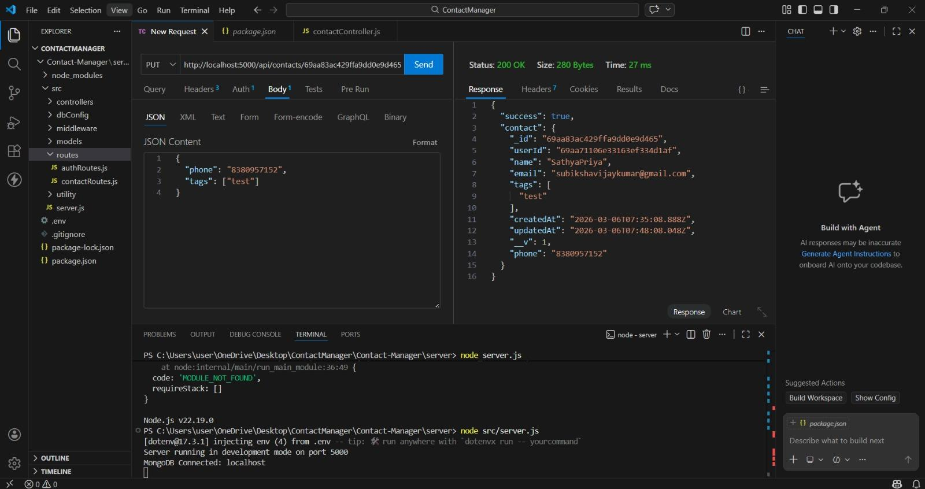

Delete:
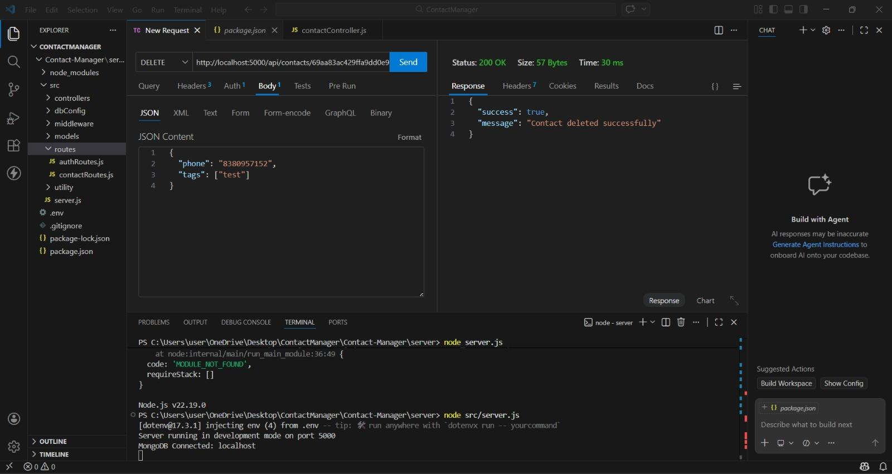

Search:
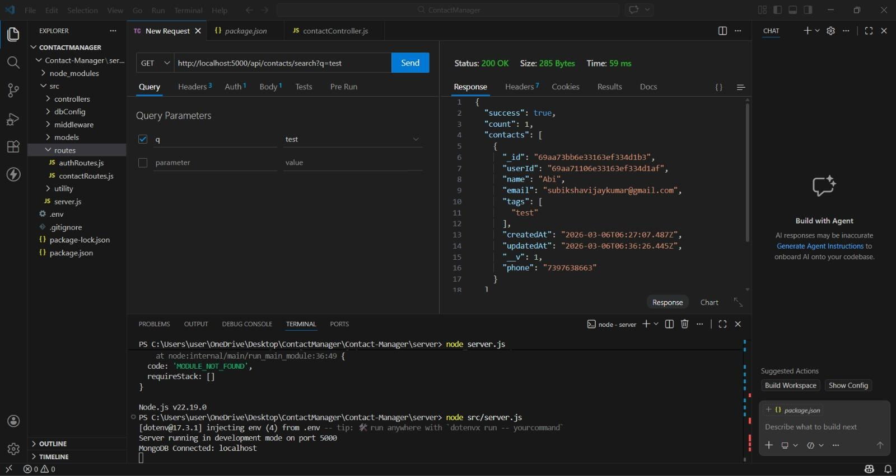

Get The Current Users :
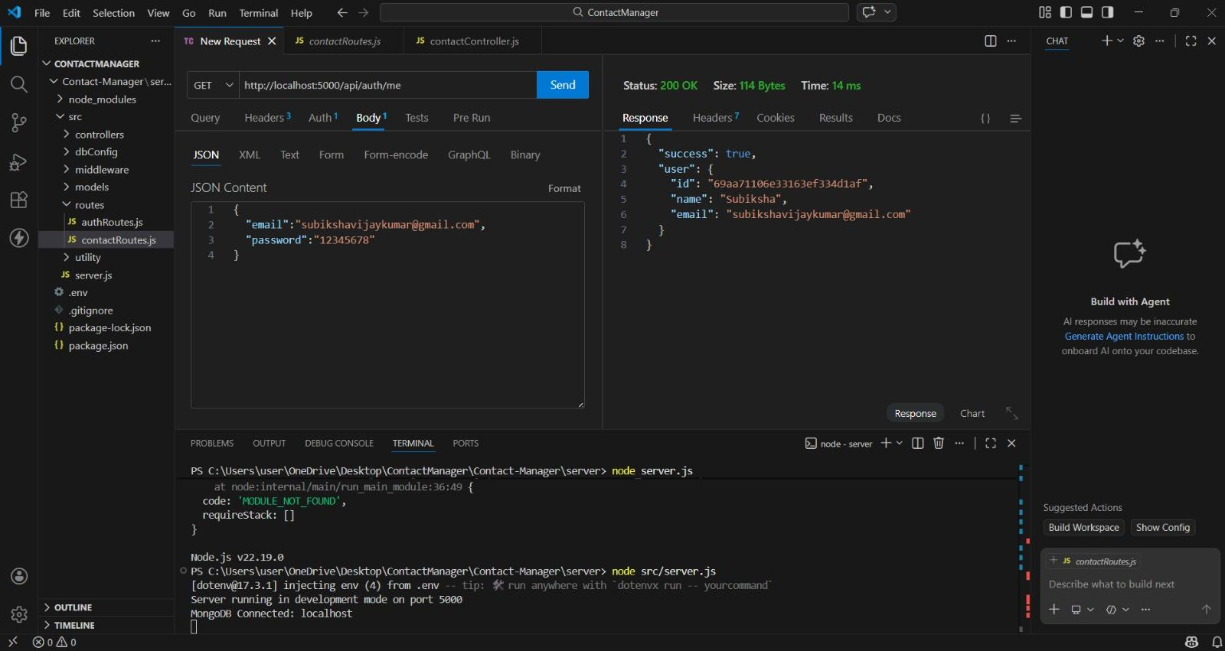

10. Project Setup
Install Node.js
Initialize project with npm init
Install dependencies
Create server file
Connect MongoDB
Create API routes
Test APIs with Postman
11. Conclusion
This project demonstrates backend development using Node.js, Express and MongoDB to create a secure API-based contact management system
12.Demo Link:
https://drive.google.com/file/d/1W0jWP1d6cYcufwYb0jSIJxrbYbbFuIzV/view?usp=sharing

