PEGA ACADEMY
Movie Ticket Request – Pega Mission Exercise
Final Submission Document
Project / Application | Movie Ticket Booking Management Application
Case Type | Movie Ticket Request
Pega Application | Fraud Investigation
Document Type | Final Submission Document
Date | August 31, 2026

Table of Contents
1. Introduction
2. Project Overview
3. Objectives
4. Application and Case Type
5. Case Lifecycle / Workflow
6. Data Model and Fields
7. Booking Execution
8. Booking Confirmation Email
9. SLA Configuration
10. Routing Booking Requests by Show Type
11. Testing and Results
12. Screenshots / Evidence
13. Conclusion
14. GitHub / Project Link

1. Project Overview
The Movie Ticket Booking Management Application is built on the Pega Platform under the Fraud Investigation application context, and centers on a Movie Ticket Request case type. The purpose of the application is to automate the end-to-end movie ticket booking process, from initial ticket request through show-time and seat details capture, availability verification, approval, and final booking execution.
The application was extended from Pega's "Ticketing and Booking" Blueprint, which targets ticketing and booking automation for entertainment venues, covering ticket sales, reservations, seating allocation, and payment processing to streamline operations and improve the customer experience.
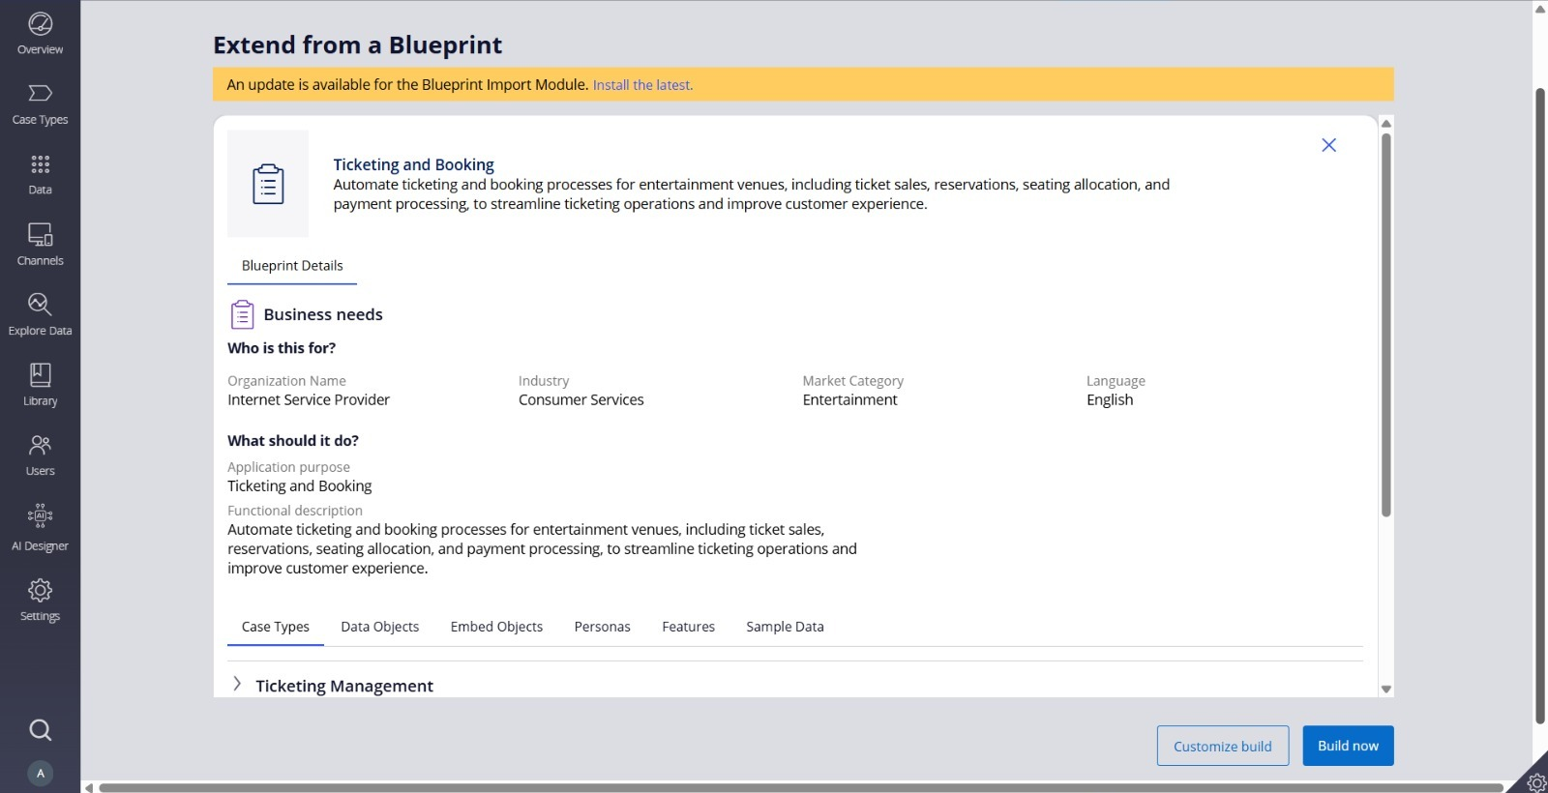
Figure 1 – Ticketing and Booking Application Blueprint Overview
Within this context, the Movie Ticket Request process accomplishes the following:
- Captures movie, show, and ticket-quantity details from the customer.
- Confirms booking details and calculates the total cost.
- Checks seat availability for the requested show.
- Routes the request for approval.
- Executes and completes the booking.

2. Case Type and Workflow
The Movie Ticket Request case type follows a multi-stage lifecycle configured in App Studio. The stages progress as follows: Create → Ticket Confirmation → Availability → Approval → Movie Ticket Request → Booking Execution.
In the Create stage, the customer (via the Web portal persona) enters the Movie Name, Show Date, Show Time, and Number of Tickets. The case then advances through Ticket Confirmation, where booking details and total cost are reviewed, and Availability, where a Booking Agent persona checks show availability. Following approval, the case reaches the Movie Ticket Request stage (Enter Movie Details) and finally the Booking Execution stage, where the Complete Booking step finalizes the case.
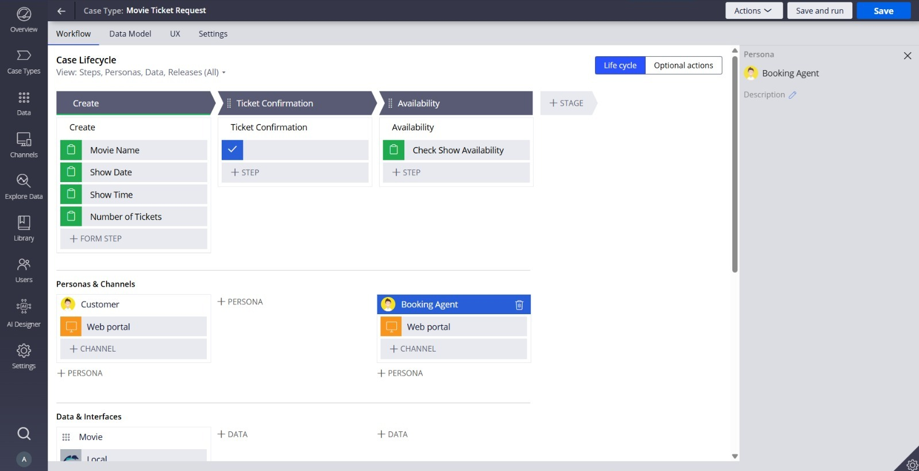
Figure 2 – Movie Ticket Request Case Lifecycle: Create, Ticket Confirmation, and Availability Stages
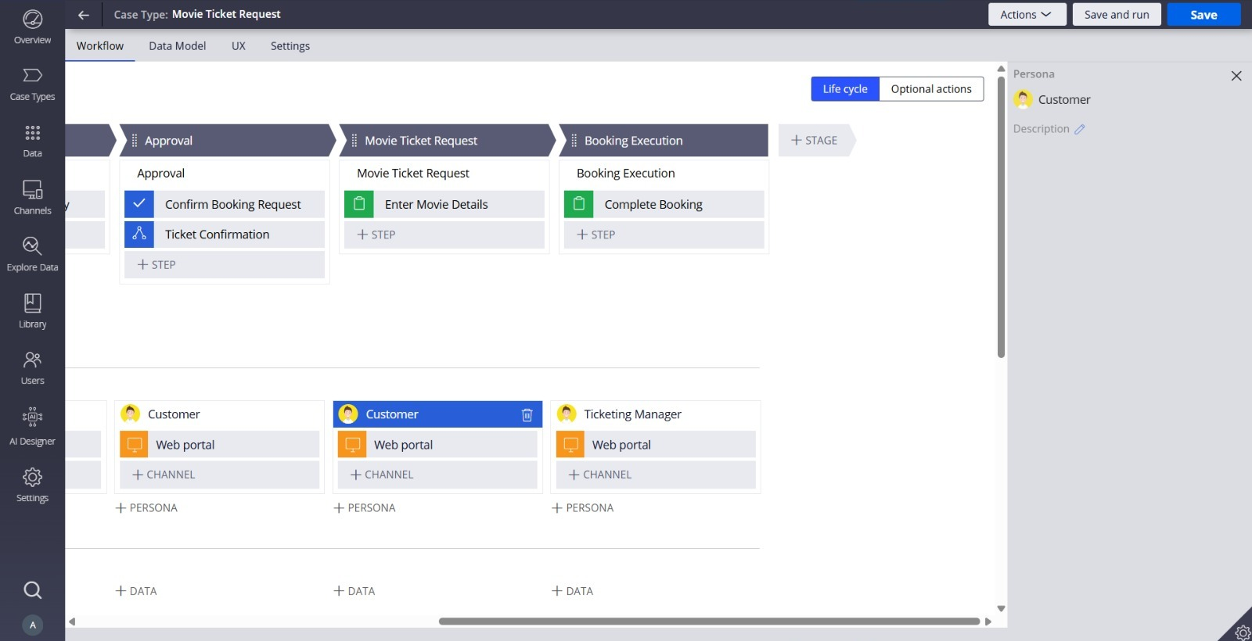
Figure 3 – Case Lifecycle (continued): Approval, Movie Ticket Request, and Booking Execution Stages
The personas configured across the lifecycle include Customer (Web portal), Booking Agent (Web portal), and Ticketing Manager (Web portal), reflecting the different roles interacting with the case at each stage.

3. Data Model / Fields
The following fields were identified as relevant to the Movie Ticket Request process:
- Movie Name
- ShowDate
- ShowTime
- Seat Number
- Total Cost
- Booking Confirmation Status
- Ticket Id
- Customer Email
- Show Type
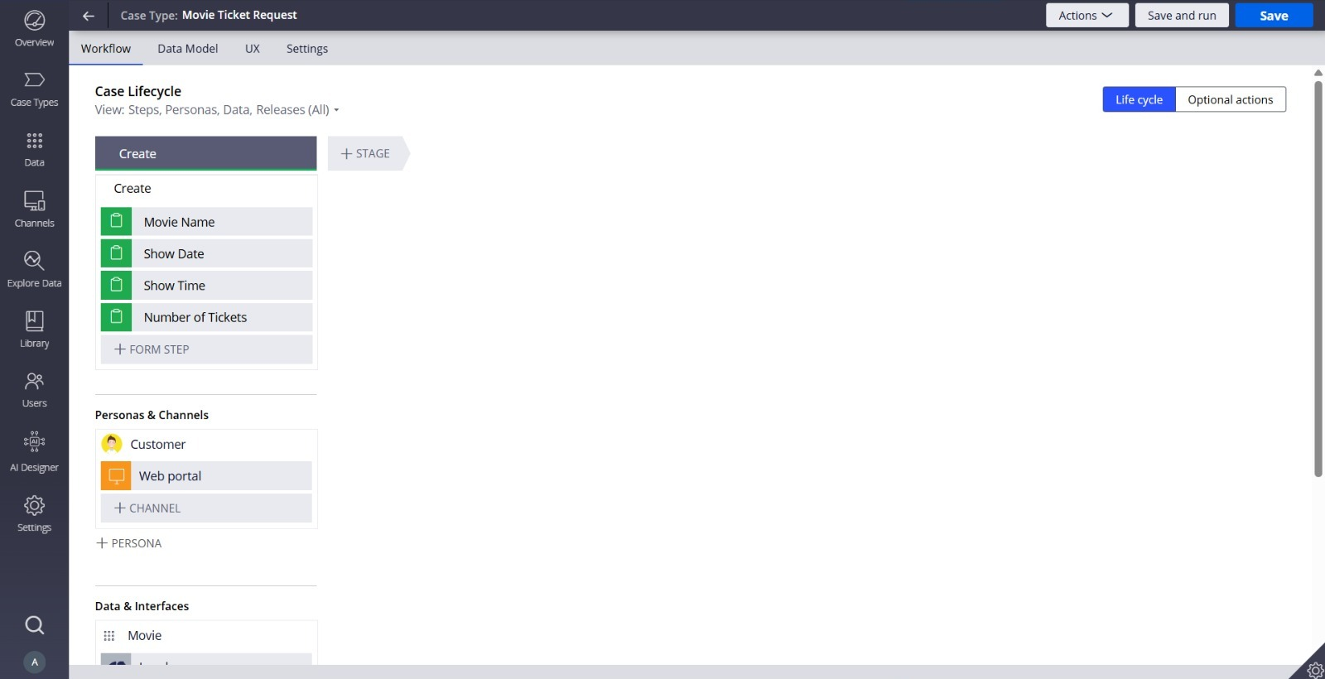
Figure 4 – Movie Ticket Request Data Fields (Create Step Configuration)
The Create step configuration screenshot (Figure 4) confirms Movie Name, Show Date, Show Time, and Number of Tickets as configured form fields. Total Cost is confirmed elsewhere in the evidence (see Figures 8 and 10), and Show Type is confirmed as a case property referenced in the routing business logic (see Figure 5).
Note: Seat Number, Booking Confirmation Status, Ticket Id, and Customer Email are described in the project scope but are not shown in the provided screenshot evidence.

4. Complete Booking
The Complete Booking step, part of the Booking Execution stage, is intended to handle the finalization of the booking (as shown in Figure 3). It is described as containing the following booking-related fields:
- Booking Confirmation Status
- Seat Number
- Ticket Id
Note: The provided screenshots confirm the existence and placement of the Complete Booking step within the Booking Execution stage (Figure 3), but do not show the detailed field configuration inside that step. The individual field-level view of Booking Confirmation Status, Seat Number, and Ticket Id is not shown in the provided evidence.

5. Booking Confirmation Email
An automatic booking confirmation email is intended to be sent to the address captured in the Customer Email field once a booking is completed.

5.1 Recipient Configuration
Send to → Field → Customer Email.
Note: A screenshot of the recipient configuration screen is not provided in the submitted evidence.

5.2 Email Template
Subject: Movie Ticket booking confirmation
The email content uses dynamically inserted Pega fields (not manually typed placeholder values), referencing the case ID and key booking details:
- Case ID: <<.pyID>>
- Movie Name: <<.MovieName>>
- Show Date: <<.ShowDate>>
- Show Time: <<.ShowTime>>
- Seat Number(s): <<.SeatNumber>>
- Total Cost: <<.TotalCost>>
Note: A screenshot of the Compose Message / email template configuration is not provided in the submitted evidence.

5.3 Test Result
A successful test send is reported with the following actual values: Case ID M-1817, Movie Name "Operation Neros", Show Date 9/15/26, Show Time 2:30 PM, Seat Number(s) 42, Total Cost 75, sent to alex.martinez@email.com.
Note: A screenshot of the delivered confirmation email is not provided in the submitted evidence. This test result is reported as described but is not independently verifiable from the attached screenshots.

6. SLA Configuration
A Custom SLA is reported to have been configured for the Movie Ticket Request case type, opened and verified in Dev Studio, with the following settings:
Setting | Configuration
Calculate time from | This case
Goal | 1 day
Goal urgency increase | 10
Deadline | 2 days
Deadline urgency increase | 10

Note: A screenshot of the SLA configuration screen in Dev Studio is not provided in the submitted evidence.

7. Routing by Show Type
User Story: Route booking request by show type.
Business logic was configured on a workflow step so that the case is automatically routed based on the Show Type value, without requiring the user to manually select a work queue:
Condition | Routing
Show Type = "Premium" | Work Queue → PremiumShowQueue
Otherwise | Work Queue → StandardQueue

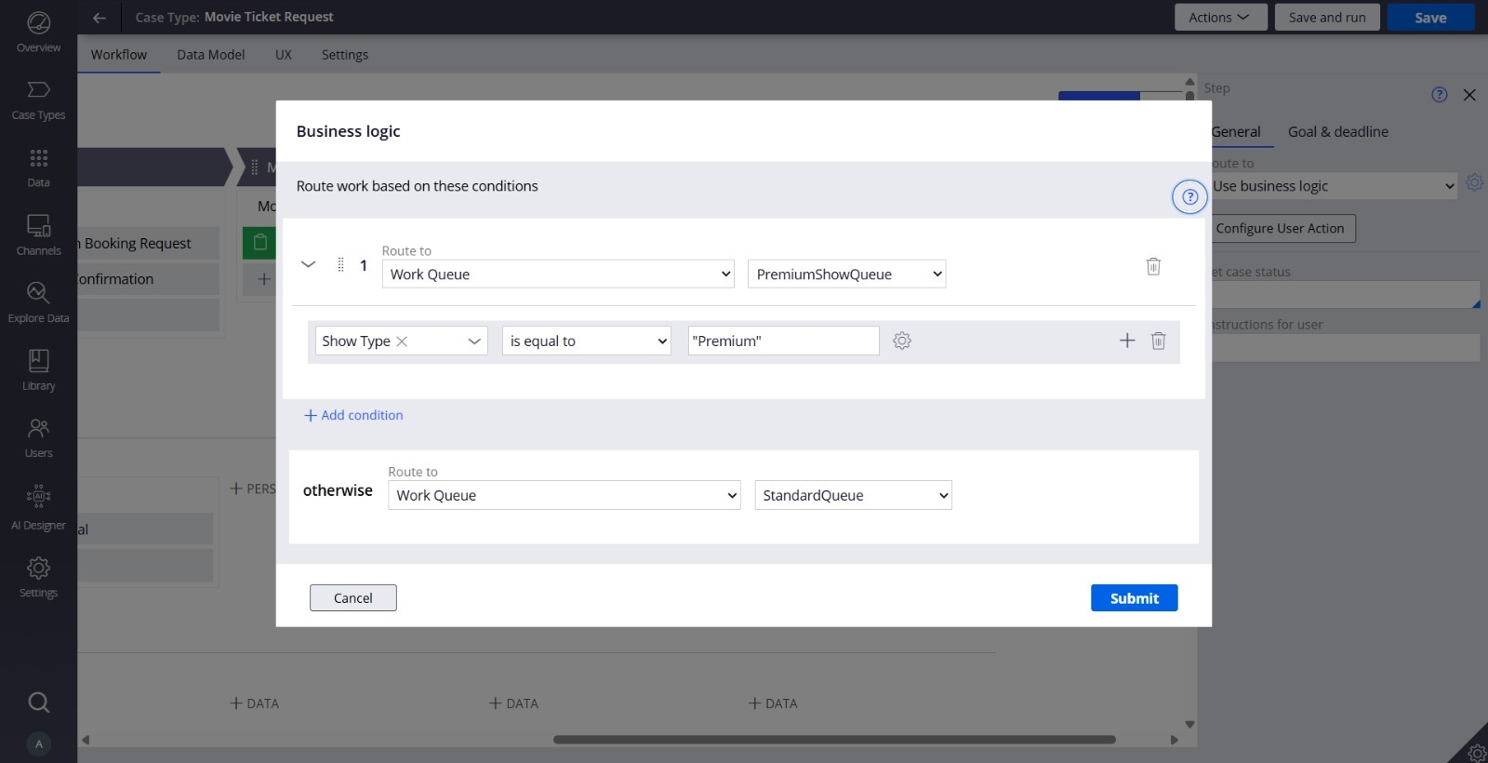
Figure 5 – Show Type Routing: Business Logic Configuration
Figure 5 confirms the automatic routing rule: when Show Type is equal to "Premium", the case routes to the PremiumShowQueue work queue; otherwise, it routes to the StandardQueue work queue.
Note: A dedicated configuration screenshot of the PremiumShowQueue work queue itself, and a screenshot demonstrating a live test of a non-Premium case being assigned to StandardQueue, are not provided in the submitted evidence. Only the business logic rule configuration (Figure 5) is confirmed.

8. Test Results
The following results are supported directly by the provided screenshots:
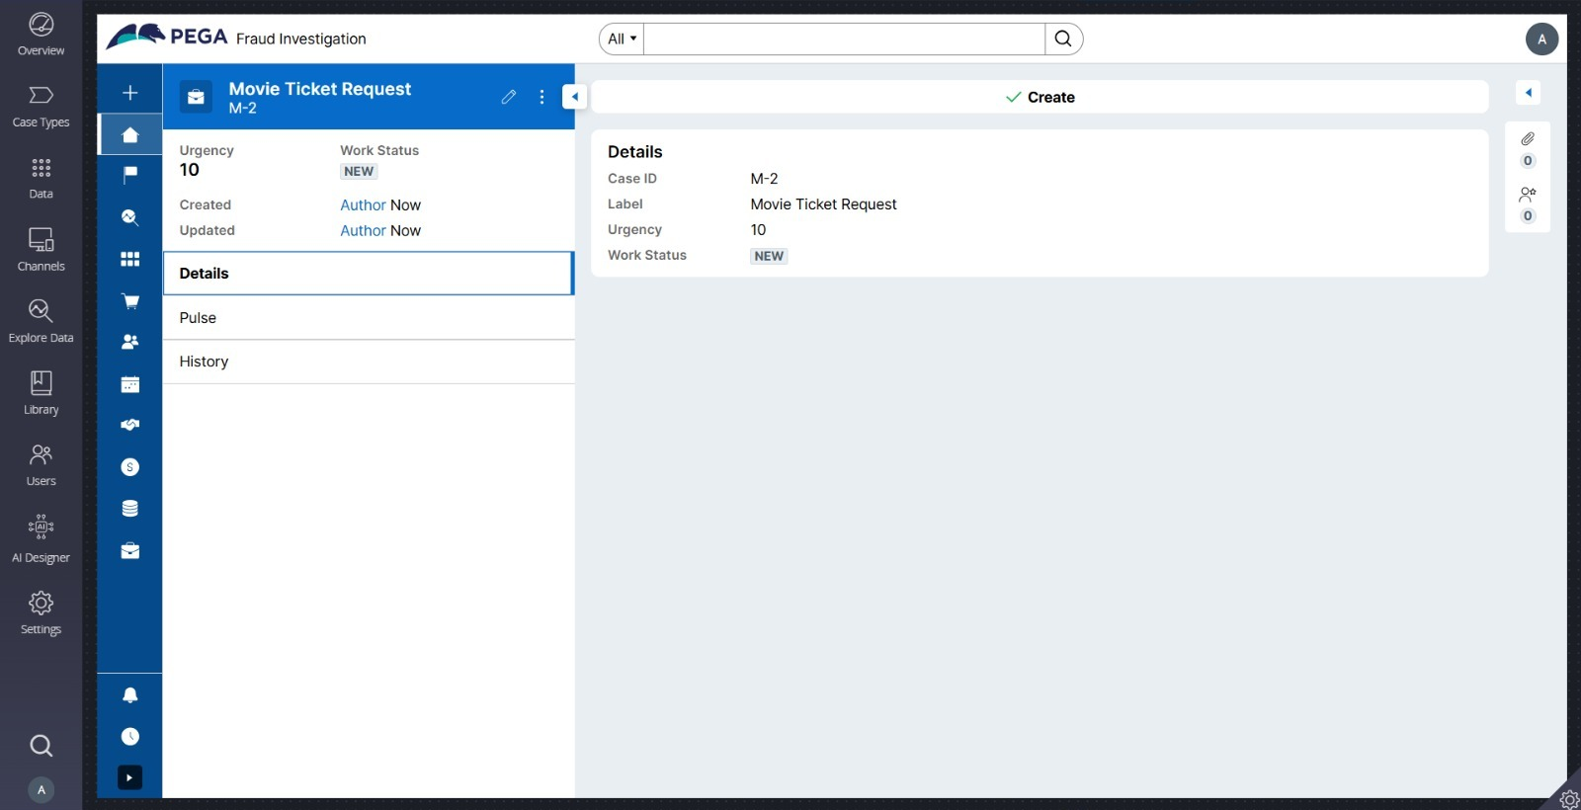
Figure 6 – Case Creation Confirmation (Case M-2, Create Stage Completed)
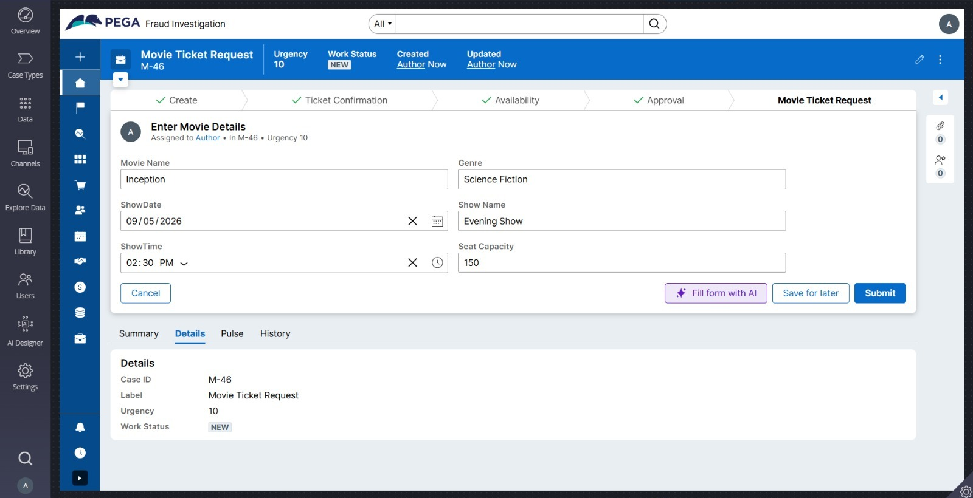
Figure 7 – Movie Details Entry (Case M-46, Movie Ticket Request Stage)
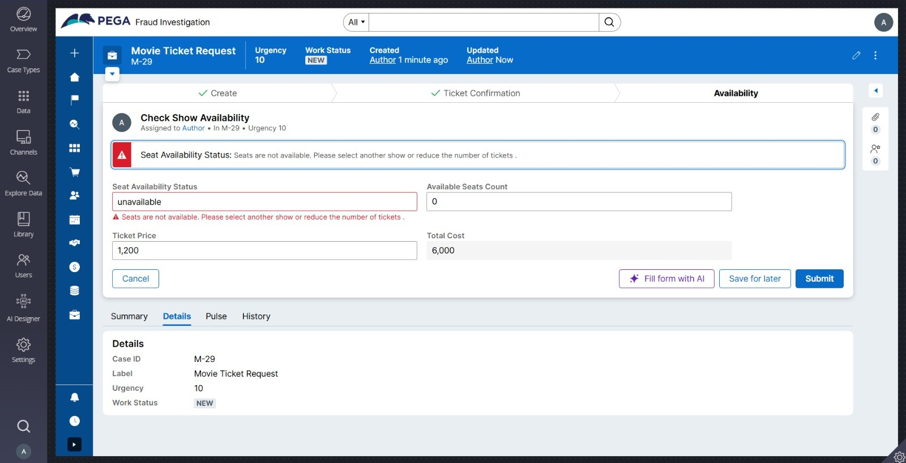
Figure 8 – Seat Availability Check: Unavailable Result (Case M-29)
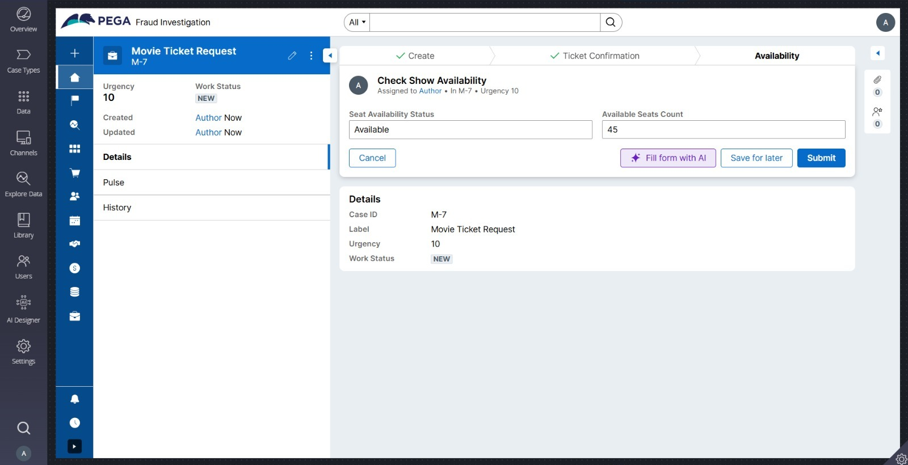
Figure 9 – Seat Availability Check: Available Result (Case M-7)
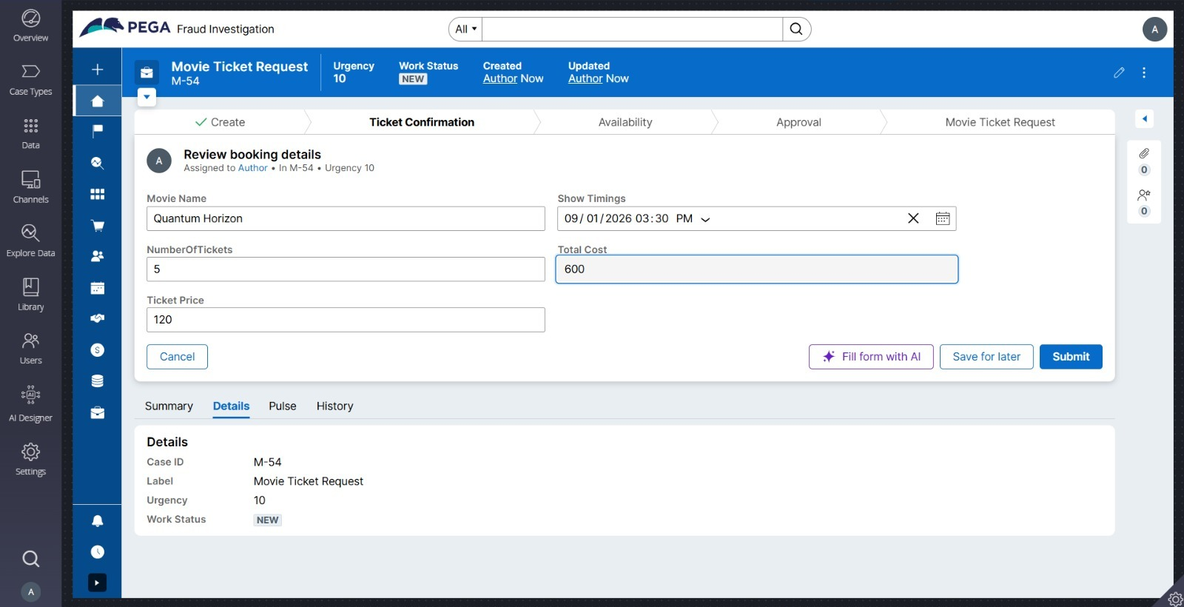
Figure 10 – Booking Details Review with Calculated Total Cost (Case M-54)
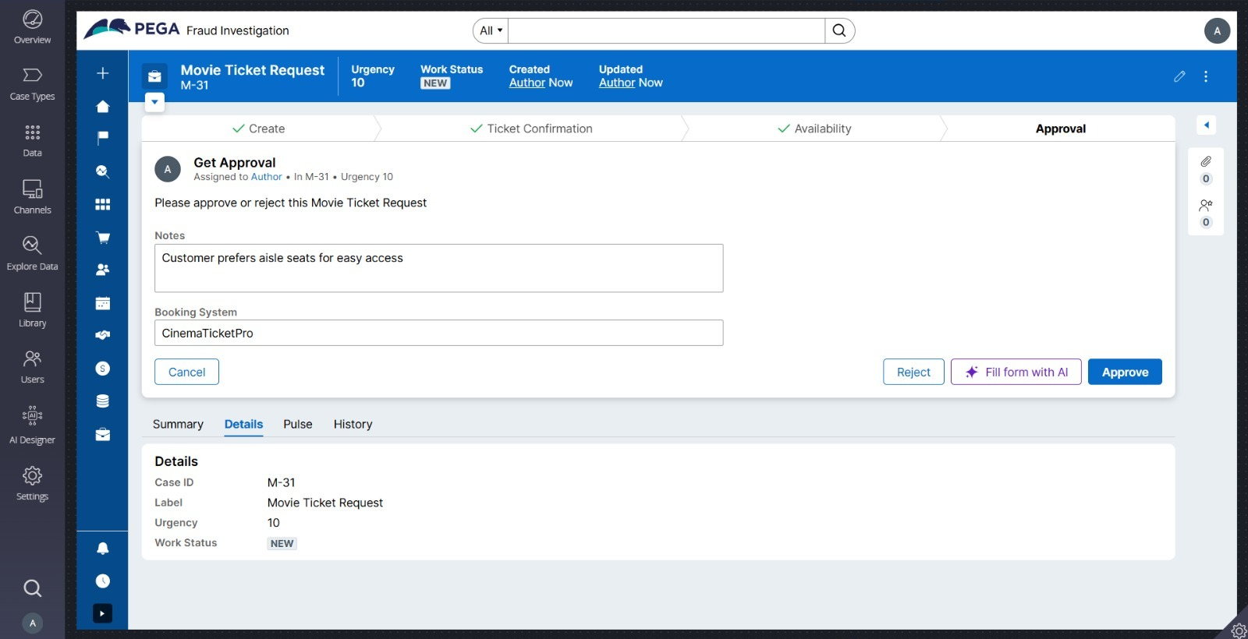
Figure 11 – Approval Step (Case M-31)
Summary of confirmed results:
- Booking cases were created and progressed successfully through the Create, Ticket Confirmation, Availability, and Approval steps (Figures 6, 7, 10, 11).
- The seat availability check correctly returns both "unavailable" (0 seats, Case M-29) and "Available" (45 seats, Case M-7) results depending on show data (Figures 8, 9).
- Total Cost is calculated and displayed based on Number of Tickets and Ticket Price (Case M-54, Figure 10).
- The Show Type routing business logic (Premium → PremiumShowQueue, otherwise → StandardQueue) is configured (Figure 5).
The following items were described as part of the completed work but are not confirmed by the provided screenshots:
- Booking confirmation email sent successfully with dynamic fields — not shown in the provided evidence.
- SLA configuration screen in Dev Studio — not shown in the provided evidence.
- PremiumShowQueue work queue configuration screen — not shown in the provided evidence.
- A live test of automatic assignment to StandardQueue for a non-Premium request — not shown in the provided evidence.

9. Conclusion
The Movie Ticket Request application was configured with a multi-stage case lifecycle covering ticket request creation, confirmation, availability checking, approval, and booking execution. Automatic routing logic based on Show Type was configured to direct Premium requests to PremiumShowQueue and all other requests to StandardQueue, as confirmed in the business logic configuration. A Custom SLA and an automatic booking confirmation email using dynamic Pega fields were reported as part of the completed configuration, though corresponding screenshots for these two items were not included in the submitted evidence.
The screenshots that were provided demonstrate that case creation, movie detail entry, seat availability checking (both available and unavailable outcomes), cost calculation, and the approval step all function as intended across multiple test case instances (M-2, M-7, M-29, M-31, M-46, M-54).

10. Final Checklist
☑ Movie Ticket Request case type configured — confirmed (Figures 2, 3)
☑ Case lifecycle stages (Create, Ticket Confirmation, Availability, Approval, Movie Ticket Request, Booking Execution) configured — confirmed (Figures 2, 3)
☑ Core booking fields (Movie Name, Show Date, Show Time, Number of Tickets, Total Cost) configured — confirmed (Figures 4, 7, 10)
☑ Complete Booking step present in Booking Execution stage — confirmed (Figure 3); field-level detail not shown
☑ Customer Email field configured — not shown in the provided evidence
☑ Booking confirmation email configured with dynamic Pega fields — reported, not shown in the provided evidence
☑ Successful confirmation email tested — reported, not shown in the provided evidence
☑ SLA configured: 1-day goal / 2-day deadline — reported, not shown in the provided evidence
☑ PremiumShowQueue created — reported, not shown in the provided evidence
☑ Show Type routing business logic configured — confirmed (Figure 5)
☑ Automatic routing tested end-to-end — not shown in the provided evidence
☑ Case workflow tested across multiple instances — confirmed (Figures 6–11)

