**PLACEMENT EMPOWERMENT PROGRAM**

**CLOUD COMPUTING AND DEVOPS CENTRE**

Host a static website on a Cloud VM

NAME: Subiksha J

DEPT: ADS-ENGG

STEPS:

Step1:

Create a static html file

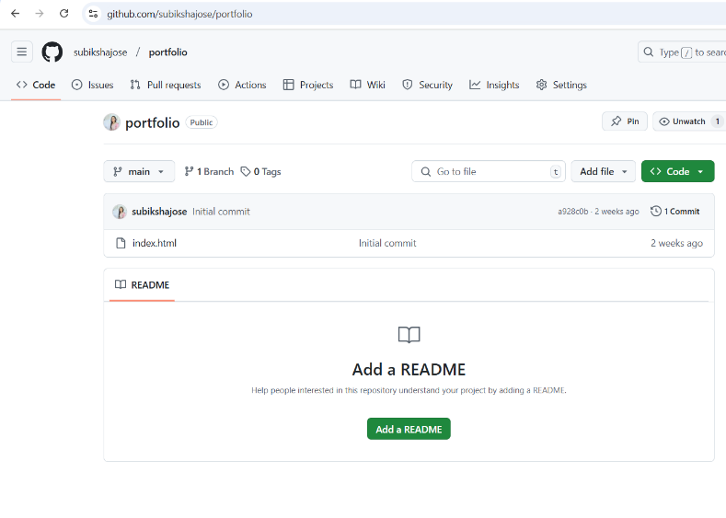

Step 2:

Launch an EC2 instance ( Ubuntu as OS, allow all network traffic)

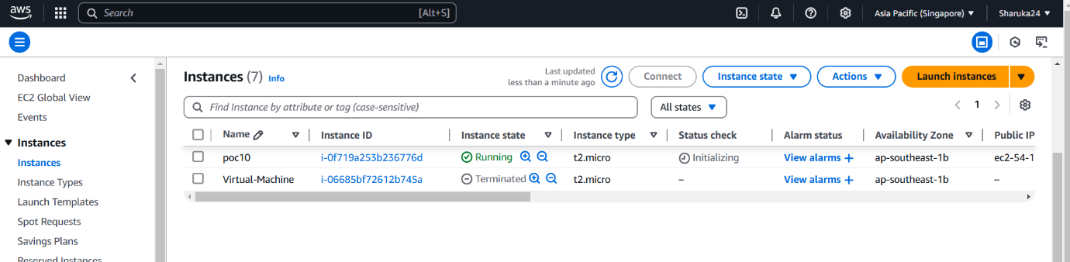

Step 3:

Select the connect option, Copy the command provided in the example in SSH section.

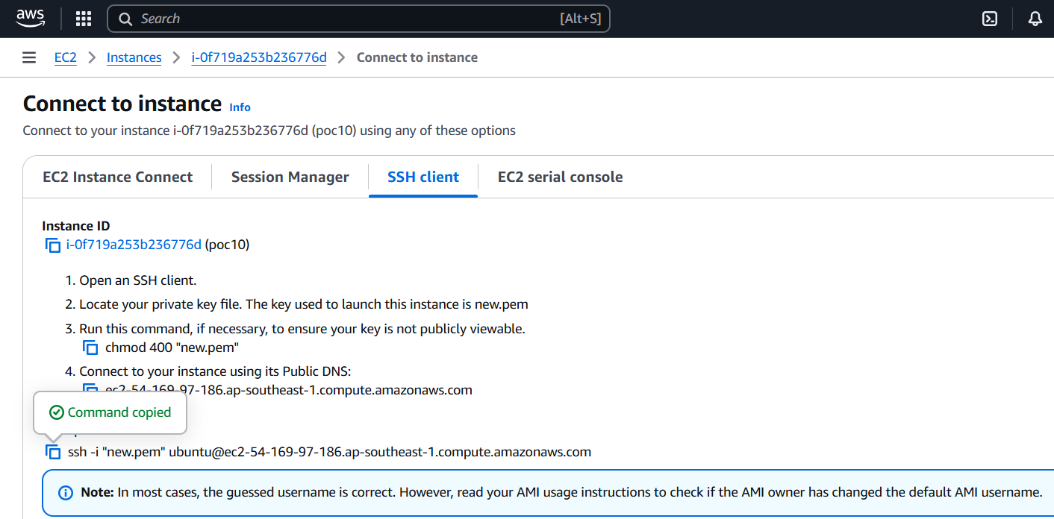

Step4:

Open powershell , navigate to downloads and paste the command. Ensure to replace with the key pair you created.

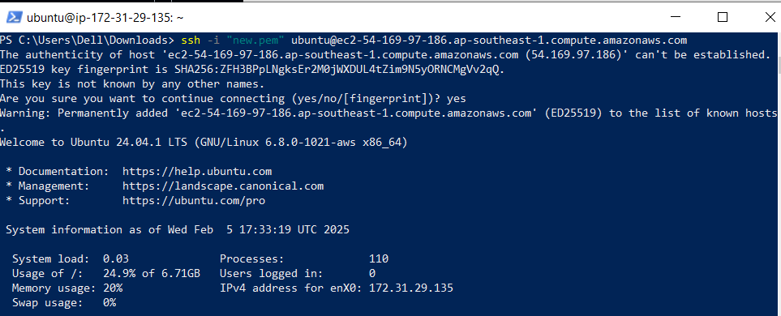

Step 6:

Follow the commands in below imgs and give yes whenever it asks for.







Step 7:

Clone your repository where you stored the html file.

Navigate to /var/www/html > ls index.html

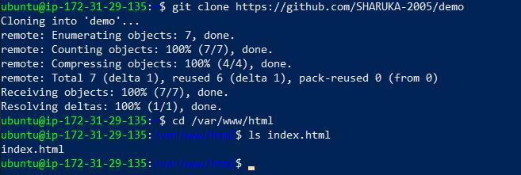

Step 8:

Copy the public IPv4 address in the EC2 instance

And paste it in the chrome browser.