# Placement Empowerment Program

Pep 11:Set Up IAM Roles and Permissions

Name: Subikaha J

Department: Ads

# Steps

## Step 1:

1. Go to [AWS Management Console](https://aws.amazon.com/console/).
2. Enter your username and password to log in.

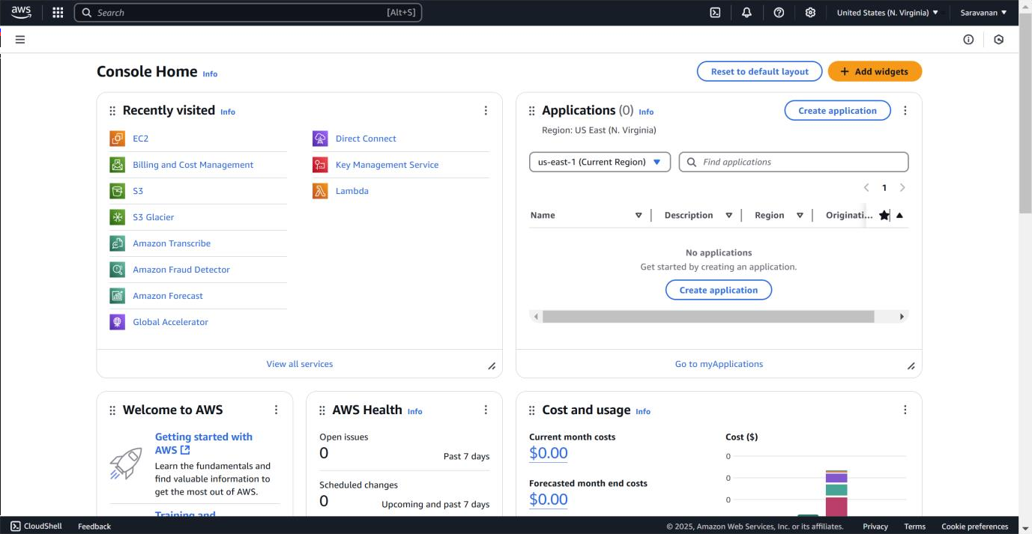

## Step 2:

1. In the AWS Management Console, type **"IAM"** in the search bar at the top.
2. Click on **IAM** from the search results.

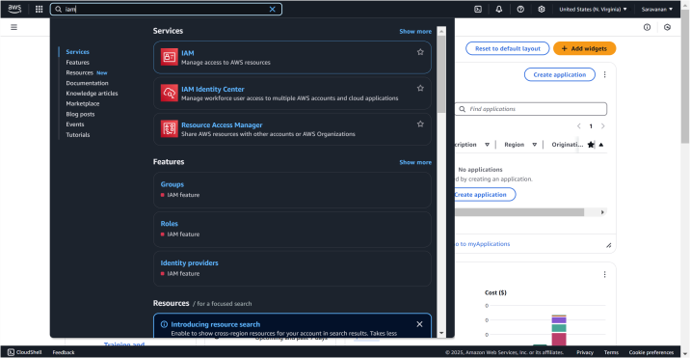

## Step 3:

* 1. On the IAM dashboard, click on **"Roles"** in the left-hand menu.
  2. On the Roles page, click the **"Create Role"** button.

## Step 4:

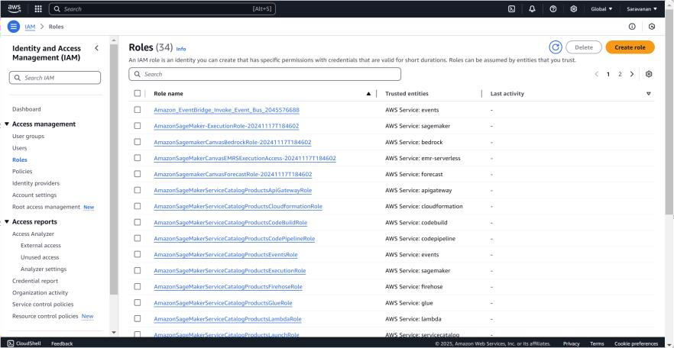

1. On the **"Create Role"** page, under **Trusted Entity Type**, select

**AWS Service** (it should be selected by default).

1. In the **Use Case** dropdown, choose **EC2**. Click **Next** to continue

## Step 5:

1. On the **Permissions** page, you’ll see a list of policies.
2. Select a policy based on what actions you want the VM to perform. For example:

To give the VM **read-only access to S3**, select

### AmazonS3ReadOnlyAccess.

You can search for policies in the search bar (e.g., type "S3" for S3 policies).

1. Once you've selected a policy, click **Next**.

## Step 6:

1. On the **Role Details** page:
   * Enter a name for your role (e.g., My-EC2-S3-Access-Role).
   * (Optional) Add a description or tags if you’d like.
2. Click **Create Role** to finish.

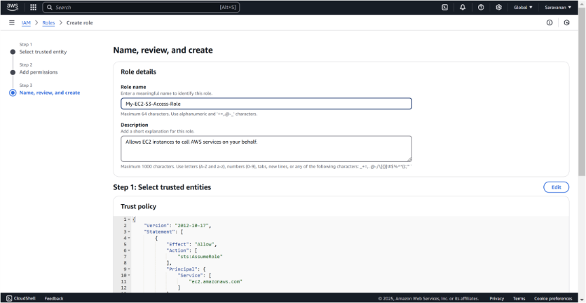

## Step 7:

1. In the AWS Management Console, search for **EC2** and click to open the **EC2 Dashboard**.
2. Select the instance (VM) you want to assign the IAM role to.

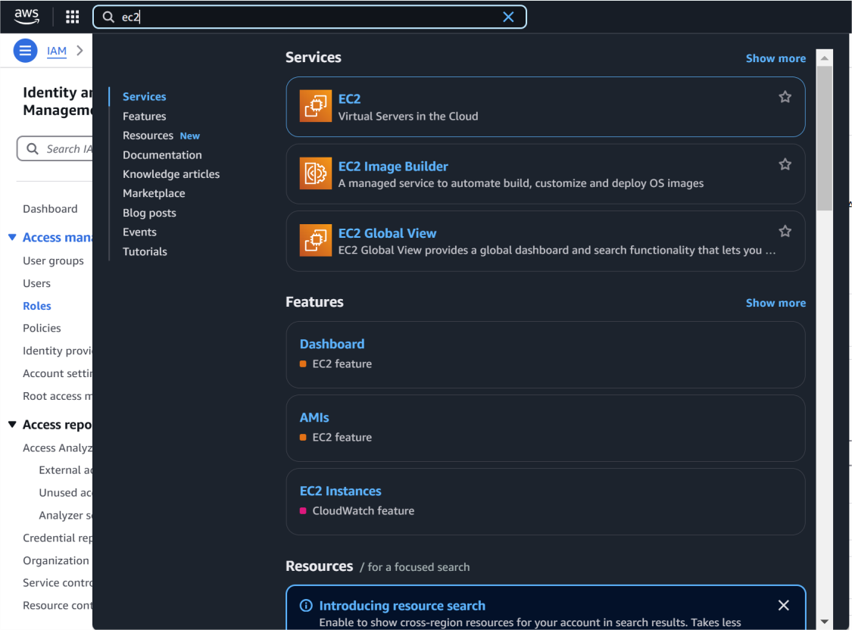

## Step 8:

1. In the **Instance details** section, click **Actions** in the top right corner.
2. From the dropdown, choose **Security** > **Modify IAM Role**.

## Step 9:

* 1. In the **Modify IAM role** window, you should see a dropdown for

### IAM role.

* 1. Select the role you created earlier (e.g., My-EC2-S3-Access- Role).
  2. Click **Update IAM role** to apply the changes.

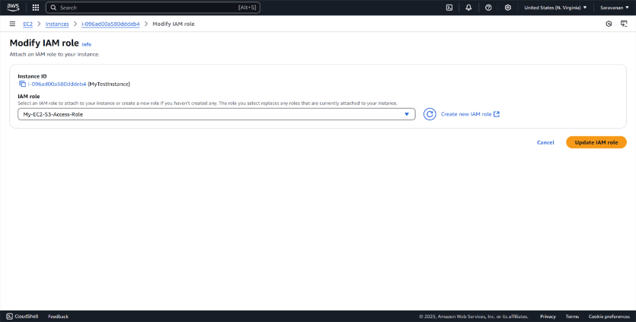

## Step 10:

1. Open your terminal (if you're using Linux or macOS) or Command Prompt (Windows).
2. Use SSH to log in to your EC2 instance. For example:

**ssh -i "your-key-pair.pem" ec2-user@your-ec2-public-ip**

## Step 11:

[ec2-user@ip-172-31-80-54 ~]$ **aws ec2 describe-regions --query "Regions[*].RegionName"**

The error confirms that your IAM role (My-EC2-S3-Access-Role) does not have permissions to perform the **ec2:DescribeRegions** action. The role currently only has S3-related permissions (e.g., AmazonS3ReadOnlyAccess) and doesn't include broader EC2 permissions.

