# Placement Empowerment Program

Poc 10:Use Cloud Storage Create a storage bucket on your cloud platform and upload/download files.

Name: Subiksha J Department: Ads

# Step-by-Step Overview

## Step 1:

1. Go to [AWS Management Console](https://aws.amazon.com/console/).
2. Enter your username and password to log in.

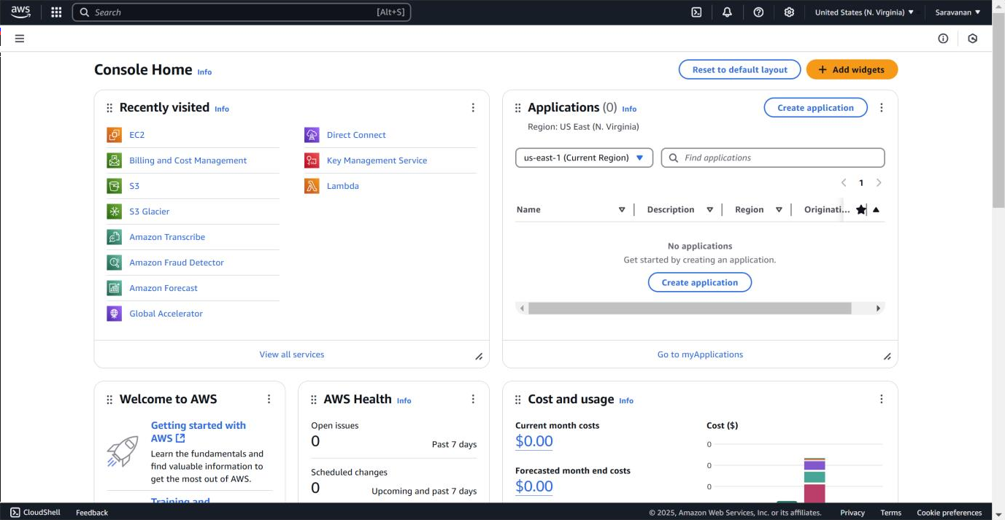

## Step 2:

In the top search bar, type **S3** and select it from the search results.

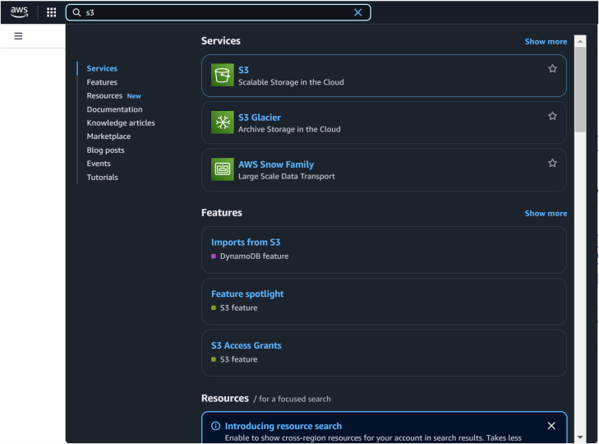

## Step 3:

Click **Create bucket**.

**Bucket name**: Enter a unique name (e.g.,saravana-s3-poc). Leave other settings as default (you can modify later).

## Step 4:

Select your bucket from the list and Click **Upload** → **Add files**.

Choose the file(s) you want to upload from your local machine and Click **Upload**.

## Step 5:

Navigate to the uploaded file inside your bucket.

Select the file and click **Download** from the **Actions** menu (or click the file name to download directly).

## Step 6:

Navigate to the uploaded file. Click the file name → Go to the **Permissions** tab. Under **Public access**, click **Edit** → Enable public access → Save changes.

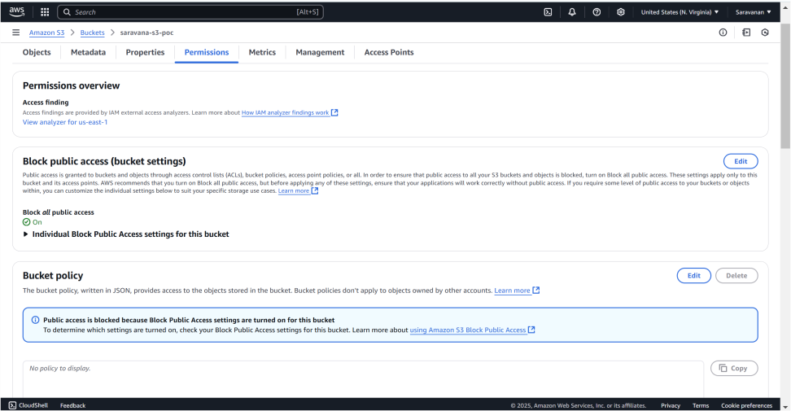

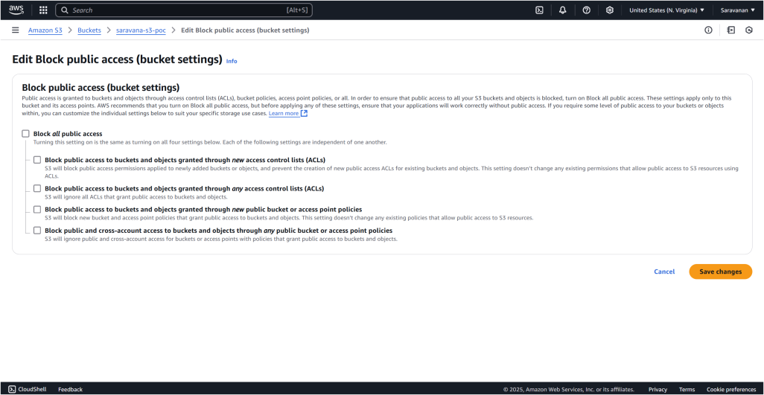

## Step 7:

Go to the **Permissions** tab of your bucket. Scroll down to **Bucket Policy** and click **Edit**.

Add the following example policy to make all files in the bucket publicly accessible:

Replace YOUR_BUCKET_NAME with your bucket name. Save the policy.

## Step 8:

Copy the Url in Copy URL option

## Step 9:

Paste the link in the new tab and you can see the uploaded file.